Pickering Emulsions Co-Stabilised by Cellulose Nanofibres and Nicotinamide Mononucleotide
Dehai Yu^{a,b,||}, Qi Luo^{a,||}, Qiang Wang^{a,*}, Huili Wangª, Zhaoping Songª, Shan Li^{d}, Wenxia Liu^{a,c,*}
ª State Key Laboratory of Biobased Material and Green Papermaking, Qilu University of Technology (Shandong Academy of Sciences), Ji’nan, Shandong Province 250353, China
^{b} National Forestry and Grassland Administration Key Laboratory of Plant Fiber Functional Materials, Fuzhou, Fujian 350108, China
^{c} Guangxi Key Laboratory of Clean Pulp & Papermaking and Pollution Control, College of Light Industry and Food Engineering, Guangxi University, Nanning 530004, China
^{d} School of Petrochemical Engineering, Changzhou University, Changzhou 213164, P. R. China
* Corresponding Authors: wangqiang8303@163.com (Q. Wang); liuwenxia@qlu.edu.cn (W. Liu)
|| Dehai Yu and Qi Luo contributed equally to this work.

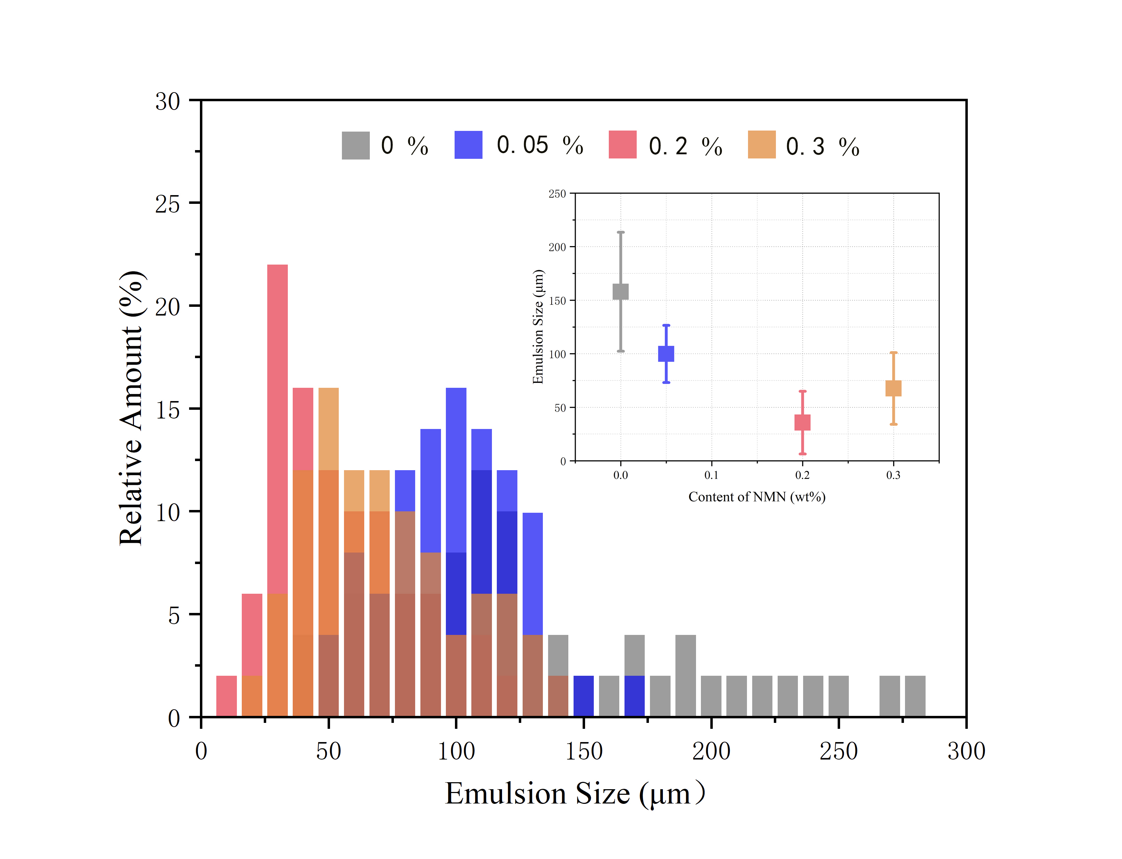
Fig. S1 Emulsion droplet diameter distribution with different concentrations of NMN

