Solvent dependency of adsorption of mercaptopurine on CC, AlN and BN nanotubes and the evaluation of noncovalent interactions

Jamelah S.Al-Otaibi^{a*}, Y.Sheena Mary^{b}, Y.Shyma Mary^{b}, Renjith Thomas^{c}
ª Department of Chemistry, College of Science, Princess Nourah bint Abdulrahman University, P.O. Box 84428, Riyadh 11671, Saudi Arabia
^{b}Thushara, Neethinagar-64, Kollam, Kerala, India
^{c} Deparment of Chemistry, St Berchmans College (Autonomous), Mahatma Gandhi University, Changanassery, Kerala, India

*Author for correspondence: email: jamelah2019@rediffmail.com

Table S1. Solvation energies

system | Energy (Hartree) | SFE (kcal/mol)
MCP | -810.135935
AlN-NT | -5945.089128
BN-NT | -1991.747242
CC-NT | -1904.371864
MCP-AlN-NT (vacuum) | -6755.268883 | -27.50
MCP-AlN-NT (toluene) | -6755.295269 | -44.05
MCP-AlN-NT (dichloromethane) | -6755.319539 | -59.28
MCP-AlN-NT (methanol) | -6755.328760 | -65.07
MCP-AlN-NT (water) | -6755.331143 | -66.57
MCP-BN-NT (vacuum) | -2801.891216 | -5.04
MCP-BN-NT (toluene) | -2801.905397 | -13.94
MCP-BN-NT (dichloromethane) | -2801.918017 | -21.86
MCP-BN-NT (methanol) | -2801.922461 | -24.65
MCP-BN-NT (water) | -2801.923531 | -25.32
MCP-CC-NT (vacuum) | -2714.512405 | -2.89
MCP-CC-NT (toluene) | -2714.521663 | -8.70
MCP-CC-NT (dichloromethane) | -2714.529876 | -13.85
MCP-CC-NT (methanol) | -2714.532840 | -15.71
MCP-CC-NT (water) | -2714.533557 | -16.16

Fig.S1 UV spectra of (a) mercaptopurine (MCP) (b) MCP-CC-NT (c) MCP-AlN-NT (d) MCP-BN-NT
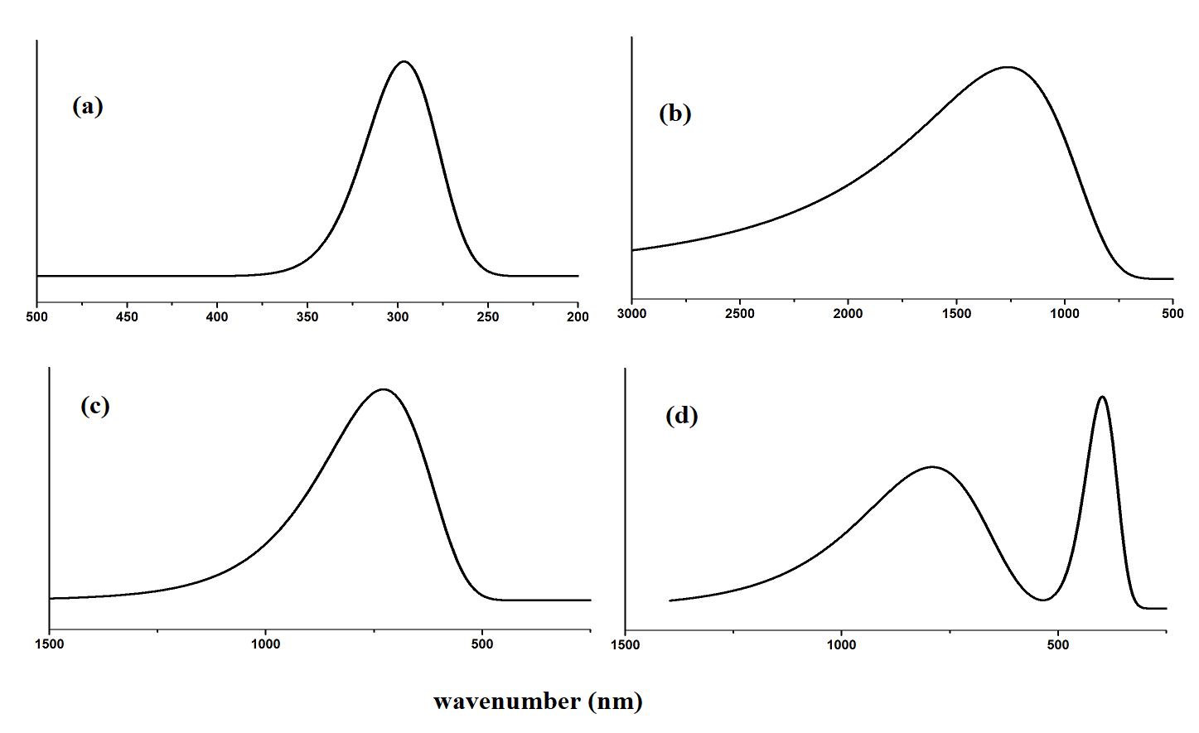
Fig.S2 Raman spectra of (a) mercaptopurine (MCP) (b) MCP-CC-NT (c) MCP-AlN-NT (d) MCP-BN-NT
