Table 1. Properties of ligands selected for the study. Further top three ligands were taken as potential ligands on the basis of its docking score.

Sl. No. | Drug (Ligands) | Mol. Wt. | Molecular Formula | HBD | HBA | tPSA | No. of Rotatable bonds
 | Dilliazem | 451 | C22H27ClN2O4S | 1 | 6 | 84.4 | 7
 | Sotalol | 272.37 | C12H20N2O3S | 3 | 5 | 86.8 | 6
 | Flecainide | 414.34 | C17H20F6N2O3 | 2 | 10 | 59.6 | 7
 | Phenytoin | 274.25 | C15H11N2NaO2 | 1 | 3 | 47.2 | 2
 | Nimodipine | 418.446 | C21H26N2O7 | 1 | 8 | 120 | 9
 | Carbamazepine | 236.27 | C15H12N2O | 1 | 1 | 46.3 | 0
 | Flupirtine | 304.32 | C17H20F6N2O3 | 2 | 10 | 89.3 | 7
 | Gabapentin | 171.24 | C9H17NO2 | 1 | 2 | 67 | 3
 | Benzodiazepine | 144.17 | C9H8N2 | 1 | 2 | 24.4 | 0
 | Glibenclimide | 490.6 | C24H34N4O5S | 3 | 5 | 133 | 7
 | Lidocaine | 234.343 | C14H22N2O | 2 | 1 | 33 | 5
 | Lubiprostone | 390.467 | C20H32F2O5 | 1 | 5 | 86 | 11
 | Topiramate | 339.366 | C12H21NO8S | 1 | 8 | 115 | 3
 | Lamotrigine | 256.096 | C9H7Cl2N5 | 2 | 5 | 90 | 1
 | Amlodipine | 408.882 | C20H25ClN2O5 | 2 | 6 | 101 | 8
 | Amiodarone | 645.319 | C25H29I2NO3 | 1 | 3 | 43 | 11
 | Nifedipine | 346.339 | C17H18N2O6 | 1 | 7 | 107 | 4
 | Verapamil | 454.611 | C27H38N2O4 | 1 | 5 | 65 | 13

Table 2. Pockets (top 2) and their area and volume predicted by CASTp server

Poc ID | Area (SA) | Volume (SA)
1 (Red) | 3132.679 | 2572.874
2 (Green) | 331.985 | 216.708

Table 3. Docking Results derived from PyRx for the selected ligands.
Sl. No. | Ligand | Pubchem CID | Docking Score | 2D-Structure
 | Glibenclimide | 3476 | -9.8 | 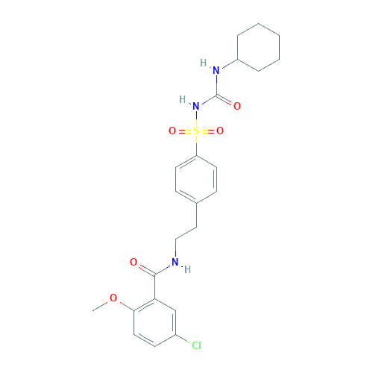
 | Lubiprostone | 157920 | -8.4 | 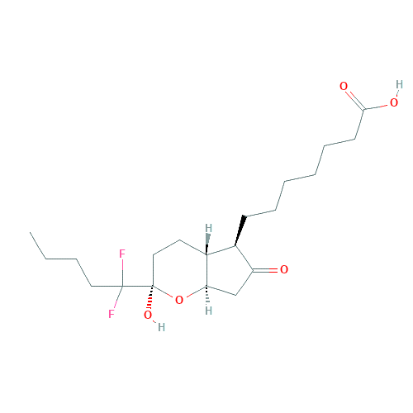
 | Flecainide | 3356 | -8.1 | 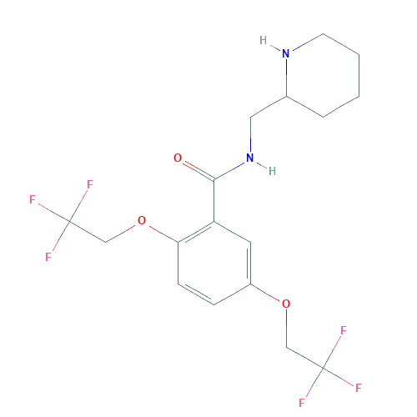
 | Phenytoin | 657302 | -7.9 | 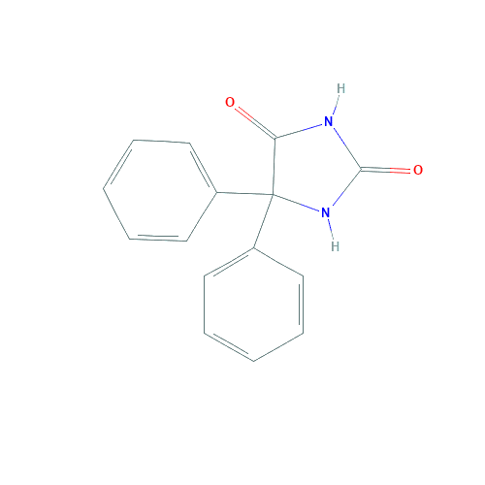
 | Flupiritine | 53276 | -7.7 | 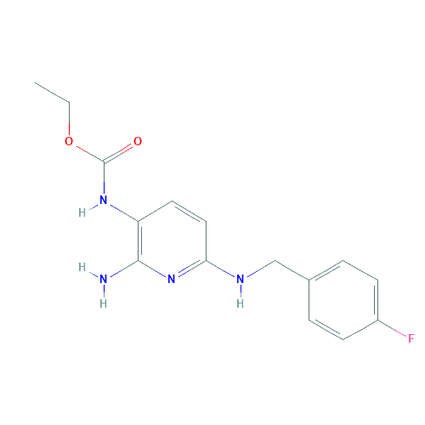
 | Carbamazepine | 2554 | -7.6 | 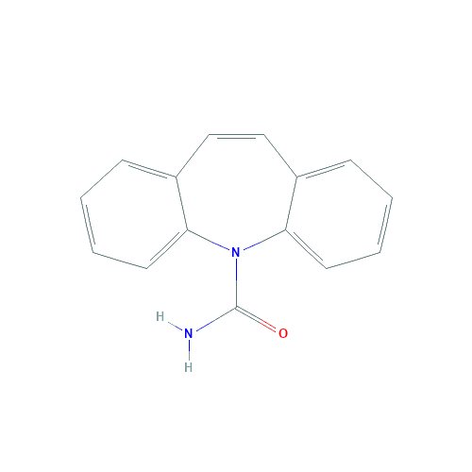
 | Benzodiazepine | 134664 | -7.5 | 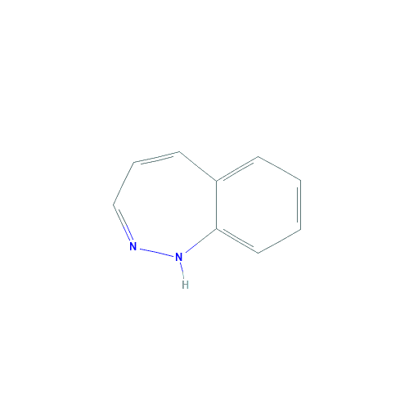
 | Verapamil | 2520 | -7.5 | 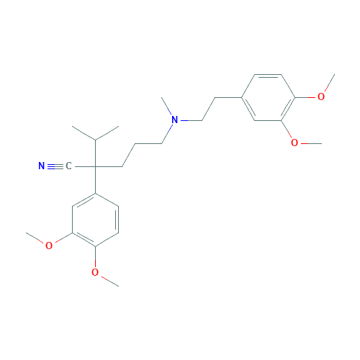
 | Topiramate | 5284627 | -7.3 | 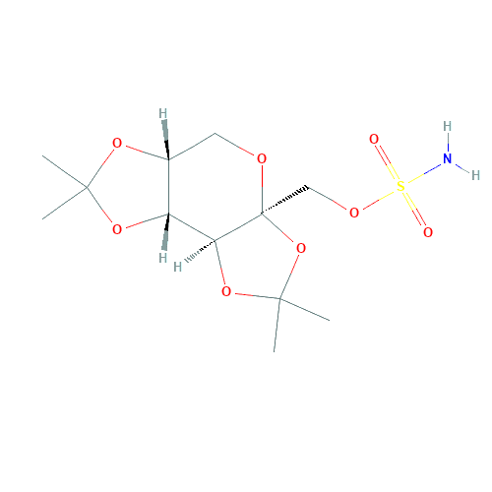
 | Lamotrigine | 3878 | -7.2 | 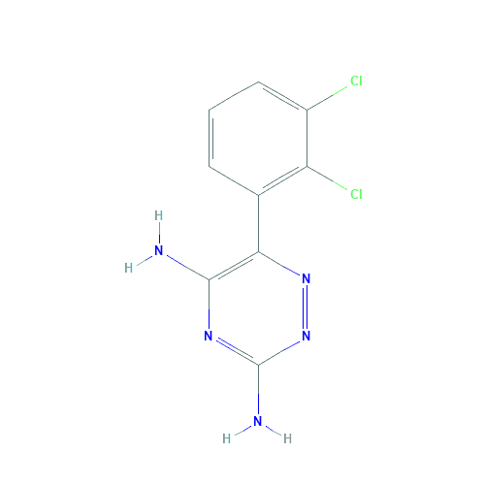
 | Nimodipine | 4497 | -7.2 | 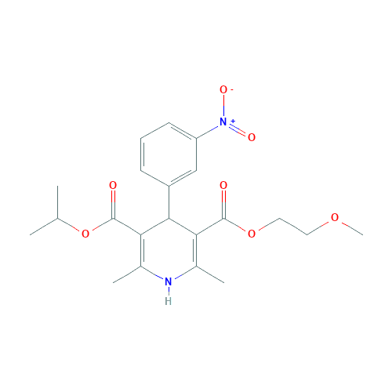
 | Amiodaron | 2157 | -7.1 | 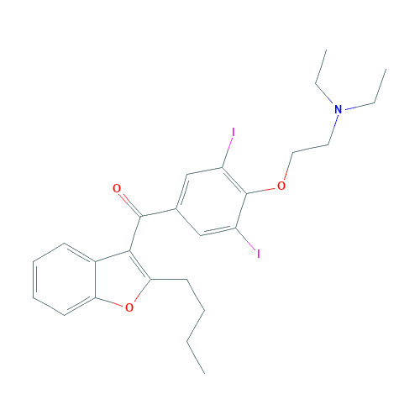
 | Diltiazem | 39186 | -6.9 | 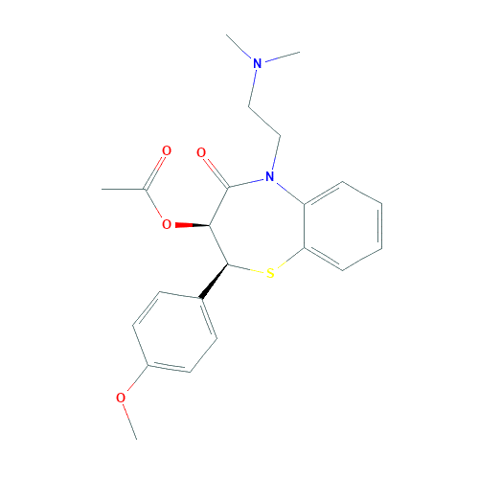
 | Nifedipine | 4485 | : -6.8 | 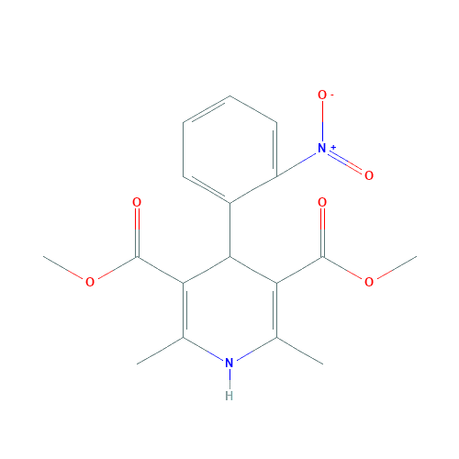
 | Amlodipine | 2162 | -6.7 | 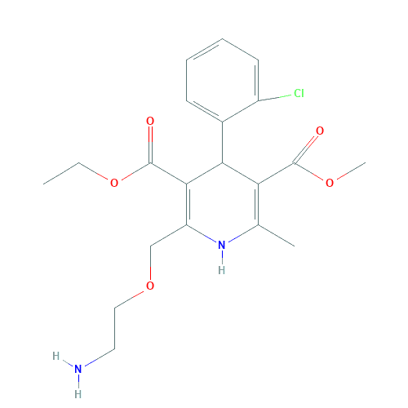
 | Sotalol | 5253 | : -6.6 | 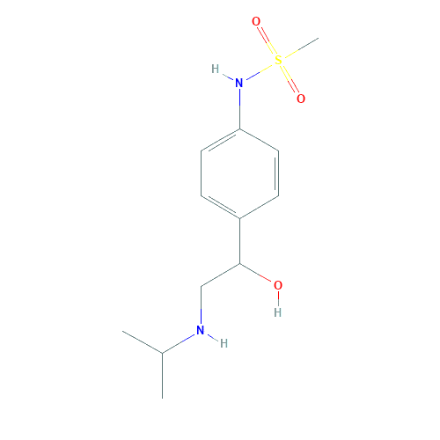
 | Lidocaine | 3676 | -6.3 | 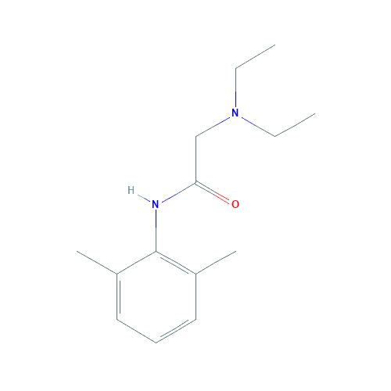
 | Gabapentin | 3446 | -6.2 | 