Effective deep learning for oral exfoliative cytology classification

Shintaro Sukegawa ^{1,2,} *, Futa Tanaka ³, Keisuke Nakano ², Takeshi Hara ^{3,4}, Kazumasa Yoshii³, Katsusuke Yamashita ⁵, Sawako Ono ⁶, Kiyofumi Takabatake ², Hotaka Kawai ², Hitoshi Nagatsuka ², Yoshihiko Furuki ¹
¹ Department of Oral and Maxillofacial Surgery, Kagawa Prefectural Central Hospital, 1-2-1, Asahi-machi, Takamatsu, Kagawa 760-8557, Japan
² Department of Oral Pathology and Medicine, Graduate School of Medicine, Dentistry and Pharmaceutical Sciences, Okayama University, Okayama 700-8558, Japan
³ Department of Electrical, Electronic and Computer Engineering, Faculty of Engineering, Gifu University, 1-1 Yanagido, Gifu, Gifu 501-1193, Japan
⁴ Center for Healthcare Information Technology, Tokai National Higher Education and Research System, 1-1 Yanagido, Gifu, Gifu 501-1193 Japan
⁵ Polytechnic Center Kagawa, 2-4-3, Hananomiya-cho, Takamatsu, Kagawa
⁶ Department of Pathology, Kagawa Prefectural Central Hospital, 1-2-1, Asahi-machi, Takamatsu, Kagawa 760-8557, Japan

Appendix
Performance metrics
We evaluated the performance metrics, with accuracy, precision, recall, and the F1 score as defined in Equations 3–7, along with the receiver operating characteristic curve (ROC), and the area under the ROC curve (AUC). The ROC curves were shown for the complete dataset from the 4-fold cross-validation, producing the median AUC value.
In the following equations, TP, TN, FP, and FN represent true positive (normal correctly identified), true negative (abnormal correctly identified), false positive (abnormal incorrectly identified), and false negative (normal incorrectly identified) results, respectively.
$accuracy=\frac{TP + TN}{TP + FP + TN + FN}$ (1)

$precision=\frac{TP}{TP + FP}$ (2)

$recall=\frac{TP}{TP + FN}$ (3)

$F1 score=2×\frac{precision × recall}{precision + recall}$ (4)

Figure S1: Average ROC in each deep learning model using SAM and SGD as an optimizer, and with and without the introduction of the learning rate scheduler

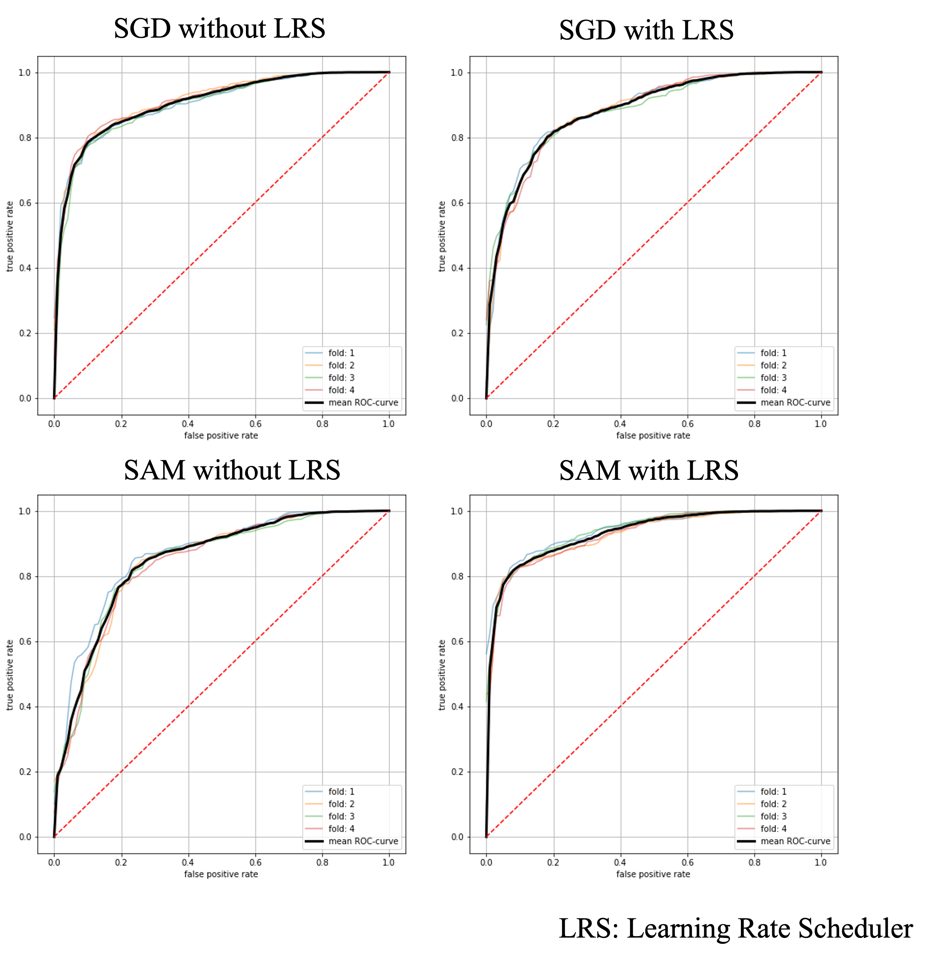

Figure S2: Data augmentation
Data augmentation
Data augmentation is a method of inflating the number of data by adding various transformations to the data. Furthermore, by providing diversity to the input data, the effect of preventing excessive adaptation to the training data can be expected. In this study, instead of physically increasing the number of images, the method of applying data augmentation for each mini-batch was randomly performed using the following method. The margins created by the data creation were filled by inverting the image.

Random Rotation; range of -90 ° to 90 °
Random Flip; top and bottom and left and right range of 30%
Random Shift; up / down and left / right range of 30%

Figure S3. Change in learning rate for each number of epochs in scheduler warmup and step-decay as a learning rate in this study.

