Supplementary table 1 Correlation analysis of five elements in three tissues of crayfish
Element | Tissue | Am | He | Element | Am | He
Cu | He | 0.00 |  | Se | 0.57**
Cu | Ex | 0.54** | 0.00 | Se | 0.32** | 0.32**
Zn | He | 0.30** |  | Mn | 0.06
Zn | Ex | -0.09 | -0.01 | Mn | 0.54 ** | 0.30**
Fe | He | 0.27 **
Fe | Ex | 0.57 ** | 0.45 **
“**”, represents P <0.01.

Supplementary table 2 Correlation analysis of five elements in hepatopancreas and abdominal muscle of crayfish
He  Am | Mn | Fe | Cu | Zn | Se
Mn |  | 0.01 | 0.28** | 0.19* | 0.34**
Fe | 0.73** |  | -0.16* | 0.30** | 0.33**
Cu | 0.34** | 0.30** |  | 0.13 | 0.02
Zn | 0.21** | 0.07 | -0.12 |  | 0.36**
Se | 0.03 | 0.04 | -0.06 | 0.17
Am, abdominal muscle; He, hepatopancreas; “*”, represents P <0.05, “**”, represents P <0.01.

Supplementary table 3 Correlation analysis of five elements in exoskeleton of crayfish
Element | Mn | Fe | Cu | Zn | Se
Fe | 0.65**
Cu | 0.28** | 0.43**
Zn | -0.17* | 0.02 | 0.36**
Se | 0.09 | 0.15 | 0.42** | 0.51**
“*”, represents P <0.05, “**”, represents P <0.01.

Supplementary table 4 The concentrations of five trace elements in sediment of crayfish field (mg kg⁻¹)
Region | Village | Fe* | Mn | Cu | Zn | Se
SDTL | Baohe | 28.52±0.11 | 284.92±10.30 | 27.80±0.27 | 97.52±1.64 | 0.26±0.05
SDTL | Chetianping | 23.39±1.34 | 361.81±38.47 | 19.65±0.86 | 67.86±3.60 | 0.11±0.02
SDTL | Taolin | 18.63±3.20 | 79.91 ±27.74 | 14.99±1.28 | 59.17±4.77 | 0.17±0.02
NEPYL | Liyushan | 86.34±1.84 | 215.48±15.97 | 139.72±4.76 | 146.02±10.32 | 0.37±0.05
NEPYL | Haikou | 28.34±1.47 | 294.57±28.12 | 26.76±0.95 | 71.99±3.90 | 0.17±0.03
NEPYL | Hengshanzui | 26.36±3.90 | 276.27 ±1.12 | 17.02±0.33 | 42.03±0.59 | 0.17±0.02
NDTL | Futian | 11.36±0.36 | 134.68 ±7.42 | 9.77±0.27 | 27.20±0.60 | 0.33±0.03
NDTL | Hujiawan | 20.46±0.39 | 189.92±17.06 | 19.37±0.59 | 50.89±2.91 | 0.22±0.03
NDTL | Hengtai | 26.55±1.01 | 283.52±20.79 | 24.84±1.19 | 64.85±3.20 | 0.16±0.02
NDTL | Pengjiatai | 26.80±1.82 | 170.03±31.44 | 27.78±0.98 | 72.82±1.65 | 0.20±0.02
NDTL | Bailuhu | 26.58±0.71 | 224.64±27.00 | 26.92±0.55 | 68.03±0.80 | 0.21±0.06
ESR | Lianhuachi | 22.93±1.68 | 352.77±96.47 | 17.92±1.31 | 48.16±3.49 | 0.25±0.03
ESR | Chunmuying | 31.02±1.21 | 751.36±181.67 | 32.55±0.76 | 77.17±2.10 | 0.68±0.14
ESR | Shima | 16.44±0.53 | 244.11±40.95 | 10.75±0.36 | 36.56±3.66 | 0.47±0.06
ESR | Ganyan | 21.21±3.67 | 186.83±28.43 | 18.54±2.15 | 57.19±4.85 | 0.24±0.03
ESR | Zhutong# | 31.86±2.73 | 550.44±88.61 | 26.76±3.83 | 71.95±7.64 | 0.19±0.06

“*”, represents mg g⁻¹, “#”, represents the village of the carp (Hypophthalmichthys nobilis), crab (Eriocheir sinensis) and crayfish (Procambarus clarkii) samples collection.

Supplementary table 5 The concentrations of five essential elements in liver/hepatopancreas of three species (mg kg⁻¹)
Species | Mn | Fe* | Cu | Zn | Se
Crayfish | 195.91±58.65a | 3.55±1.47a | 317.96±118.85a | 77.50±18.77c | 2.15±0.52b
Carp | 15.74 ±1.26c | 0.70±0.24b | 108.59±26.84b | 189.27±35.48a | 7.60±1.48a
Crab | 29.06 ±8.12b | 0.91±0.21b | 122.49±29.52b | 131.59±15.38b | 2.48±0.59b
Carp, Bighead carp (Hypophthalmichthys nobilis); Carb, Chinese Mitten crab (Eriocheir sinensis); Crayfish, red swamp crayfish (Procambarus clarkii); Data were showed with mean ± SD; a, b and c, ranked by Duncan test at P < 0.05; “*”, represents mg g⁻¹.

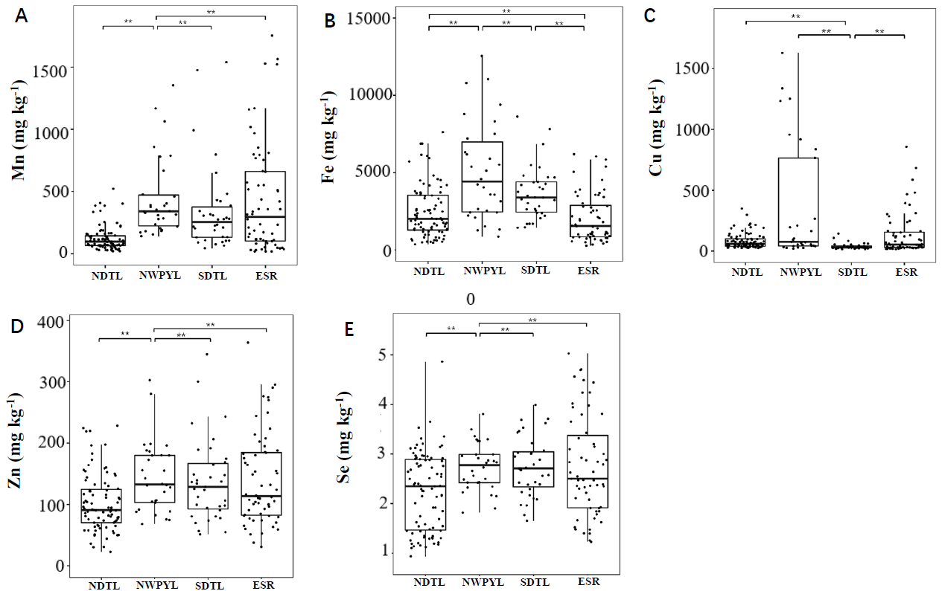
Supplementary figure 1: The concentrations of Mn, Fe, Cu, Zn and Se in hepatopancreas of the four investigated regions.

The horizontal lines within the boxes represent the 50th values; the upper and lower limits of the boxes represent the 75th and 25th values; SDTL, represents South of Dongting Lake region; NDTL, represents North of Dongting Lake region; NWPYL, represents Northwest of Poyang Lake region; ESR represents Enshi region; “**”, represents P<0.01.

Supplementary figure 2 The concentrations of Mn, Fe, Cu, Zn and Se in exoskeleton of the four investigated regions

The horizontal lines within the boxes represent the 50th values; the upper and lower limits of the boxes represent the 75th and 25th values; SDTL, represents South of Dongting Lake region; NDTL, represents North of Dongting Lake region; NWPYL, represents Northwest of Poyang Lake region; ESR represents Enshi region; “**”, represents P<0.01.

