Removal of mixed cationic dyes by a biosorbent based on magnetic tragacanth gum hydrogel

Mehdi Jaymand∗^{,1}

- Nano Drug Delivery Research Center, Health Technology Institute, Kermanshah University of Medical Sciences, Kermanshah, Iran.

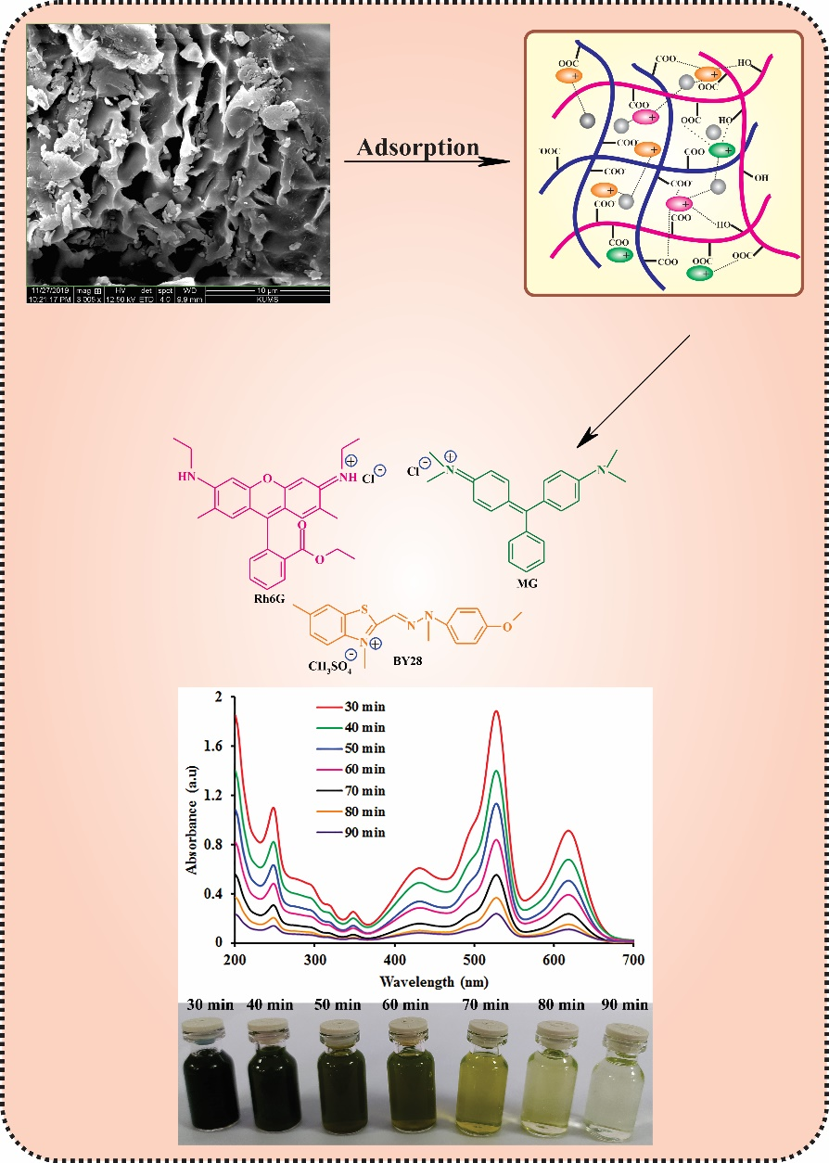
Malachite green (MG), basic yellow 28 (BY28), and rhodamine 6G (Rh6G) cationic dyes were removed efficiently single, binary, and ternary systems form industrial simulated wastewater via adsorption process using a magnetic tragacanth gum-grafted poly(acrylic acid) hydrogel.

∗ Correspondence to: Mehdi Jaymand, Nano Drug Delivery Research Center, Health Technology Institute, Kermanshah University of Medical Sciences, Kermanshah, Iran. E-mail addresses: m_jaymand@yahoo.com; m.jaymand@gmail.com; mehdi.jaymand@kums.ac.ir

