Synthesis and comparative assessment of ESIPT core containing lightfast fluorescent monoazo dyes
Supriya H. Ramugade , Sekar Nagaiyan N.
¹Department of Dyestuff Technology, Institute of Chemical Technology, Matunga, Mumbai 400 019, India.
Supriya H. Ramugade: ORCID ID – 0000-0001-8504-9927
Sekar Nagaiyan N: ORCID ID - 0000-0001-7568-5129
Corresponding author: Sekar Nagaiyan N.
Corresponding author email id: n.sekar@ictmumbai.edu.in, nethi.sekar@gmail.com (N. Sekar).

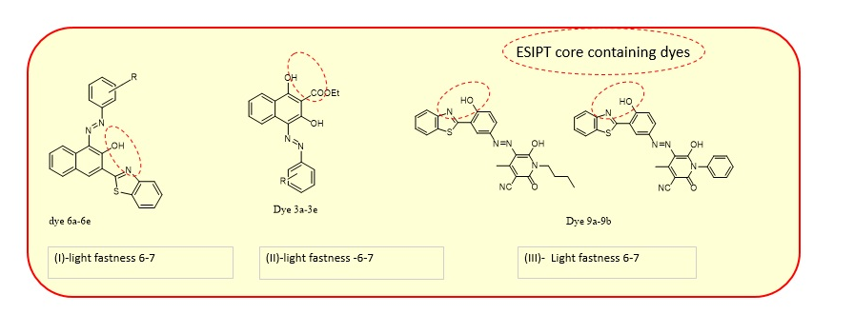
Fig.S1 comparison of the lightfastness of dyes containing ESIPT core.

-OH
-N=N-
Fig S2- FTIR of dye 6aA

-OH

-N=N-

Fig S3- FTIR of dye 6bA

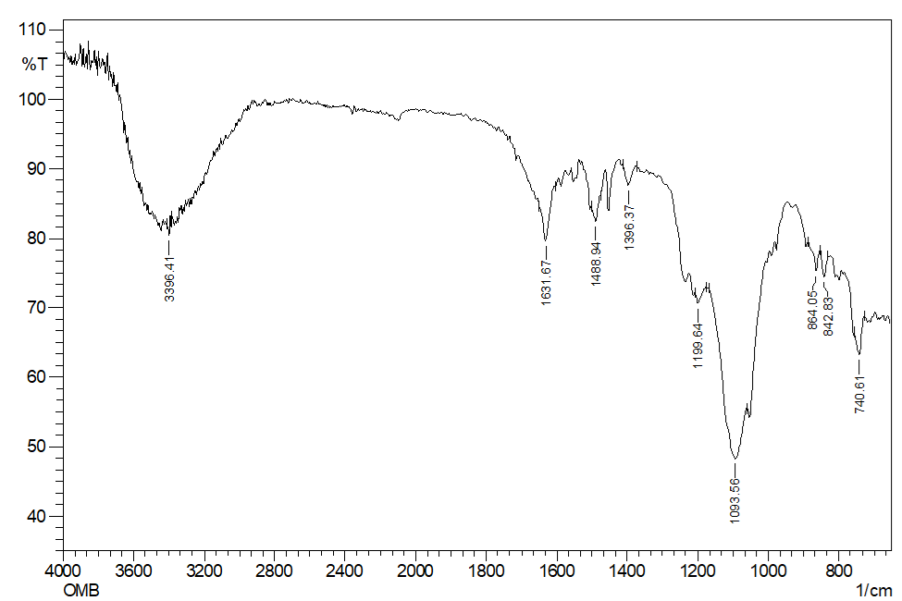
-OH
-N=N-

Fig S4- FTIR of dye 7aA

-OH
-N=N-

Fig S5- FTIR of dye 7bA

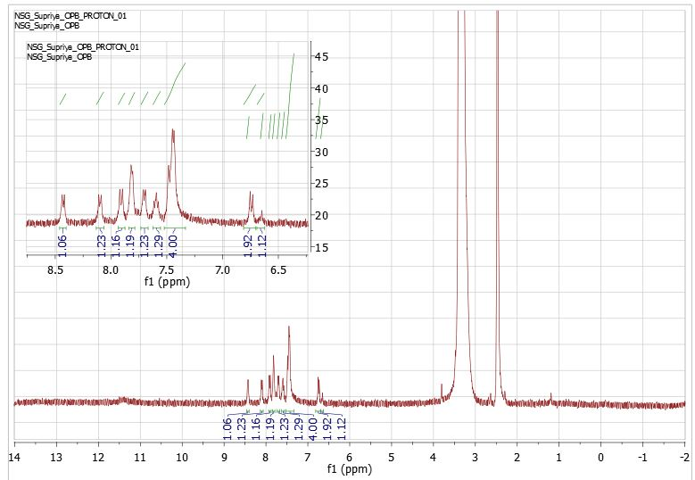

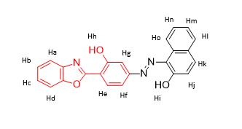

Fig S6: ¹H NMR of dye “(E)-1-((3-(Benzo[d]oxazol-2-yl)-4-hydroxyphenyl) diazenyl) naphthalen-2-ol(6aA)

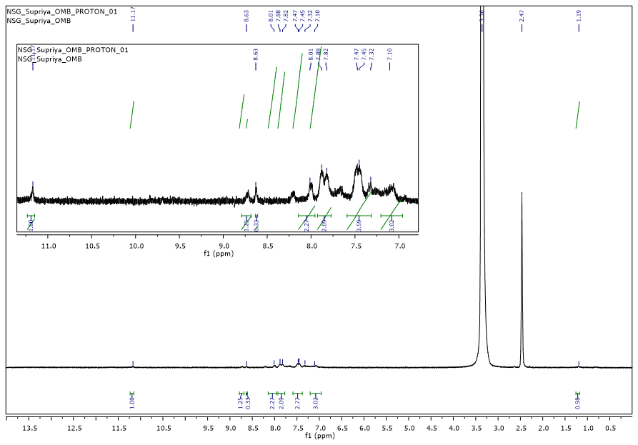

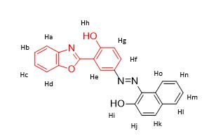

Fig S7- ¹H NMR of dye (E)-1-((3-(Benzo[d]oxazol-2-yl)-5-((4-hydroxyphenyl) diazenyl) naphthalen-2-ol(7aA)

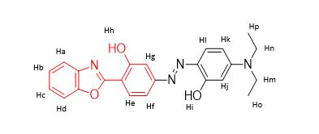

Fig S8- ¹H NMR of dye -“(Z)-2-(Benzo[d]oxazol-2-yl)-5-((4-(diethylamino)-2-hydroxyphenyl) diazenyl) phenol” (7bA)

Fig S9-M/Z of dye 7bA

Fig S10. Absorption spectra of dye 6bA

Fig S11. Absorption spectra of dye 7aA

Fig S12. Absorption spectra of dye 7bA

