Supplementary Table S1. Sequences of primers used in mouse genotyping and qPCR.

 | Forward (5'-3') | Reverse (5'-3')
Genotyping
Flox | CAGGGTTCCCTTCCCAAATCCCAAA | TCCAGGTTCACAGTGGGGTAGACAA
Alb-Cre | GCGATCGCTGCCAGGATATACG | CCAGAGTCATCCTTAGCGCCGT
qPCR
Gapdh | AGGTCGGTGTGAACGGATTTG | GGGGTCGTTGATGGCAACA
Glut9 | CTTCCTCTACGGGTACAACCT | CAGAGCAGAGTCAGGGTATCC
Fas | AAGGCTGGGCTCTATGGATT | TGAGGCTGGGTTGATACCTC
Acc | CGCCAACAATGGTATTGCAGC | TCGGATTGCACGTTCATTTCG
Scd1 | TTCTTGCGATACACTCTGGTGC | CGGGATTGAATGTTCTTGTCGT
Srebp1 | CCATCTTGGCCACAGTACCT | TCCTGCTTGAGCTTCTGGTT
Il1β | GAAATGCCACCTTTTGACAGTG | TGGATGCTCTCATCAGGACAG
Il6 | CTGCAAGAGACTTCCATCCAG | AGTGGTATAGACAGGTCTGTTGG
Tnfα | CAGGCGGTGCCTATGTCTC | CGATCACCCCGAAGTTCAGTAG
Mcp1 | TAAAAACCTGGATCGGAACCAAA | GCATTAGCTTCAGATTTACGGGT

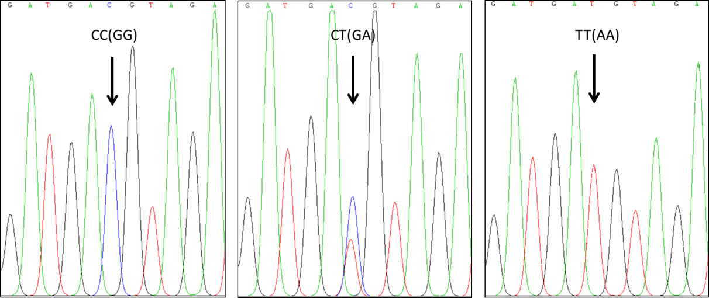

Supplementary Figure S1. rs1014290 (G>A) genotype analysis. Samples displayed a single C peak for CC(GG) genotype, mixed C/T peaks for CT(GA) genotype, and a single T peak for TT(AA) genotype.

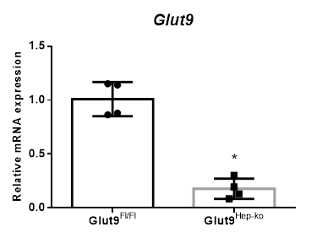
Supplementary Figure S2. Glut9^{Hep-ko} mice hepatic Glut9 knockdown identification. (A) Hepatic mRNA expression of Glut9^{Fl/Fl} and Glut9^{Hep-ko} mice. *P<0.05

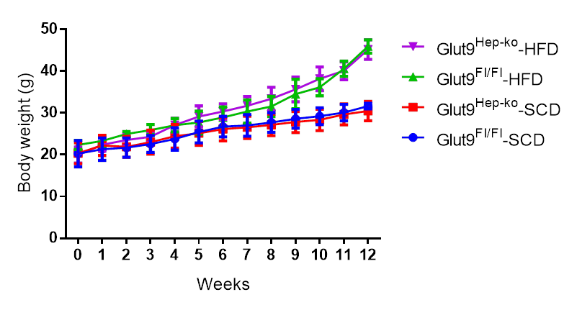
Supplementary Figure S3. Body weight for Glut9^{Fl/Fl} and Glut9^{Hep-ko} mice during 12-week of SCD and HFD feeding.

