Supplementary Material for
Connection between high pore-fluid pressure and frictional instability at tsunamigenic plate boundary fault of 2011 Tohoku-Oki earthquake
Ehsan Jamali Hondori^{1*} and Jin-Oh Park¹
¹Atmosphere and Ocean Research Institute, The University of Tokyo, Kashiwa, Japan.
ehsan.jamali@aori.u-tokyo.ac.jp
jopark@aori.u-tokyo.ac.jp

Contents of this file

Seismic Depth Sections and Velocity Model
Velocity Uncertainty Analysis
Fitting a Consolidation Curve
Figures S1 to S11
Introduction
Here we illustrate the result of Kirchhoff prestack depth migration (KPSDM) imaging of the full 2D seismic data along line D13 together with the P-wave velocity model. We also describe the procedure which has been used to estimate uncertainty in P-wave velocity model. Moreover, we provide the details of a curve fitting approach used for the consolidation curve estimation from the incoming sediments. Figs. S1-S11 are also provided for additional clarifications.

Seismic Depth Sections and Velocity Model
The Pacific plate is subducting beneath Okhotsk plate in the Japan Trench subduction zone. The 2D seismic data along line D13 could image the major geological features as the KPSDM section in Fig. S1 shows. The P-wave velocity model, which is developed using a layer stripping method and several iterations of grid-based traveltime tomography, is shown in Fig. S2. The black rectangle marks the target area where a wedge-shaped low-velocity zone between backstop interface and oceanic crust is found. We focus on this area, located at 40-0 km horizontal distances toward the trench axis to estimate pore fluid pressure and effective stress to investigate the plate boundary fault slip behavior. For the sake of computational efficiency, we applied reverse time migration (RTM) only on this target area. Fig. S3 shows a comparison between KPSDM and RTM on imaging steeply dipping structures in the dashed rectangle from Fig. S1, where KPSDM could not resolve the reflectors correctly but RTM images the subsurface features properly.

Velocity Uncertainty Analysis
In order to assess the accuracy of our P-wave velocity model, we perturbed the interval velocity values below seafloor by various percentages and compared the flatness, continuity, and resolution of reflections in the resulting KPSDM common image gathers (CIG) at several locations marked as S4-S9 with vertical dashed lines in Figs. S1, S2. The uncertainty in the velocity of the incoming sediments is less than 5%. The velocity uncertainty for a horizontal location at 10 km distance from the trench axis is 5% at 9 km depth, while the uncertainty increases to 10 % at a depth of 12 km for a location 52 km away from the trench axis, as shown in Figs. S4-S9. A green arrow points to the reflection from the top of basaltic oceanic crust as a reference.

Fitting a Consolidation Curve
First, we confirm that the empirical relationship between P wave velocity and porosity¹ is valid for the Japan Trench seismic data. Fig. S10 shows that porosity values estimated using this relationship are in good agreement with the core samples retrieved from IODP JFAST site C0019, DSDP sites 434, 435, 436, and Shimanto complex laboratory experiments². Then we can convert the P-wave velocity of the incoming sediments to porosity and calculate the void ratio. Based on the porosity values from JFAST core samples we exclude the void ratio values exceeding 1.5, which correspond to a maximum porosity of 0.6. We derive a logarithmic-linear relationship between the hydrostatic vertical effective stress and void ratio³ for the incoming sediments, where pore pressure is assumed to be hydrostatic (Fig. S11). The resulting logarithmic-linear consolidation curve for our data is defined by the following equation:

$$e= -0.5605\log\left(σ_{v}^{'}\right)+0.9858,$$
where, e denotes void ratio and vertical effective stress of the incoming sediments (in MPa) is shown by σ_{v}′.

References
1. Hoffman, N. W., and Tobin, H. J. An empirical relationship between velocity and porosity for underthrust sediments in the Nankai Trough accretionary prism, Proc. Ocean Drill. Program Sci. Results 190/196, 1–23 (2004).
2. Tsuji, T. et al. Modern and ancient seismogenic out-of-sequence thrusts in the Nankai accretionary prism: Comparison of laboratory-derived physical properties and seismic reflection data. Geophys. Res. Lett. 33, L18309 (2006).
3. Saffer, D. Pore pressure development and progressive dewatering in underthrust sediments at the Costa Rican subduction margin: Comparison with northern Barbados and Nankai, J. Geophys. Res. 108, 2261 (2003).
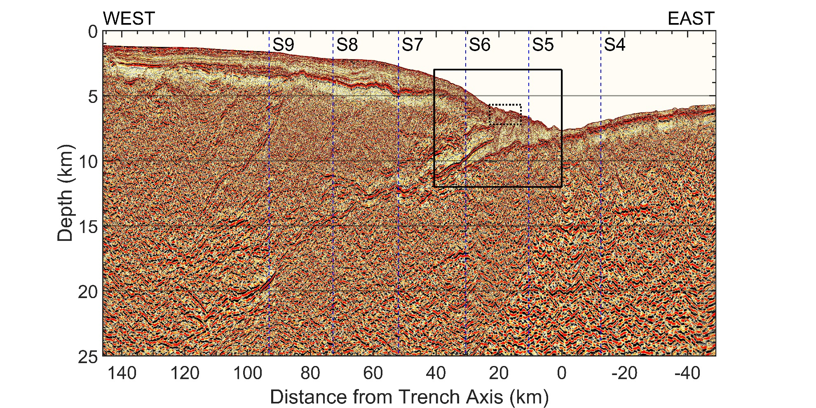
Fig. S1 | KPSDM image of the 2D seismic line D13. Black rectangle marks the target area with a wedge-shaped low velocity zone within 40-0 km to trench. Dashed small rectangle shows the area for comparing KPSDM and RTM in Fig. S3. The vertical dashed lines labeled with S4-S9 indicate the locations for the velocity uncertainty analysis panels shown in Figs. S4-S9.
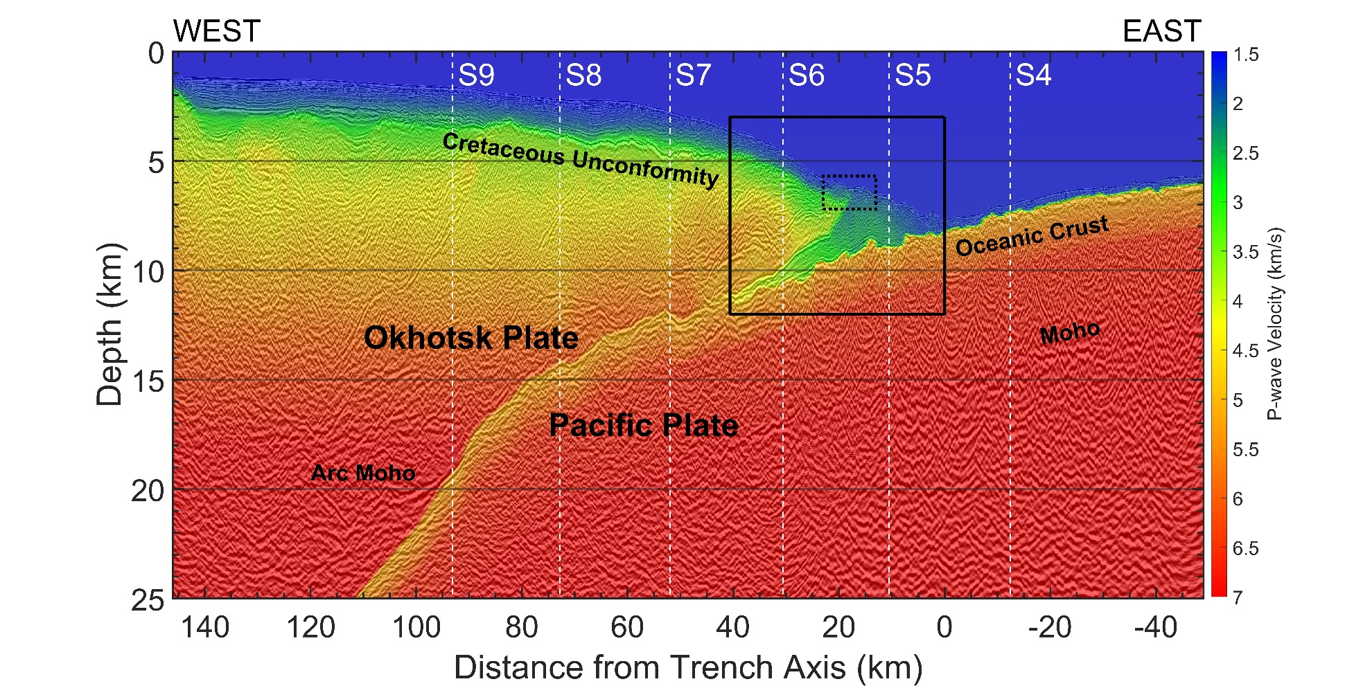
Fig. S2 | P-wave Velocity Model overlaid on KPSDM image of the 2D seismic line D13. The wedge-shape low-velocity zone within the black rectangle is the target area in the main text. Reflections from cretaceous unconformity, oceanic Moho, and arc Moho are also indicated with the labels.
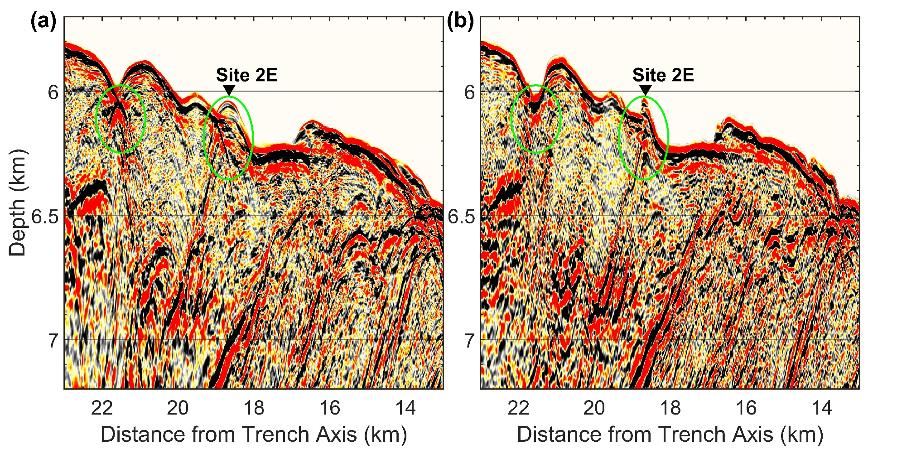
Fig. S3 | Comparison between KPSDM and RTM images. (a) KPSDM section and (b) RTM section. Note the area marked by green ovals, where RTM better resolves the steeply dipping reflectors.

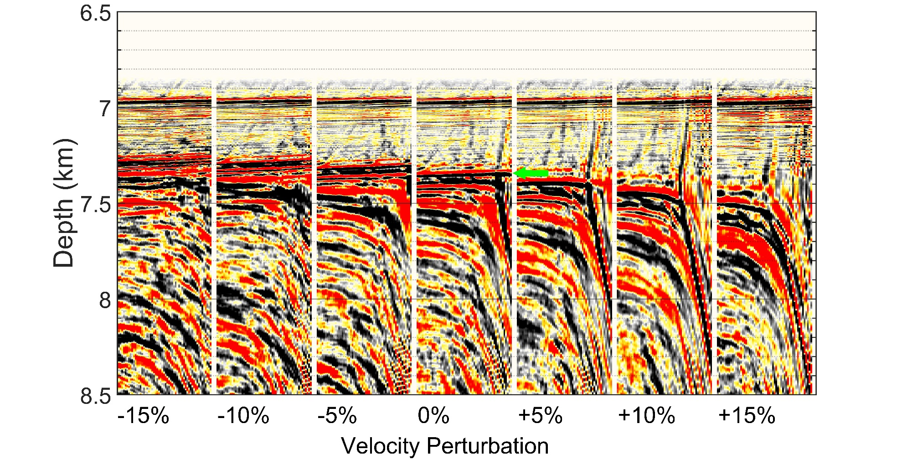
Fig. S4 | Velocity uncertainty analysis by comparing flatness, continuity, and resolution of reflections in KPSDM common image gathers. Analysis for location S4 as indicated by the label and vertical dashed line in Fig. S1. The green arrow points to the reflection from top of oceanic crust.
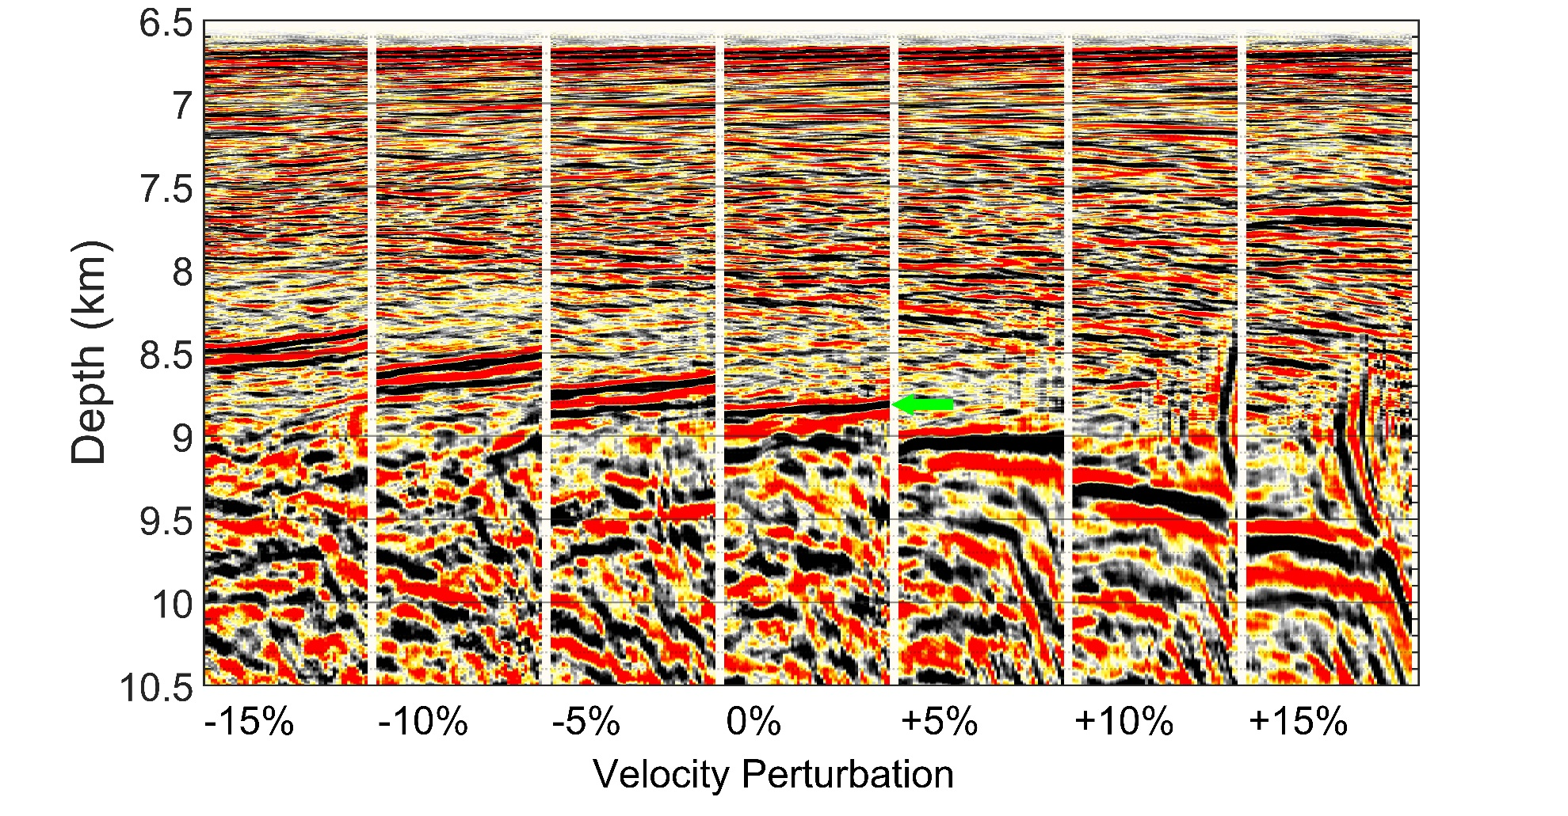
Fig. S5 | Velocity uncertainty analysis by comparing flatness, continuity, and resolution of reflections in KPSDM common image gathers. Analysis for location S5 as indicated by the label and vertical dashed line in Fig. S1. The green arrow points to the reflection from top of oceanic crust.
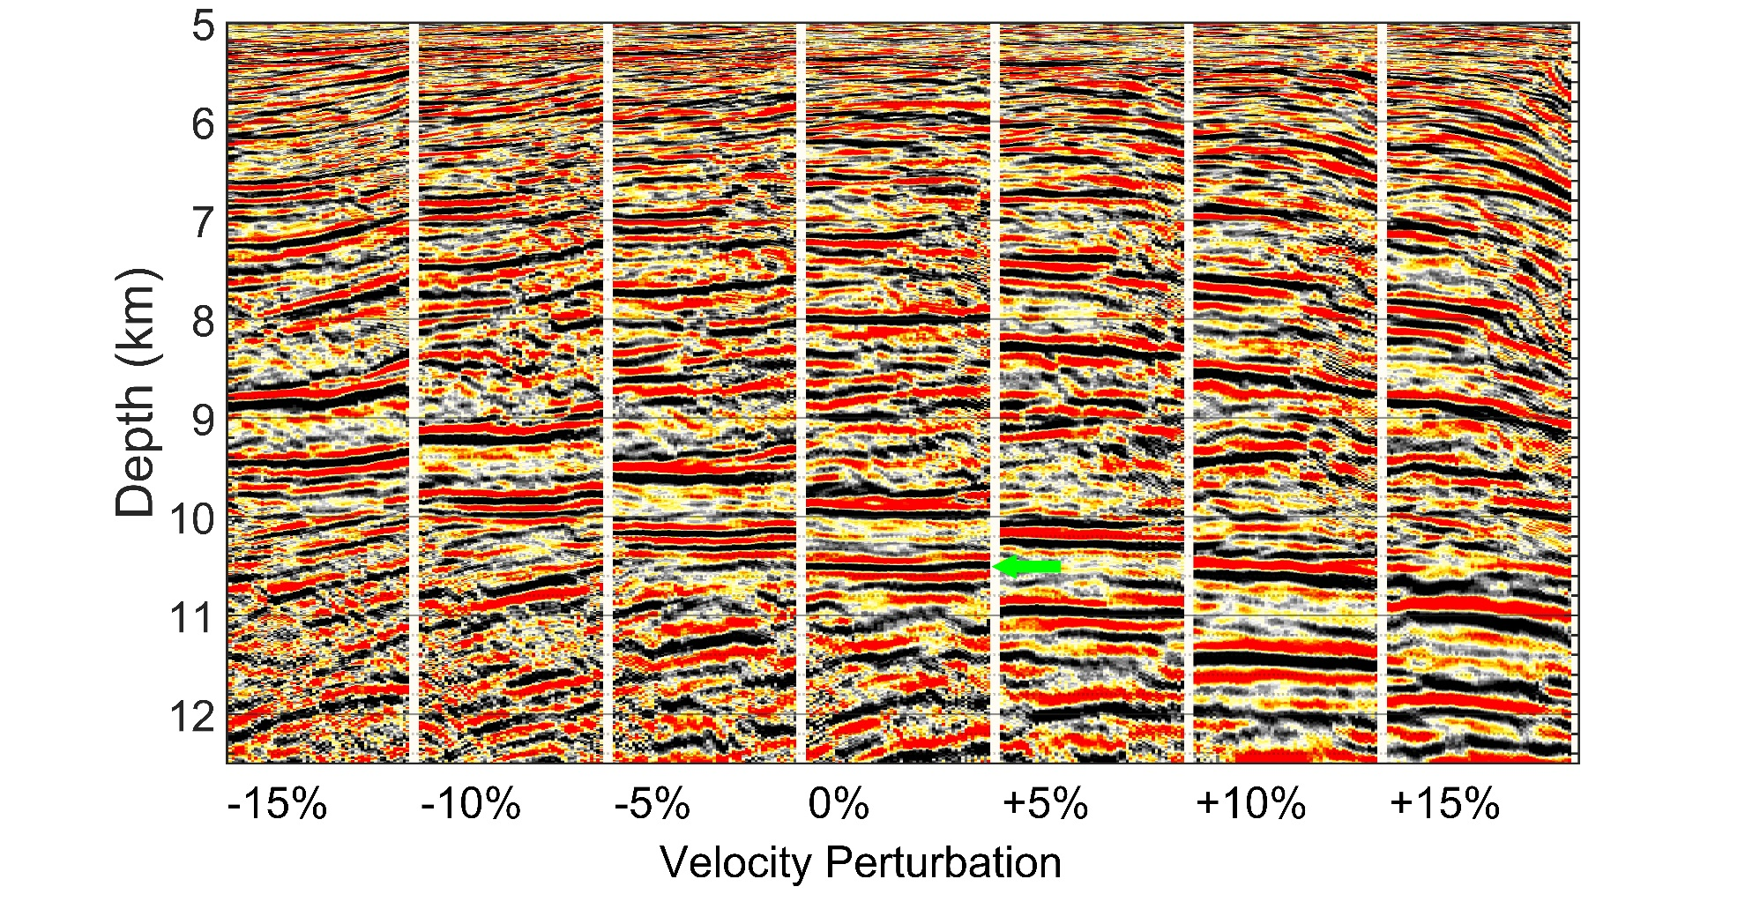
Fig. S6 | Velocity uncertainty analysis by comparing flatness, continuity, and resolution of reflections in KPSDM common image gathers. Analysis for location S6 as indicated by the label and vertical dashed line in Fig. S1. The green arrow points to the reflection from top of oceanic crust.
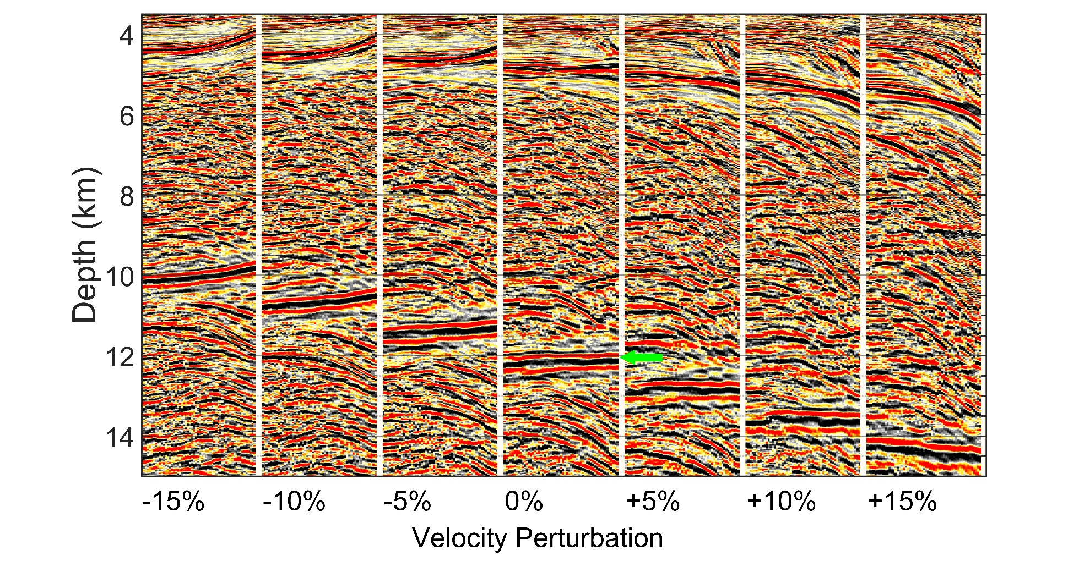
Fig. S7 | Velocity uncertainty analysis by comparing flatness, continuity, and resolution of reflections in KPSDM common image gathers. Analysis for location S7 as indicated by the label and vertical dashed line in Fig. S1. The green arrow points to the reflection from top of oceanic crust.
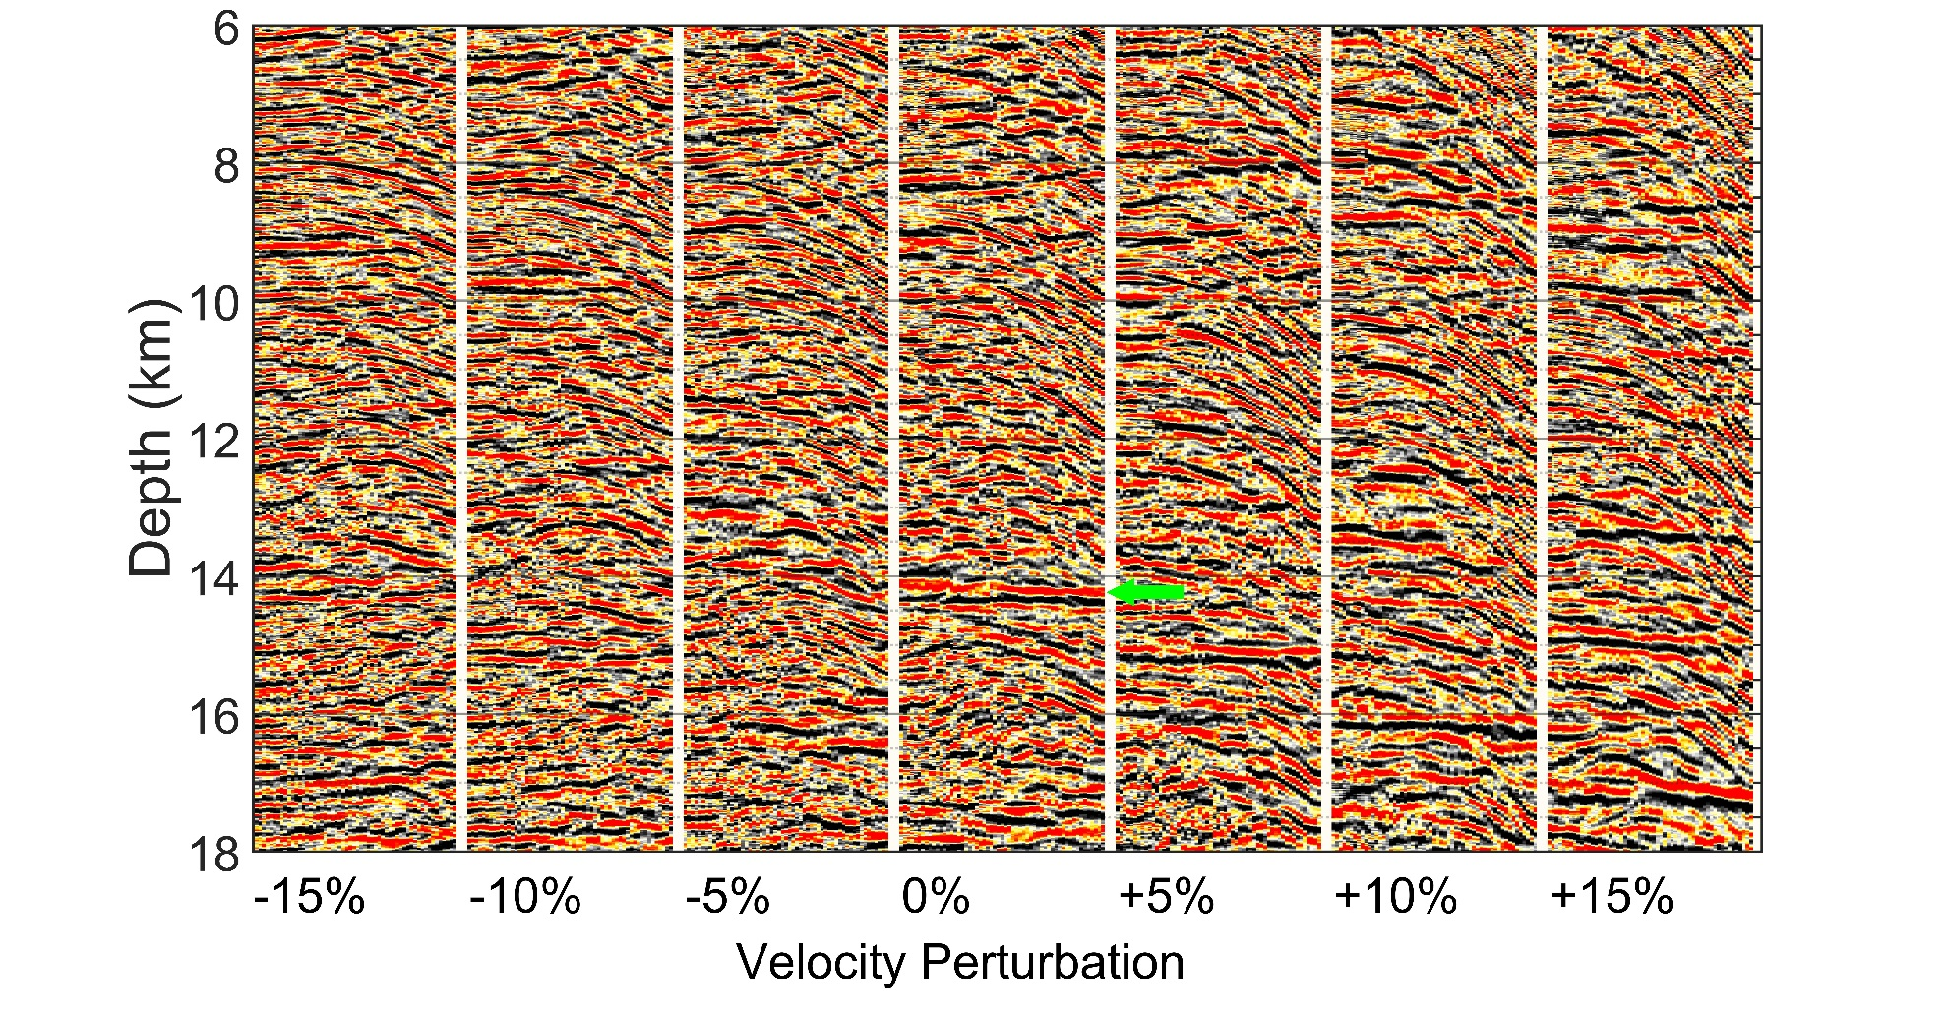
Fig. S8 | Velocity uncertainty analysis by comparing flatness, continuity, and resolution of reflections in KPSDM common image gathers. Analysis for location S8 as indicated by the label and vertical dashed line in Fig. S1. The green arrow points to the reflection from top of oceanic crust.
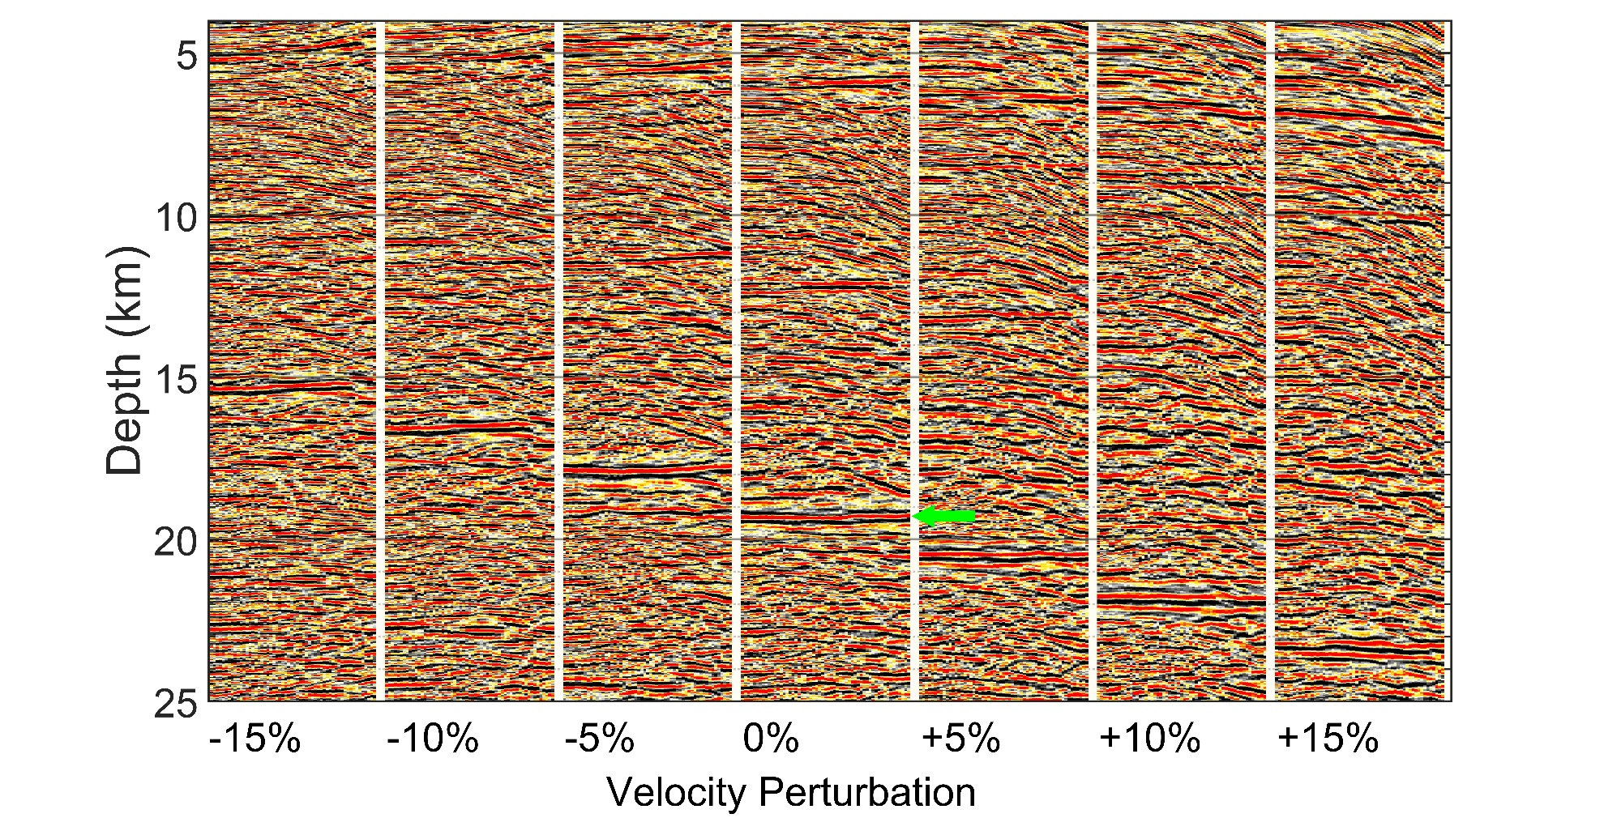
Fig. S9 | Velocity uncertainty analysis by comparing flatness, continuity, and resolution of reflections in KPSDM common image gathers. Analysis for location S9 as indicated by the label and vertical dashed line in Fig. S1. The green arrow points to the reflection from top of oceanic crust.
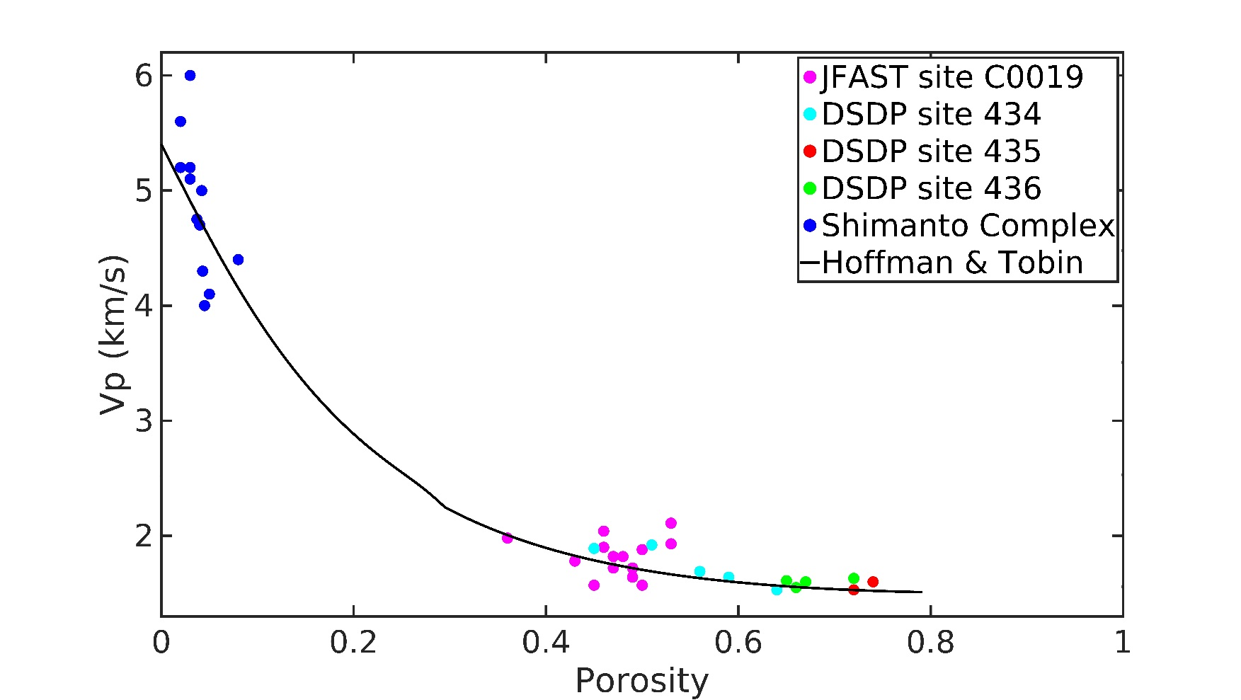
Fig. S10 | P-wave velocity versus porosity. Plotted for the core samples retrieved from IODP JFAST site C0019, DSDP sites 434, 435, 436, and Shimanto complex laboratory experiments². The empirical relationship¹ is in good agreement with the core samples and can be used in Japan Trench.
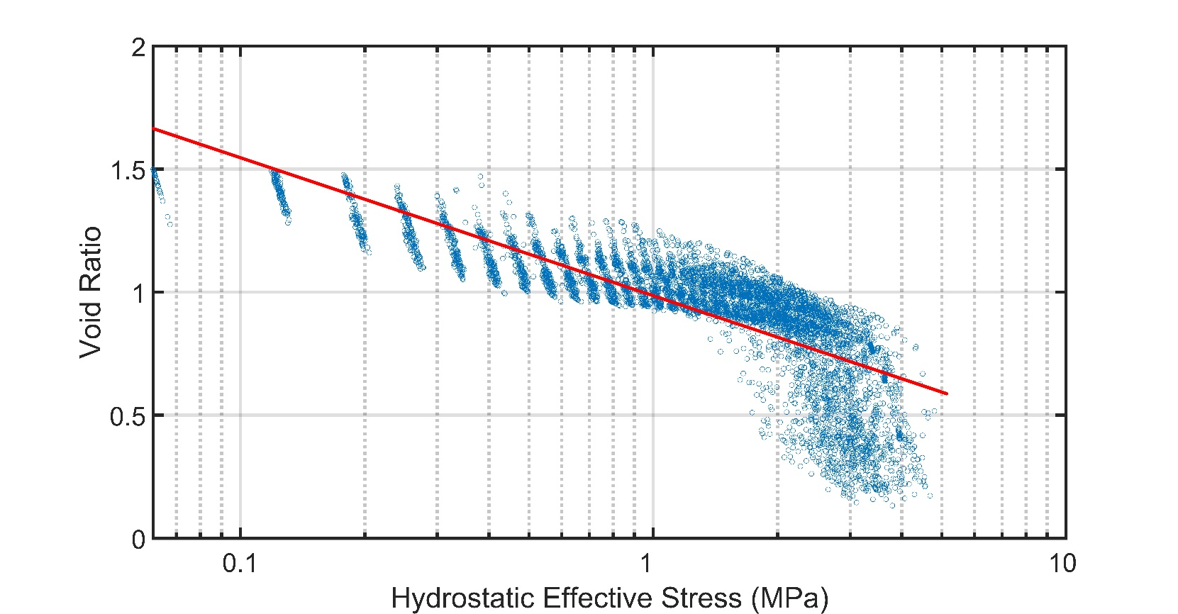
Fig. S11 | Logarithmic-linear consolidation curve fitting. The vertical effective stress for the undeformed incoming sediments is calculated from the beginning of the seismic profile (at -50 km horizontal distance) toward the trench, where pore fluid pressure is assumed to be hydrostatic (blue circles). Then a logarithmic-linear relationship is fitted (red line) between void ratio and hydrostatic effective stress to build the consolidation curve for extracting vertical effective stress of the underthrust sediments. For the sake of visual clarity, only 2% of the data points which were used for curve fitting are shown here (every 50th point).

