Supplementary File

Rapid molecular diagnosis of Parechovirus infection using the reverse transcription loop-mediated isothermal amplification technique

Tadafumi Yokoyama, Yuko Tasaki, Natsumi Inoue, Naotoshi Sugimoto, Eri Nariai, Sanae Kuramoto, Taizo Wada.

Supplementary Figure
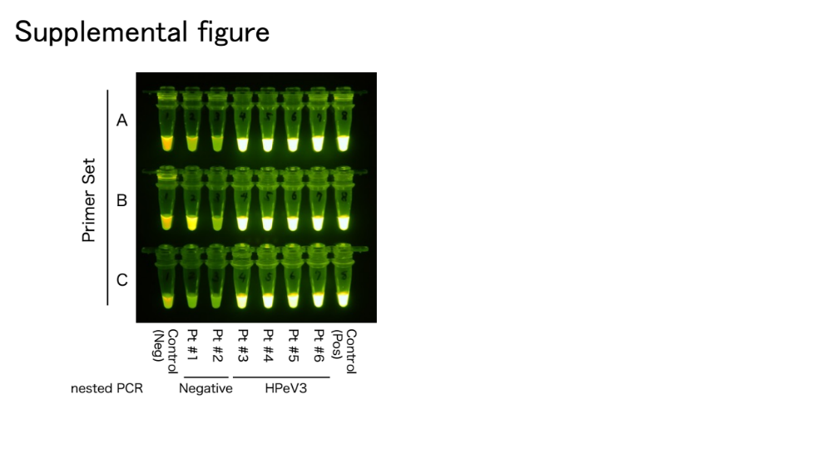

Supplementary Figure. The results of RT-LAMP using different primer sets
The RT-LAMP experiments were conducted using Sets A, B, and C. All sets show the same results.
Neg, negative; Pos, positive; RT-LAMP, reverse transcription loop-mediated isothermal amplification

Supplementary Table 1: Primer information for direct sequencing

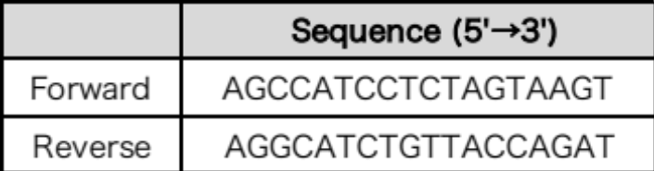

Supplementary Table 2: List of candidates of the combinations of primers

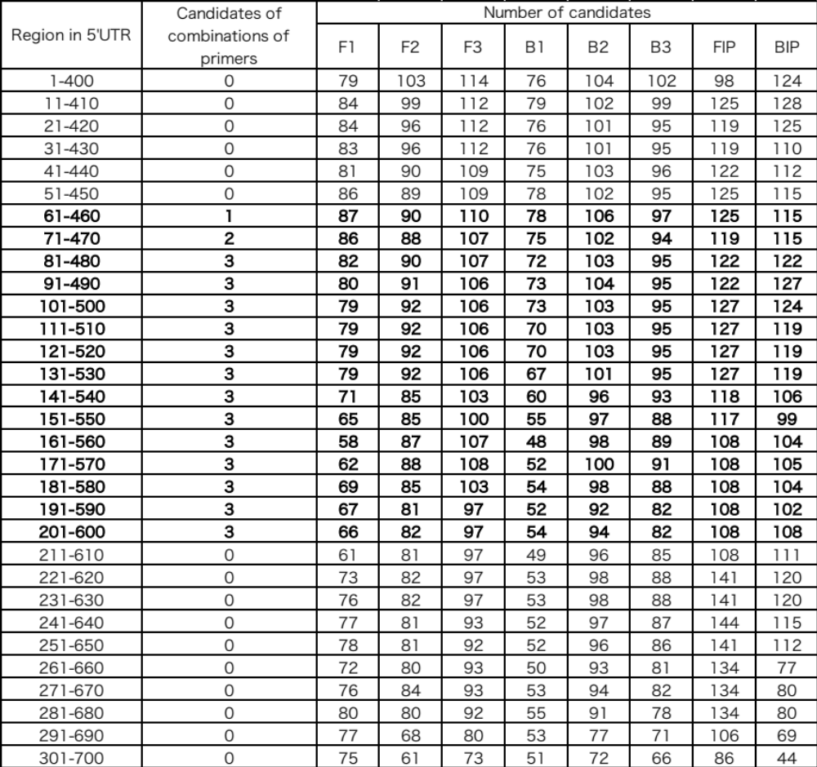

Supplementary Table 3: Results of the RT-LAMP for different RNA amounts and reaction times

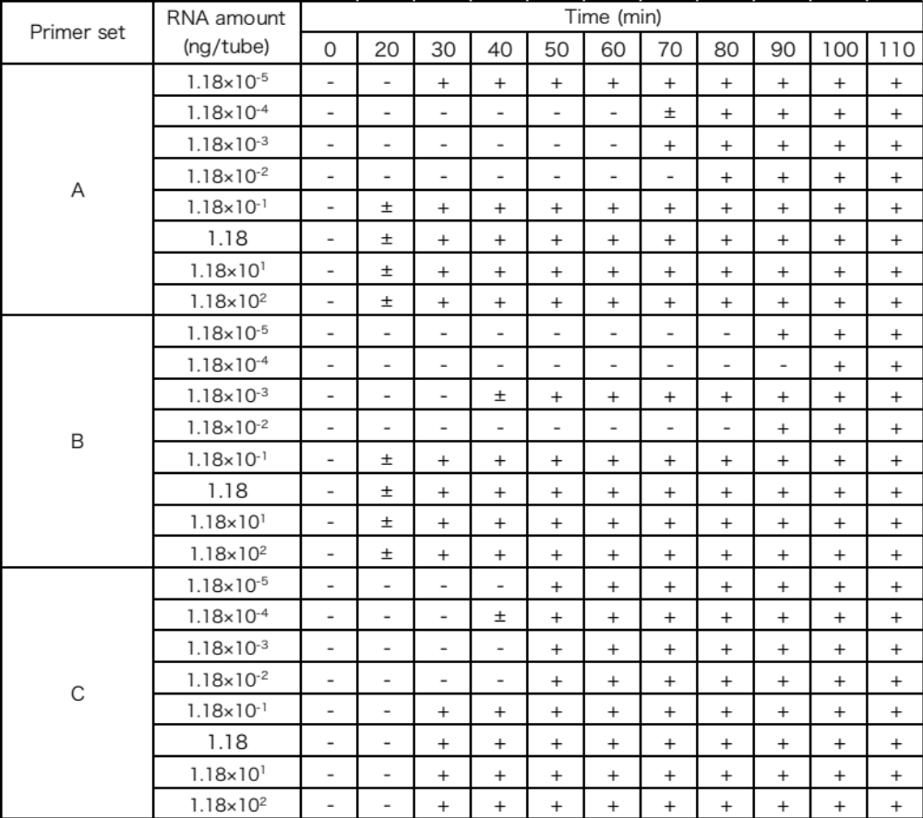

Supplementary Table 4: Results of the RT-LAMP for different viruses

