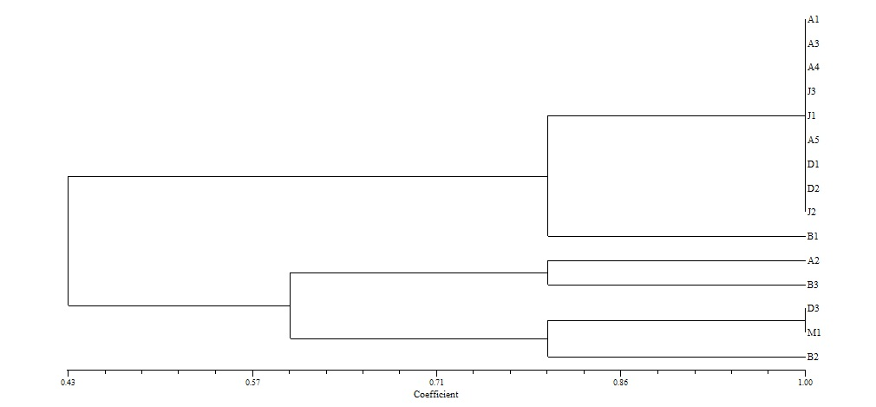
Cluster 1
Cluster 2
Cluster 3

Fig S1: Dendrogram of Rhizobial isolates based on ARDRA profile of HaeIII

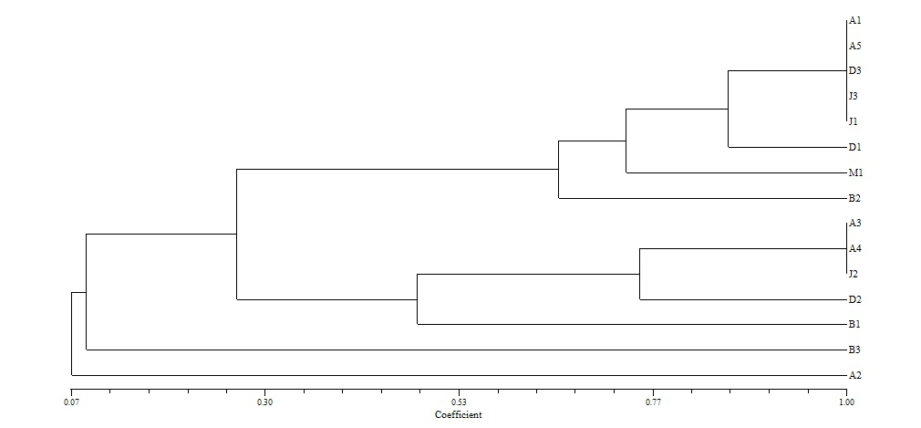
Cluster 1
Cluster 2
Cluster 3
Cluster 4

Fig S2: Dendrogram of Rhizobial isolates based on ARDRA profile of HinfI

Fig. S3: Dendrogram of Rhizobial isolates based on pooled ARDRA profile
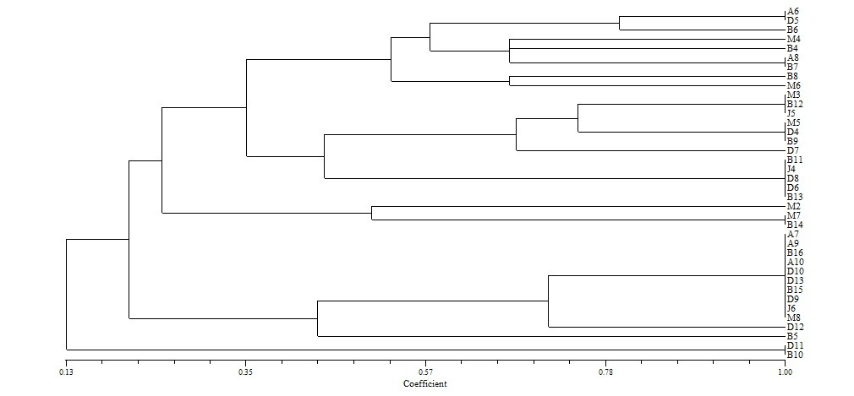
Cluster 1
Cluster 5

Fig. S4: Dendrogram of NRE based on ARDRA profile of HaeIII

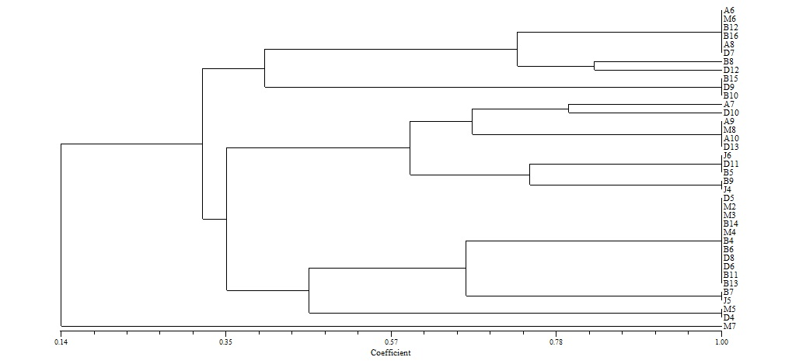
Cluster 1
Cluster 2
Cluster 3
Cluster 4

Fig.S5: Dendrogram of NRE based on ARDRA profile of HinfI

Fig. S6: Dendrogram of NRE based on pooled ARDRA profile

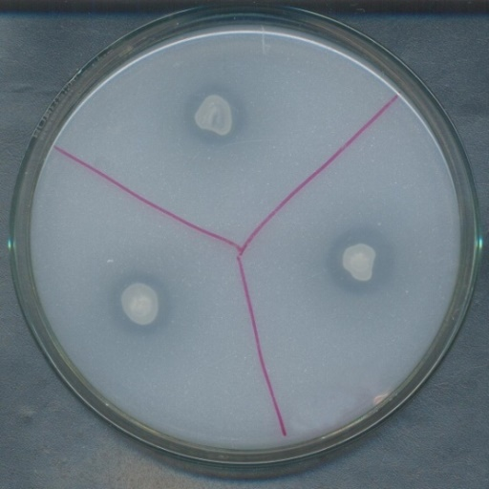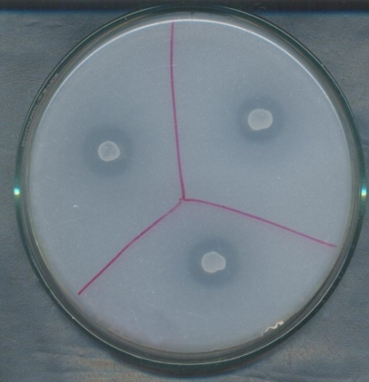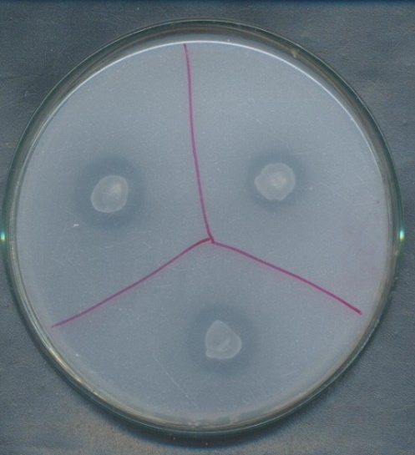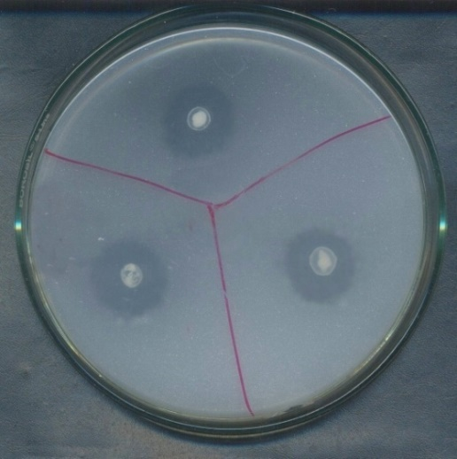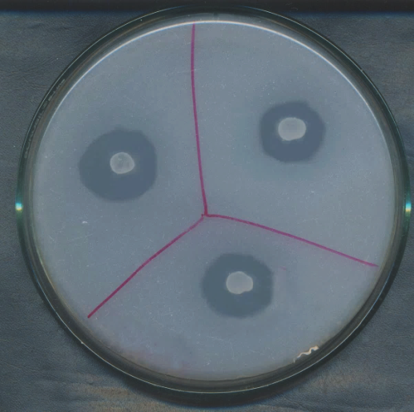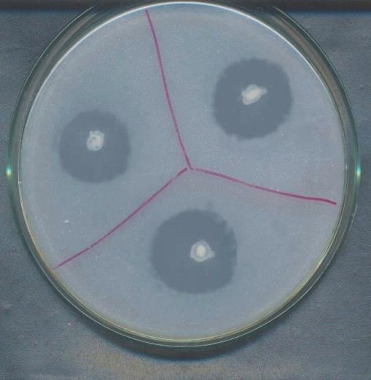
B3
B6Cluster 2
B12
B3+B6Cluster 3
B3+B12
B3+B6+B12Cluster 4

Fig. S7: Solubilization of tri-calcium phosphate by selected strains individually and in combination on Sperber agar (B3-Rhizobium sp. AAU B3; B6- Bacillus sp. AAU B6; B12- Bacillus sp. AAU B12)

Fig. S8: Solubilization of potash by selected strains individually and in combination on Aleksandrov agar (B3-Rhizobium sp. AAU B3; B6- Bacillus sp. AAU B6; B12- Bacillus sp. AAU B12)

