Supporting Information

Table S1. Number of N. suaveolens- and N. tabacum-specific bands from Randomly Amplified Polymorphic DNA-Polymerase Chain Reaction (RAPD-PCR). Products obtained from each viable seedling and viable regenerated plant were separated by agarose gel electrophoresis and enumerated by visual inspection.
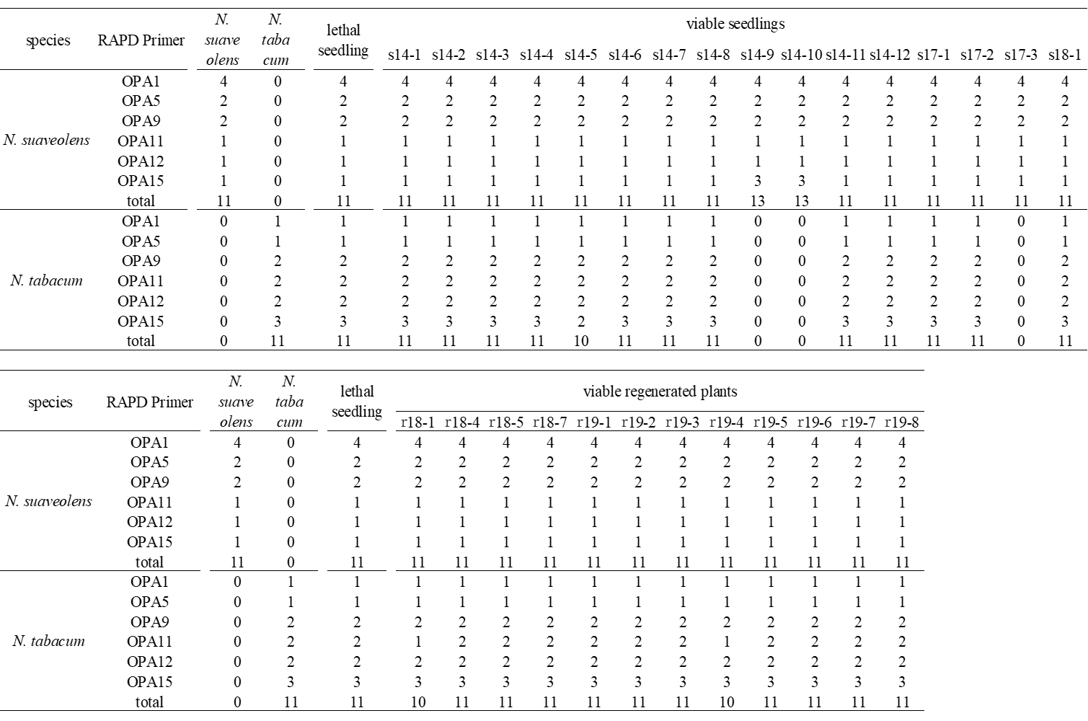

Table S2. Phenotype of each viable seedling and each viable regenerated plant. See also Figure 1 and Figure 4.
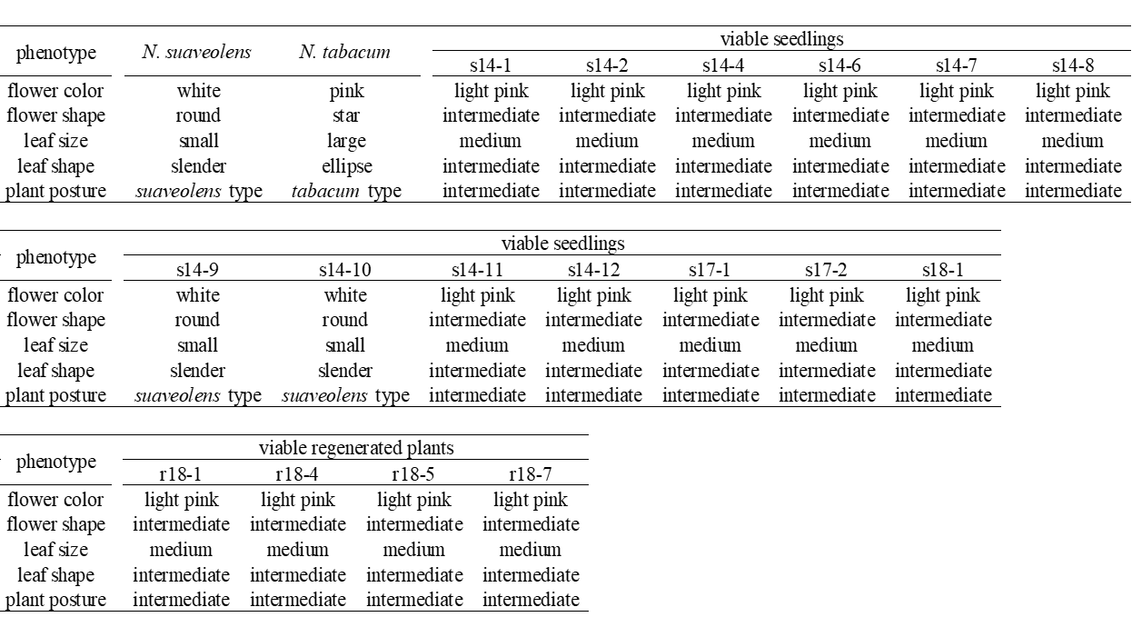

Table S3. Genes targeted for expression analysis.
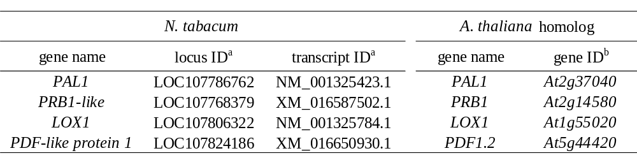
a: Corresponding to National Center for Biotechnology Information (NCBI) database (https://www.ncbi.nlm.nih.gov/)
b: Corresponding to The Arabidopsis Information Resource (TAIR) database (https://www.arabidopsis.org/index.jsp)

Table S4. GRAS-Di on the Q chromosome (Linkage group No. 11) in lethal seedlings and viable seedling No. s17-2 from the N. suaveolens x N. tabacum cross. ‘+’ indicates the presence of allele of N. tabacum, ‘-’ indicates the absence of allele of N. tabacum.
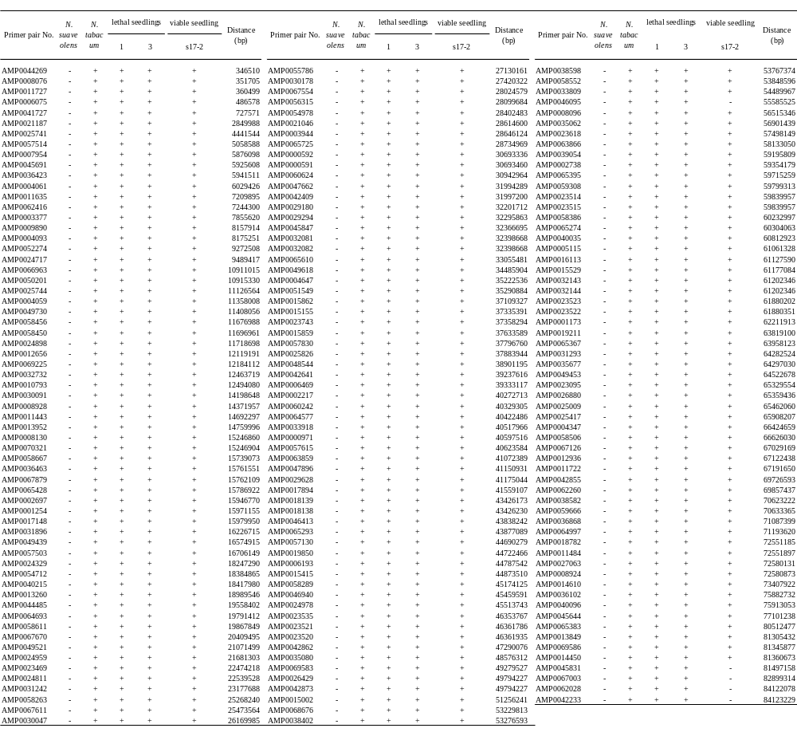

Table S5. Primers used for this study.
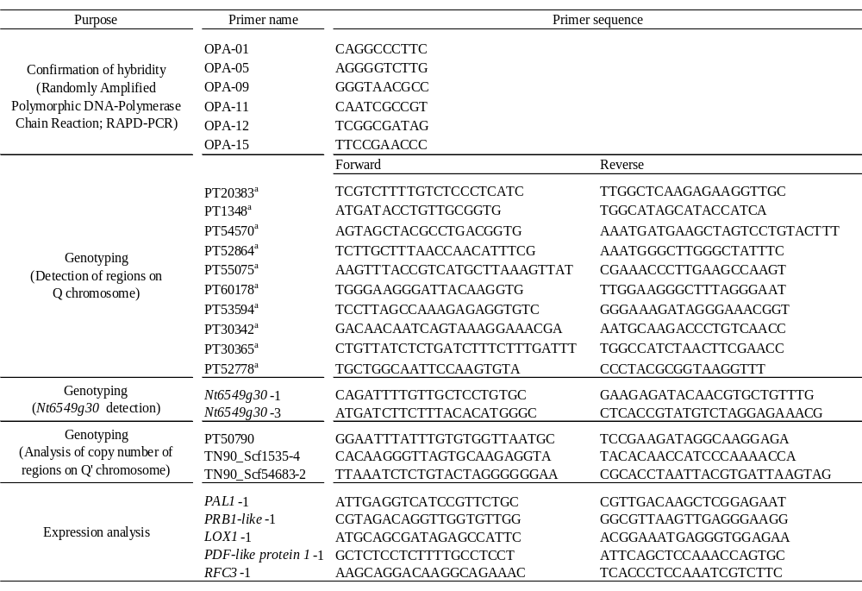
a: Bindler et al.^{40, 41}

