Supplementary file 1: Figure S1, Figure S2, Table S3

Genomic insight into diet adaptation in the biological control agent Cryptolaemus montrouzieri

Hao-Sen Li¹, Yu-Hao Huang¹, Mei-Lan Chen^{1,2}, Zhan Ren¹, Bo-Yuan Qiu¹, Patrick De Clercq³, Gerald Heckel⁴, Hong Pang¹*
1 State Key Laboratory of Biocontrol, School of Life Sciences / School of Ecology, Sun Yat‐sen University, Guangzhou, Guangdong, China
2 School of Environment and Life Science, Nanning Normal University, Nanning 530001, China
3 Department of Plants and Crops, Faculty of Bioscience Engineering, Ghent University, Ghent, Belgium
4 Institute of Ecology and Evolution, University of Bern, Bern, Switzerland
*Author for Correspondence: lsshpang@mail.sysu.edu.cn

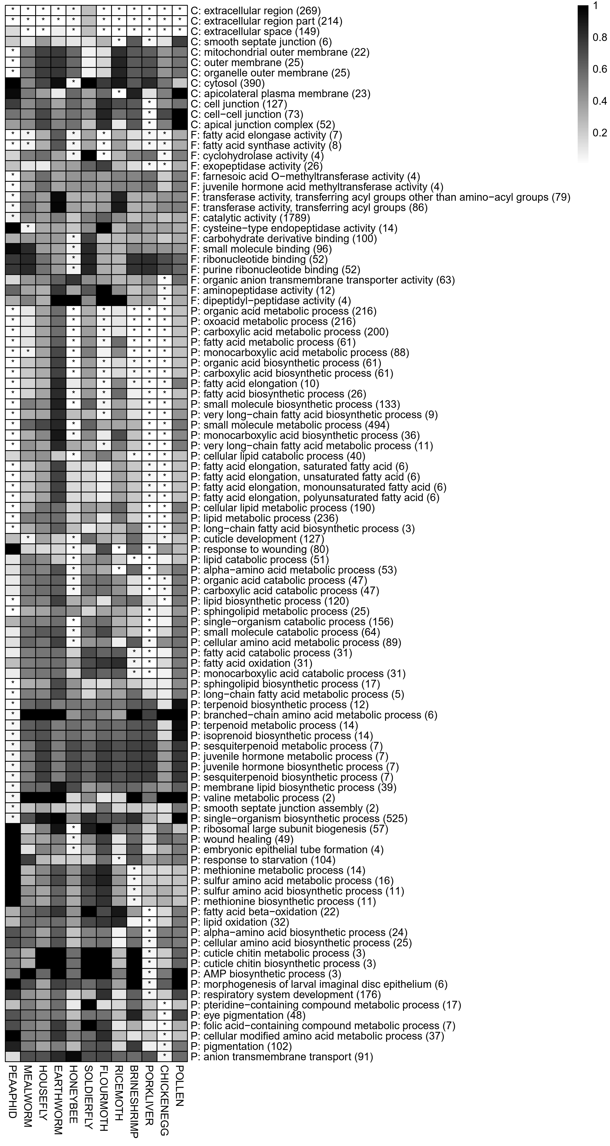
Figure S1

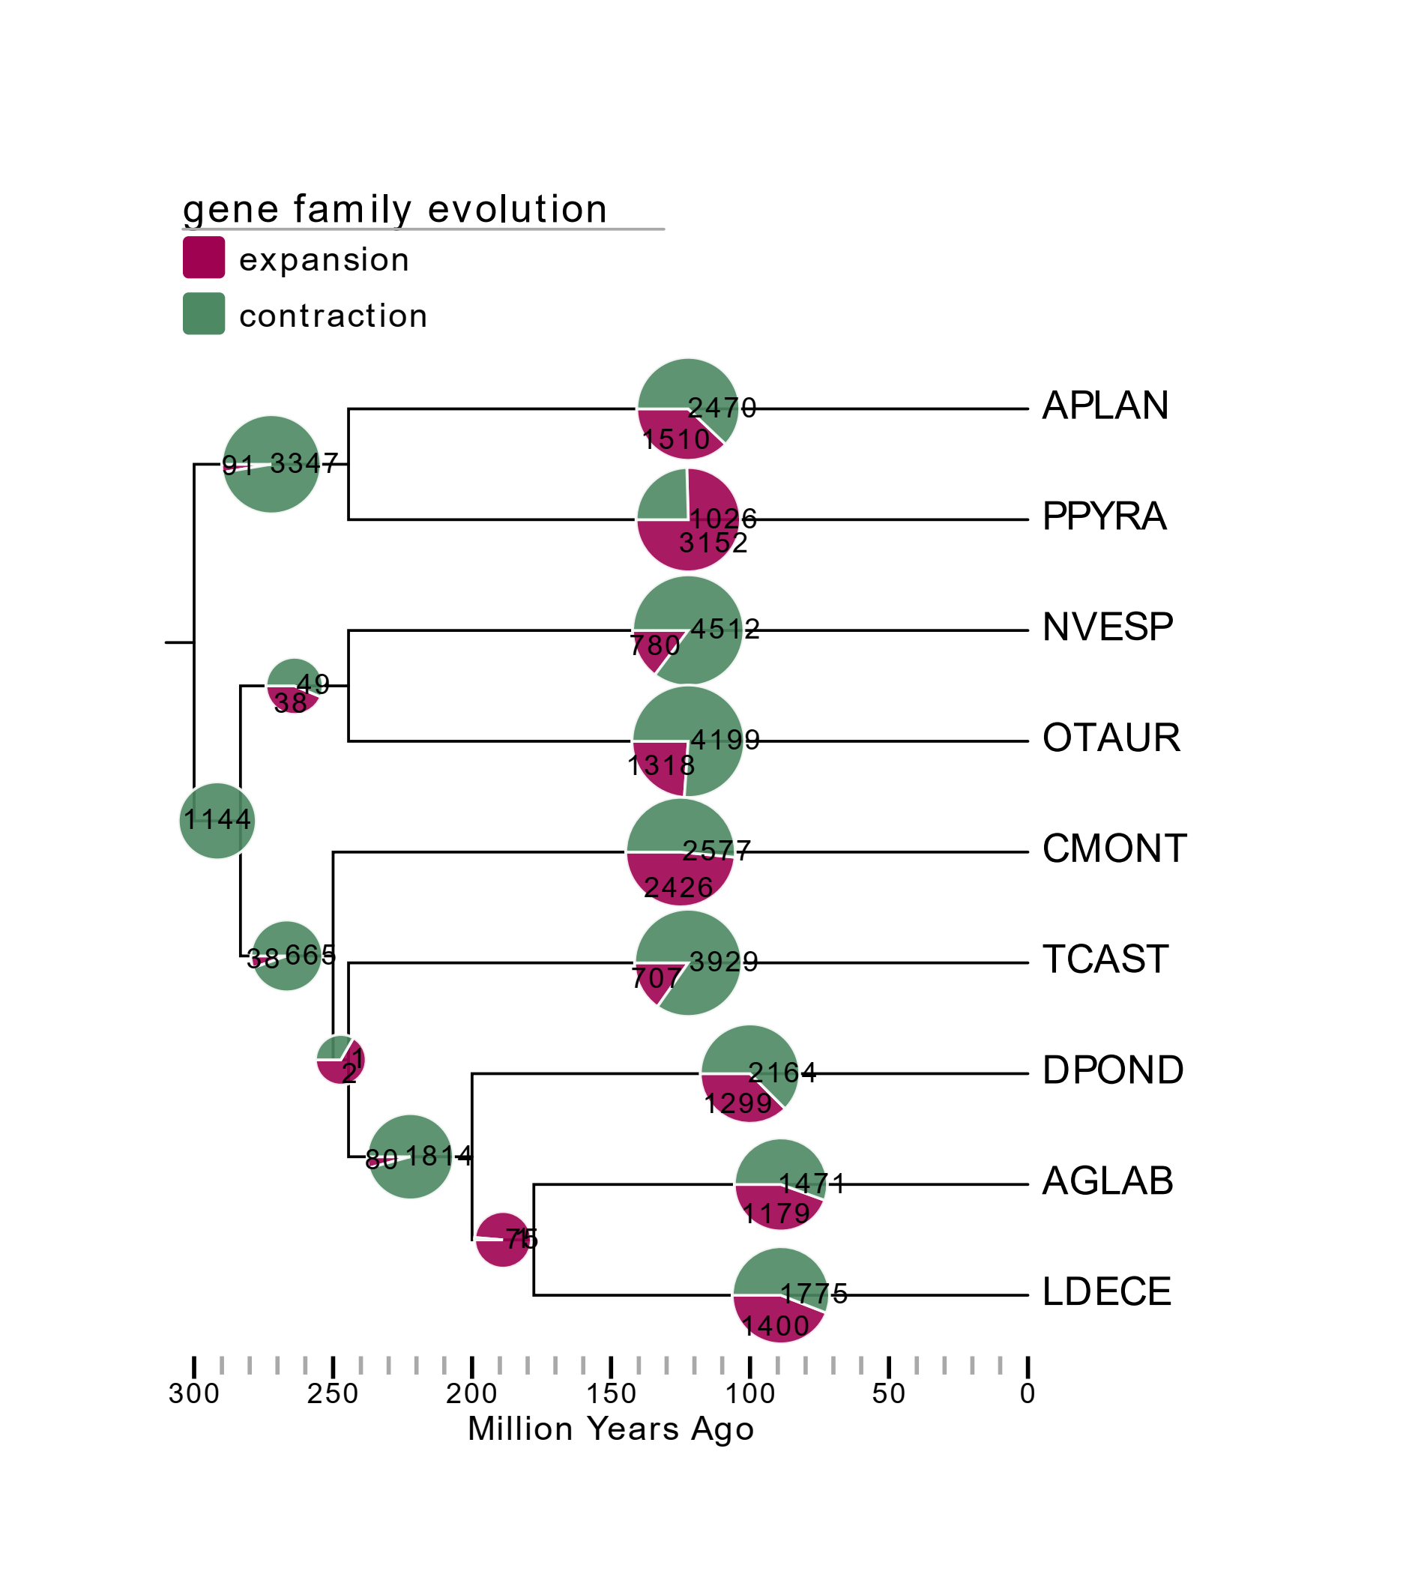
Figure S2

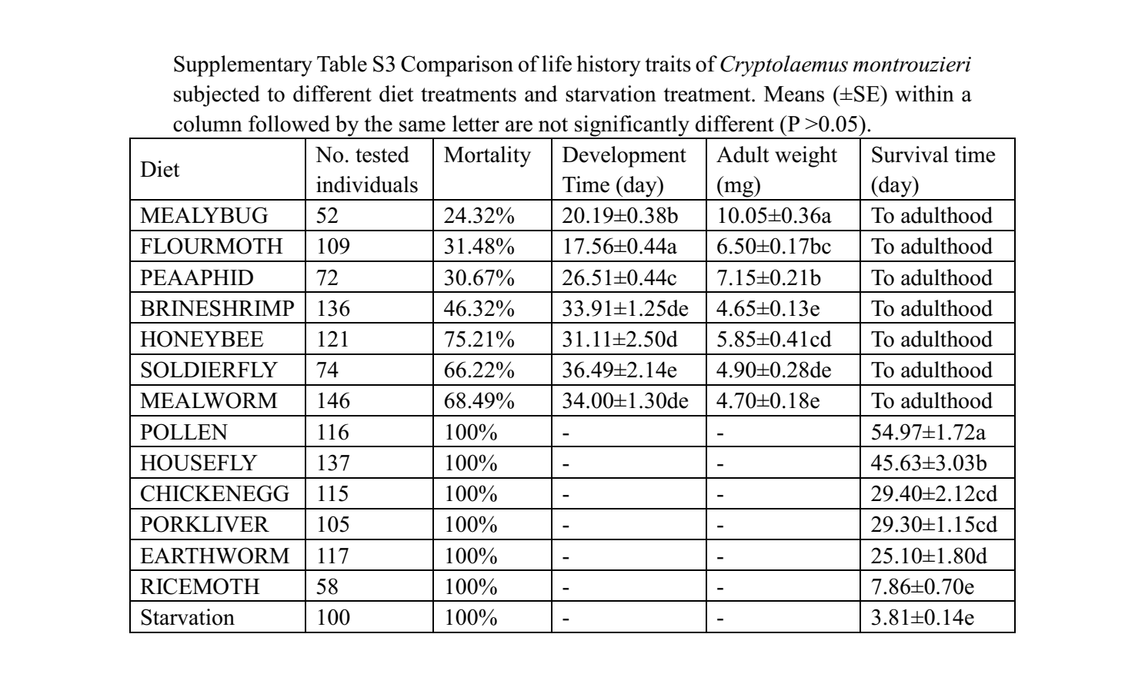
Table S3

