Supplement
Supplementary Figure S1. Scatterplot demonstrating LVESD and the performance of DeepECG-HFrEF algorithm for identifying LVSD
Supplementary Tables
Table S1. Baseline characteristics of study population according to the first echocardiographic results
Table S2. Clinical data of ECGs corresponding to HFrEF classified by the DeepECG-HFrEF algorithm
Table S3. Characteristics of ECGs corresponding to HFrEF classified by the DeepECG-HFrEF algorithm
Table S4. Performance of DeepECG-HFrEF algorithm using different EF cut-offs
Table S5. Studies on validation of AI algorithms developed for identification of LVSD

Figure S1. Scatterplot demonstrating LVESD and the performance of DeepECG-HFrEF algorithm for identifying LVSD
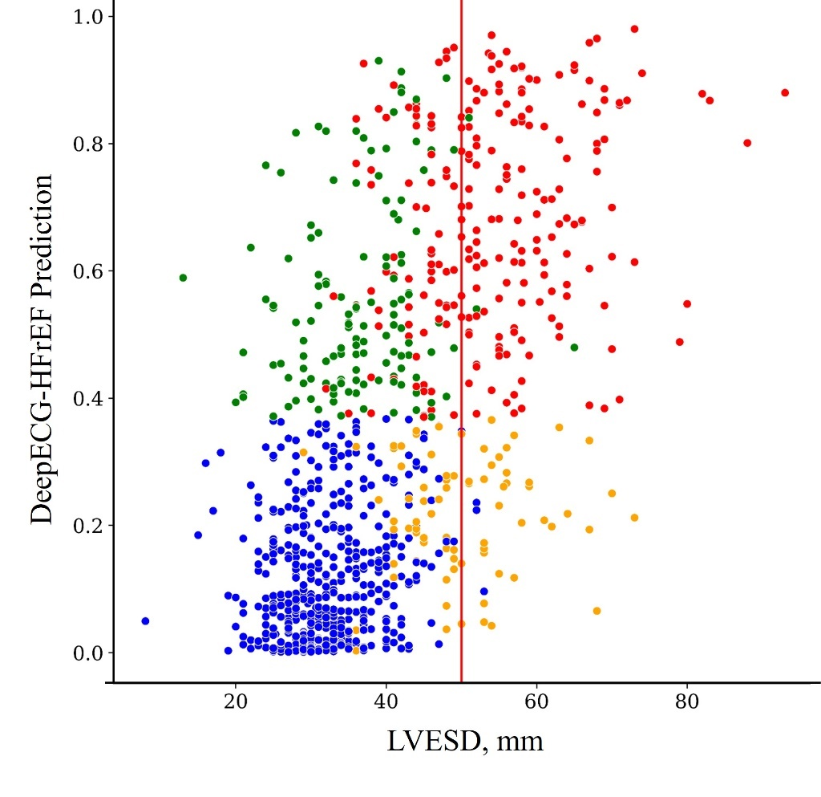
Abbreviation: LVESD, left ventricular end systolic dimension; LVSD, left ventricular systolic dysfunction.

Table S1. Baseline characteristics of study population according to the first echocardiographic results
 | HFrEF (N=349) | HFmrEF (N=113) | HFpEF (N=213)
Clinical characteristics
Age, years | 66.5±14.5 | 72.0±11.8 | 68.5±15.1
Men | 237 (67.9%) | 56 (49.6%) | 90(42.3%)
BMI, kg/m² | 23.3±4.2 | 23.3±3.5 | 23.7±4.1
Current smoker | 59(16.9%) | 11(9.7%) | 24(11.3%)
Hypertension | 207(59.3%) | 40(35.4%) | 129(60.6%)
Diabetes mellitus | 150(43.0%) | 40(35.4%) | 70(32.9%)
Status of HF
De novo HF | 153(43.8%) | 58(51.3%) | 103(48.4%)
Acute decompensated HF | 196(56.2%) | 55(48.7%) | 110(51.6%)
NYHA Class IV | 210(60.2%) | 70(61.9) | 94(44.1%)
Etiology of HF
Ischemic heart disease | 161(46.1%) | 50(44.2%) | 17(22.1%)
Valvular heart disease | 31(8.9%) | 15(13.3%) | 88(41.3%)
Cardiomyopathy | 123(35.2%) | 28(24.8%) | 36(16.9%)
Other | 34(9.7%) | 20(17.7%) | 42(19.7%)
Counts of paired dataset per patient
Once | 133(38.1%) | 45(39.8%) | 77(36.2%)
Two times | 130(37.2%) | 47(41.6%) | 77(36.2%)
Three times | 71(20.3%) | 19(16.8%) | 46(21.6%)
Four times | 15(4.3%) | 2(1.8%) | 13(6.1%)
Echocardiography
EF, % | 27.1±7.2 | 44.2±3.0 | 59.3±6.3
LVESV, mL | 143.7±72.9 | 65.9±23.3 | 54.7±35.6
LVEDV, mL | 193.4±85.4 | 117.3±39.7 | 118.9±55.8
E/A ratio | 1.8±1.2 | 1.2±0.9 | 1.3±1.0
Deceleration time, ms | 145.8±64.0 | 177.6±84.3 | 185.6±68.1
E/e' | 22.1±13.2 | 18.1±9.8 | 19.0±10.7
RVSP, mmHg | 48.5±13.6 | 44.9±14.2 | 49.8±17.9
Laboratory
eGFR, mL/min/1.73m² | 59.8±32.9 | 62.8±31.2 | 65.0±31.8
BNP, pg/mL | 1796.9±1579.5 | 1203.7±1244.9 | 1019.8±1229.1
Abbreviation: BMI, body mass index; BNP, B-type natriuretic peptide; EF, ejection fraction; eGFR, estimated glomerular filtration rate; HF, heart failure; HFpEF, heart failure with preserved ejection fraction; HFmrEF, heart failure with mid-range ejection fraction; HFrEF, heart failure with reduced ejection fraction; NYHA, New York Heart Association; LVEDV, left ventricular end-diastolic volume; LVESV, left ventricular end systolic volume; RVSP, right ventricular systolic pressure.

Table S2. Clinical data of ECGs corresponding to HFrEF classified by the DeepECG-HFrEF algorithm
 | DeepECG-HFrEF (+) N=424 | DeepECG-HFrEF (-) N=123 | Overall ECG N=547 | p value
Clinical characteristics
Age | 68.2±13.7 | 68.2±13.3 | 68.2±13.6 | 0.984
Male | 300(70.8%) | 71(57.7%) | 371(67.8%) | 0.008
BMI, kg/m² | 23.5±4.0 | 23.2±4.0 | 23.4±4.0 | 0.436
Current smoker | 74(17.5%) | 20(16.3%) | 94(17.2%) | 0.892
Hypertension | 261(61.6%) | 76(61.8%) | 337(61.6%) | 1.000
Diabetes | 197(46.5%) | 50(40.7%) | 247(45.2%) | 0.260
Status of HF |  |  |  | 0.362
De novo HF | 123(29.0%) | 30(24.4%) | 153(28.0%)
Acute decompensated HF | 301(71.0%) | 93(75.6%) | 394(72.0%)
Echocardiography
EF, % | 26.6±6.9 | 30.1±6.1 | 27.4±6.9 | <0.001
LVESV, mL | 150.0±70.2 | 114.6±55.8 | 142.3±68.8 | <0.001
LVEDV, mL | 201.1±81.3 | 163.7±69.9 | 193.0±80.4 | <0.001
E/A ratio | 1.7±1.2 | 1.3±0.9 | 1.6±1.2 | 0.007
Deceleration time, ms | 145.7±50.5 | 175.4±104.0 | 152.9±68.7 | 0.008
E/e' | 22.7±11.4 | 20.3±16.9 | 22.1±12.9 | 0.096
RVSP, mmHg | 48.4±13.8 | 44.0±13.8 | 47.4±13.9 | 0.005
Laboratory
eGFR, 30mL/min/1.73m2 | 57.7±30.9 | 58.5±31.3 | 57.9±30.9 | 0.818
BNP, ng/L | 1904.1±1636.5 | 1227.0±1131.4 | 1785.2±1579.0 | 0.001
Abbreviation: BMI, body mass index; BNP, B-type natriuretic peptide; EF, ejection fraction; eGFR, estimated glomerular filtration rate; HF, heart failure; HFpEF, heart failure with preserved ejection fraction; HFmrEF, heart failure with mid-range ejection fraction; HFrEF, heart failure with reduced ejection fraction; LVEDV, left ventricular end-diastolic volume; LVESV, left ventricular end systolic volume; RVSP, right ventricular systolic pressure.
Table S3. Characteristics of ECGs corresponding to HFrEF classified by the DeepECG-HFrEF algorithm
 | DeepECG-HFrEF (+) N=424 | DeepECG-HFrEF (-) N=123 | Overall ECG N=547 | p value
Heart rate, bpm | 91.9±21.6 | 82.5±24.7 | 89.8±22.6 | <0.001
PR interval, ms | 172.1±36.6 | 176.0±37.4 | 172.9±36.8 | 0.420
QRS duration, ms | 123.2±33.4 | 123.3±38.2 | 123.2±34.5 | 0.990
QTc interval, ms | 488.1±47.6 | 480.5±49.4 | 486.4±48.1 | 0.121
Rhythm
Sinus rhythm | 310(73.1%) | 74(60.2%) | 384(70.2%) | 0.007
AF or AFL | 95(22.4%) | 37(30.1%) | 132(24.1%) | 0.094
Other* | 20(4.7%) | 12(9.8%) | 32(5.9%) | 0.048
PR prolongation† | 37(13.0%) | 12(16.4%) | 49(9.0%) | 0.448
QRS widening‡ | 111(26.2%) | 39(31.7%) | 150(27.4%) | 0.251
LBBB | 32(7.5%) | 12(9.8%) | 44(8.0%) | 0.452
RBBB | 22(5.2%) | 11(8.9%) | 33(6.0%) | 0.134
IVCD | 32(7.5%) | 7(5.7%) | 39(7.1%) | 0.556
QTc prolongation§ | 327(77.1%) | 85(69.1%) | 412(75.3%) | 0.075
Q wave | 126(29.7%) | 27(22.0%) | 153(28.0%) | 0.110
anteroseptal | 78(18.4%) | 14(11.4%) | 92(16.8%)
Lateral wall | 9(2.1%) | 1(0.8%) | 10(1.8%)
inferior wall | 39(9.2%) | 12(9.8%) | 51(9.3%)
Axis |  |  |  | 0.161
Normal or LAD | 361(85.3%) | 98(79.7%) | 459(83.9%)
RAD or no man's land | 62(14.7%) | 25(20.3%) | 87(15.9%)
*VT, VF, high-degree AVB or junctional rhythm. †PR interval >200ms. ‡QRS duration >140ms. §Male >450ms, Female >470ms
Abbreviation: AF, atrial fibrillation; AFL, atrial flutter; IVCD, intraventricular conduction delay; LAD, left axis deviation; LBBB, left bundle branch block; RAD, right axis deviation; RBBB, right bundle branch block.

Table S4. Performance of DeepECG-HFrEF algorithm using different EF cut-offs
EF | Prevalence | AUC (95% CI) | Sensitivity | Specificity | PPV | NPV | Accuracy
<50% | 0.583 | 0.850 (0.829-0.871) | 0.811 | 0.723 | 0.804 | 0.733 | 0.775
<40% | 0.424 | 0.845 (0.823-0.866) | 0.779 | 0.763 | 0.708 | 0.824 | 0.770
<30% | 0.235 | 0.816 (0.790-0.840) | 0.760 | 0.739 | 0.472 | 0.909 | 0.744
Abbreviation: AUC, Area under the receiver operating curve; CI, confidence interval; EF, ejection fraction; PPV, positive predictive value; NPV, negative predictive value.

Table S5. Studies on validation of AI algorithms developed for identification of LVSD
Study | Location | Network | Name of AI algorithm | Endpoint LVSD definition | Study populationª | ECGª, n | Menª,  n (%) | Ageª,  (Mean/Median Years) | HFª,  n (%) | AUC
Attia et al.(1),  Retrospective | USA | CNN | — | EF ≤ 35 | — | 8,989 | 5,168 (57%) | 61.8 ± 16.5ª | 1,803 (20%) | 0.93^{b}
Kwon et al.(2),  Retrospective | Korea | DNN | DEHF | EF ≤ 40 | Community general hospitalª | 9,965^{c}  10,490^{d} | 11,907 (52%) | — | 1391 (6%) ª | 0.84^{c}  0.89^{d}
Adedinsewo et al.(3), Retrospective | USA | CNN | AI-ECG | EF ≤ 35 | Patients presenting to the emergency department with acute dyspnea | — | 847 (53%) | 67.9 | — | 0.89
Mondo et al.(4), Retrospective | Uganda | CNN | AI-ECG | EF ≤ 35 | General cardiac clinic | — | 266 (42%) | 57.0 ± 18.8 | 77 (12%) | 0.87
Attia et al.(5), Retrospective | USA | CNN | AI-ECG | EF ≤ 40 | COVID-19 patients | — | 18 (67%) | 66.5 ± 13.8 | — | 0.95
Cho et al.(6), Retrospective | Korea | CNN | — | EF < 40 | Cardiovascular teaching hospitalª | 3,470^{c}  4,362^{d} | 2610^{d} (60%) | — | 2,021 (12%) | 0.91^{c}  0.96^{d}
Jentzer et al.(7), Retrospective | USA | CNN | AI-ECG | EF ≤ 40 | Cardiac intensive care unit patients | — | 3588 (63%) | 68.2 ± 14.8 | 960 (17%) | 0.83
Kashou et al.(8), Retrospective | USA | CNN | AI-ECG | EF ≤ 40 | Community-based cohort | — | 983 (48%) | 63 ± 11 | 45 (2%) | 0.97
— Not specifically mentioned in the paper
ª Validation set ^{b} Test set ^{c} Internal validation ^{d} External validation
Abbreviation: AI, artificial intelligence; AI-ECG, artificial intelligence-enabled ECG; AUC, area under the receiver operating characteristic; CNN, convolutional neural network; DEHF, deep-learning algorithm for ECG-based HF identification; DNN, deep neural network; ECG, electrocardiogram; EF, ejection fraction; HF, heart failure; LVSD, left ventricular systolic dysfunction; USA, United States of America.

1. Attia ZI, Kapa S, Lopez-Jimenez F, McKie PM, Ladewig DJ, Satam G, et al. Screening for cardiac contractile dysfunction using an artificial intelligence–enabled electrocardiogram. Nature Medicine. 2019;25(1):70-4.
2. Kwon J-m, Kim K-H, Jeon K-H, Kim HM, Kim MJ, Lim S-M, et al. Development and Validation of Deep-Learning Algorithm for Electrocardiography-Based Heart Failure Identification. kcj. 2019;49(7):629-39.
3. Adedinsewo D, Carter RE, Attia Z, Johnson P, Kashou AH, Dugan JL, et al. Artificial Intelligence-Enabled ECG Algorithm to Identify Patients With Left Ventricular Systolic Dysfunction Presenting to the Emergency Department With Dyspnea. Circ Arrhythm Electrophysiol. 2020;13(8):e008437.
4. Mondo CK, Attia ZI, Benavente ED, Friedman P, Noseworthy P, Kapa P, et al. External validation of an electrocardiography artificial intelligence-generated algorithm to detect left ventricular systolic function in a general cardiac clinic in Uganda. European Heart Journal. 2020;41(Supplement_2).
5. Attia ZI, Kapa S, Noseworthy PA, Lopez-Jimenez F, Friedman PA. Artificial Intelligence ECG to Detect Left Ventricular Dysfunction in COVID-19: A Case Series. Mayo Clinic Proceedings. 2020;95(11):2464-6.
6. Cho J, Lee B, Kwon JM, Lee Y, Park H, Oh BH, et al. Artificial Intelligence Algorithm for Screening Heart Failure with Reduced Ejection Fraction Using Electrocardiography. Asaio j. 2021;67(3):314-21.
7. Jentzer JC, Kashou AH, Attia ZI, Lopez-Jimenez F, Kapa S, Friedman PA, et al. Left ventricular systolic dysfunction identification using artificial intelligence-augmented electrocardiogram in cardiac intensive care unit patients. International Journal of Cardiology. 2021;326:114-23.
8. Kashou AH, Medina-Inojosa JR, Noseworthy PA, Rodeheffer RJ, Lopez-Jimenez F, Attia IZ, et al. Artificial Intelligence-Augmented Electrocardiogram Detection of Left Ventricular Systolic Dysfunction in the General Population. Mayo Clin Proc. 2021;96(10):2576-86.

