

Supplementary Material:
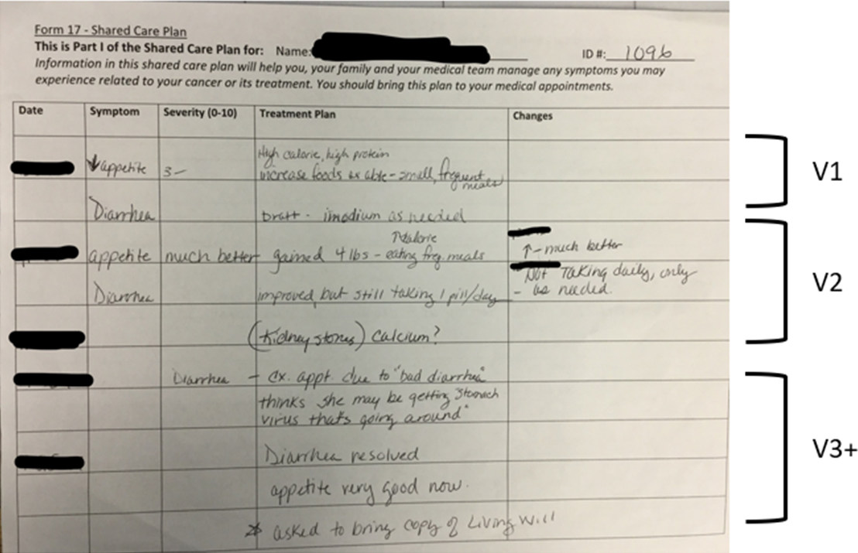
Example of a Shared Care Plan completed by CONNECT nurse and patient.
^{a.} Vx = Visit 1, visit 2, visit 3 (right margin)

