Supplementary Material
Unraveling the ecological processes modulating the population structure of Escherichia coli in a highly polluted urban stream network

Martín Saraceno^{1,2}, Sebastián Gómez Lugo², Nicolás Ortiz³, Bárbara M. Gómez³, Carmen A. Sabio y García², Nicolás Frankel^{2,4}, Martín Graziano^{1,2*}

¹CONICET - Universidad de Buenos Aires. Instituto de Ecología, Genética y Evolución de Buenos Aires (IEGEBA). Buenos Aires 1428, Argentina. ²Universidad de Buenos Aires. Facultad de Ciencias Exactas y Naturales. Departamento de Ecología, Genética y Evolución. Buenos Aires 1428, Argentina. ³Instituto Nacional del Agua. Ezeiza 1804, Argentina. ⁴CONICET - Universidad de Buenos Aires. Instituto de Fisiología, Biología Molecular y Neurociencias (IFIBYNE). Buenos Aires 1428, Argentina. *Corresponding author: marting@ege.fcen.uba.ar

Appendix A1: Spatial predictors and supplementary results to pRDA analyzes.

Figure S1: Maps of selected Asymmetric Eigenvector Maps (AEMs) for positive and negative spatial autocorrelation. AEMs were selected through a forward selection procedure associated to each response variable. In the case of E. coli relative phylogenetic composition, a subset of selected AEMs with the greater R² contribution was employed in the variance partition analysis. AEMs used for each response variable analysis are identified with a square symbol next to each AEM label (E. coli abundance), and a star symbol (relative phylogenetic composition). Significant AEMs in pRDA analysis are indicated in fuchsia.
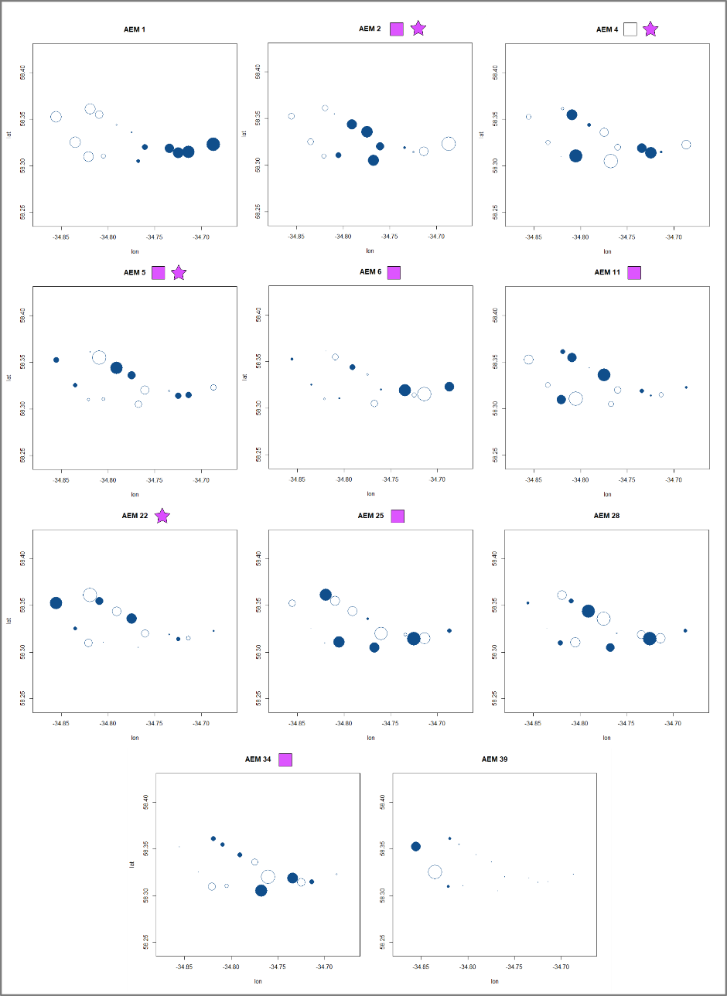
Table S1: Partial RDA analysis of pure effects of spatial matrix. The contribution of each set of spatial predictors was assessed for each of the response variables through a pRDA analysis conditioned by environmental and urban infrastructure sets. A) E. coli abundance as response variable; B) E. coli phylogenetic relative composition as response variable. DIN, dissolved inorganic nitrogen; SRP, soluble reactive phosphorous; AEM, asymmetric eigenvector map.
A) | F value | Significance (P<0.05)
Spatial predictors matrix  (global model) | F_{7,24}= 11.94 | *
AEM2 | F_{1,24}= 6.37 | *
AEM4 | F_{1,24}= 3.56
AEM5 | F_{1,24}= 5.57 | *
AEM6 | F_{1,24}= 9.13 | *
AEM11 | F_{1,24}= 6.36 | *
AEM25 | F_{1,24}= 8.26 | *
AEM34 | F_{1,24}= 5.19 | *
RDA1 axis | F_{1,30}= 104.46 | *
B) | F value | Significance (P<0.05)
Spatial predictors matrix  (global model) | F_{4,25}= 52.50 | *
AEM2 | F_{1,25}= 27.13 | *
AEM4 | F_{1,25}= 57.14 | *
AEM5 | F_{1,25}= 35.88 | *
AEM22 | F_{1,25}= 58.11 | *
RDA1 axis | F_{1,25}= 156.60 | *
RDA2 axis | F_{1,25}= 35.04 | *

Figure S2: Effects of spatial predictors on the relative abundance of E. coli phylogroups. Biplot of pRDA analysis of AEMs controlling for the rest of the variable sets (scaling = 3). Significant variables are identified with an asterisk. AEM, asymmetric eigenvector map.
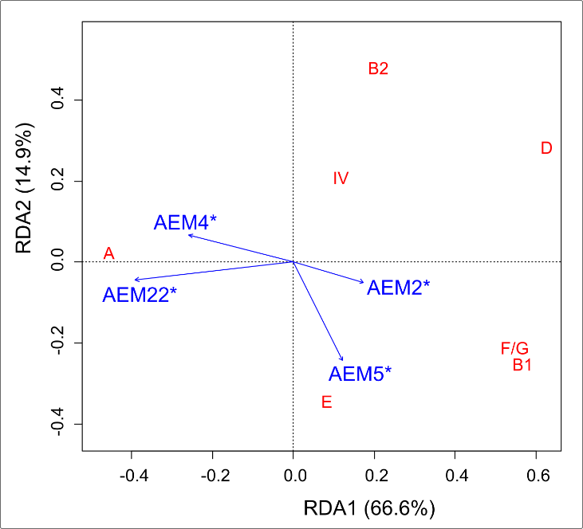
Appendix A2: Variable selection procedure

A principal component analysis (PCA) was performed separately for each predictor set of environmental and urban infrastructure, and groups of covariate variables were graphically identified. Cumulative variance proportion explained by first two PCA axes was 60% for environmental variables and 90% for urban variables (Supplementary Figure S3). Based on the PCA results and the analysis of correlations between all available variables, we selected variables for variance partitioning analysis across each covariate group, also considering the ecological relevance of each variable based on previous knowledge related with the persistence of E. coli in secondary habitats. Among the environmental set of variables, we retained parameters related to relevant nutrients such as DIN, SRP, Iron and DOC, and variables affecting the physical availability of bacteria in the water column, such as flow velocity and mean water column depth. Moreover, macrophyte coverage and turbidity were also selected, as the association of bacteria to surfaces through biofilm formation might play an important role on its availability in the water column. Parameters with low spatial variability or with known high temporal daily variations such as pH, OD and temperature were not selected. Within urban predictors, it was observed a high correlation cluster of variables between population and road densities, and the impervious surface coverage, selecting the impervious surface coverage as it was the less correlated parameter with the rest of the infrastructure parameters (Spearman’s rho and VIF estimators). Additionally, drainage density was selected against drinking water coverage, due to its hypothesized association with bacterial entry to streams. Finally, a PCA analysis and the variance inflation factor (VIF) was computed into the final predictor sets to assure an appropriate proportion of explained variance as well as to control for excessive collinearity (see Supplementary Table S2 for VIF values).

Figure S3: Results of principal component analysis (PCA) including all available variables within the environmental set (right) and the urban set (left). Graphs represent biplots (type 3 scaling). DIN, dissolved inorganic nitrogen; SRP, soluble reactive phosphorous, DOC, dissolved organic carbon; DO, dissolved oxygen.
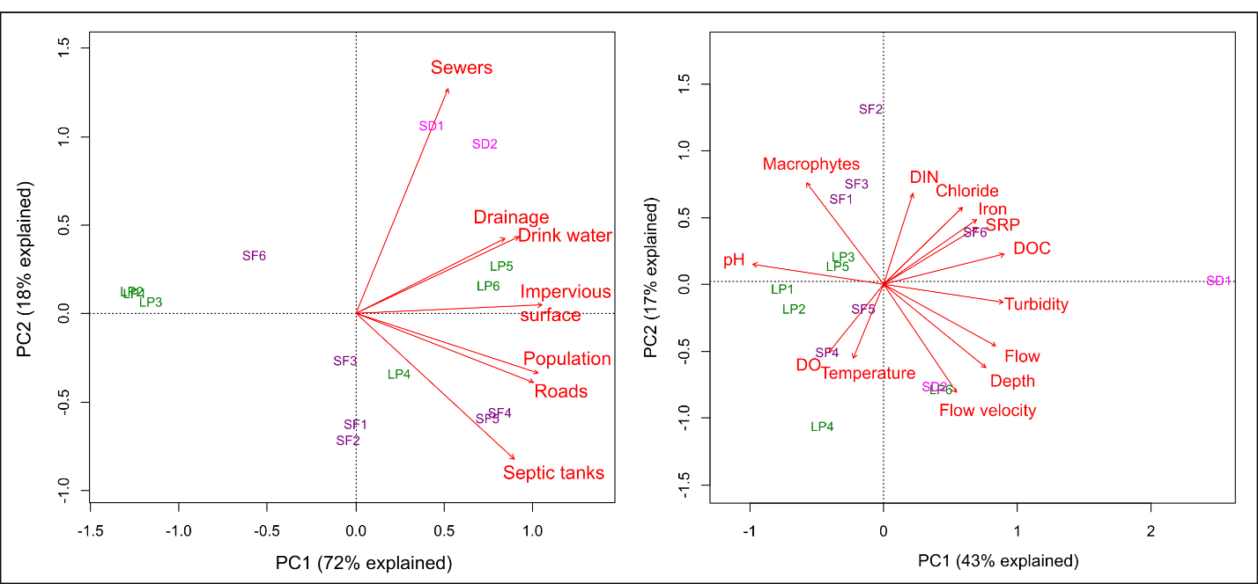

Table S2: Variance inflation factor (VIF) values for each selected predictor set. Differences between response variables are due to the different number of samples used for analysis (LP2 was discarded for phylogenetic analysis due to the lack of available isolates). Environmental parameters are unshaded, while urbans are shaded in light gray. DIN, dissolved inorganic nitrogen; SRP, soluble reactive phosphorous.
VIF
 | E. coli abundance | E. coli phylogenetic composition
Macrophyte coverage | 2.32 | 2.04
DIN | 3.20 | 3.99
SRP | 4.37 | 5.71
Turbidity | 2.95 | 2.71
Iron | 1.65 | 1.86
Water Depth | 2.75 | 2.48
Flow velocity | 2.27 | 2.66
Sanitary sewer density | 1.54 | 1.51
Septic tanks density | 1.46 | 1.36
Drainage density | 1.96 | 1.73
Appendix A3: Supplementary information on the global correlations between variables.

Table S3: Results of node centrality statistics. A correlation matrix of all variables was obtained through Pearson’s method. Then, it was employed as input to establish a correlations network including only the correlations among variables greater than 0.5. The Betweenness estimator reflect the number of interacting nodes for each variable, and the Expected Influence estimator the degree of interaction, considering the number of positive and negative interacting nodes weighted by the correlation between each variable. DO, dissolved oxygen; DIN, dissolved inorganic nitrogen; SRP, soluble reactive phosphorous; DOC, dissolved organic carbon.

 | Betweenness | Expected Influence
pH | 21 | -4.817574384
Conductivity | 17 | 2.538391980
Temperature | 0 | 0.510314928
DO | 0 | 0.510314928
DIN | 7 | -0.005191183
SRP | 7 | 2.439327046
DOC | 10 | 3.599434141
Turbidity | 0 | 1.353034908
Chloride | 6 | 1.523783836
Iron | 0 | 1.554592377
Macrophytes coverage | 2 | -1.907411653
Mean flow | 1 | 2.457246490
Mean flow velocity | 6 | 2.483385819
Depth | 1 | 1.359467538
Drinking water coverage | 13 | 3.650032514
Sanitary sewer density | 12 | 2.946458441
Septic tanks density | 0 | 2.333566994
Impervious surface | 34 | 4.797111509
Drainage density | 10 | 1.891505510
Roads density | 0 | 2.950515938
Population density | 2 | 3.447489698
E. coli | 0 | 1.461723305

Figure S4: Relationship of E. coli abundance with environmental and urban infrastructure features. Clustered correlogram of environmental and urban infrastructure parameters. Levels of significance of Pearson’s correlation among parameters are expressed as ‘***’, p<0.0001; ‘**’, p<0.001; ‘*’ and p<0.05.

