Exploring Therapeutic Efficacy of Coriandrum sativum and Allium sativum Aggregate in Alloxan-Induced Diabetic mice
Shahzad Qamar^{1*}, Mubasher Butt², Rukhsana Anwar³, Basit Jabbar^{4*}

^{1, 3} University College of Pharmacy, University of the Punjab, Lahore, 54000, Pakistan.
² Institute of Pharmacy, Gulab Devi Educational Complex, Ferozepur Road, Lahore 54000, Paksitan.
⁴ Centre of Excellence in Molecular Biology, 87 West Canal Bank Road, Thokar Niazbaig, Lahore, 53700, Pakistan.

*shahzadqamarpharmacist@gmail.com
*basit.ibb.pu@gmail.com

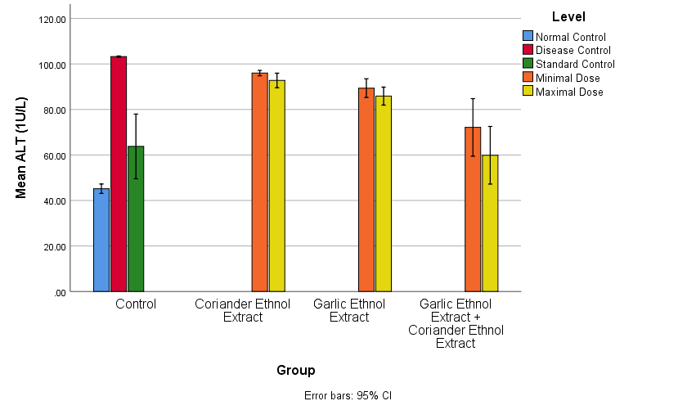
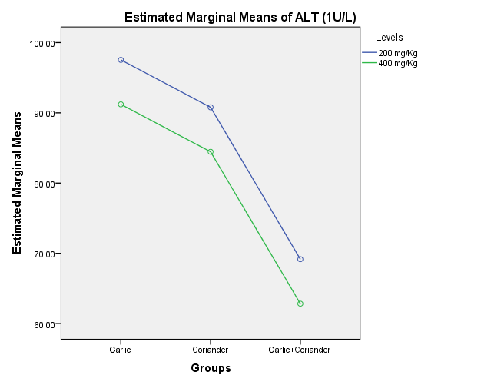
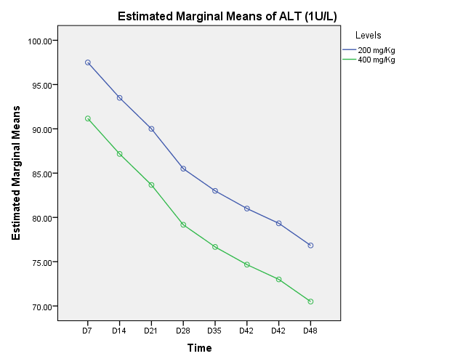
a

c
b

Supplementary Figure Ia): Effects of Medicinal herbs on ALT (1U/L) in diabetic mice(s). b) Estimation of comparative effectiveness of extracts on ALT (1U/L) over two dose levels. c) Estimation of comparative effectiveness of extracts on ALT (1U/L) over eight equal time intervals.

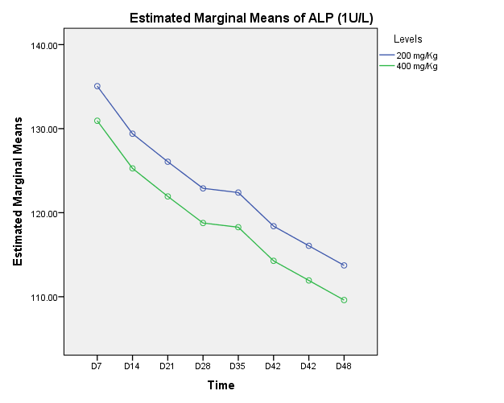
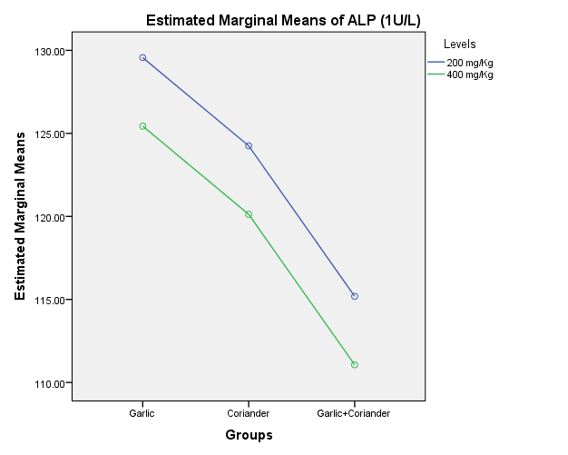
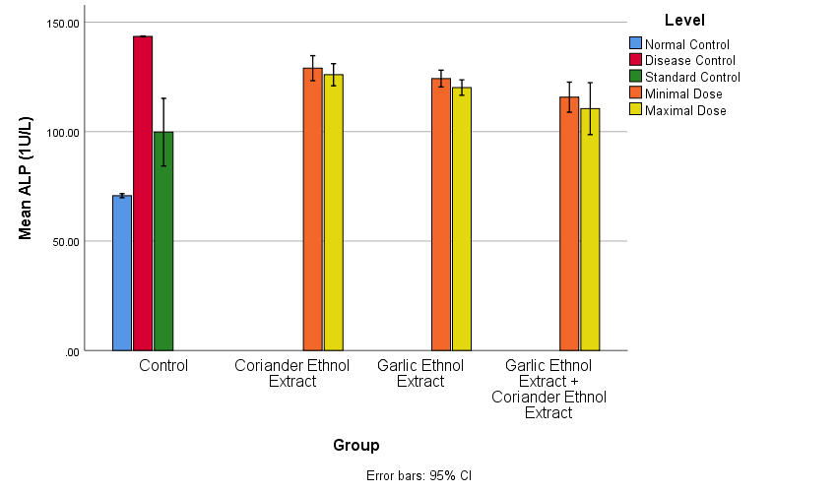
c
b
a
Supplementary Figure 2a): Effects of Medicinal herbs on ALP (1U/L) in diabetic mice(s). b) Estimation of comparative effectiveness of extracts on ALP (1U/L) over two dose levels. c) Estimation of comparative effectiveness of extracts on ALP (1U/L) over eight equal time intervals.

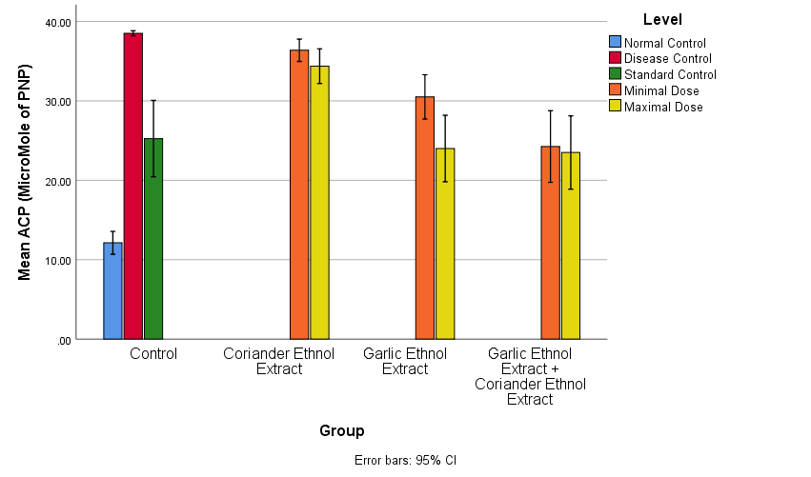
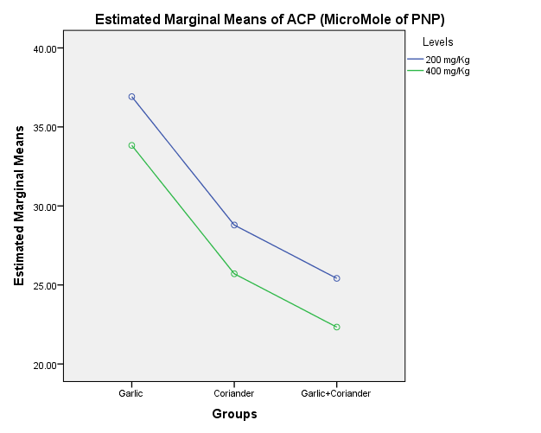
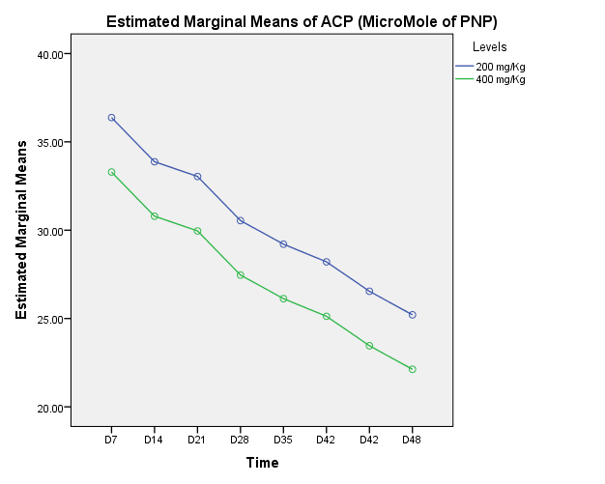
a

Supplementary Figure 3a): Effects of Medicinal herbs on ACP (mM of PNP) in diabetic mice(s). b) Estimation of comparative effectiveness of extracts on ACP (mM of PNP) over two dose levels. c) Estimation of comparative effectiveness of extracts on ACP (mM of PNP) over eight equal time intervals.

c
b
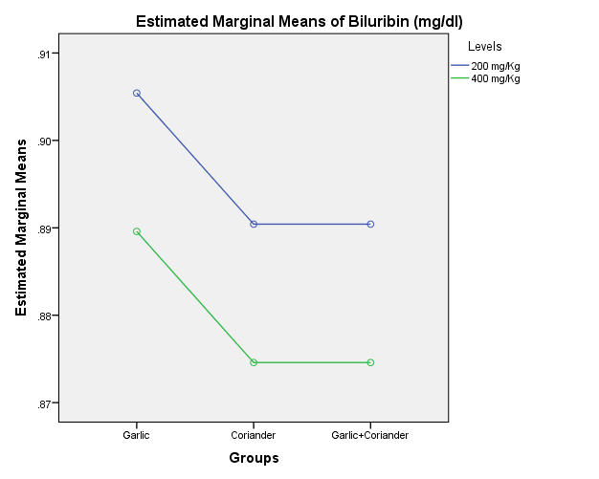
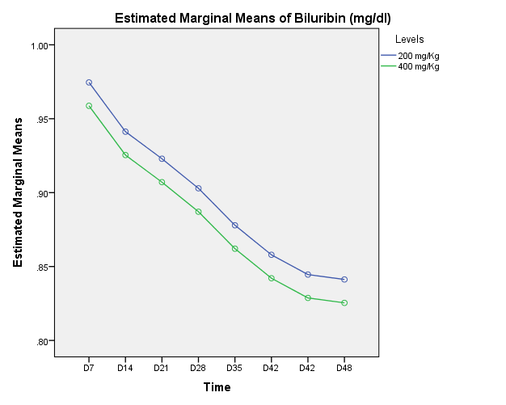
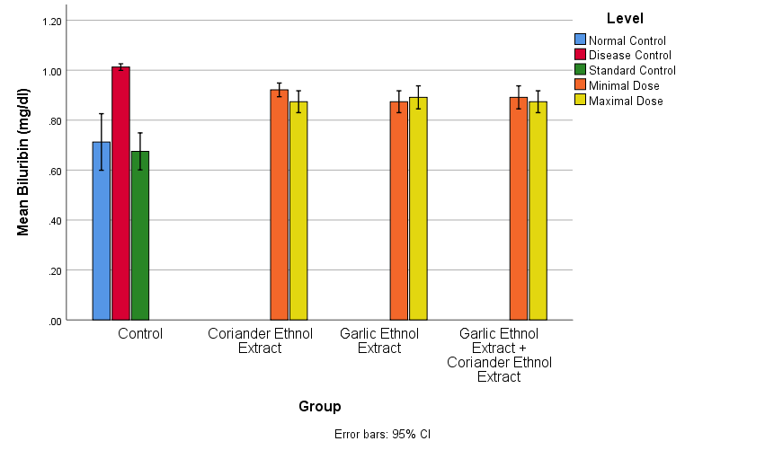
Supplementary Figure 4a): Effects of Medicinal herbs on Bilirubin (mg/dl) in diabetic mice(s). b) Estimation of comparative effectiveness of extracts on Bilirubin (mg/dl) over two dose levels. c) Estimation of comparative effectiveness of extracts on Bilirubin (mg/dl) over eight equal time intervals.

b
c
a

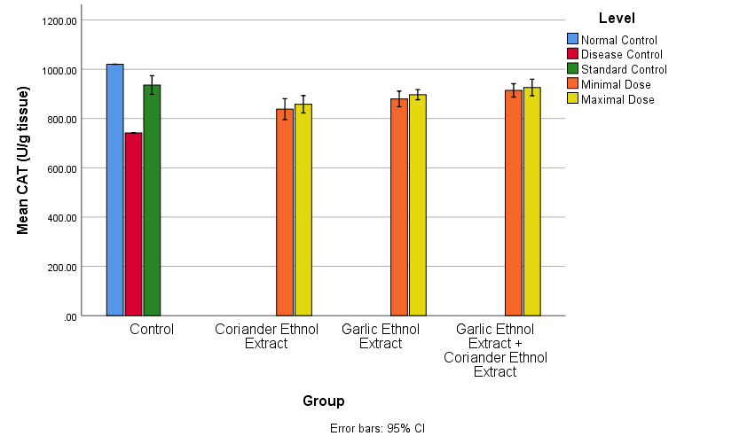
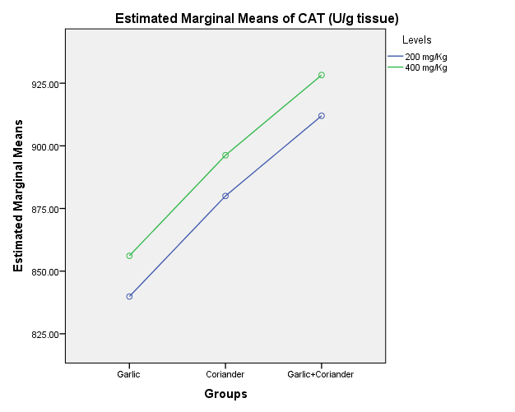
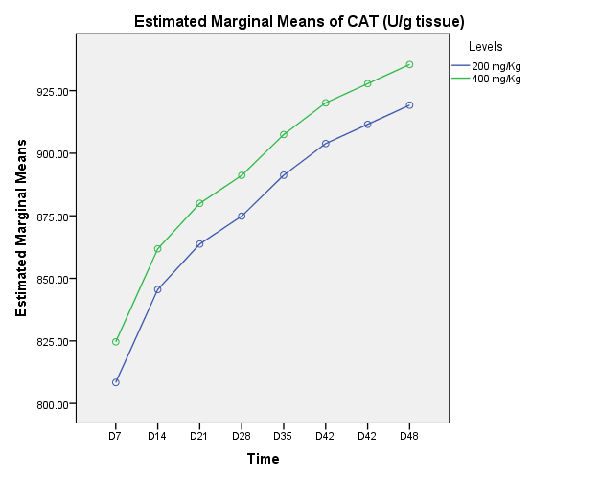
a

b
c

Supplementary Figure 5a): Effects of Medicinal herbs on CAT (U/g tissue) in diabetic mice(s). b) Estimation of comparative effectiveness of extracts on CAT (U/g tissue) over two dose levels. c) Estimation of comparative effectiveness of extracts on CAT (U/g tissue) over eight equal time intervals.

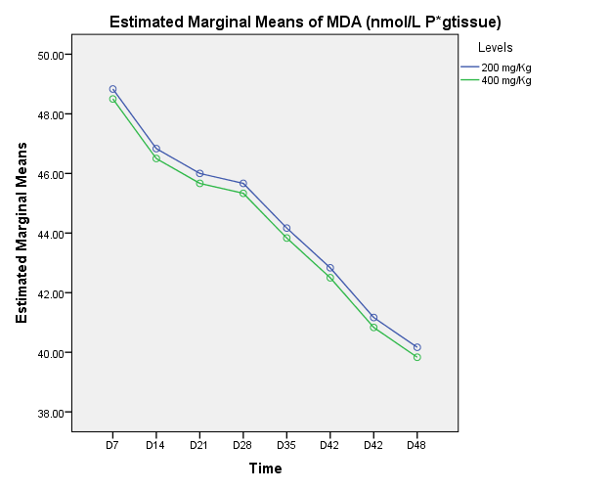
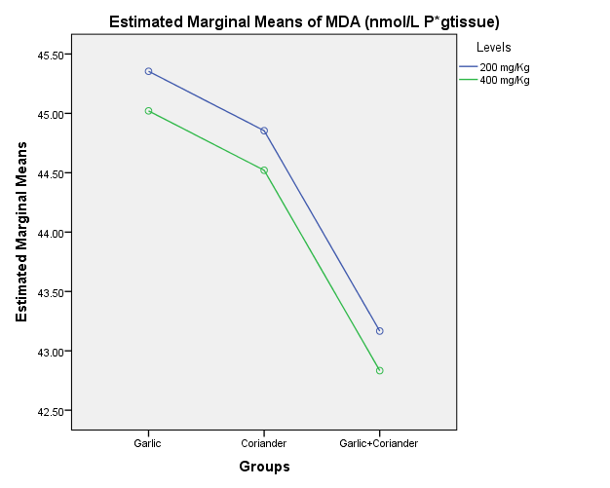
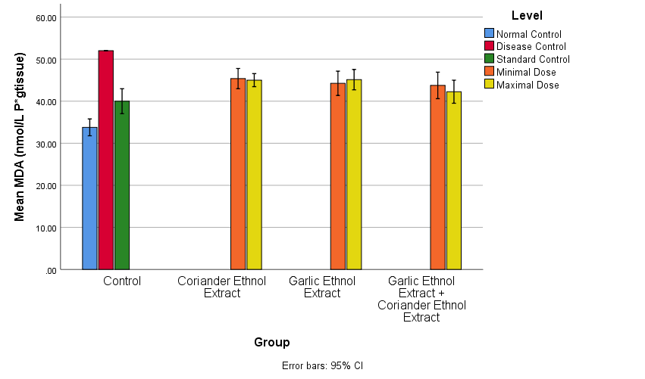
a

b
c
Supplementary Figure 6a): Effects of Medicinal herbs on MDA (nmol/L P* g tissue) in diabetic mice(s). b) Estimation of comparative effectiveness of extracts on MDA (nmol/L P* g tissue) over two dose levels. c) Estimation of comparative effectiveness of extracts on MDA (nmol/L P* g tissue) over eight equal time intervals.

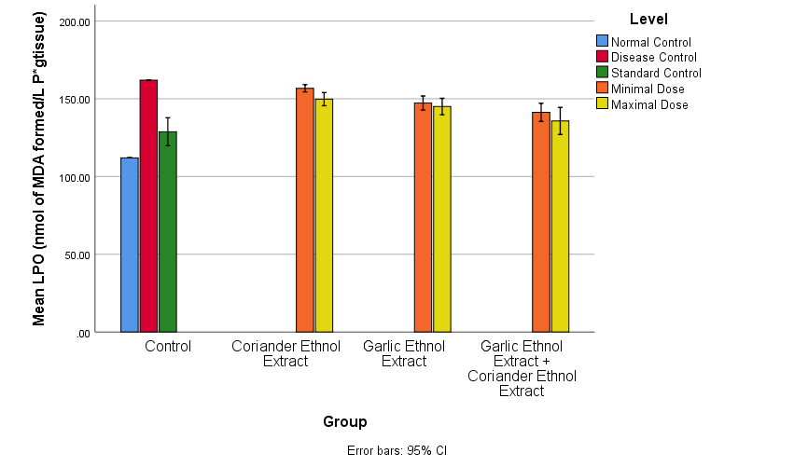
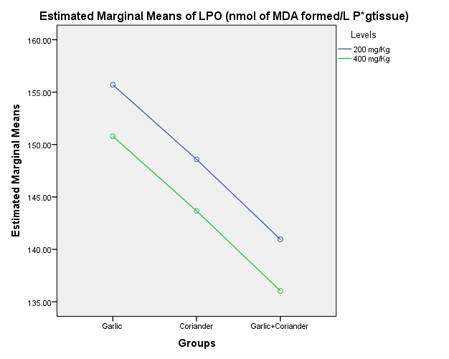
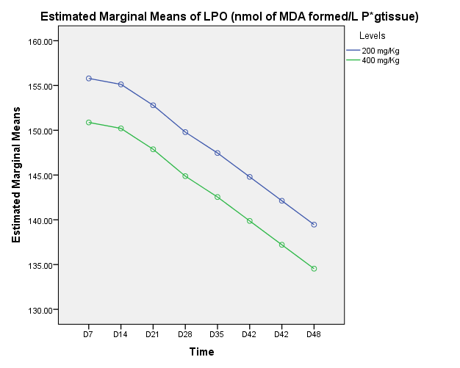
Supplementary Figure 7a): Effects of Medicinal herbs on LPO (nmol of MDA formed/L P* g tissue in diabetic mice(s). b) Estimation of comparative effectiveness of extracts on LPO (nmol of MDA formed/L P* g tissue over two dose levels. c) Estimation of comparative effectiveness of extracts on LPO (nmol of MDA formed/L P* g tissue) over eight equal time intervals.

c
b
a

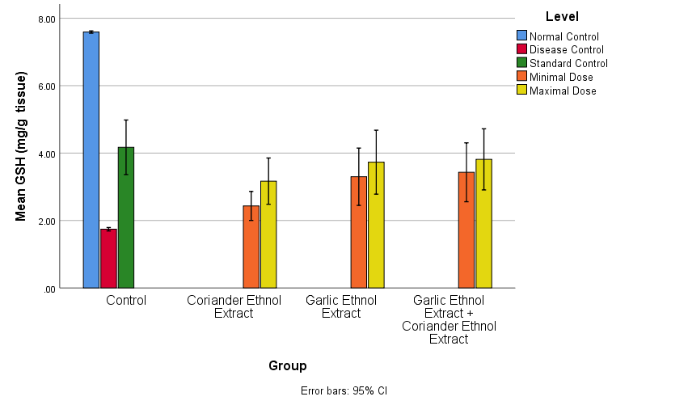
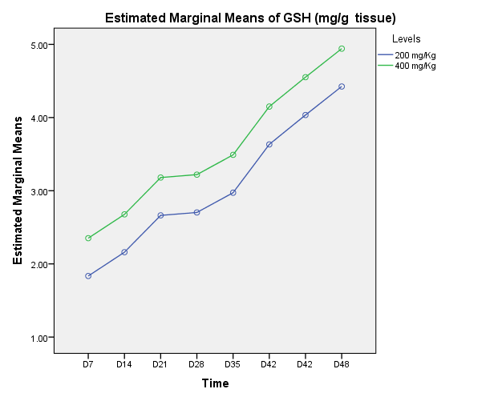
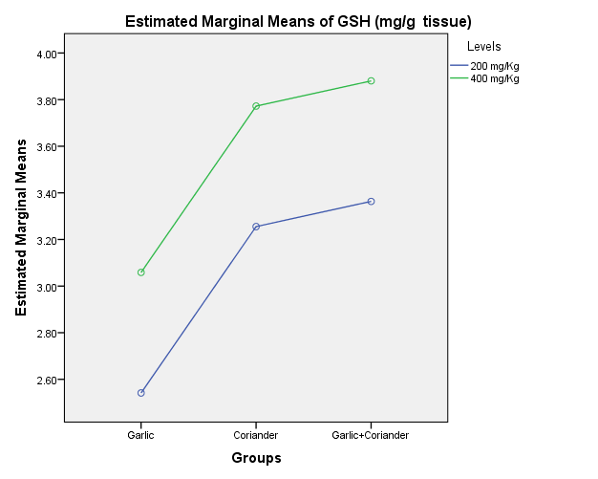
a

c
b

Supplementary Figure 8a): Effects of Medicinal herbs on GSH (mg/g tissue) in diabetic mice(s). b) Estimation of comparative effectiveness of extracts on GSH (mg/g tissue) over two dose levels. c) Estimation of comparative effectiveness of extracts on GSH (mg/g tissue) over eight equal time intervals.

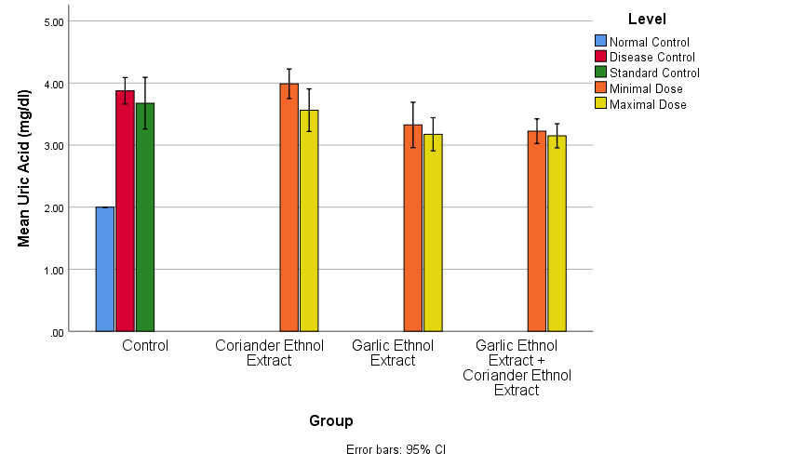
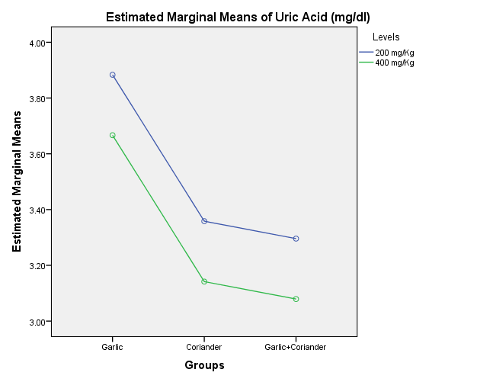
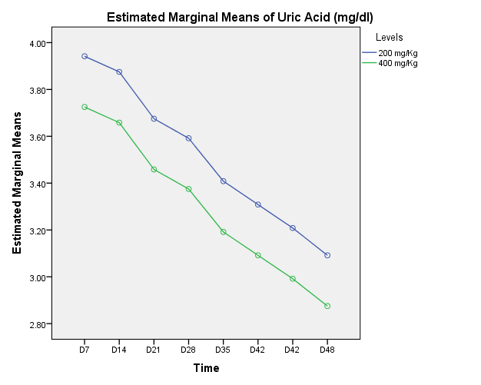
Supplementary Figure 9a): Effects of Medicinal herbs on Uric acid (mg/dl) in diabetic mice(s). b) Estimation of comparative effectiveness of extracts on Uric acid (mg/dl) over two dose levels. c) Estimation of comparative effectiveness of extracts on Uric acid (mg/dl) over eight equal time intervals.

c
b
a

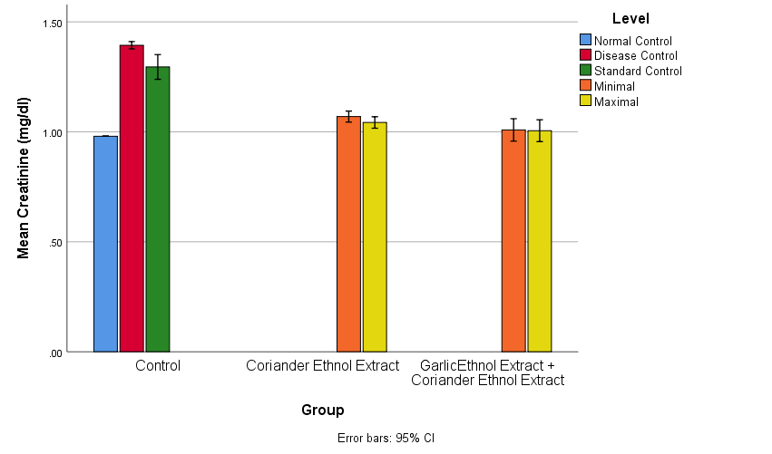
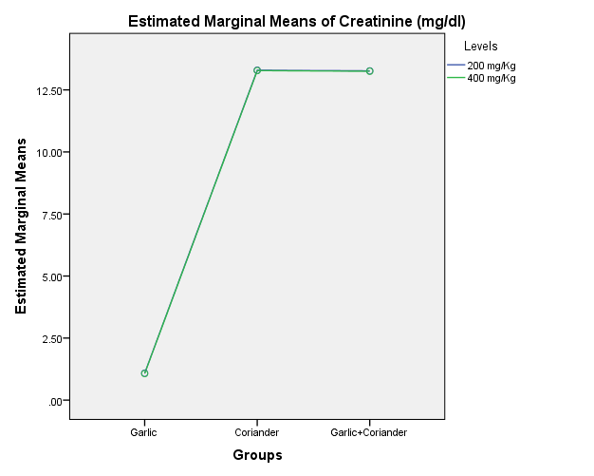
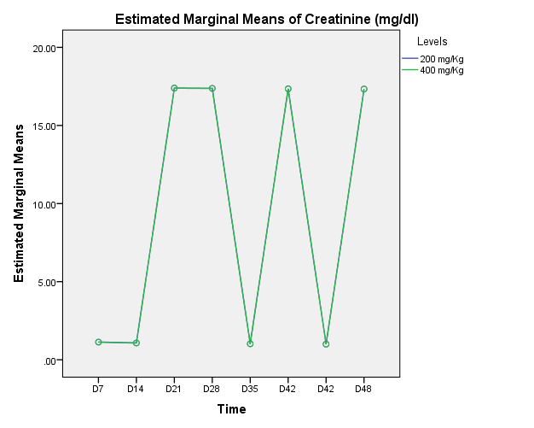
b
c
a

Supplementary Figure 10a): Effects of Medicinal herbs on Creatinine (mg/dl) in diabetic mice(s). b) Estimation of comparative effectiveness of extracts on Creatinine (mg/dl) over two dose levels. c) Estimation of comparative effectiveness of extracts on Creatinine (mg/dl) over eight equal time intervals.

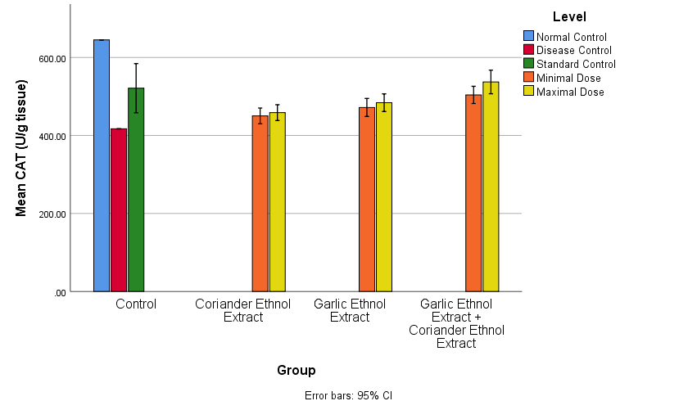
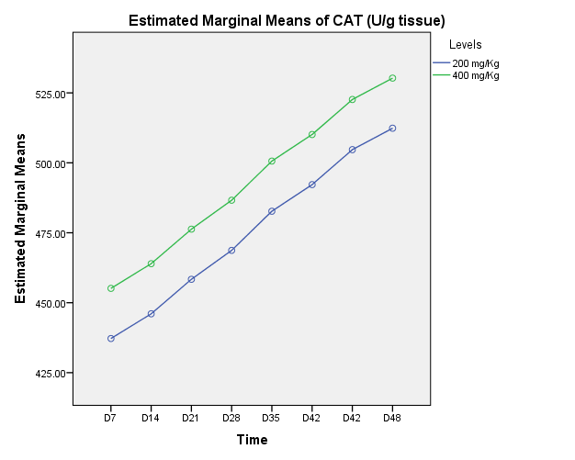
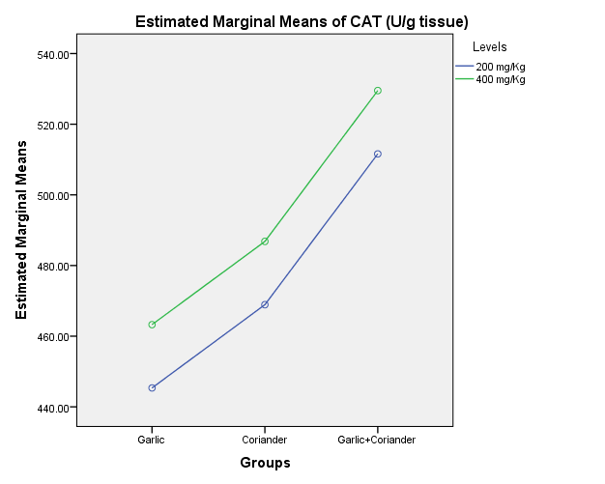
c
b
a
Supplementary Figure 11a): Effects of Medicinal herbs on CAT (U/g tissue) in diabetic mice(s). b) Estimation of comparative effectiveness of extracts on CAT (U/g tissue) over two dose levels. c) Estimation of comparative effectiveness of extracts on CAT (U/g tissue) over eight equal time intervals.

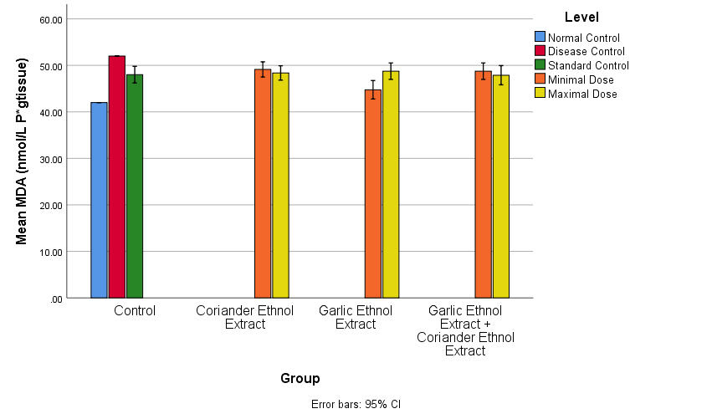
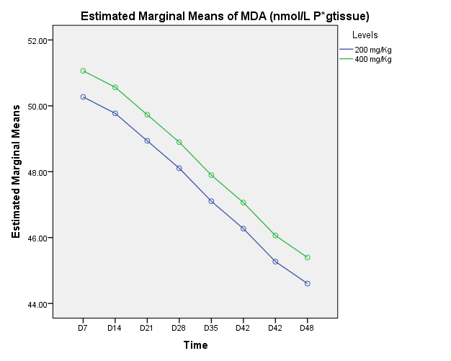
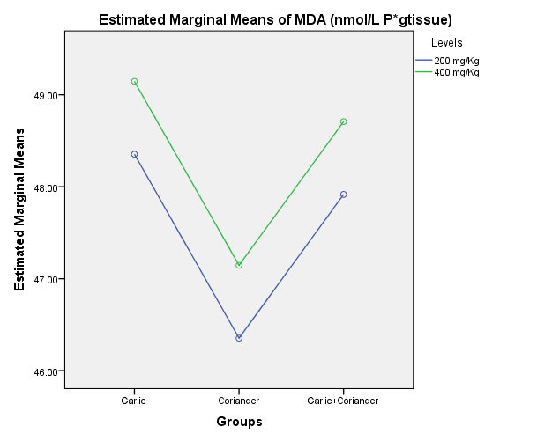
b
c
a
Supplementary Figure 12a): Effects of Medicinal herbs on MDA (nmol/L P* g tissue) in diabetic mice(s). b) Estimation of comparative effectiveness of extracts on MDA (nmol/L P* g tissue) over two dose levels. c) Estimation of comparative effectiveness of extracts on MDA (nmol/L P* g tissue) over eight equal time intervals.

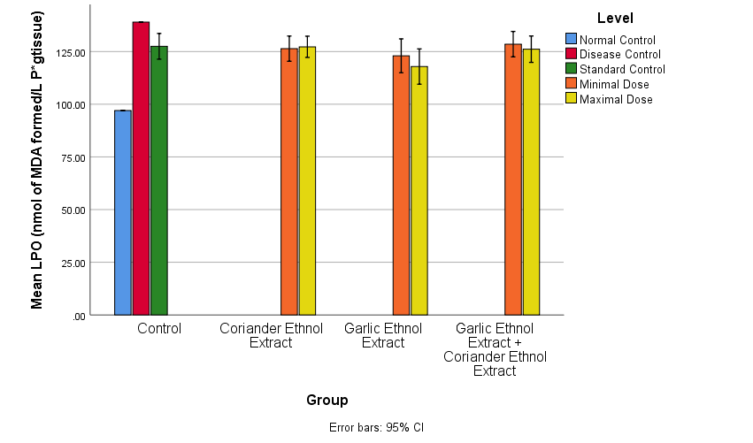
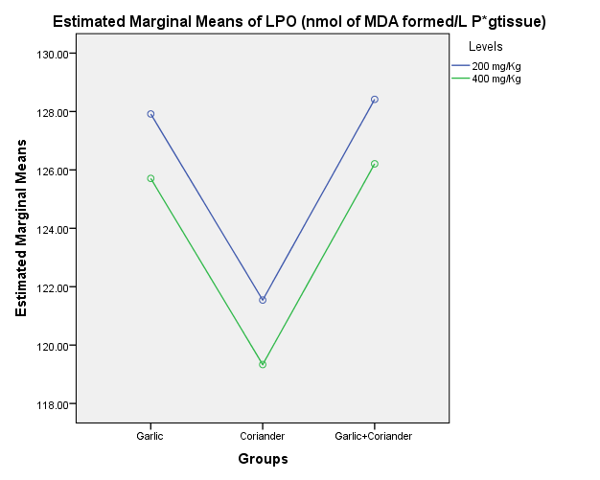
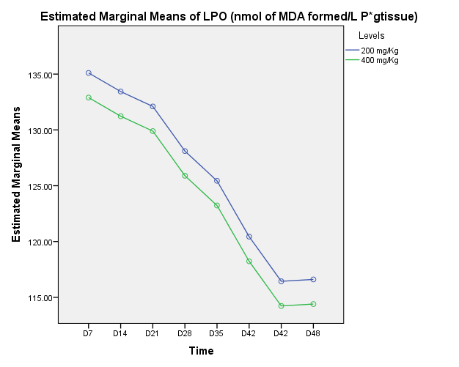
b
c
a
Supplementary Figure 13a): Effects of Medicinal herbs on LPO (nmol/L P* g tissue) in diabetic mice(s). b) Estimation of comparative effectiveness of extracts on LPO (nmol/L P* g tissue) over two dose levels. c) Estimation of comparative effectiveness of extracts on LPO (nmol/L P* g tissue) over eight equal time intervals.

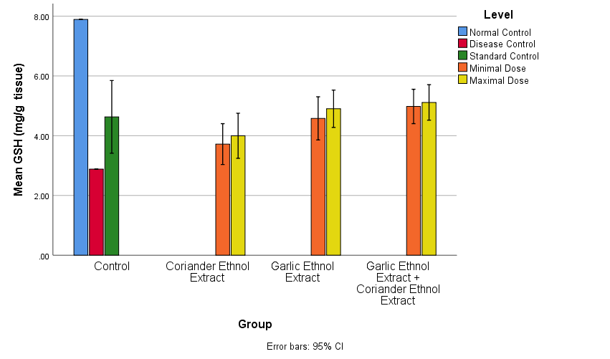
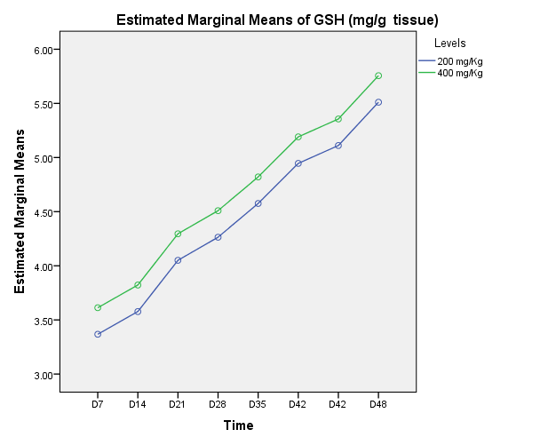
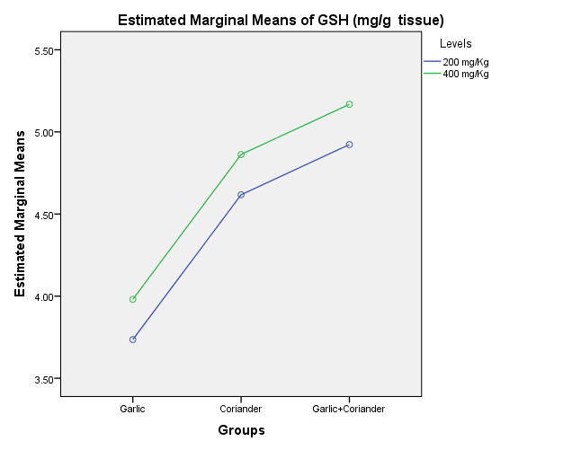
c
b
a
Supplementary Figure 14a): Effects of Medicinal herbs on GSH (mg/g tissue) in diabetic mice(s). b) Estimation of comparative effectiveness of extracts on GSH (mg/g tissue) over two dose levels. c) Estimation of comparative effectiveness of extracts on GSH (mg/g tissue) over eight equal time intervals.

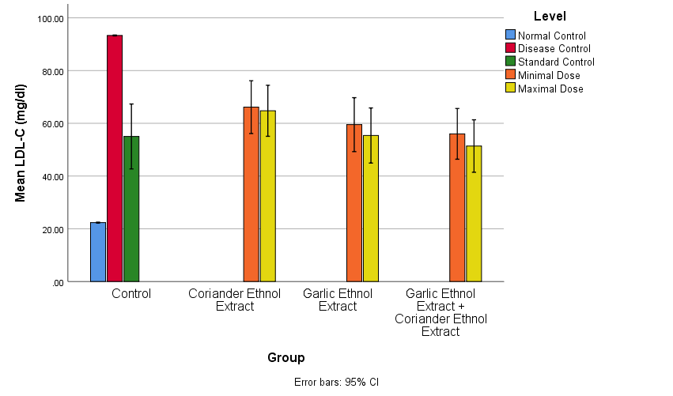
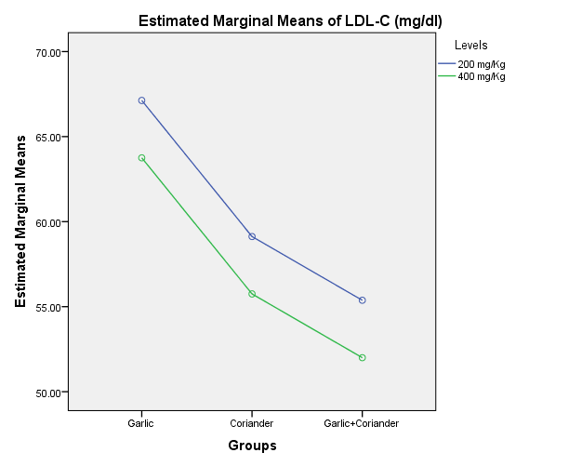
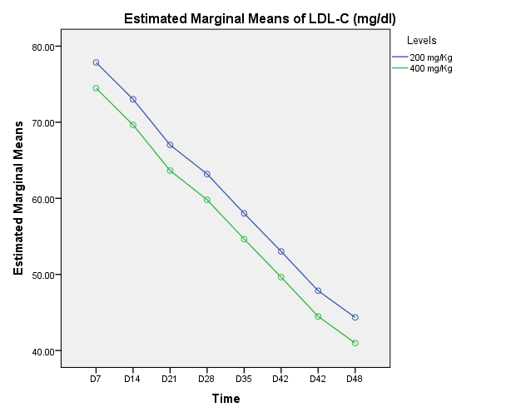
b
c
a
Supplementary Figure 15a): Effects of Medicinal herbs on LDL-C (mg/dl) in diabetic mice(s). b) Estimation of comparative effectiveness of extracts on LDL-C (mg/dl) over two dose levels. c) Estimation of comparative effectiveness of extracts on LDL-C (mg/dl) over eight equal time intervals.

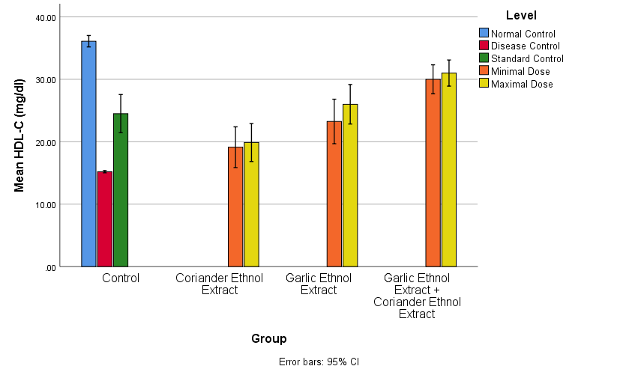
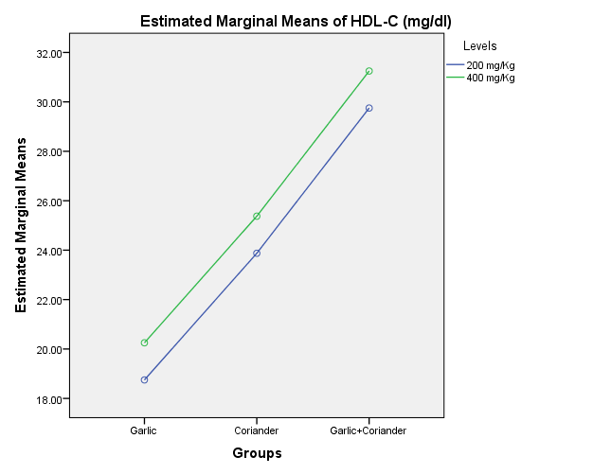
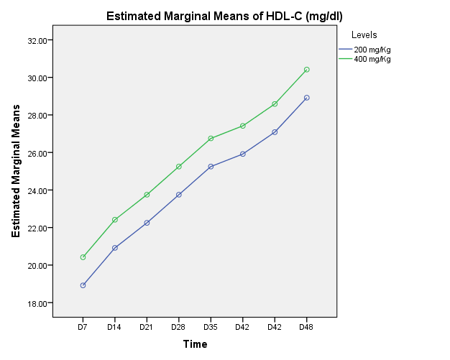
b
c
a
Supplementary Figure 16a): Effects of Medicinal herbs on HDL-C (mg/dl) in diabetic mice(s). b) Estimation of comparative effectiveness of extracts on HDL-C (mg/dl) over two dose levels. c) Estimation of comparative effectiveness of extracts on HDL-C (mg/dl) over eight equal time intervals.

