Supplementary Information

Myotonic dystrophy RNA toxicity alters astrocyte morphology, adhesion and migration

Diana M. Dincã, Anchel Gonzalez-Barriga, Géraldine Sicot, Louison Lallemant, Laure-Elise Pillet, Noémie Cresto, Sandra O. Braz, Hélène Polveche, Aline Huguet-Lachon, Cuauhtli N. Azotla-Vilchis, Luis E. Agonizantes-Juárez, Julie Tahraoui, Cécile Martinat, Oscar Hernández-Hernández, Didier Auboeuf, Nathalie Rouach, Cyril F. Bourgeois, Geneviève Gourdon, Mário Gomes-Pereira

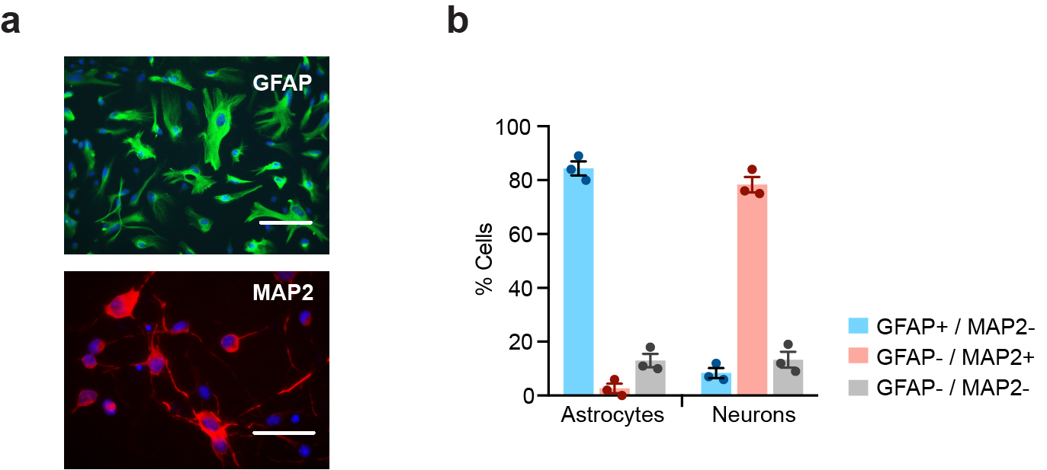

Supplementary Fig. 1. Expression of astrocytic and neuronal markers in primary cell cultures derived from mouse brains. (a) We confirmed astrocyte and neuron enrichment in primary cultures through the immunofluorescence of astrocyte- and neuron-specific proteins, GFAP and MAP2, respectively. Representative immunofluorescent detection of primary mouse astrocytes expressing GFAP (red), and primary mouse neurons expressing MAP2 (green). Scale bar, 100 µm. (b) Percentage of primary cells expressing GFAP or MAP2. Data are means ± SEM; n=3 independent WT cultures. The expression analysis of GFAP and MAP2 revealed that 84.3 ± 4.5% of primary cells growing under conditions that favor astrocyte proliferation expressed GFAP. Conditions that favor neuronal survival yielded MAP2 staining in 78.3 ± 4.9 % of cells.
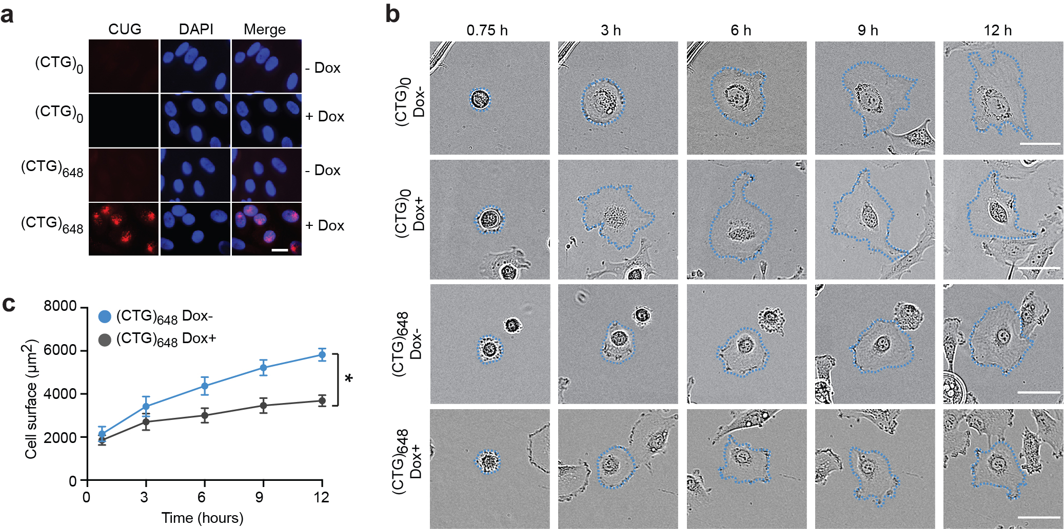
Supplementary Fig. 2. Human glial cells transfected with expanded CTG repeats exhibit abnormal adhesion and reduced cell size. (a) FISH detection of CUG RNA foci in human glia MIO-M1 cells expressing an inducible (CUG)₆₄₈ DMPK RNA, or a no-expansion (CUG)₀ control construct. Transgene induction by doxycycline was performed over 3 days and is indicated (Dox+, Dox-). Scale bar, 200 µm. (b) Representative time-lapse bright field images of glial MIO-M1 cells expressing normal or expanded DMPK transcripts, over 12 hours after plating. Scale bar, 50 μm. (c) Size of individual MIO-M1 (CTG)₆₄₈ glial cells, following transgene induction (Dox+, n=31), versus non-induced cells (Dox-, n=30). Data are means ± SEM (*p<0.05, Two-way repeated measures ANOVA).
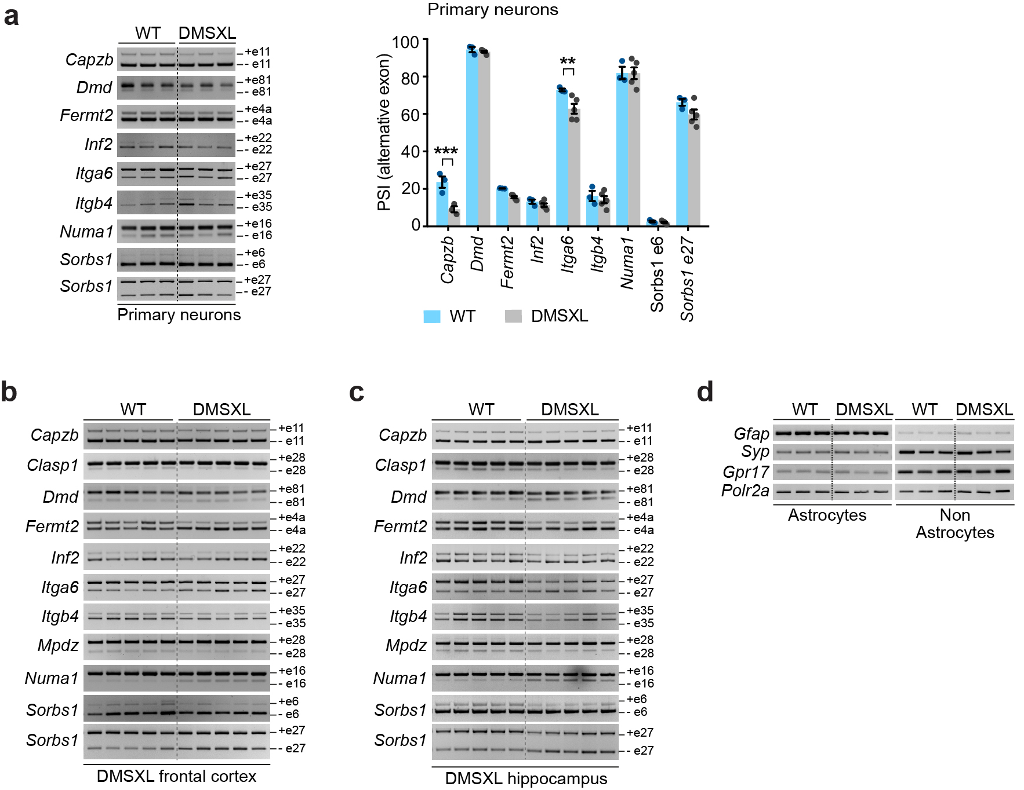
Supplementary Fig. 3. DM1 RNA toxicity is more pronounced in mouse astrocytes than in neurons. (a) Representative RT-PCR splicing analysis of transcripts associated with cell adhesion and cytoskeleton in primary DMSXL and WT neurons. Alternative exons are indicated on the right. PSI quantification of alternative exons. Data are means ± SEM, n=3-5 independent cultures per genotype (**p<0.01; Two-way ANOVA, Sidak post-hoc test for multiple comparisons). (b) Representative RT-PCR analysis of Capzb, Clasp1, Dmd, Fermt2, Inf2, Itga6, Itgb4, Mpdz, Numa1, Sorbs1 in DMSXL frontal cortex, relative to WT control mice at 1 month of age. Alternative exons are indicated on the right. (c) Representative RT-PCR splicing analysis of Capzb, Clasp1, Dmd, Fermt2, Inf2, Itga6, Itgb4, Mpdz, Numa1, Sorbs1 in DMSXL hippocampus, relative to WT control mice at 1 month of age. Alternative exons are indicated on the right. (d) Semi-quantitative expression analysis of Gfap, Syp and Gpr17 in astrocyte and non-astrocyte cell fractions, purified from brain cortex of 1-month-old mice. n = 3 independent cell fractions, collected from 3 animals per genotype.
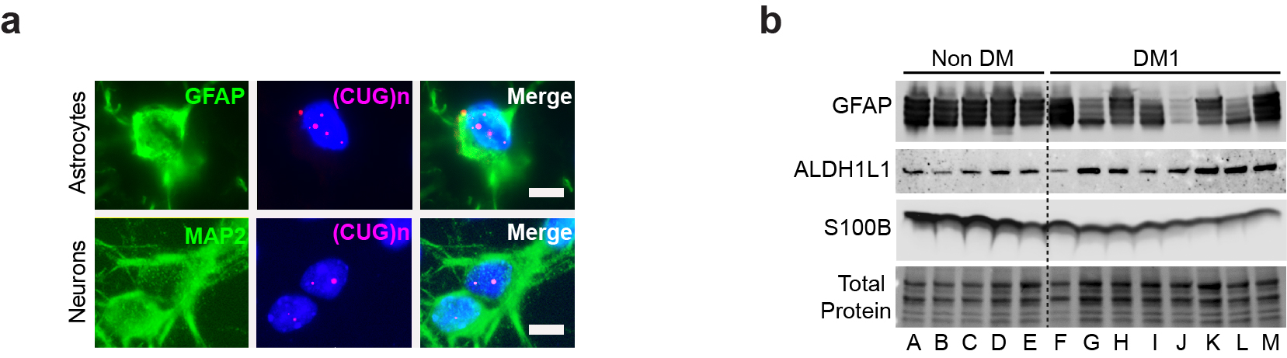

Supplementary Fig. 4. Foci accumulation and expression of astrocyte-specific protein in DM1 human brains. (a) FISH analysis of nuclear foci accumulation in human frontal cortex. Representative GFAP-expressing astrocytes and MAP2-posive neurons are shown. Scale bar, 20 µm. (b) Western blot detection of GFAP, ALHD1L1 and S100B astrocyte proteins in human frontal cortex. n=5, non-DM; n=8, DM1.
Supplementary Tables
Supplementary Table 1. RNA sequencing of primary DMSXL astrocytes versus primary WT astrocytes: expression analysis.
Data uploaded onto the GEO database, and available to Editors and Reviewers.
GEO GSE162093; https://www.ncbi.nlm.nih.gov/geo/query/acc.cgi?&acc=GSE162093
Password: inolscaojhutpsv

Supplementary Table 2. RNA sequencing of primary DMSXL astrocytes versus primary WT astrocytes: splicing analysis.
Data uploaded onto the GEO database, and available to Editors and Reviewers.
GEO GSE162093; https://www.ncbi.nlm.nih.gov/geo/query/acc.cgi?&acc=GSE162093
Password: inolscaojhutpsv

Supplementary Table 3. RNA sequencing of primary DMSXL neurons versus primary WT neurons: expression analysis.
Data uploaded onto the GEO database, and available to Editors and Reviewers.
GEO GSE162093; https://www.ncbi.nlm.nih.gov/geo/query/acc.cgi?&acc=GSE162093
Password: inolscaojhutpsv

Supplementary Table 4. RNA sequencing of primary DMSXL neurons versus primary WT neurons: splicing analysis.
Data uploaded onto the GEO database, and available to Editors and Reviewers.
GEO GSE162093; https://www.ncbi.nlm.nih.gov/geo/query/acc.cgi?&acc=GSE162093
Password: inolscaojhutpsv
Supplementary Table 5. Genes selected for missplicing validation in primary DMSXL astrocytes. Genes are distributed by the three top categories enriched in primary DMSXL astrocytes. GO ontology terms associated with each category are categorized into one of the 3 ontologies. BP, biological process; CC, cellular component; MF, molecular function.
Category | Accession ID | Name | Ontology | Genes for validation
Cell adhesion | GO:0048041 | Focal adhesion assembly | BP | Clasp1  Dmd  Fermt2  Itga6  Itgb4  Mpdz  Sorbs1
Cell adhesion | GO:0010810 | Regulation of cell-substrate adhesion | BP | Clasp1  Dmd  Fermt2  Itga6  Itgb4  Mpdz  Sorbs1
Cell adhesion | GO:0005913 | Cell-cell adherens junction | CC | Clasp1  Dmd  Fermt2  Itga6  Itgb4  Mpdz  Sorbs1
Cell adhesion | GO:0005925 | Focal adhesion | CC | Clasp1  Dmd  Fermt2  Itga6  Itgb4  Mpdz  Sorbs1
Cell adhesion | GO:0050839 | Cell adhesion molecule binding | MF | Clasp1  Dmd  Fermt2  Itga6  Itgb4  Mpdz  Sorbs1
Cytoskeleton | GO:0031110 | Regulation of microtubule polymerization or depolymerization | BP | Clasp1  Fermt2  Inf2  Numa1
Cytoskeleton | GO:0005874 | Microtubule | CC | Clasp1  Fermt2  Inf2  Numa1
Cytoskeleton | GO:0008017 | Microtubule binding | MF | Clasp1  Fermt2  Inf2  Numa1
Cytoskeleton | GO:0015631 | Tubulin binding | MF | Clasp1  Fermt2  Inf2  Numa1
Cytoskeleton | GO:0008092 | Cytoskeletal protein binding | MF | Clasp1  Fermt2  Inf2  Numa1
Plasma membrane | GO:0099072 | Regulation of postsynaptic membrane neurotransmitter receptor levels | BP | Capzb  Clasp1  Dmd  Fermt2  Mpdz  Numa1
Plasma membrane | GO:0099738 | Cell cortex region | CC | Capzb  Clasp1  Dmd  Fermt2  Mpdz  Numa1
Plasma membrane | GO:0030027 | Lamellipodium | CC | Capzb  Clasp1  Dmd  Fermt2  Mpdz  Numa1
Plasma membrane | GO:0030165 | PDZ domain binding | MF | Capzb  Clasp1  Dmd  Fermt2  Mpdz  Numa1

Supplementary Table 6. Oligonucleotide primer sequences for the splicing analysis of mouse alternative exons.

GeneS | Alternative exonª | Size (bp) | Oligonucleotide primer sequences
Ank2 | 51 | 93 | GAACGTGGTTCTCCGATTGT  CGTCTCTGGGGGTATGTCAG
Capzb | 11 | 113 | GCACGCTGAATGAGATCTACTTTG  CCGGTTAGCGTGAAGCAGAG
Clasp1 | 28 | 24 | TGACCTGGAAGCAGCAGTGG  CCGCAGATAATGGGGAATGC
Dclk1 | 20 | 74 | GATGATGGTCTCCCAGAAAATGAG  TTGCGTCTTCGTCGGAAAAC
Dmd | 81 | 32 | TCCCCAGGACACAAGCACAG  CCATCGCTCTGCCCAAATC
Fermt2 | 4a | 36 | GCTTGAGCTGGAAGGACCTCTTATC  GCAGAAGTTGGTGACAAAGGGC
Fn1 | 33 | 270 | CCACTGTGGAGTACGTGGTTAGTG  TGGGTGTCACCTGACTGAACTTC
Inf2 | 22 | 57 | CTGAAGATACCCCGGATGCC  CCGACGAGAGCACTCACTTG
Itga6 | 27 | 130 | GGGATTCTGATGCTGGCTCTATTAG  GGCTTTGGGTAGTGTGAGGTGTTC
Itgb4 | 35 | 162 | CAGGGTGGAGAAGACTACGAAAAC  GGTTAGGGATGTTGAGCCGATG
Mapt | 2/3 | 87/87 | CACTCTGCTCCAAGACCAAG  TGTCTCCGATGCCTGCTTC
Mapt | 10 | 93 | CTGAAGCACCAGCCAGGAGG  TGGTCTGTCTTGGCTTTGGC
Mbnl1 | 7 | 54 | GCTGCCCAATACCAGGTCAAC  TGGTGGGAGAAATGCTGTATGC
Mbnl2 | 9 | 54 | ACCGTAACCGTTTGTATGGATTAC  CTTTGGTAAGGGATGAAGAGCAC
Mpdz | 28 | 99 | TGAACAAGCTGTGGAAGCCA  GGAGGGAGGAACATTGCACA
Numa1 | 16 | 42 | GACCCACTTGGCTGAAATGC  GTCAGCTTCTTACTTAGTTCTTCC
Sorbs1 | 6 | 90 | CTGCATCTGGGAAGACTCGCCT  GACTTGCTTTCATGCTTCGGAGATTC
Sorbs1 | 27 | 168 | CCAGCTGATTACTTGGAGTCCACAGAAG  GTTCACCTTCATACCAGTTCTGGTCAATC
Spna2 | 23 | 60 | CTATGGCAGCAGCATCCAGG  CCTTTTCTCTTCTCACCCAGTTCC
Tanc2 | 23 | 30 | GCCATGATTGAGCATGTTGACTACGT CCTCTTCCATCAGCTTGCTCAACA
ª Alternative exons are numbered according to the FasterDB web interface (http://fasterdb.ens-lyon.fr/faster/home.pl)
Supplementary Table 7. Oligonucleotide primer sequences for the splicing analysis of human alternative exons.

Gene | Alternative exonª | Size (bp) | Oligonucleotide primer sequences
CAPZB | 10b | 113 | GCACCGCCCATTACAAGTTG  AGCCTCCACCAGGTCATTCTTC
CLASP1 | 27 | 108 | CGCTAAAGTGGTTTCACAGTCCC  TTCTGCTACATCCTCAGTCTGCCG
DMD | 85 | 32 | TCCCCAGGACACAAGCACAG  CATCGCTCTGCCCAAATCATC
FERMT2 | 4a | 33 | TGACCAGTCTGAAGATGAGGCAC  GCTTGAGGCTTGAACATTTTTGC
INF2 | 22 | 57 | GGAAGCGAAGGAAGAAGCGTC  GGTTGCCTTTAGGAAGCAGGTG
ITGA6 | 27 | 130 | GAGTGACTGTGTTTCCCTCAAAGAC  CAGCCACGCCAAAAATAAAGG
ITGB4 | 35 | 159 | CCGCTCAGAACACTCACACTCG  TGGTTGGGCAGGAGGTCTTC
MPDZ | 28 | 99 | CCATTCGGAAAGCAGGCAAC  TTCGGCAAAGGCTGAAGGAG
NUMA1 | 20 | 42 | GTATGAGGGTGCCAAGGTCAAG  TGGTCAGAGTCAGCCAGTTTCTTAC
POLR2A | N/A | N/A | AGAGAAGCTGGTGCTCCGTA  AGCGCAGGAAGACATCATCA
SORBS1 | 6 | 96 | AGTTGCAGACGACTTGTCCTGC  CCCTTCCCAGTGCAGATTTTTG
SORBS1 | 30 | 168 | CTGGGGATCTCACTAGCTTGGAG  GCCGTGGTGTTCTCCTTCATAC
ª Alternative exons are numbered according to the FasterDB web interface (http://fasterdb.ens-lyon.fr/faster/home.pl)
Supplementary Table 8. Primary antibodies for western blotting and immunofluorescence

Protein | Supplier | Catalogue # | RRID | Application
ALDH1L1 | Arigo | ARG10691 | N/A | WB
CELF1 | Millipore | 05-621 | AB_309851 | WB
CELF2 | Sigma | C9367 | AB_1078584 | WB
GFAP | Abcam | Ab7260-50 | AB_305808 | WB, IF
GM130 | BD Biosciences | 610822 | AB_398141 | IF
MAP2 | Santa Cruz Biotechnology | sc-80013 | AB_1126218 | IF
MBNL1 | GE Morris; Oswestry, UK | MB1a(4A8) | AB_2618248 | IF
MBNL2 | GE Morris; Oswestry, UK | MB2a(3B4) | AB_2618250 | IF
S100B | Abcam | Ab52642 | AB_882426 | WB
TUBB3 | Covance | PRB-435P-100 | AB_291637 | WB
VCL | Cell Signaling Technology | 4650 | AB_10559207 | WB
VCL | Sigma-Aldrich | V9131 | AB_477629 | IF
RRID, Research Resource Identifier; N/A, not applicable; WB, western blot; IF, immunofluorescence.

Supplementary Table 9. Oligonucleotide primer sequences for RT-PCR analysis of acutely dissected astrocytes
Gene | Oligonucleotide primer sequences
Gfap | GCTAACGACTATCGCCGCCAAC TCCAGCCGAGCAAGTGCCTC
Grp17 | TCACAGCTTACCTGCTTCCC  GACCGTTCATCTTGTGGCTCT
Polr2a | GGCTGTGCGGAAGGCTCTG  TGTCCTGGCGGTTGACCC
Syp | CCCCCTTCCTTCTCTCCCTCTG CCATCTCCTCTCCACCCATTTCATC

