Table of Content
Extended Data 2
Inclusion and exclusion criteria for adults 2
Inclusion and exclusion criteria for the elderly 4
Extended Data Figure 1. The incidences of adverse reactions reported within 14 days after each vaccination for the 10 µg or 30 µg dose levels in younger participants aged 18-55 years. 8
Extended Data Figure 2. The incidences of adverse reactions reported within 14 days after each vaccination for the 10 µg or 30 µg dose levels in older participants aged 65-85 years. 9
Extended Data Figure 3. Changes of vital signs measured in the younger and older participants before and after the prime vaccination. 10
Extended Data Figure 4. Changes of laboratory values from baseline measured in younger and older participants before and after the prime vaccination. 11
Extended Data Figure 5. Seroconversion and fold increases of the specific neutralizing antibodies and binding antibody responses to RBD and S1 in participants. 12
Extended Data Figure 6. The association between neutralizing antibodies to live SARS-CoV-2 and ELISA antibodies to receptor binding domain, spike glycoprotein at day 43 post-vaccination. 13
Extended Data Table 1. Participant disposition and analysis sets. 14
Extended Data Table 2. List of severe adverse events graded as grade 3 or greater reported till day 43 of the study period. 15
Extended Data Table 3. Geometric mean titer of the virus-neutralizing antibodies and specific binding antibody responses to RBD or S1 in participants. 16
Extended Data Table 4. Characteristics of the convalescent patients, by severity of COVID-19. 17

Extended Data

Inclusion and exclusion criteria for adults
Inclusion criteria:
- The subject is a male or female aged ≥18 to ≤55 years with a body mass index (BMI) of ≥18 to ≤30 at Screening Visit.
- Individuals who are in good health at the time of entry into the trial as determined by medical history, physical examination (including vital signs and ECG) and eligibility screening tests (hematology, biochemistry and urinalysis) and clinical judgment of the investigator at Screening Visit.
- The subject can provide informed consent, signs and dates a written informed consent form (ICF) prior to the initiation of any trial procedures.
- They must be able to understand and follow trial-related instructions.
- They must be willing and able to comply with scheduled visits, treatment schedule, laboratory examination, and other requirements of the trial.
- Negative SARS-CoV-2 antibody screening (fingerstick);
- Normal chest CT (without imaging features of COVID-19);
- Axillary temperature: ≤37.0°C.
- Throat swabs tested negative for SARS-CoV-2 by RT-PCR.
- At Screening Visit, women of childbearing potential (WOCBP) must be negative in the blood β-hCG test. Women that are postmenopausal (continuous menopause for more than 12 months) or permanently sterilized will be considered as not having reproductive potential.
- WOCBP must take effective contraceptive measures 14 days before screening and agree to take effective contraceptive measures continuously during the trial period (from 14 days before the Screening Visit to 60 days after the last immunization).
- WOCBP must agree not to donate eggs (ova and oocytes) for the purposes of assisted reproduction during the trial starting after the Screening Visit and continuing until 60 days after receiving the last immunization.
- Men who are sexually active with a WOCBP and have not had a vasectomy must agree to practice an effective form of contraception with their female partner of childbearing potential during the trial, starting after the Screening Visit and continuing until 60 days after receiving the last immunization.
- Men must be willing to refrain from sperm donation, starting after the Screening Visit and continuing until 60 days after receiving the last immunization.
Exclusion criteria:
- Have had any acute illness, as determined by the investigator, with or without fever, within 72 h prior to the dose 1. An acute illness which is nearly resolved with only minor residual symptoms remaining is allowable if, in the opinion of the investigator, the residual symptoms will not compromise their well-being if they participate as trial subjects in the trial, or that could prevent, limit, or confound the protocol-specified assessments.
- Subjects who are breastfeeding on the day of the Screening Visit or who plan to breastfeed during the trial, starting after Screening Visit and continuing until at least 90 days after receiving the last immunization. Screening and visiting women or partners who plan to become pregnant within one year.
- Known allergy, hypersensitivity, or intolerance to the planned investigational vaccine (including all excipients).
- Have a history of allergy or serious reactions to vaccinations.
- Received any vaccination within 4 weeks prior to Visit 1.
- Disagree not to vaccinate during the trial starting after the Screening Visit and continuing until 28 days after receiving the last immunization, except emergency vaccination (e.g. Rabies vaccine, Tetanus vaccine).
- Had any medical condition (e.g., autoimmune disease) or any major surgery (e.g., requiring general anesthesia) within the past 5 years, which in the opinion of the investigator, could compromise their well-being if they participate as trial subjects in the trial, or that could prevent, limit, or confound the protocol-specified assessments.
- Have any surgery plan during the trial, starting after the Screening Visit and continuing until at least 90 days after receiving the last immunization.
- Chronic use of any systemic medication, including immunosuppressants or other immunomodulators, for more than 14 consecutive days within 6 months before the Screening Visit, unless, in the opinion of the investigator, the medication did not interfere with, limit, or confound protocol-specified assessments or could have jeopardized the subject's safety.
- Administration of any immunoglobulins and/or any blood products within 3 months prior to the Screening Visit.
- Administration of another study drug, including a vaccine, within 60 days or 5 half-lives (whichever is longer) prior to the Screening Visit.
- Have a known history of being positive in AIDS or HIV test.
- Have active HBV or HCV infection in medical investigation.
- Have a history of SARS, SARS-CoV-2 or MERS infection. SARS antibody should be screened in patients with suspected SARS infection.
- Previously participated in a clinical trial involving lipid nanoparticles.
- Are subject to exclusion periods from other clinical trials or simultaneous participate in another clinical trial.
- Any affiliation with the study center (e.g., being a close relative or subordinate of the investigators, such as an employee or student of the study center).
- Have a history (within the past 5 years) of substance abuse or known medical, psychological, or social conditions. Investigators consider that it could compromise their well-being or prevent, limit, or confound the protocol-specified assessments if they participate as subjects of the trial.
- Have a history of narcolepsy.
- Have a history of alcohol abuse or drug addiction within 1 year before the Screening Visit.
- Have a history of suspected immunosuppressive condition, acquired or congenital, as determined by medical history and/or physical examination at Screening Visit.
- Have any abnormality or permanent body art (e.g., tattoo) that, in the opinion of the investigator, would obstruct the ability to observe local reactions at the vaccination site.
- Have had any blood loss >400 mL (e.g., due to donation of blood or blood products or injury) within the 28 days prior to Screening Visit, or plan to donate blood or serum during the trial (starting after Screening Visit and continuing until at least 28 days after receiving the last immunization).
- Have travel or residence history in any country or region (as defined at the time of the Screening Visit) with a high risk of SARS-CoV-2 infection within 14 days prior to the Screening Visit;
- Plan to visit any country or region with a high risk of SARS-CoV-2 infection (as defined at Screening Visit) from the Screening Visit to 14 days after receiving the last immunization;
- Symptoms of COVID-19, e.g., respiratory symptoms, fever, cough, shortness of breath and breathing difficulties.
- Contact with a COVID-19-confirmed patient or a SARS-CoV-2-positive patient within 30 days prior to the Screening Visit.
- Are vulnerable persons, i.e., soldiers, subjects in detention, CRO or Fosun Phar. staffs or their family members.

Inclusion and exclusion criteria for the elderly
Inclusion criteria:
- The subject is a male or female aged ≥65 to ≤85 years old at Screening Visit.
- Individuals who are in good health at the time of entry into the trial as determined by medical history, physical examination (including vital signs and ECG) and eligibility screening tests (hematology, biochemistry and urinalysis) and clinical judgment of the investigator at Screening Visit.
- The subject can provide informed consent, signs and dates a written informed consent form (ICF) prior to the initiation of any trial procedures.
- They must be able to understand and follow trial-related instructions.
- They must be willing and able to comply with scheduled visits, treatment schedule, laboratory examination, and other requirements of the trial.
- Negative in the SARS-CoV-2 antibody screening (fingertip blood sample);
- Chest CT shows no imaging features of COVID-19;
- Axillary temperature: ≤37.0°C.
- Throat swabs tested negative for SARS-CoV-2 by RT-PCR. At Screening Visit, women of childbearing potential (WOCBP) must be negative in the blood β-hCG test. Women that are postmenopausal (continuous menopause for more than 12 months) or permanently sterilized will be considered as not having reproductive potential.
- WOCBP must take effective contraceptive measures 14 days before screening and agree to take effective contraceptive measures continuously during the trial period (from 14 days before the Screening Visit to 60 days after the last immunization).
- WOCBP must agree not to donate eggs (ova and oocytes) for the purposes of assisted reproduction during the trial starting after the Screening Visit and continuing until 60 days after receiving the last immunization.
- Men who are sexually active with a WOCBP and have not had a vasectomy must agree to practice an effective form of contraception with their female partner of childbearing potential during the trial, starting after the Screening Visit and continuing until 60 days after receiving the last immunization.
- Men must be willing to refrain from sperm donation, starting after the Screening Visit and continuing until 60 days after receiving the last immunization.
Exclusion criteria:
- Patients who are found with baseline laboratory abnormality at Grade 3 or above (according to the grading standard in Appendix B) in physical examination and eligibility screening at Screening Visit.
- Have had any acute illness, as determined by the investigator, with or without fever, within 72 h prior to the dose 1. If investigators consider that residual symptoms will not compromise their well-being, and will not prevent, limit, or confound the protocol-specified assessments if they participate as subjects of the trial, patients having acute diseases with only minor residual symptoms that are almost healed can be included in this trial.
- Known allergy, hypersensitivity, or intolerance to the planned investigational vaccine (including all excipients).
- Have a history of allergy or serious reactions to the vaccine.
- Received vaccination within 4 weeks prior to Visit 1.
- Subjects who disagree to avoid other vaccination during the trial, starting after the Screening Visit and continuing to 28 days after receiving the last immunization, except emergency vaccination (e.g. Rabies vaccine, Tetanus vaccine).
- Administration of any immunoglobulins and/or any blood products within 3 months prior to the Screening Visit.
- Have any serious or life-threatening medical condition (e.g. autoimmune disease, cardiovascular disease, etc.) in the past five years, if the investigator consider that participating in the trial as a subject may damage their health, or may prevent, limit or confound the assessment specified in the trial protocol.
- Have any surgery plan during the trial, starting after the Screening Visit and continuing until at least 90 days after receiving the last immunization.
- Chronic use of any systemic medication, including immunosuppressants or other immunomodulators, for more than 14 consecutive days within 6 months before the Screening Visit, unless, in the opinion of the investigator, the medication did not interfere with, limit, or confound protocol-specified assessments or could have jeopardized the subject's safety.
- Administration of another study drug, including a vaccine, within 60 days or 5 half-lives (whichever is longer) prior to the Screening Visit.
- Have a known history of being positive in AIDS or HIV test.
- Have a history of HBV or HCV infection.
- Have a history of SARS, SARS-CoV-2 or MERS infection. SARS antibody should be screened in patients with suspected SARS infection.
- Previously participated in a clinical trial involving lipid nanoparticles.
- Outside the exclusion periods from other clinical trials or simultaneously participate in another clinical trial.
- Any affiliation with the study center (e.g., being a close relative or subordinate of the investigators, such as an employee or student of the study center).
- Have a history (within the past 5 years) of substance abuse or known medical, psychological, or social conditions. Investigators consider that it could compromise their well-being or prevent, limit, or confound the protocol-specified assessments if they participate as subjects of the trial.
- Have a history of narcolepsy.
- Have a history of alcohol abuse or drug addiction within 1 year before the Screening Visit.
- Have a history of suspected immunosuppressive condition, acquired or congenital, as determined by medical history and/or physical examination at Screening Visit.
- Have any abnormality or permanent body art (e.g., tattoo) that, in the opinion of the investigator, would obstruct the ability to observe local reactions at the vaccination site.
- Have had any blood loss >400 mL (e.g., due to donation of blood or blood products or injury) within the 28 days prior to Screening Visit, or plan to donate blood or serum during the trial (starting after Screening Visit and continuing until at least 28 days after receiving the last immunization).
- Have travel or residence history in any country or region (as defined at the time of the Screening Visit) with a high risk of SARS-CoV-2 infection within 14 days prior to the Screening Visit;
- Plan to visit any country or region with a high risk of SARS-CoV-2 infection (as defined at Screening Visit) from the Screening Visit to 14 days after receiving the last immunization;
- Symptoms of COVID-19, e.g., respiratory symptoms, fever, cough, shortness of breath and breathing difficulties.
- Contact with a COVID-19-confirmed patient or a SARS-CoV-2 nucleic acid or antibody-positive patient within 30 days prior to the Screening Visit.
- Are vulnerable persons, i.e., soldiers, subjects in detention, CRO or Fosun Phar. staffs or their family members.

Extended Data Figure 1. The incidences of adverse reactions reported within 14 days after each vaccination for the 10 µg or 30 µg dose levels in younger participants aged 18-55 years.

Fever was graded according to both NMPA criteria and FDA criteria. Other adverse reactions were graded according to the grading guidelines for adverse events in vaccine clinical trials, issued by National Medical Products Administration (NMPA), China.

Extended Data Figure 2. The incidences of adverse reactions reported within 14 days after each vaccination for the 10 µg or 30 µg dose levels in older participants aged 65-85 years.

Fever was graded according to both NMPA criteria and FDA criteria. Other adverse reactions were graded according to the grading guidelines for adverse events in vaccine clinical trials, issued by National Medical Products Administration (NMPA), China.

Extended Data Figure 3. Changes of vital signs measured in the younger and older participants before and after the prime vaccination.
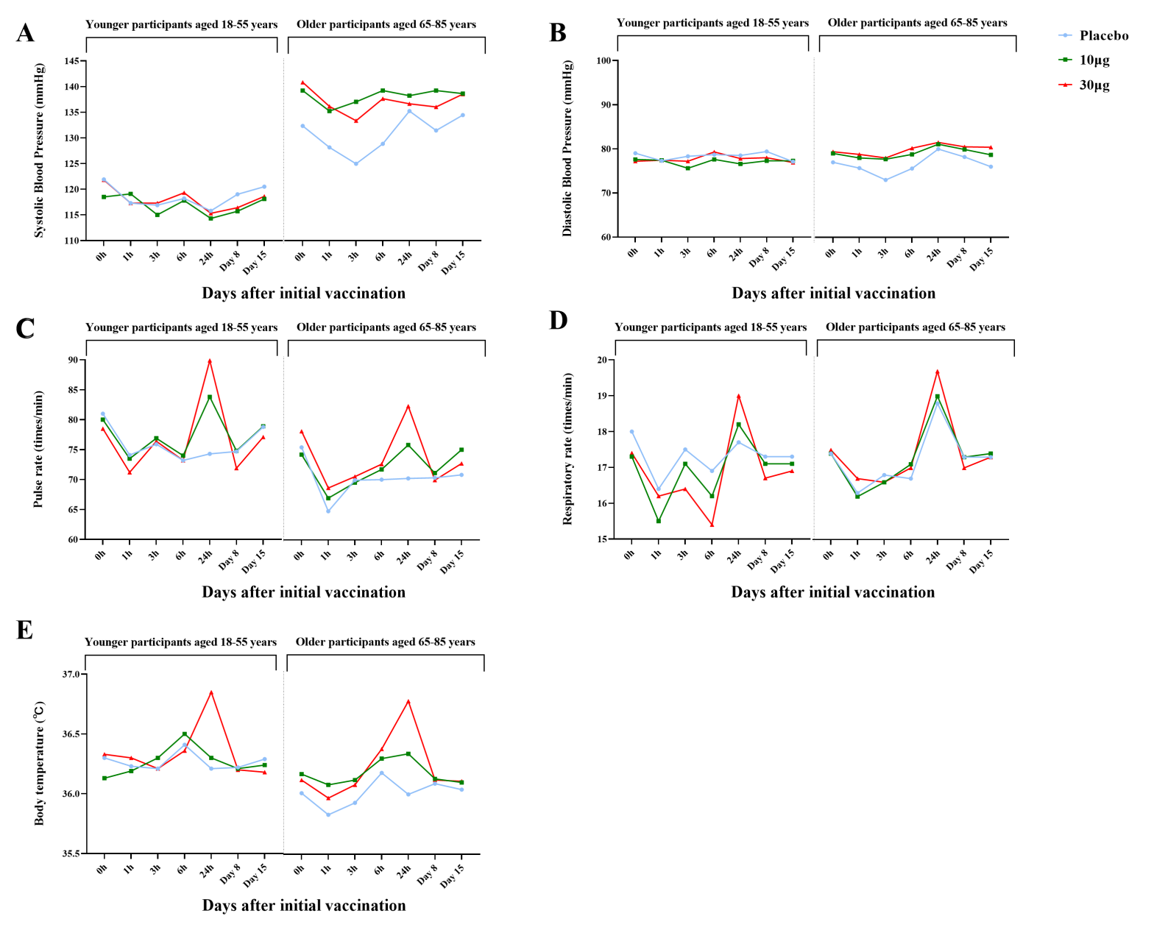
Vital signs including systolic blood pressure (A), diastolic blood pressure (B), pulse rate (C), respiratory rate (D), and body temperature (E) were tested before vaccination and at hours 1, 3, 6, 24, and days 7 and 14 after the prime dose of BNT162b1 at 10 µg or 30 µg, or placebo.

Extended Data Figure 4. Changes of laboratory values from baseline measured in younger and older participants before and after the prime vaccination.
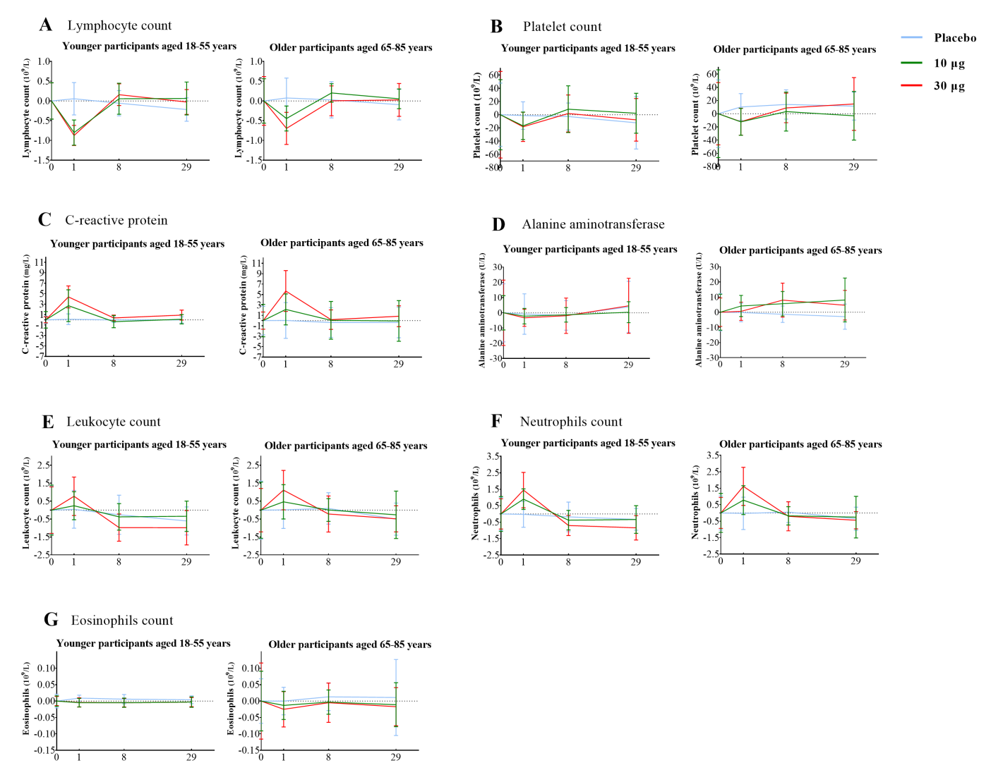

Extended Data Figure 5. Seroconversion and fold increases of the specific neutralizing antibodies and binding antibody responses to RBD and S1 in participants.
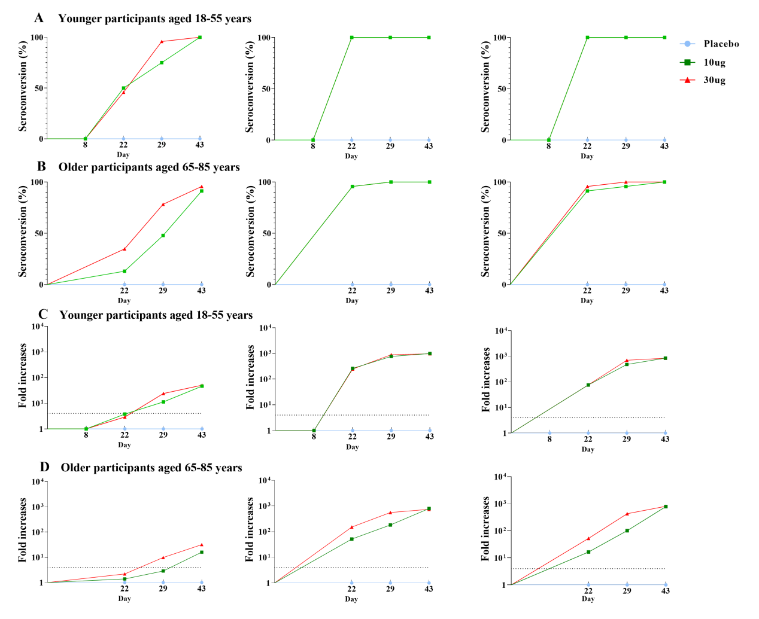
RBD= receptor binding domain. ELISA= enzyme-linked immunosorbent assay. Seroconversion was defined as at least a four-fold increase in post-vaccination titer from baseline or the lower limit of tests. A dashed line at the Y axis represents a four-fold increase in figures C and D.

Extended Data Figure 6. The association between neutralizing antibodies to live SARS-CoV-2 and ELISA antibodies to receptor binding domain, spike glycoprotein at day 43 post-vaccination.
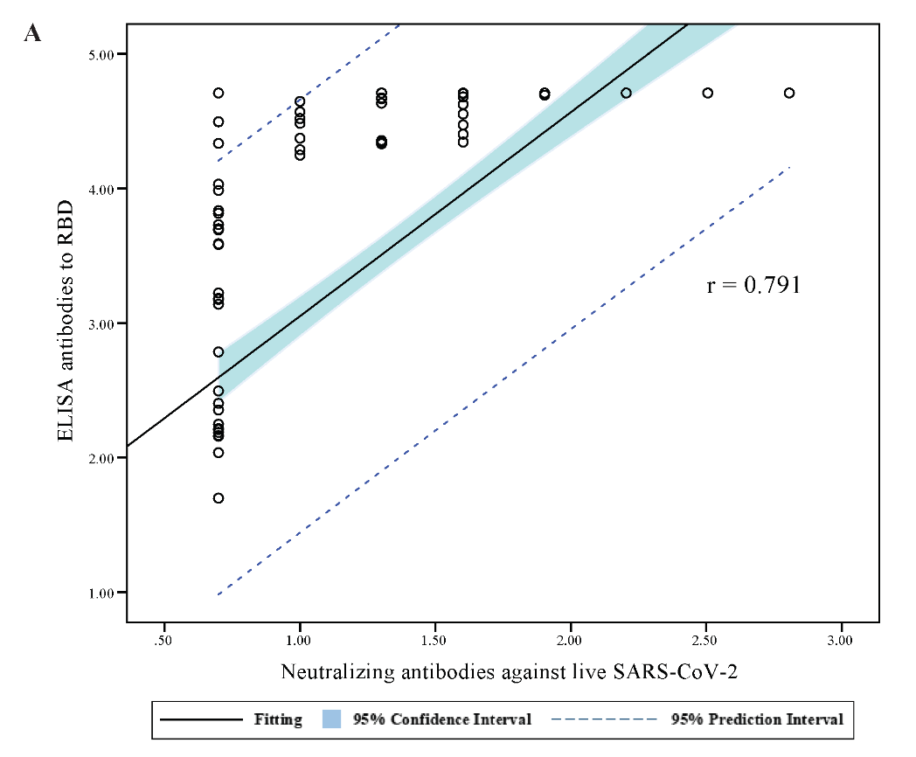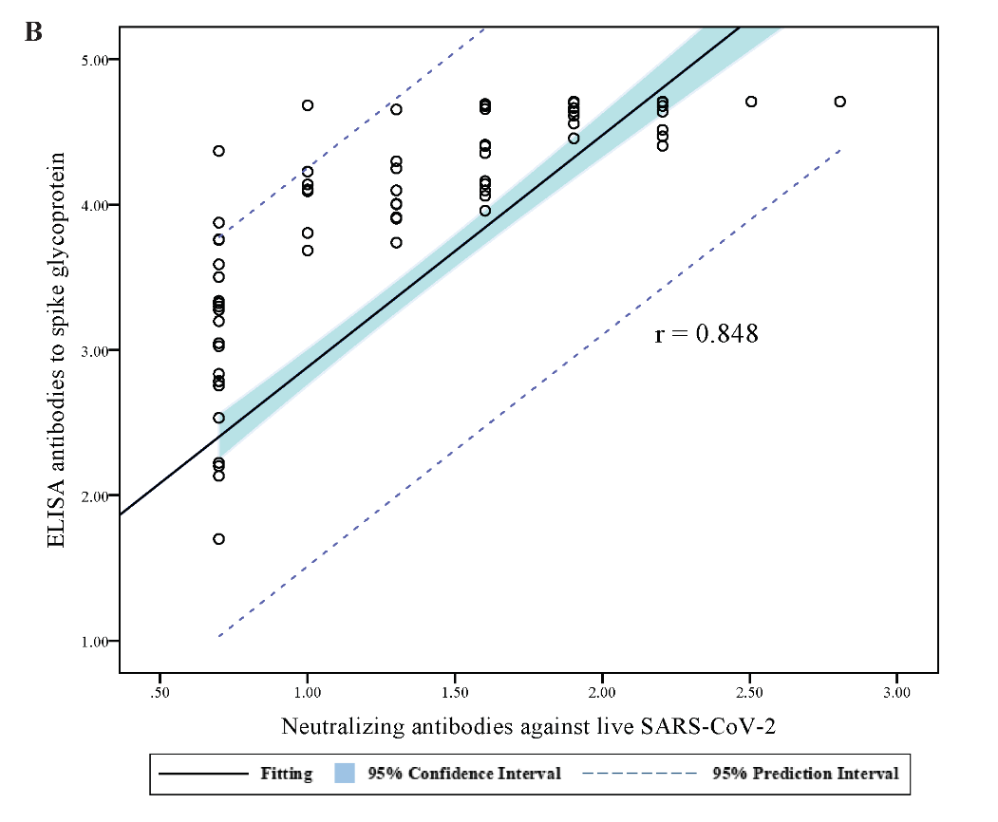
p<0.0001
p<0.0001
RBD= receptor binding domain. ELISA= enzyme-linked immunosorbent assay. Both age groups combined for this analysis, and each empty circle represented one participant in figures A and B. Panel A showed the association between ELISA antibodies to RBD and neutralizing antibodies to live SARS-CoV-2 at day 43 post-vaccination. Panel B showed the association between ELISA antibodies to spike glycoprotein and neutralizing antibodies to live SARS-CoV-2 at day 43 post-vaccination.

Extended Data Table 1. Participant disposition and analysis sets.
Cohort | BNT162b1 vaccinated |  |  | Antibody analysis |  |  |  |  |  | T-cell analysis
Cohort | Prime | Boost |  | Day 1 | Day 8 | Day 22 | Day 29 | Day 43 |  | Day 1 | Day 29 | Day 43
Younger participants aged 18-55 years
10 μg | 24 | 24 |  | 24 | 24 | 24 | 24 | 24 |  | 24 | 24 | 24
30 μg | 24 | 24 |  | 24 | 24 | 24 | 24 | 24 |  | 24 | 24 | 24
Placebo | 24 | 24 |  | 24 | 24 | 24 | 24 | 24 |  | 24 | 24 | 24
Older participants aged 65-85 years
10 μg | 24 | 23* |  | 24 | - | 23 | 23 | 24 |  | 24 | 23 | -
30 μg | 24 | 23* |  | 24 | - | 23 | 23 | 24 |  | 24 | 23 | -
Placebo | 24 | 24 |  | 24 | - | 24 | 24 | 24 |  | 24 | 24 | -
*The adverse events resulting in withdrawal were observed in 2 subjects. One subject in the 10 μg dose group was withdrawn due to unrelated SAE, humerus fracture by a car accident. Another subject in the 30µg elderly group was withdrawn from the study after dose 1 due to solicited grade 2 local AEs (flush, pain, and induration) and unsolicited AEs (grade 3 fever or cold intolerance with or without temperature record, erythema, and pruritus at vaccination site).

Extended Data Table 2. List of severe adverse events graded as grade 3 or greater reported till day 43 of the study period.
Age (years) | Dose group | Number of events (symptom) | Average start time  (min to max) | Average time to resolve  (min to max) | Treatment*
26 - 30 | 30 μg | 2 (fever) | 19h (13-24 h) | 17h (10-24h) | All received
31 - 35 | 10 μg | 1 (fever) | 24h | 48h | All received
31 - 35 | 30 μg | 2 (fever) | 17h (10-24h) | 60h (24-96h) | All received
36 - 40 | 10 μg | 1 (fever) | 14h | 19h | All received
36 - 40 | 30 μg | 4 (fever) | 21h (10-24h) | 35h (18-48h) | 3 of 4 received
41 - 45 | 30 μg | 1 (fever) | 11h | 48h | All received
46 - 50 | 10 μg | 1 (fever) | 12h | 20h | All received
46 - 50 | 30 μg | 1 (fever) | 24h | 48h | All received
51 - 55 | 30 μg | 1 (fever) | 8h | 48h | All received
61 - 65 | 30 μg | 1 (fever) | 16h | 24h | All received
66 - 70 | 30 μg | 2 (fever) | 180h (24h-14 day) | 96h (72-120h) | 1 of 2 received
*Treatment included drug or non-drug medication. Fever was graded according to the grading guidelines for adverse events in vaccine clinical trials, issued by National Medical Products Administration (NMPA), China, in which defined grade 3 fever as axillary temperature ≥38.5℃. If we re-graded the fever according to the guidelines of Food and Drug Administration (FDA), the United States, only seven participants experienced grade 3 fever (1 younger adult in the 10 μg group, 4 younger adults in the 30 μg group, and 2 older adults in the 30 μg group).

Extended Data Table 3. Geometric mean titer of the virus-neutralizing antibodies and specific binding antibody responses to RBD or S1 in participants.
 | Younger participants aged 18-55 years |  |  |  | Older participants aged 65-85 years
 | 10 µg (n=24) | 30 µg (n=24) | Placebo (n=24) |  | 10 µg (n=23) | 30 µg (n=23) | Placebo (n=24)
ELISA antibodies to S1 IgG
Day 8
GMT | 26548.9  (18381.5, 38345.1) | 41530.5  (33984.2, 50752.5) | 52.6  (47.4, 58.3) |  | 5271.6  (2484.6, 11184.6) | 23447.2  (15268.3, 36007.5) | 62.7  (47.6, 82.4)
Day 22
GMT | 46810.5  (41673.3, 52581.0) | 49773.4  (46947.1, 52769.8) | 50.0  (50.0, 50.0) |  | 40942.9  (33177.5, 50525.8) | 44159.6  (37139.3, 52506.9) | 61.0  (45.7, 81.4)
ELISA antibodies to RBD IgG
Day 8
GMT | 38314.6  (30173.5, 48652.1) | 47324.7  (43213.7, 51826.8) | 57.4  (49.0, 67.1) |  | 10748.6  (5512.3, 20958.7) | 38256.1  (30078.9, 48656.5) | 75.8  (56.0, 102.7)
Day 22
GMT | 49710.3  (46764.7, 52841.4) | 51200.0  (51200.0, 51200.0) | 60.6  (48.5, 75.8) |  | 46980.8  (42022.0, 52525.0) | 50977.2  (50528.9, 51429.4) | 65.8  (53.2, 81.2)
Neutralizing antibodies to SARS-CoV-2
Day 8
GMT | 56.6  (31.5, 101.6) | 119.9  (81.5, 176.2) | 5.0  (5.0, 5.0) |  | 14.4  (8.7, 23.7) | 49.4  (26.3, 92.6) | 5.0  (5.0, 5.0)
Day 22
GMT | 232.9  (151.3, 358.5) | 254.0  (184.6, 349.4) | 5.0  (5.0, 5.0) |  | 80.0  (49.2, 130.2) | 160.0  (96.7, 264.6) | 5.0  (5.0, 5.0)
Data are mean (95% CI) or n (%). GMT = geometric mean antibody titer. RBD = receptor binding domain. ELISA= enzyme-linked immunosorbent assay.

Extended Data Table 4. Characteristics of the convalescent patients, by severity of COVID-19.
Characteristic | Non-symptom | Mild | Moderate | Severe | Total
No. of patients | 3 | 8 | 10 | 3 | 24
Age, mean (SD), years | 50.0 (20.5) | 44.9 (18.1) | 41.3 (21.0) | 59.3 (15.9) | 45.8 (19.1)
Sex (female) | 2 (67%) | 6 (75%) | 5 (50%) | 0 | 13 (54%)
A median of days since diagnosis (range) | 21.0 (18.0, 26.0) | 18.5 (15.0, 29.0) | 21.0 (15.0, 40.0) | 30.0 (18.0, 40.0) | 20.5 (15.0, 43.0)
GMT of virus-neutralizing antibodies (95% CI) | 40.0 (2.0, 789.4) | 226.3 (74.1, 691.3) | 91.9 (38.6, 219.0) | 160.0* | 119.9 (70.4, 203.9)
Data are mean (SD) or n (%). GMT = geometric mean titer. * GMT of virus-neutralizing antibodies for 3 patients were all 160.0.

