Supplementary Material of
Chemical vapor deposition based superelastic and superhydrophoboic thermoplastic polymeric nanofibrous aerogels for water purification

Jianwei Lu^{1,2,3}*, Yangang Jiang¹, Ru Xiao², Karl I. Jacob³*, Lei Tao⁴, Songjun Li¹*, Li Guo¹*
1. Research School of Polymeric Materials, School of Materials Sciences & Engineering, Jiangsu University, Zhenjiang, 212013, China
2. State Key Laboratory for Modification of Chemical Fibers and Polymer Materials, College of Materials Science & Engineering, Donghua University, Shanghai 201620, China
3. School of Materials Science &Engineering, Georgia Institute of Technology, Atlanta, Georgia 30332, United States
4. Changzhou Vocational Institute of Textile and Garment, Changzhou, 213164, China

Correspondence to: Songjun Li (Email: Lsjchem@ujs.edu.cn)
Li Guo (Email: liguo@ujs.edu.cn)
Jianwei Lu (Email: jianwei@ujs.edu.cn)

Fig. S1 Contact angles of EVOH nanofiber membranes and water/t-BuOH mixtures with various t-BuOH contents

Fig. S2 The nanofibrous suspensions with various t-BuOH contents after 10 min.

Fig. S3 Photograph of the frozen nanofibrous suspensions prepared by dispersion medium with various t-BuOH contents.

Fig. S4 The photographs of EVOH NFAs (GA contents from left to right is 0, 0.25, 0.50, 0.75, 1.00, 1.25, 1.50 vol% relative to the dispersion system)

Fig. S5 (a) Proposed mechanism of crosslinking between EVOH nanofibers and glutaraldehyde,[1] (b) ATR-FTIR spectra of EVOH NFAs, un-cross-linked EVOH NFAs and GA.

Fig. S6 EVOH NFAs with various GA contents after releasing loading (200 g).

Fig. S7 Photograph of silane-coated EVOH NFA (left) and EVOH NFA (right).

Fig. S8 The proposed reactions between EVOH nanofibers and MTS.

Fig. S9 (a) C 1s, (b) O 1s and (c) Si 2p core level spectra of silane-coated EVOH NFAs.

Fig. S10 XPS survey scans of EVOH NFAs.

Fig. S11 FE-SEM images of the (a) surface and (b) interior of the silane-coated EVOH NFAs.

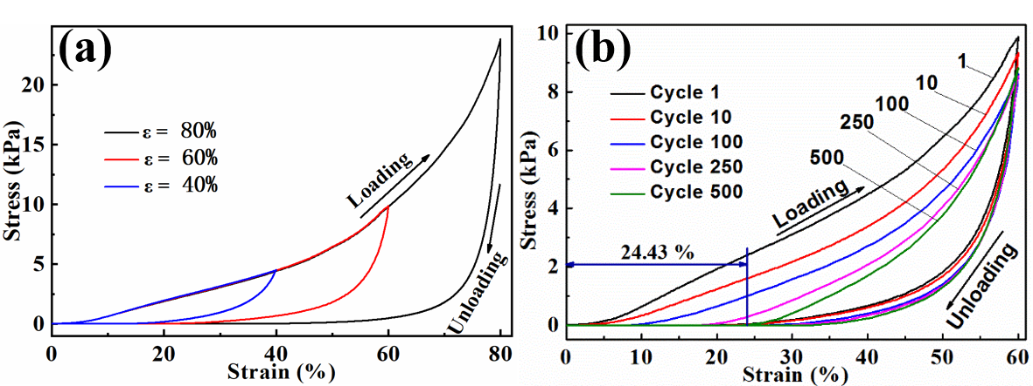
Fig. S12 (a) compressive σ-ε curves of EVOH NFAs at different strains (ε = 40, 60, 80%), (b) cyclic σ-ε curves of EVOH NFAs with ε of 60%.

Table S1 The volume, mass, density and porosity of EVOH NFAs.
Glutaraldehyde aqueous solution contents（vol%） | Volume  （cm³） | Mass  （mg） | Density  （mg/cm³） | Porosity  （%）
0 | 17.72-18.53 | 1.98×10² | 10.69-11.17 | 99.04-99.08
0.25 | 16.09-17.07 | 1.95×10² | 11.42-12.12 | 98.96-99.02
0.50 | 12.36-15.60 | 1.92×10² | 12.31-15.53 | 98.67-98.94
0.75 | - | 1.99×10² | - | -
1.00 | - | - | - | -
1.25 | - | - | - | -
1.50 | - | - | - | -

Table S2 Comparison of sorption capacities of various sorbents.
Sorbents | Min sorption capacity (g/g) | Max sorption capacity (g/g) | Density (mg/cm³) | Porosity (%) | Cost | Reference
PVA-co-PE NFA aerogels | 23 | 50 | 11.1 | 99 | Low | [2]
Carbon aerogels | 74.22 | 223.56 | 7.8 | - | Medium | [3]
Polydimethylsiloxane sponge | 4 | 11 | 180 ~ 750 | - | Medium | [4]
Cellulose nanofibril  aerogels | 139 | 256 | 1.7~8.1 | 99.5~99.9 | Low | [5]
Polymers | 60 | 23 | - | - | Low | [6]
PVA-CNF hybrid aerogels | 44.56 | 95.25 | 13 | 99.01 | Medium | [7]
Cellulose nanofibril  aerogels | 65 | 205 | 2.9 | 99.81 | Low | [8]
Microporous conjugated polymers | 6 | 23 | - | - | High | [6]
Carbon nanofiber aerogels | 51 | 139 | 10 | > 99 | Medium | [9]
Carbonaceous fiber aerogel | 22 | 87 | 36 | - | Medium | [10]
Cellulose nanocrystal aerogel | 34 | 99 | 22.4~23.3 | 96.3~97.2 | High | [11]
Carbon-based aerogels | 393 | 1002 | 0.7~10.2 | 99 | High | [12]
EVOH NFAs coated with Al₂O₃ | 30.57 | 73.03 | 17.78 | 98.35 | Medium | [13]
EVOH nanofibrous aerogels | 44.83 | 101.86 | 12.3 | 98.95 | Low | [14]
Silane-coated EVOH NFAs | 40.08 | 91.85 | 17.78 | 98.35 | Low | Present study

The work mentioned in this work is defined as the work doing for generating compression deformation per unit volume [15, 16], which was defined as
(1)
where is the work, and are the initial and final compression strain, respectively, and is the compression stress. The compression work and recovery work were calculated by the integration of the relevant stress-strain curves. The energy dissipation was the difference of the absolute value of compression work and recovery work.

Reference
1. A.W. Chan, R.A. Whitney, R.J. Neufeld, Kinetic controlled synthesis of pH-responsive network alginate. Biomacromolecules 9(9), 2536-2545 (2008)
[2] Q.Z. Liu, J.H. Chen, T. Mei, X.W. He, W.B. Zhong, K. Liu, W.W. Wang, Y.D. Wang, M.F. Li, D. Wang, A facile route to the production of polymeric nanofibrous aerogels for environmentally sustainable applications. J. Mater. Chem. A 6(8) 3692-3704 (2018)
[3] W.S. Chen, Q. Zhang, K. Uetani, Q. Li, P. Lu, J. Cao, Q.W. Wang, Y.X. Liu, J. Li, Z.C. Quan, Y.S. Zhang, S.F. Wang, Z.Y. Meng, H.P. Yu, Sustainable carbon aerogels derived from nanofibrillated cellulose as high-performance absorption materials, Adv. Mater. Interfaces, 3, 1600004 (2016)
[4] S.J. Choi, T.H. Kwon, H. Im, D.I. Moon, D.J. Baek, M.L. Seol, J.P. Duarte, Y.K. Choi, A Polydimethylsiloxane (PDMS) sponge for the selective absorption of oil from water. ACS Appl. Mater. Interfaces 3(12), 4552-4556 (2011)
[5] F. Jiang, Y.L. Hsieh, Amphiphilic superabsorbent cellulose nanofibril aerogels. J. Mater. Chem. A 2(18), 6337-6342 (2014)
[6] A. Li, H.X. Sun, D.Z. Tan, W.J. Fan, S.H. Wen, X.J. Qing, G.X. Li, S.Y. Li, W.Q. Deng, Superhydrophobic conjugated microporous polymers for separation and adsorption. Energ. Environ. Sci. 4, 2062-2065 (2011)
[7] Q.F. Zheng, Z.Y. Cai, S.Q. Gong, Green synthesis of polyvinyl alcohol (PVA)-cellulose nanofibril (CNF) hybrid aerogels and their use as superabsorbents. J. Mater. Chem. A 2(9), 3110-3118 (2014)
[8] O. Laitinen, T. Suopajarvi, M. Osterberg, H. Liimatainen, Hydrophobic, superabsorbing aerogels from choline chloride-based deep eutectic solvent pretreated and silylated cellulose nanofibrils for selective oil removal. ACS Appl. Mater. Interfaces 9(29), 25029-25037 (2017)
[9] Z.Y. Wu, C. Li, H.W. Liang, Y.N. Zhang, X. Wang, J.F. Chen, S.H. Yu, Carbon nanofiber aerogels for emergent cleanup of oil spillage and chemical leakage under harsh conditions. Sci. Rep. 4, 4-16 (2014)
[10] R.L. Liu, X.Q. Li, H.Q. Liu, Z.M. Luo, J. Ma, Z.Q. Zhang, Q. Fu, Eco-friendly fabrication of sponge-like magnetically carbonaceous fiber aerogel for high-efficiency oil-water separation. Rsc Adv. 6(36), 30301-30310 (2016)
[11] H.Q. Ma, S.J. Wang, F.B. Meng, X.Y. Xu, X.L. Huo, A hydrazone-carboxyl ligand-linked cellulose nanocrystal aerogel with high elasticity and fast oil/water separation. Cellulose, 24(2), 797-809 (2017)
[12] C. Li, Z.Y. Wu, H.W. Liang, J.F. Chen, S.H. Yu, Ultralight multifunctional carbon-based aerogels by combining graphene oxide and bacterial cellulose. Small 13, 1700453 (2017)
[13] J. Lu, Y. Li, W. Song, M.D. Losego, R. Monikandan, K.I. Jacob, R. Xiao, Atomic layer deposition onto thermoplastic polymeric nanofibrous aerogel templates for tailored surface properties. ACS Nano 14(7), 7999-8011. (2020)
[14] J.W. Lu, D.D. Xu, J.K. Wei, S. Yan, R. Xiao, Superoleophilic and flexible thermoplastic polymer nanofiber aerogels for removal of oils and organic solvents. ACS Appl. Mater. Interfaces 9(30), 25533-25541 (2017)
[15] T.A. Schaedler, A.J. Jacobsen, A. Torrents, A.E. Sorensen, J. Lian, J.R. Greer, L. Valdevit, W.B. Carter, Ultralight metallic microlattices. Science 334, 962-965 (2011)
[16] Y. Si, J.Y. Yu, X.M. Tang, J.L. Ge, B. Ding, Ultralight nanofibre-assembled cellular aerogels with superelasticity and multifunctionality. Nat. Commun. 5, 5802 (2014)

