Supplementary Data - MORTALITY RATE DUE TO PULMONEARY FIBROSIS ASSOCIATED WITH SARS-
COV-2 INFECTION: SCOPE OF BEST FIT REGRESSION
JAYDIP DATTA
__________________________________________________________________________________

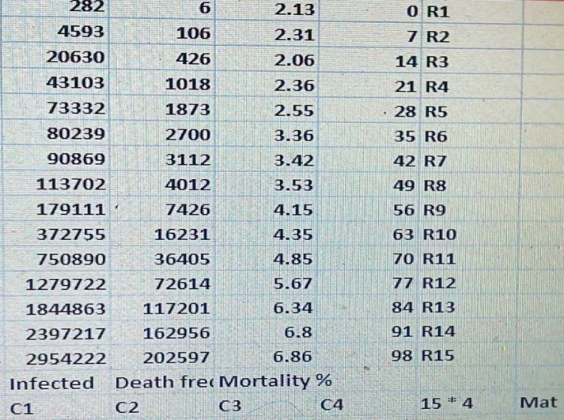
REF :COVID-19: The Potential Treatment of Pulmonary Fibrosis Associated with SARS-CoV-2 Infection - J Clin Med. 2020 Jun; 9(6 ) . doi: 10.3390/jcm9061917 , Table – 1 , P.2 , [Weekly WHO reports regarding an increase in the number of patients suffering from Corona virus Disease 2019 (COVID-19) ]-( Public availability of Data ) .
2.
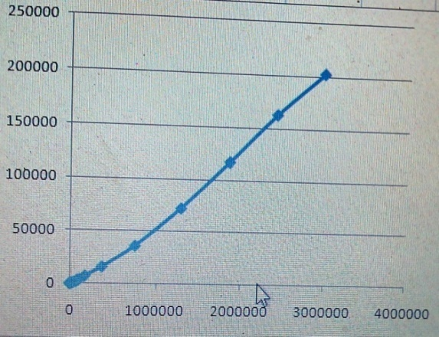
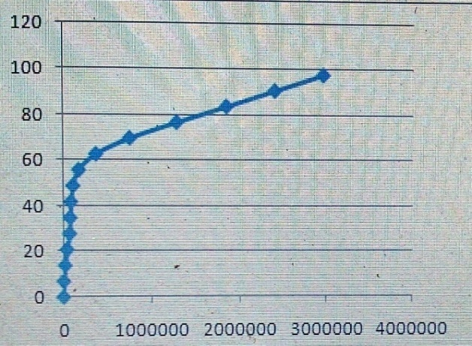
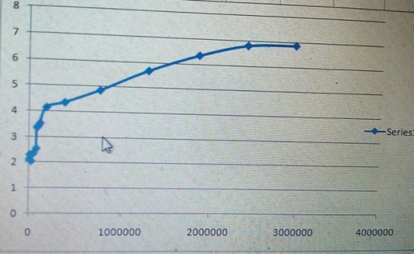
3.
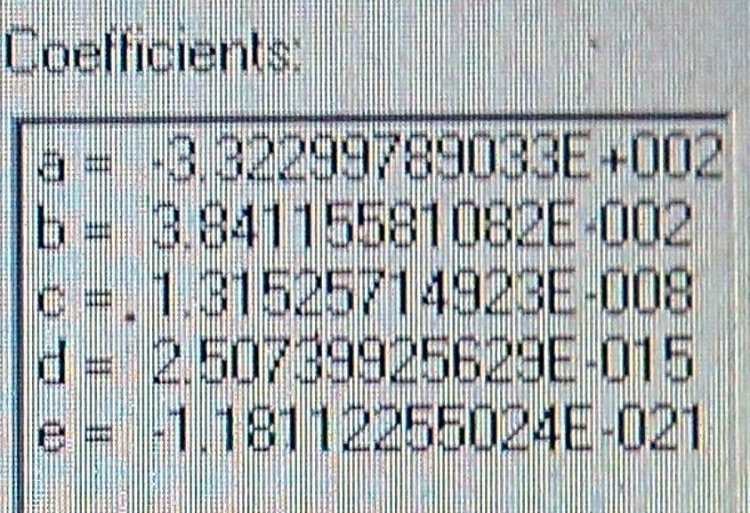
4.
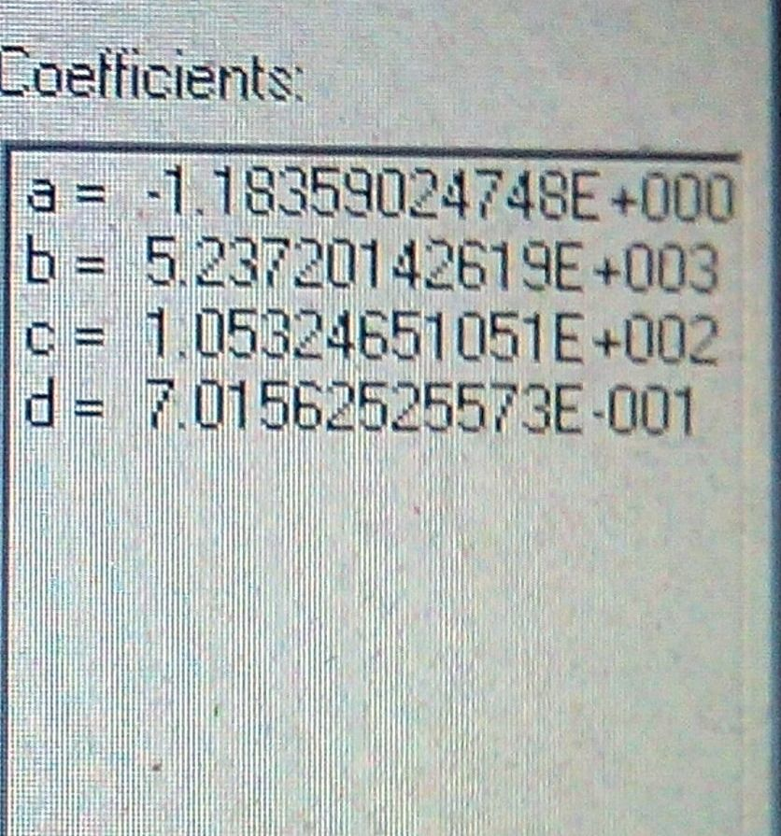
5.
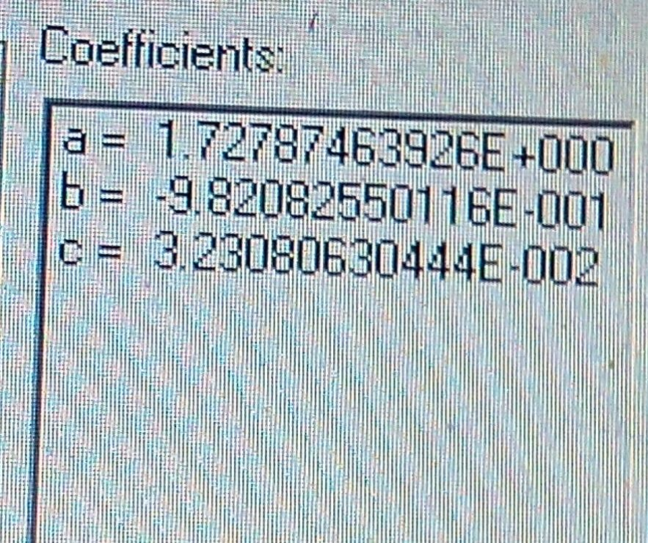
6.

7.

8. Code – JSON Export
{
"files": [
{
"links": {
"self": "https://zenodo.org/api/files/0b329600-cbd6-4d39-b201-dae1e0267760/Supplementary%20Data%20-SARS-COV-2%20lung%20fibrosis.docx"
},
"checksum": "md5:3b2e602b205518929c28fdfe90ceb31c",
"bucket": "0b329600-cbd6-4d39-b201-dae1e0267760",
"key": "Supplementary Data -SARS-COV-2 lung fibrosis.docx",
"type": "docx",
"size": 749031
}
],
"owners": [
99235
],
"doi": "10.5281/zenodo.4393577",
"stats": {
"version_unique_downloads": 0.0,
"unique_views": 0.0,
"views": 0.0,
"version_views": 0.0,
"unique_downloads": 0.0,
"version_unique_views": 0.0,
"volume": 0.0,
"version_downloads": 0.0,
"downloads": 0.0,
"version_volume": 0.0
},
"links": {
"doi": "https://doi.org/10.5281/zenodo.4393577",
"conceptdoi": "https://doi.org/10.5281/zenodo.4393575",
"bucket": "https://zenodo.org/api/files/0b329600-cbd6-4d39-b201-dae1e0267760",
"conceptbadge": "https://zenodo.org/badge/doi/10.5281/zenodo.4393575.svg",
"html": "https://zenodo.org/record/4393577",
"latest_html": "https://zenodo.org/record/4393577",
"badge": "https://zenodo.org/badge/doi/10.5281/zenodo.4393577.svg",
"latest": "https://zenodo.org/api/records/4393577"
},
"conceptdoi": "10.5281/zenodo.4393575",
"created": "2020-12-25T17:13:38.640119+00:00",
"updated": "2020-12-25T17:13:40.111995+00:00",
"conceptrecid": "4393575",
"revision": 1,
"id": 4393577,
"metadata": {
"access_right_category": "success",
"doi": "10.5281/zenodo.4393577",
"description": "<p>The dataset contains number of infected pateints - Death Frquencies - Mortality rate globally due to pulmonary fibrosis associated with&nbsp;SARS-COV-2 infection with effect from 21st Jan to 28 th April ,2020 . Data analysis report by best fit regression software Curve Expert V.1.4 supported with Spreadsheet ( Excel , Office 2007 ) are included for computation of statistical significance .</p>",
"language": "eng",
"title": "Supplementary Data - MORTALITY RATE DUE TO PULMONERY FIBROSIS ASSOCIATED WITH SARS- COV-2 INFECTION: SCOPE OF BEST FIT REGRESSION",
"license": {
"id": "CC-BY-4.0"
},
"notes": "JAYDIP DATTA . Growth of D614G Virus : Morgan \u2013 Morgan \u2013 Finney\u00a0( MMF ) Regression\u00a0, 15 October 2020, PREPRINT (Version 1) available at Research Square [+https://doi.org/10.21203/rs.3.rs-92776/v1+]",
"relations": {
"version": [
{
"count": 1,
"index": 0,
"parent": {
"pid_type": "recid",
"pid_value": "4393575"
},
"is_last": true,
"last_child": {
"pid_type": "recid",
"pid_value": "4393577"
}
}
]
},
"version": "Version 1.0",
"references": [
"10.3390/jcm9061917"
],
"keywords": [
"SARS-COV-2 , Lung fibrosis , Mortality stats , Best fit regression , Pearson coefficiant"
],
"publication_date": "2020-12-25",
"creators": [
{
"name": "JAYDIP DATTA"
}
],
"access_right": "open",
"resource_type": {
"type": "dataset",
"title": "Dataset"
},
"related_identifiers": [
{
"scheme": "doi",
"identifier": "10.5281/zenodo.4393575",
"relation": "isVersionOf"
}
]
}
}

REF : https://zenodo.org/record/4393577

