Supplementary materials
Table S1. Smartphone Addiction Scale for College Students (SAS-C)
Item number | Item content
SASC01 | Classmates and friends often say that I spend too much time on my smartphone.
SASC02 | I feel I need to spend more time on my smartphone to be satisfied.
SASC03 | Using my smartphone decreases my learning efficiency.
SASC04 | Friends and family complain that I use my smartphone too much.
SASC05 | I prefer to chat on the mobile phone rather than have face-to-face communication.
SASC06 | The first thing I think of is using on my smartphone when I am sad.
SASC07 | If my smartphone is not available for a while I worry about losing it.
SASC08 | I have to open the same mobile app more than three times in the same day.
SASC09 | Using on my smartphone has affected my academic performance.
SASC10 | The delay caused by using on my smartphone has brought me many troubles.
SASC11 | I feel anxious when I cannot use my smartphone for a period of time.
SASC12 | I care about the latest apps and download them to my phone.
SASC13 | My mobile phone is an important part of my life.
SASC14 | If the phone doesn't ring for a period of time, I feel uncomfortable and subconsciously check whether I have missed calls or messages.
SASC15 | I am anxious and become grumpy if my mobile phone cannot be connected online or cannot receive a signal.
SASC16 | I monitor the online situation of my friends on my smartphone to the extent of insomnia.
SASC17 | My academic performance has decreased due to using my smartphone.
SASC18 | I open some mobile applications without thinking.
SASC19 | I often have the illusion that my smartphone is ringing or shakes.
SASC20 | I always keep the apps in my smartphone up to date.
SASC21 | I'm fidget when without a cell phone.
SASC22 | I open the apps on my smartphone when I have nothing to say to my friends.

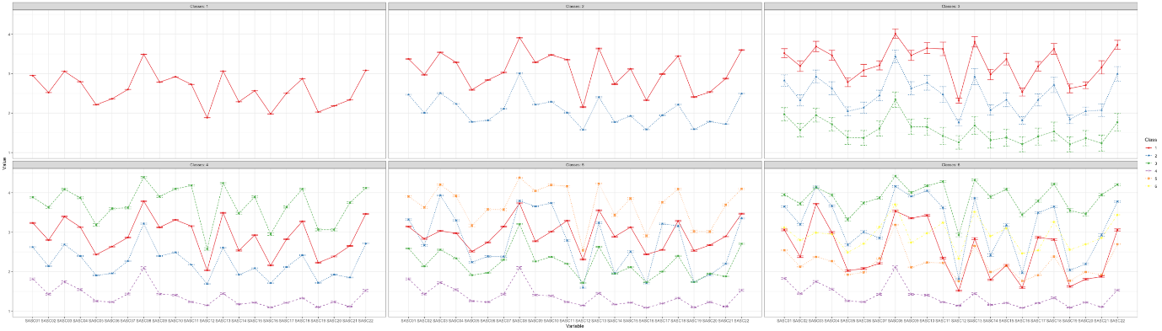
Fig. S1. The 1 to 6 latent profiles using the PSU item scores

