Supplementary Materials for

Trophoblast replacement enables rhesus monkey cloning by somatic cell nuclear transfer
Zhaodi Liao et al.
Correspondence to: Qiang Sun, qsun@ion.ac.cn; Zhen Liu, zliu2010@ion.ac.cn.

This PDF file includes:

Supplementary Fig. 1 to 3
Supplementary Tables 1 to 4
Captions for Supplementary Movie 1

Other Supplementary Materials for this manuscript include the following:

Supplementary Movie 1

Supplementary Figures

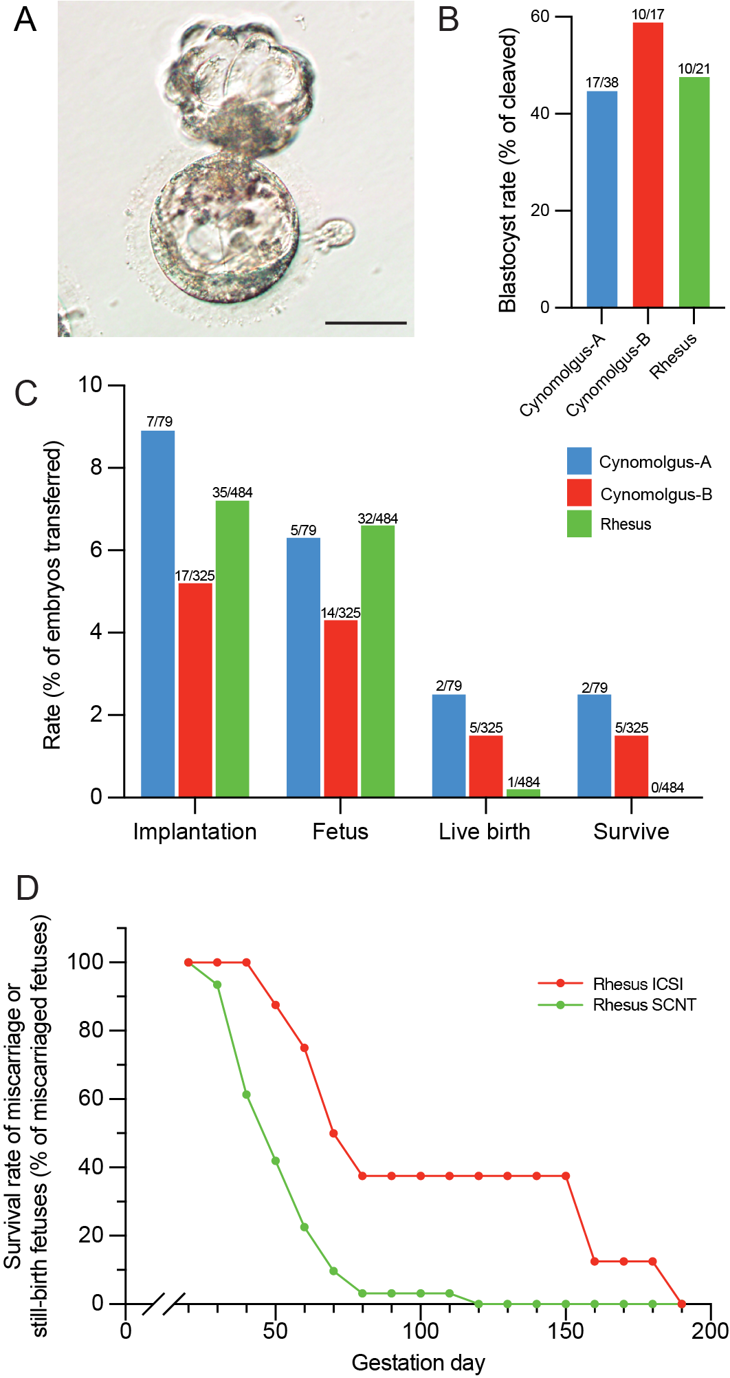

Supplementary Fig. 1⎥ Deficient development of rhesus SCNT embryos after implantation. (a) Representative image showing the rhesus monkey SCNT blastocyst. Scale bar, 100 μm. (b) Rhesus monkey SCNT embryos develop into blastocyst stage with an efficiency comparable to that of cynomolgus monkey. Kdm4d and trichostatin A were used for rhesus monkey cloning as well as for cynomolgus monkey cloning. Data of cynomolgus-A and B were adopted from Liu et al., 2018 and Liu et al., 2019. (c) Comparing the rate of implantation, fetus, live birth and fetus survive after birth between cynomolgus monkey and rhesus monkey. (d) Comparing the post-implanted fetus survive rate of the aborted rhesus monkey derived by ICSI and SCNT. The rate was calculated by a period of 10-day during the gestation. Data were shown in Table S1.

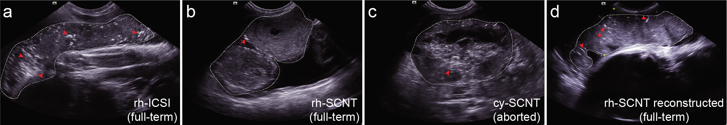

Supplementary Fig. 2⎥ The abnormal development of monkey SCNT placentas. (a-d) Ultrasound of representative placentas of full-term ICSI and SCNT, late-stage- aborted SCNT and the full-term reconstructed SCNT. The placentas were outlined by white dotted lines and the calcification area or dots were indicated with red arrowheads.

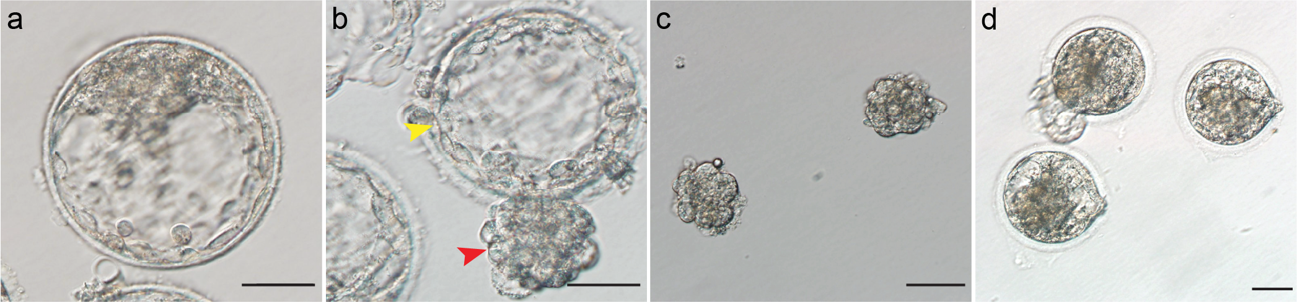

Supplementary Fig. 3⎥ The procedure of monkey SCNT blastocyst reconstruction. (a) An ICSI blastocyst right before laser irradiation. Scale bar, 100 μm. (b) An ICSI blastocyst with ICMs hatched out of the zona pellucida about 6 h after the laser irradiation. Scale bar, 100 μm. (c) The SCNT-ICMs that were obtained by immunosurgery. Scale bar, 50 μm. (d) The reconstructed SCNT embryos by injecting the SCNT-ICMs into ICM- removed ICSI blastocysts. Scale bar, 50 μm.
Supplementary Tables

Supplementary Table 1. Abortion and/or still-birth rate of post-implanted rhesus embryos derived by ICSI and SCNT

Supplementary Table 2. Statistic of the thickness and calcification levels in ICSI and SCNT derived monkey placentas.

Supplementary Table 3. Trials of the reconstruction of rhesus SCNT embryos.

Supplementary Table 4. Short-tandem analysis of the cloned rhesus monkey generated by trophoblast replacement.

Supplementary Movie 1.
Illustration of the trophoblast replacement procedure.

