SUPLEMENTARY MATERIALS
Challenge of 2D representation of 3D objects in architectural and heritage studies. In search of gaze patterns similarities.

Marta Rusnak*
Corresponding author, Wrocław University of Science and Technology, Bolesława Prusa 53/55, 53-317 Wrocław, marta.rusnak@pwr.edu.pl, https://orcid.org/0000-0002-5639-5326

Acknowledgments

Author contributions
Not applicable

Competing interests:
The author declares no competing interests.

Data availability statement:
The of datasets generated from 68 participants and analyzed during the current study are available in the RepOD repository. A lack of consent from all participants means other eye-tracking data are not publicly available. In line with the applicable legal and ethical principles, such a right belonged to volunteers. All graphic materials are included in the supplement. Study consent forms are preserved in the WUST archives.
Marta Rusnak, Problem of 2D representation of 3D objects in architectural and heritage studies. Re-analysis of phenomenon of longitudinal church, doi:10.18150/GMKZHI, RepOd V1; https://repod.icm.edu.pl/dataset.xhtml?persistentId=doi:10.18150/GMKZHI

Participants declarations and ethical approval:
The research was in accordance with the procedure, reported to the Dean, and authorities of the Faculty of Architecture, Wrocław University of Science and Technology. All methods were performed in accordance with the ethical guidelines and regulations of the Declaration of Helsinki. The following threats or inconveniences were reported to the Ethics Committee: temporary load on the head and neck (maximum 15 minutes), pressure on the nose, pressure on the ears, inconvenience while putting on the goggles, the possibility of fear, claustrophobia, dizziness. The participants while using VR were sitting there had no chance of falling. Informed consent was obtained from all participants. In the approved information form participants were informed of the possibility of withdrawing from the study at any time without giving reasons for their withdrawal. The participants of the study were over 18 years of age and were rewarded with a gift voucher. In line with these declarations, it was found that the research did not violate the applicable ethical regulations.

Funding:

This work was supported by the National Science Center, Poland (NCN) under Miniatura Grant [2021/05/X/ST8/00595].

Cooperation:
Hardware consultation: Ewa Ramus (Neuro Device, Warszawa, Poland), graphic cooperation: Wojciech Fikus (Wroclaw University of Science and Technology, Poland), data collecting: Mateusz Rabiega (Wroclaw University of Science and Technology, Poland), Magdalena Nawrocka (Wroclaw University of Science and Technology, Poland), Małgorzata Cieślik (independent, Wrocław, Poland), Daria Kruczek (independent, London, UK)

The author would like to thank Ewa Ramus, Neuro Device and the technology company Tobii for the opportunity to develop an initial prototype of VR eye-tracking implementation. It is worth mentioning the support of Andrzej Żak.
PART 1/3: Supplementary NOTES
Supplementary: Personalization of settings and making the participants familiar with a new situation
One significant difference in relation to the original research was the fact that the device itself is placed on the head of a participant and that such a person is in turn allowed to move not only their eyes but also their neck or torso. A lot of time was spent on disinfecting the goggles, making sure the device is worn properly and taking care of the cables linking the goggles with a computer so that they obstructed the participants’ head movements as little as possible. (Some participants, especially petite women, found the device slightly uncomfortable due to its weight.) An auxiliary spherical image, unrelated to the topic of research, was used to adjust the spacing of the eye tracker lenses as well as to demonstrate the capabilities of the headset. This presentation was also intended to lessen the potential stress or awkwardness that might stem from being put in an unfamiliar situation; it also gave the researchers a chance to make sure the participants see everything clearly and feel comfortable. When both the participants and the researchers agreed that everything had been appropriately configured, the former were asked not to make any alterations or adjustments to either the headset or the chair once the experiment commenced. After this process was finished, one researcher observed the behavior of the participant and another researcher supervised the process of calibration and displaying of the presentation including the stimuli. Notes were made, both during and after the experiment, on the participants’ reactions or encountered difficulties.

Supplementary Note 2. Reasons for resignation from the experiment and ways of verifying the manner of collecting data and the quality of registrations
Verification of data was carried out on the same day that the tests were conducted, right after the participants left. It was important as it made it possible to make adjustments to the number of people exposed to the different stimuli so that when the research is concluded, each stimuli would have been seen by a similarly sized group of people.
A few participants failed to comply with the rules of the experiment, which is why a small part of the collected data had to be considered scientifically unreliable and therefore unusable in the analysis. The reason for such exclusion was mostly undesired changes in the position of some elements of the VR set. Due to the applied methodology, it was impossible to interrupt the process of displaying the stimuli, re-calibrate the device or move the chair back to its initial position, and restart the registration. The process was meant to be a continuous, one-off event. One person resigned from participation complaining about the brightness of the display. Unfortunately, the methodology, which insisted on identical settings for all participants, made it impossible to adjust this aspect of the presentation.
A few other registrations could not be conducted due to technical reasons – for instance, the rims of glasses worn by a participant proved too large to fit beneath the VR goggles or a person was so small that they did not feel comfortable enough with the headset on. Despite several attempts at calibrating the device, three participants claimed that the image they see is blurred and therefore they could not take part in the test. One person resigned in the course of the experiment, because the display of the stimuli made them feel dizzy. Two registrations had to be excluded since the computer crashed and the software stopped working during the experiment. Two people were wearing glasses with optical filters which prevented the tracking of their eye movements. One participant abandoned the experiment in its course because of feeling too much strain in their neck muscles.
Another reason for reducing the number of participants was an insufficient number of registered fixations accompanied by a significant lack of continuity in their visual path. For example, one recording registered only four fixations and the registered time of looking at the image amounted to less than half a second. The reason for such a situation could be either the build of the participant’s eyes (dropping eyelids or long lashes) or a layer of optical filter on their glasses. An analytically problematic aspect of the research was that the software lacked a feature reporting the calibration results for individual participants or allowing the researchers to monitor the behavior of the participants’ eyes. It is possible that the people whose registrations were excluded had closed their eyes or that the registration was disturbed by some individual physical feature that in case of a stationary eye tracker would have been noticed at the calibration stage. That is why a threshold had to be established above which the registration would be considered as containing sufficient amount of data. It was decided that registrations consisting of less than four seconds of registered visual activity would be excluded from the analysis.
Supplementary Note 3. Comparison of eye trackers in the context of their usability
Both kinds of tests discussed in this paper have their advantages and disadvantages. In 2016 it was not yet possible to conduct such eye-tracking research in a VR environment. Nowadays one of the biggest pros of a stationary eye tracker is its moderate cost. Eye-tracking research done on spherical images and the processing of the collected data requires considerable computing power, not to mention the cost of the devices and the applied software. Moreover, in contrast to a VR test, a test involving a stationary eye tracker can be conducted by a single researcher. Another advantage of such research is the ease with which one can prepare the flat stimuli – it is possible to simply use photos, visualizations, photo montages. Various software and features used for editing flat images are easily accessible and lots of people possess the know-how necessary to use them effectively. The advantages and disadvantages of VR set have been discussed by Meissner, Pfeiffer, Pfeiffer and Oppewal.
Both tests were carried out in a lab of similar size because the participants were sitting during the experiment. Were they to move, while using VR technology, the room would have to be much bigger and devoid of any architectural obstacles in order to ensure the volunteers’ safety. Perhaps, due to high risk of accidents during registration, it would also prove necessary to buy out a civil liability insurance for the researchers, which would additionally increase the costs.
A huge advantage of the new research was the fact that VR technology itself attracted more attention and people seemed more willing to participate in an experiment involving such devices. However, the author fears that this beneficial effect of an exciting technological novelty will soon diminish and stop attracting people. It should be emphasized again that the aforementioned psychological and physical inconveniences could lead to registration deviations. This was the reason why such a large percentage of the collected data was excluded
It is beyond doubt that a serious disadvantage of the research involving a stationary eye tracker was that the analyzed cognitive situation had to be simplified. The fact that the participant was not allowed to move could also have resulted in some sort of psychological strain whose effect on human perception it is difficult to estimate. The care for the participants’ comfort required the test to be relatively short. More time-consuming tests would therefore make it essential to provide a chin rest for the volunteers. Quite a few participants of the VR research complained about the discomfort, usually connected with the weight of the headset. One can see, therefore, that both technologies are somewhat lacking in this respect.
Research done in the VR environment eliminates numerous doubts relating to the cropping of the presented image, but it does not mean that the preparation of spherical stimuli has no disadvantages. As it was mentioned before, the participant was unable to see their feet, which results in a feeling of unreality whose impact on the results is unfathomable. Actually, all kinds of research in VR environment face the problem of the impact of the level of immersion and realism on the test results.
Another inconvenience of the tests is the amount of time they consume. This refers for example to the preparation for each individual experiment: the goggles need to be disinfected, put on, adjusted, the nose cover pads have to be replaced, the cables need to be connected and arranged so that they do not add to the discomfort. The need to touch someone’s head or ask them to tie their hair, remove a band or hair pins requires the researchers to be tactful since the entire situation may be awkward for both parties. The fact that once the goggles are put on, the participant does not see the researchers makes it even worse. Due to the headset’s weight, people of smaller build may complain about pressure on their head and neck. Moreover, tests involving a stationary eye tracker may seem less extraordinary and therefore prove less stressful.

PART 2/3: Supplementary tables
3D - new research | Name of  3D stimulus | Entire spherical image | Old Research AOI – the part of the image visible in the previous study | 2D (Rusnak, 2018) | Name of  2D stimulus | Entire image
3D - new research | Short cathedral AS | 23.3 fix | 70.1% = 16.3 fix | 2D (Rusnak, 2018) | Cathedral A | 29.2 fix
3D - new research | Medium-length cathedral BS | 23.6 fix | 72.0% = 16.9 fix | 2D (Rusnak, 2018) | Cathedral B | 29.2 fix
3D - new research | Long cathedral CS | 23.7 fix | 75.9% = 17.9 fix | 2D (Rusnak, 2018) | Cathedral C | 24.9 fix
Table S1. Average number of fixations for the new spherical images and the visualizations used in the previous study.

Stimuli type | OLD VAULTS CATHEDRAL WITH A…
Stimuli type | SHORT NAVE |  | MEDIUM-LENGTH NAVE |  | LONG NAVE
2D stimuli | A | 0.72s (9%) | B | 1.20s (15%) | C | 1.44s (18.2%)
3D stimuli | AS | 0.76s (9.5%) | BS | 1.16s (14.5%) | CS | 1.52s (19.0%)
Table S2. Comparison of the dwell time value in relation to research conducted on the basis of 2D and 3D stimulus.

CHARACTERISTICS SUPPORTING THE HYPOTHESIS ABOUT THE EXISTENCE OF A LONGITUDINAL CHURCH EFFECT | CHARACTERISTICS OPPOSING THE HYPOTHESIS ABOUT THE EXISTENCE OF A LONGITUDINAL CHURCH EFFECT OR NOT PROVIDING A DEFINITE RESULT
ANALYSIS RELATED TO VISUAL ACTIVITY IN THE OLD RESEARCH AOI
Number of fixations within the Old Research AOI
Total visit duration outside the Old Research AOI
Number of participants looking to the side
Number of participants looking to the back
Number of participants looking up
Number of participants looking down at the floor
ANALYSIS RELATED TO THE VISUAL ACTIVITY IN THE PRESBYTERY AOI
Number of visitors in the AOI | Dwell time / Total visit duration
Average fixation duration | Revisits
 | Time to first fixation
ANALYSIS RELATED TO THE VISUAL ACTIVITY IN THE VAULTS AOI
Number of visitors in the AOI
Average fixation duration
Time to first fixation
Table S3. Summary of the analyses

PART 3/3: Supplementary figures

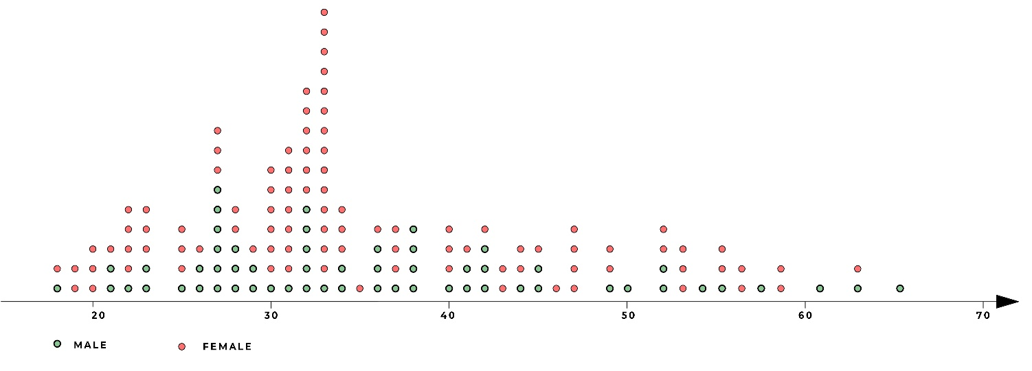
Figure S1. Age and sex distribution.

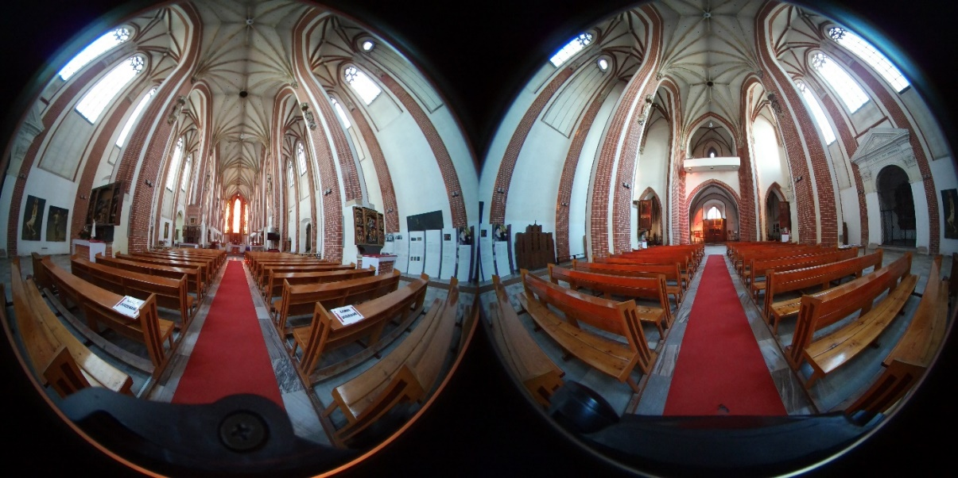
Figure S2. Church 1- Spherical photo. Church of the Virgin Mary on Piasek Island in Wrocław.

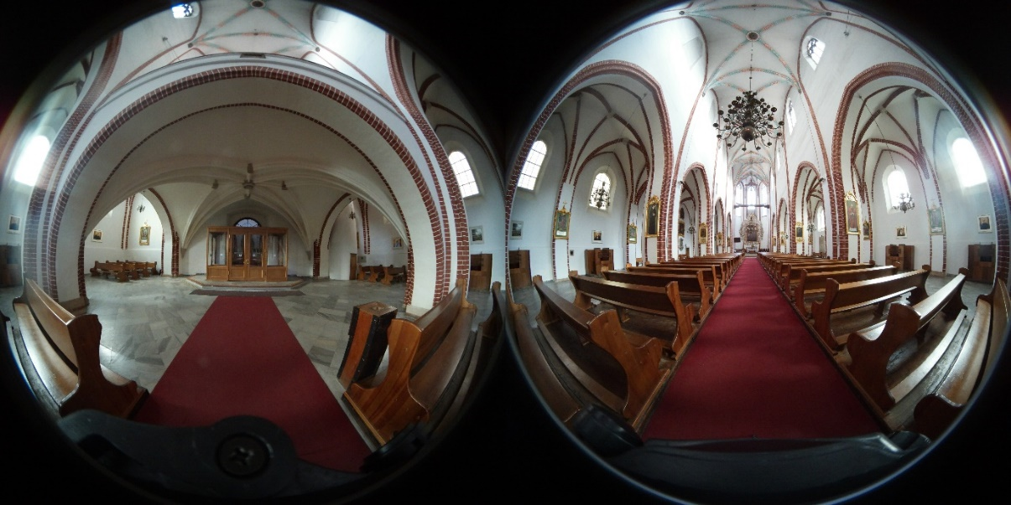
Figure S3. Church 2- Spherical photo. Church of Corpus Christi in Wrocław.

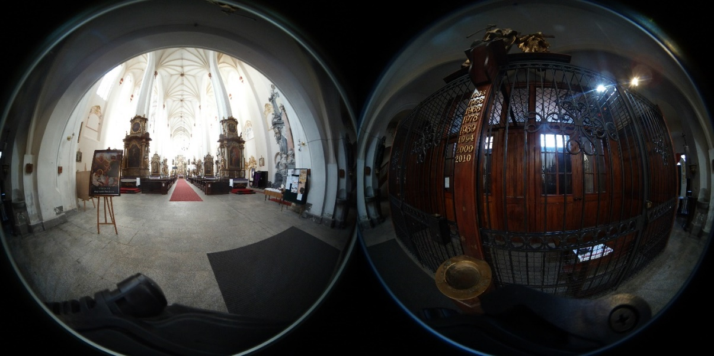
Figure S4. Church 3- Spherical photo. Church of St. Dorothy in Wrocław.

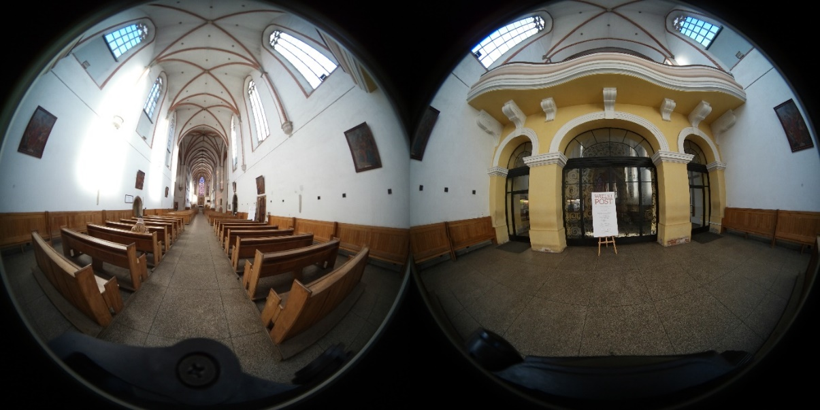
Figure S5. Church 4- Spherical photo. Dominican Church in Wrocław.

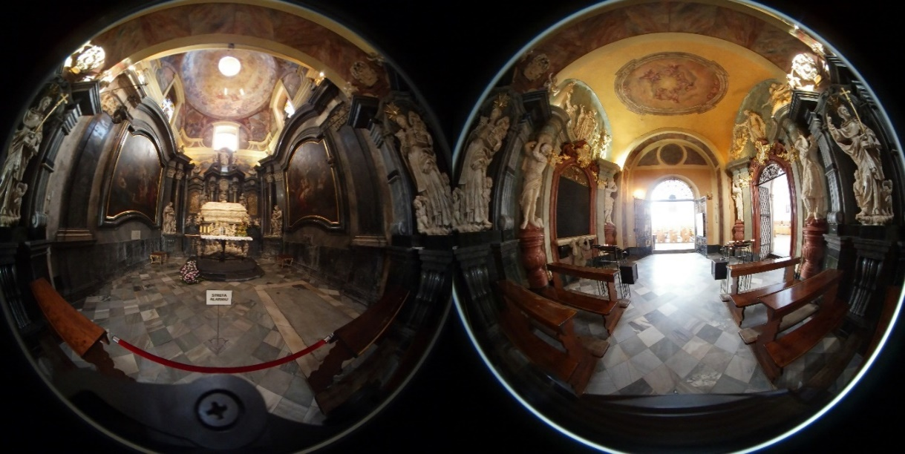
Figure S6. Church 5 -Czesław's Chapel in the Dominican Church in Wrocław.

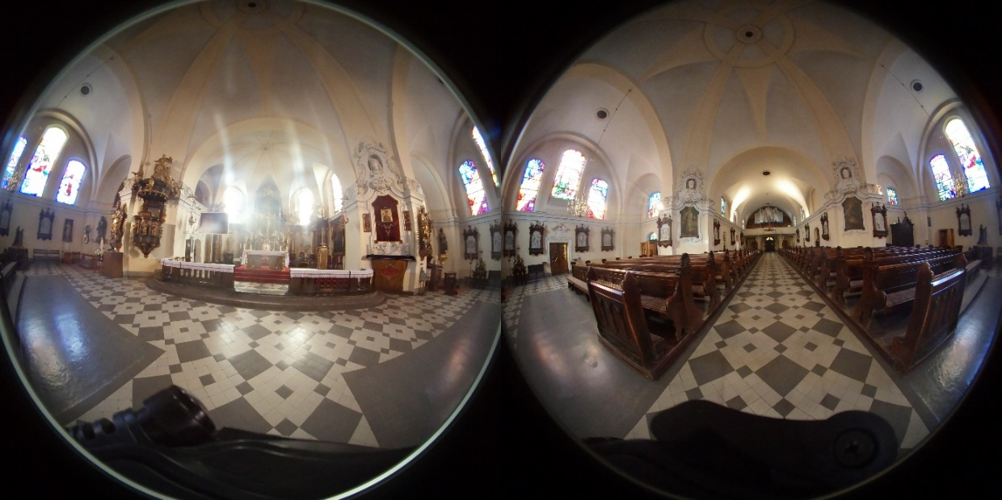
Figure S7. Church 6- Church of St. Maurice in Wrocław.

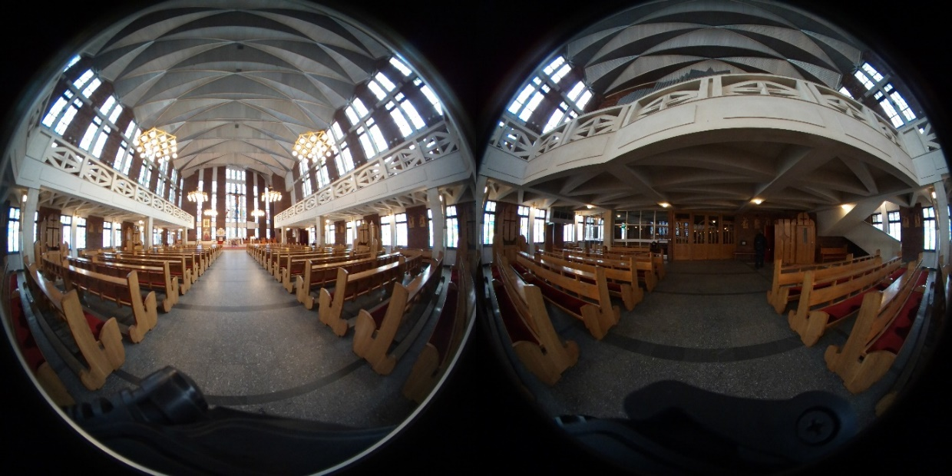
Figure S8. Church 7- Church of St. Ignatius of Loyola in Wrocław.

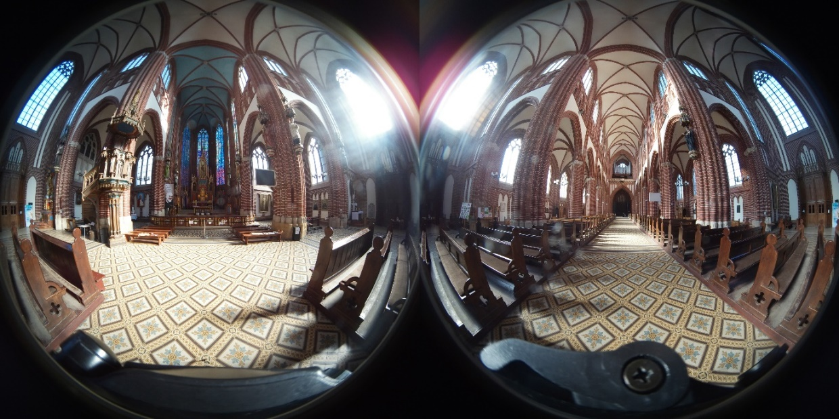
Figure S9. Church 8- Spherical photo. Church of St. Michael the Archangel in Wrocław

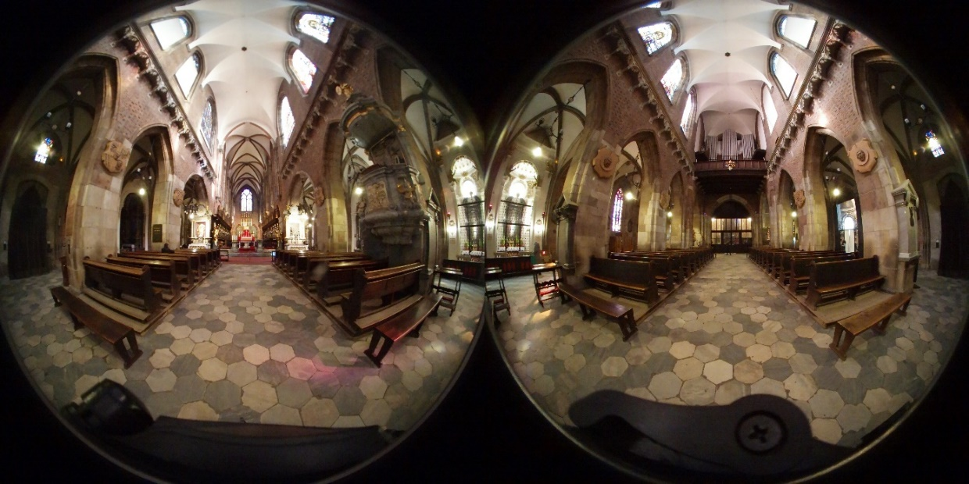
Figure S10. Church 9- Cathedral in Wrocław.

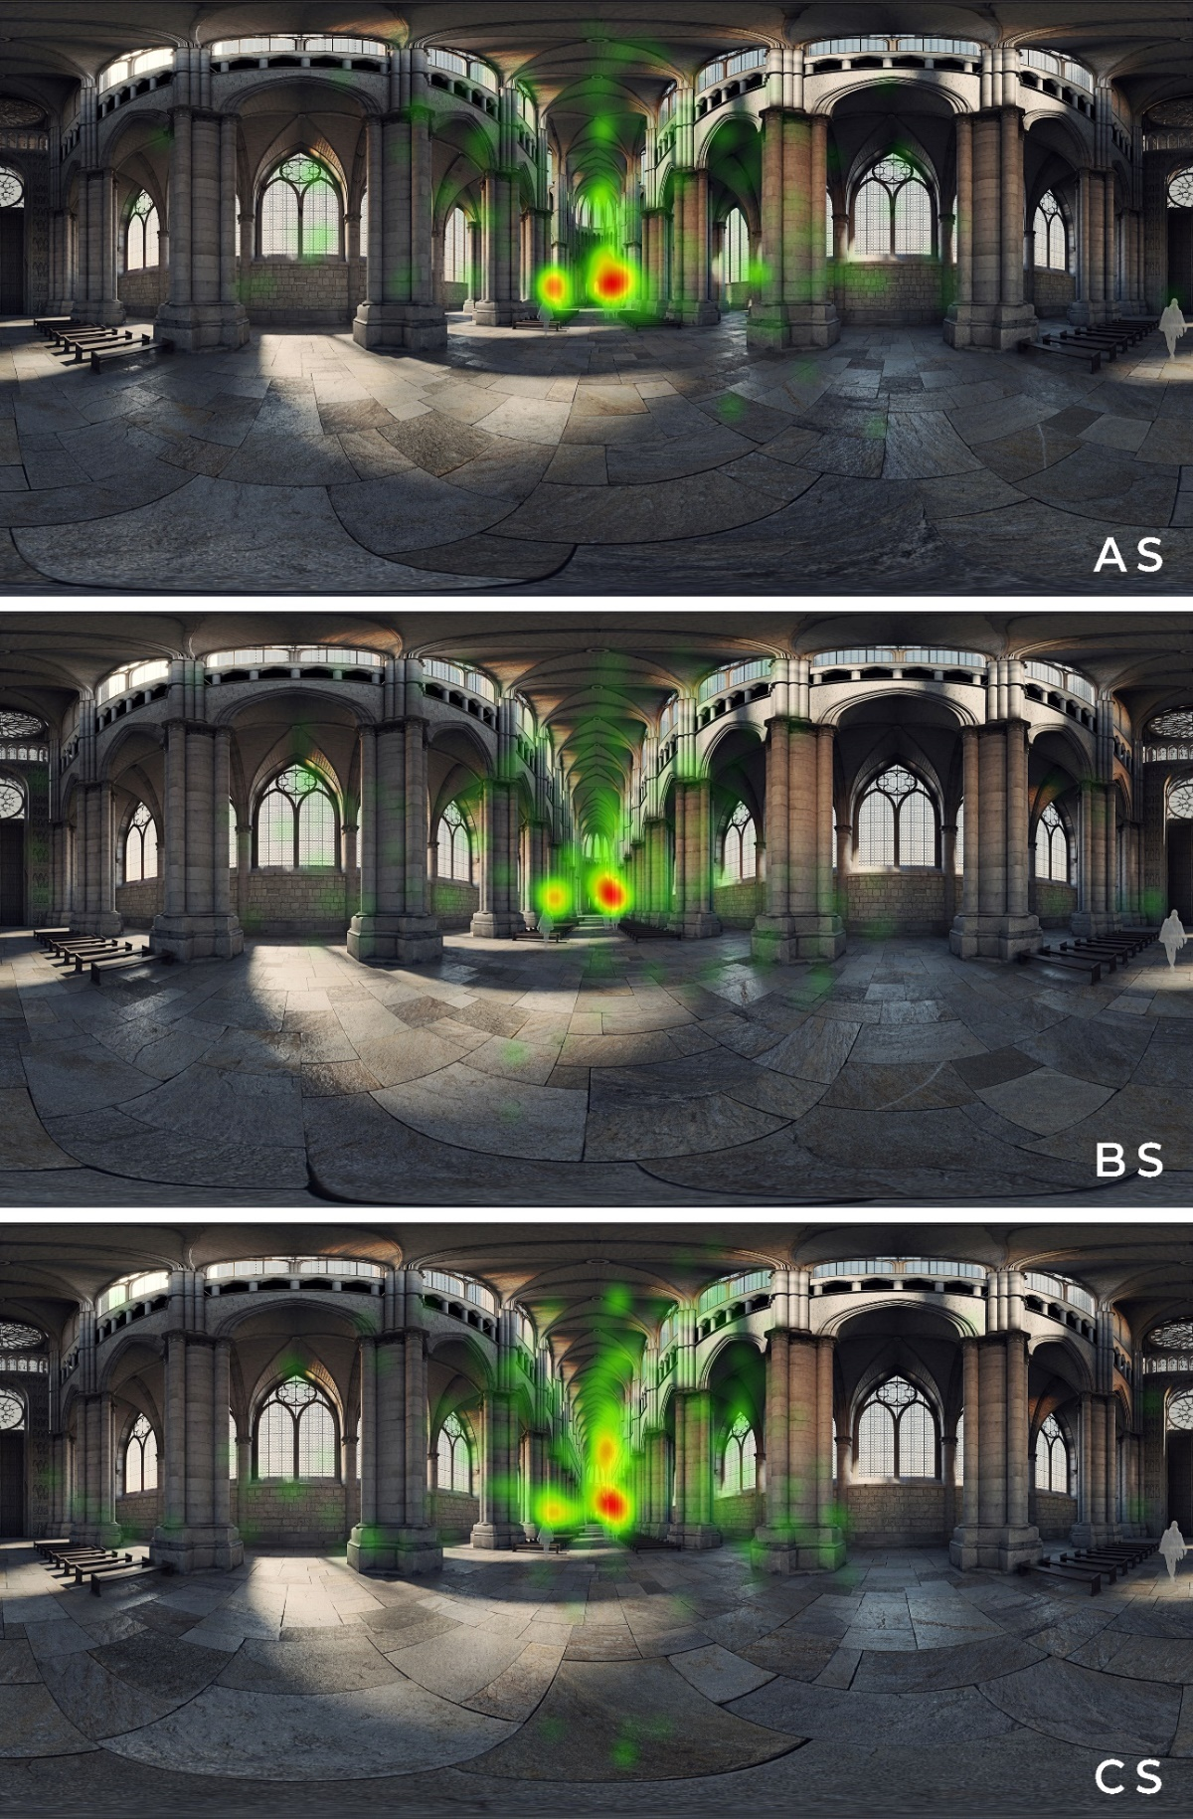
Figure S11. Heat maps AS, BS and CS. Where: AS- interior with sort nave, BS – interior with medium nave, CS- interior with long nave.

