Supplemental information for

Impaired arginine-induced insulin secretion in MODY2 patient with UGGT1^{R1526C} variant

This pdf file includes:
Abbreviations
Supplementary Figures S1, S2 and S3

Abbreviations

A/PBD, arginine/proinsulin binding domain

CAT, cationic amino acid transporters

CASTER1, cytosolic arginine sensor for mTORC1 subunit 1

DR, disordered region
ER, endoplasmic reticulum
ERRS, ER retention signal
GCK, glucokinase
HOMAβ, homeostatic model assessment of β cells
IP, immunoprecipitation
MODY, maturity-onset diabetes of the young
SNPs, human single nucleotide polymorphisms
UGGT, UDP-glucose:glycoprotein glucosyltransferase
WB, Western blot

Supplementary Figure S1. A human UGGT1 variant, UGGT1^{Q1518*} lacking an arginine/proinsulin binding domain and ER retention signal, is a secreted protein (Supplemental data for Figure 1).
(S1) The arginine/proinsulin binding domain (A/PBD) is a disordered region (DR) calculated by PPSIPRED (http://bioinf.cs.ucl.ac.uk/psipred/)

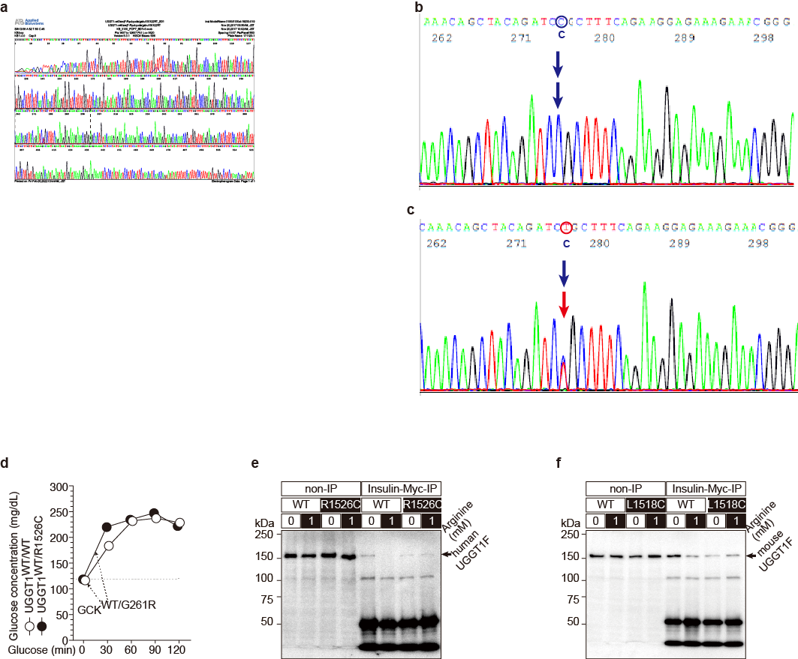
Supplementary Figure S2. Impaired arginine-induced insulin secretion in a MODY2 patient with UGGT1^{WT/R1526C}. (Supplementary data for Fig. 2).
(S2a-c) Sequence raw data of UGGT1^{WT/WT} (S2b) and UGGT1^{WT/R1526C} (S2c).
(S2d) Glucose-intolerant hyperglycemia in both UGGT1^{WT/WT} and UGGT1^{WT/R1562}C MODY2 patients.
(S2e and S2f) Original WB data for impaired arginine competitive interaction (Fig. 2f) with human UGGT1F^{R1526C} (S2b) and mouse UGGT1F^{L1517C} (S2c) mutants.

Supplementary Figure S3. Source of Data

