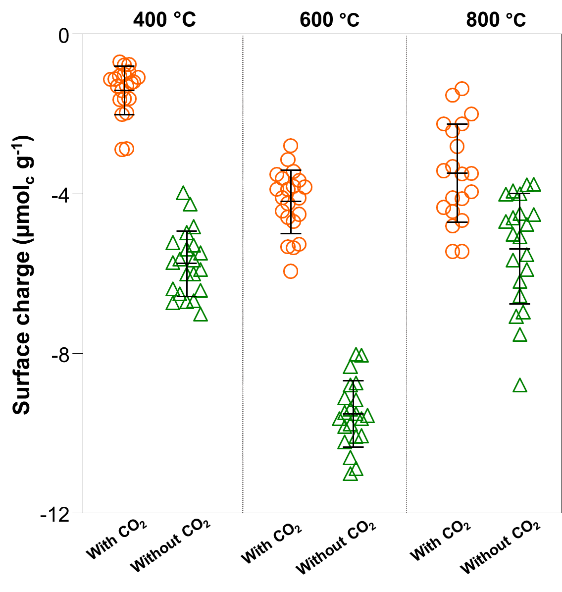
Fig. S1. Surface charge properties of the Phyt400, Phyt600 and Phyt800 under the conditions with or without CO₂ support.

