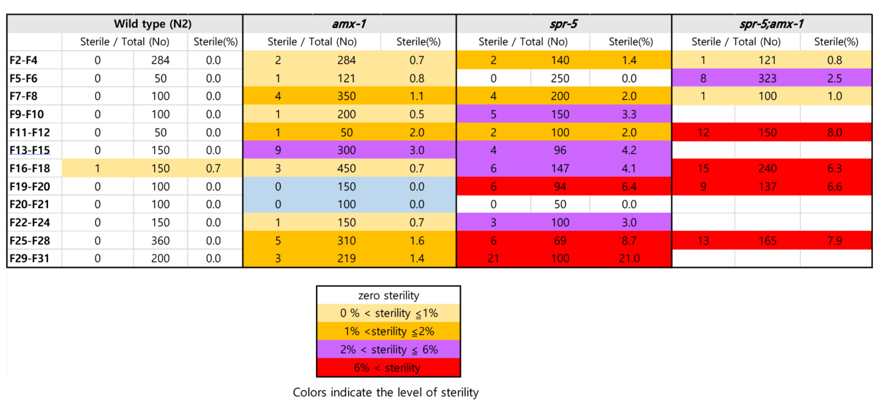
Supplemental Figure 1.
Sterility was observed over generations (F2-F31). Sterility in amx-1 occurs regardless of generations, while sterility in spr-5 is more frequent in later generations. Sterility was scored when worms produced no viable progenies until 2 days after L4 stage. Colors indicate the level of sterility.

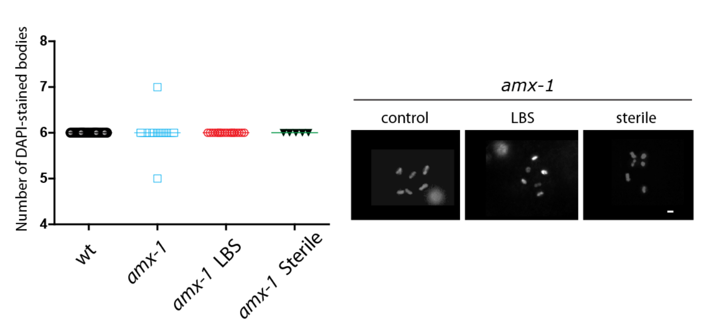
Supplemental Figure 2.
The number of DAPI-stained bodies was observed in diakinesis oocytes. Worms displaying sterility presented no telomere fusion but showed normal six bivalent chromosomes. The number of -1 or -2 oocytes scored. N=20-25 worms except for sterile worms (n=5). Bars, 2 µm. Since some standard deviations are zero, it is not possible to perform statistical analysis.

Supplemental Table 1. Primer information for gene expression assed by qPCR

