Additional file 2
Cross-validation routine results
Pseudoreplication results in models that are overly optimistic, where error and systematic bias inflates values in predictions [1]. To classify behaviour and show how it can be used to reliably predict behavioural events from large datasets, we developed a cross-validation routine using the ‘buffered leave block out’ method. We investigated the consequences of temporal dependence in the data when evaluating the predictive power of SEMs behavioural models by contrasting results of models fit to different temporal aggregations of data and time decompositions [2, 3]. We had an evaluation dataset composed of 50 tracks (blocks) and then predicted against this evaluation with training datasets of increasing temporal buffers of 1, 5, 10, 15, 20, 30, 45 and 60 minutes. We included 7-time decompositions because we expected the influence of time on the unobserved latent behavioural state would be non-linear. For every prediction against a track in the evaluation dataset, a random selection of training data per temporal buffer was done, resulting in 50 random selection of training dataset per temporal buffer and time decomposition (8 temporal buffer x 50 tracks x 7 splines = 2800 models per species).

For each SEM combination made of a temporal aggregation and time decomposition and for all predictions against the evaluation tracks, we calculated the absolute mean weighted root mean square error (RMSE). In Figure 1, we showed the absolute mean weighted RMSE values for all SEM combinations including identified and un-identified models [4].

We observed that the predictive capacity of models decreased significantly (e.g. high RMSE values) for certain temporal aggregations and time decompositions, with some errors > 150,000.
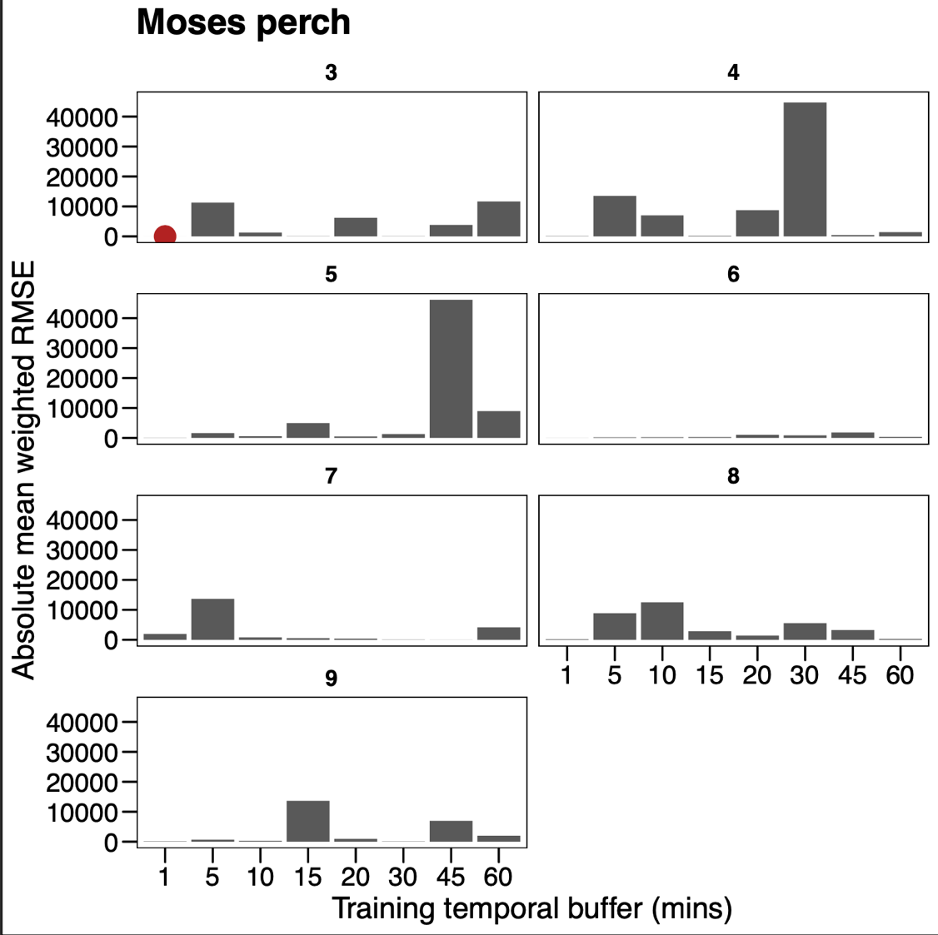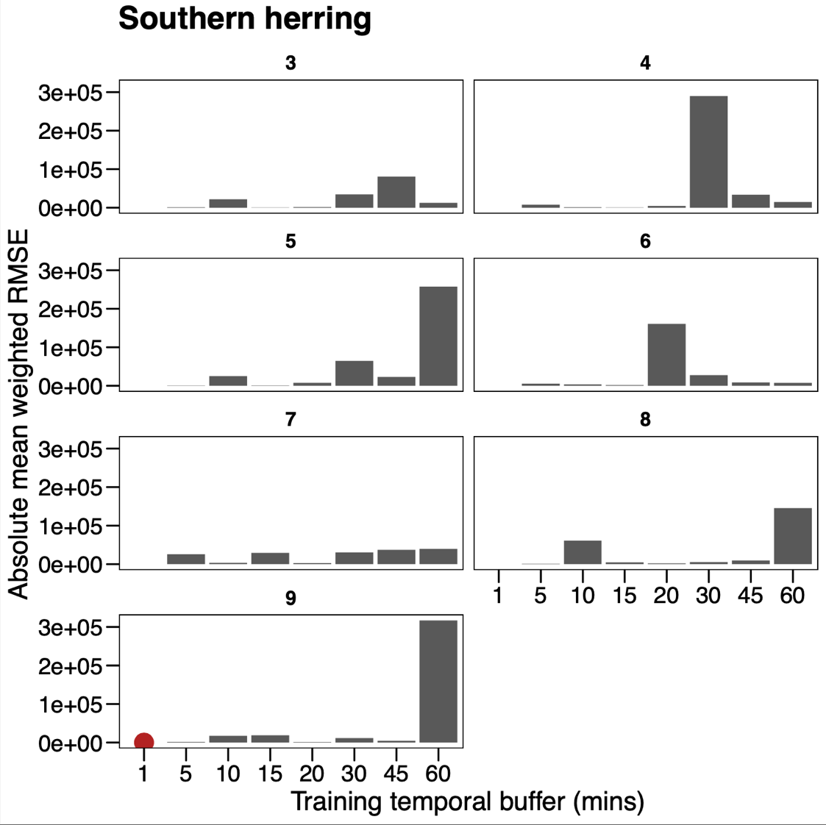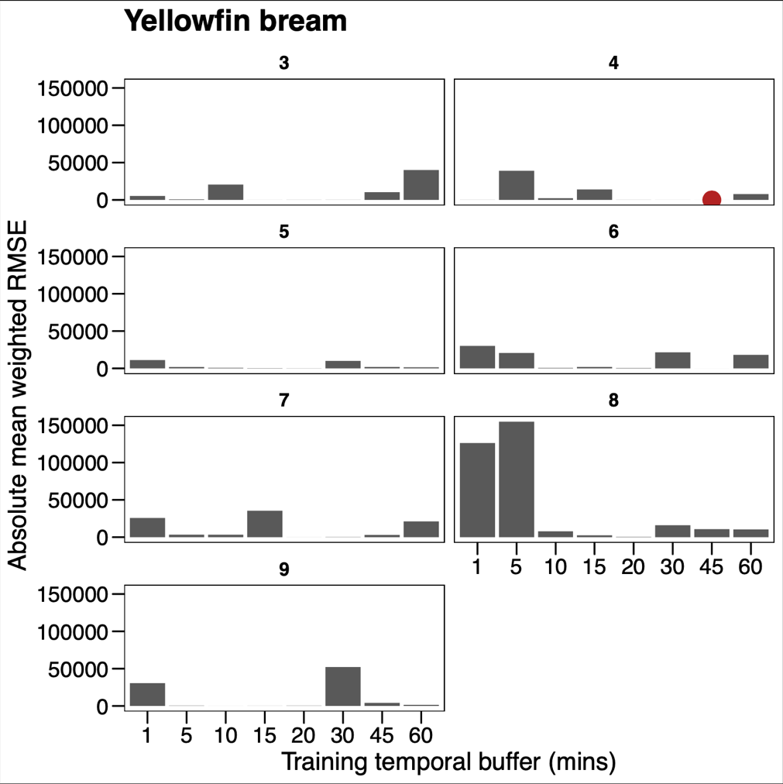

Figure 1: Absolute mean weighted root mean square error (RMSE) for all structural equation model (SEM) combinations for each training temporal buffer (mins), time decomposition (3-9) and species (moses perch, southern herring and yellowfin bream). SEM combination with the lowest RMSE value (highest predictive capacity) shown as a red dot.

References
1. Hurlbert SH. Pseudoreplication and the design of ecological field experiments. Ecological Monographs. 1984;54(2):187-211.
2. Ploton P, Mortier F, Réjou-Méchain M, Barbier N, Picard N, Rossi V, et al. Spatial validation reveals poor predictive performance of large-scale ecological mapping models. Nat Commun. 2020;11(1).
3. Parmentier I, Harrigan RJ, Buermann W, Mitchard ETA, Saatchi S, Malhi Y, et al. Predicting alpha diversity of African rain forests: Models based on climate and satellite-derived data do not perform better than a purely spatial model. Journal of Biogeography. 2011;38(6):1164-76.
4. Kline RB. Principles and practice of structural equation modeling. Todd L, editor. New York, United States of America: Guilford Press; 2011. 534 p.

