Additional file 1
Computer vision detection and tracking model
We developed a computer vision fish detection model that detected and tracked three target fish species across underwater videos. To train the computer vision model we use 335 manually annotated 1 min video snippets that included frames from a variety of backgrounds, angles, and environmental conditions (Figure 1). The training dataset had ~13,000 manual bounding box annotations around the target fish species (southern herring (Herklotsichthys castelnaui), Moses perch (Lutjanus russellii), and yellowfin bream (Acanthopagrus australis)). Each species had >1,500 annotations: southern herring (3,895 annotations), moses perch (1,553 annotations) and yellowfin bream (7,642 annotations).
Figure 1: Sample fish images and bounding box annotations to train the fish detection model

We used a deep learning object detection architecture called Faster R-CNN [1]. To minimise errors and misclassifications, we used species-specific confidence thresholds and a spatial-temporal filter [2, 3]. The species-specific thresholds filtered detection outputs where the model was less or more confident that it was a target species [3]. To filter false positives (a non-targeted object detected as a target species), we used a species-specific spatial-temporal filter called Sequential Non-Maximum Suppression (Seq-NMS) [2]. Seq-NMS links detections of neighbouring frames if there is an intersection above a defined threshold [2]. The overlap (intersection over union) of bounding boxes in subsequent frames needed to be > 30% [4]. Seq-NMS creates detection chains, and we can configure it to accept detections that are persistent through a specific number of frames [4].
Here we show the three training versions with increasing number of training annotations and the influence of the confidence threshold on the overall F1 performance for each target species (Figure 2). As the confidence threshold changes, we saw drops or increase on the F1 performance of each species.
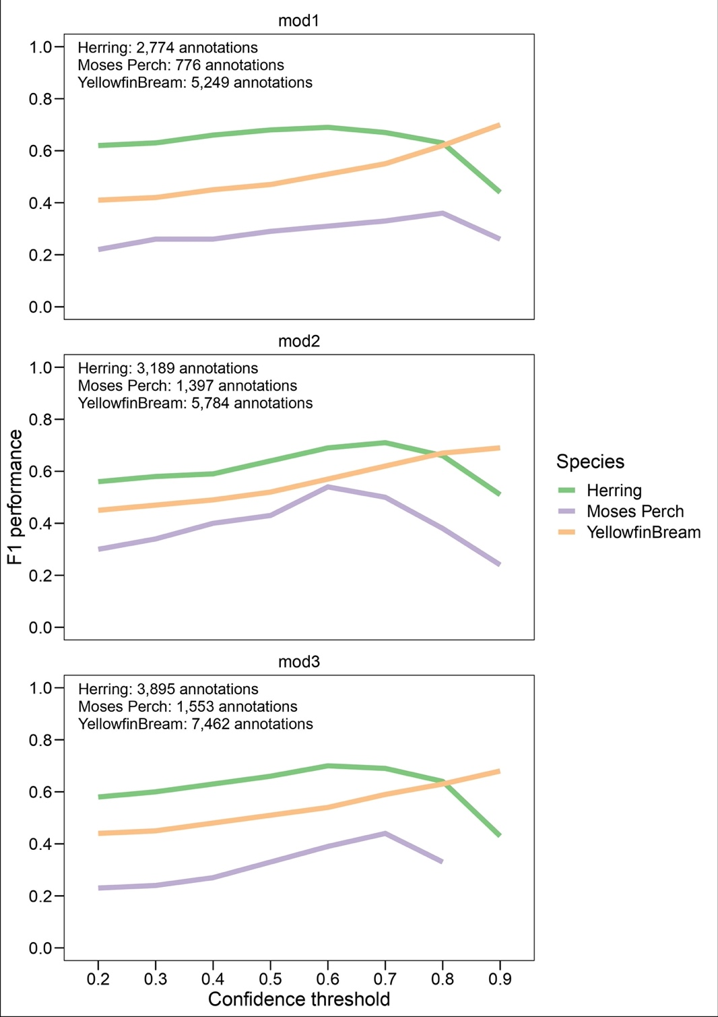
Figure 2: Changes in F1 performance for the three target species (southern herring, moses perch and yellowfin bream) and three training versions (mod1, mod2, mod3) with increasing number of training annotations.
We also examined the influence of both specific-specific confidence threshold and spatial-temporal filter (1, 5, 10 and 15 frames) for the three target species. Using Figure 3, we selected the species-specific and confidence threshold combination that resulted in the highest F1 performance. For southern herring, it was a confidence threshold of 0.7 and a spatial-temporal filter of 1 frame. For Moses perch, a confidence threshold of 0.7 and spatial-temporal filter of 15 frames and for yellowfin bream a confidence threshold of 0.9 with a spatial-temporal filter of 1 frame. We used these thresholds and filters to analyse the full dataset in the main text.

Figure 3: Changes in F1 performance when using different processing confidence threshold and spatial-temporal filters (STF).

The detection chains generated by the spatial-temporal filter Seq-NMS can be configured to provide movement data. For each chain, Seq-NMS provided a tracking angle of movement in 2 dimensions relative to the camera frame. The tracking angles were generated from the tracker vector within each bounding box (Figure 4).

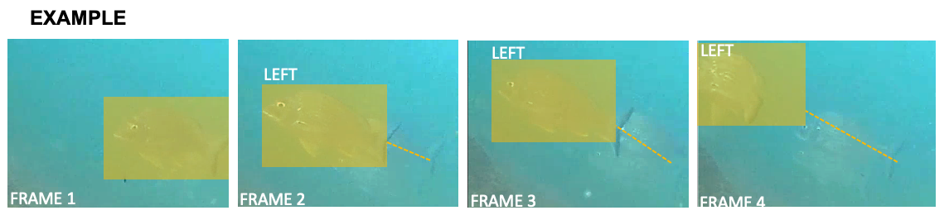
Figure 4: Sample frames of a detection chain tracking a yellowfin bream individual. For more information see Lopez-Marcano, Jinks [4].

References
1. Ren S, He K, Girshick R, Sun J. Faster R-CNN: Towards real-time object detection with region proposal networks. arXiv. 2016.
2. Han W, Khorrami P, Le Paine T, Ramachandran P, Babaeizadeh M, Shi H, et al. Seq-NMS for video object detection. arXiv. 2016;3.
3. Villon S, Mouillot D, Chaumont M, Subsol G, Claverie T, Villéger S. A new method to control error rates in automated species identification with deep learning algorithms. Scientific Reports. 2020;10(1):10972.
4. Lopez-Marcano S, Jinks E, Buelow CA, Brown CJ, Wang D, Kusy B, et al. Automatic detection of fish and tracking of movement for ecology. Ecol Evol. 2021;11(12):8254-63.

