Supplementary Information

Synthesis, antimicrobial, PASS, SAR, molecular docking, molecular dynamics and pharmacokinetic studies of designed benzylidene derivatives

Sarkar M. A. Kawsar^{1,}* · Mohammad Imran Hosen¹ · Ismail Celik² · Sopi Thomas Affi³ · Meryem Erol² · Sajia Islam¹ · Sujan Dey⁴ · Anowar Hosen⁵

¹Laboratory of Carbohydrate and Nucleoside Chemistry (LCNC), Department of Chemistry, Faculty of Science, University of Chittagong, Chittagong-4331, Bangladesh
²Department of Pharmaceutical Chemistry, Faculty of Pharmacy, Erciyes University, Kayseri, Turkey
³Laboratory of Thermodynamics and Medium Physico-Chemistry (LTPCM), Faculty of Basic and Applied Sciences (UFR-SFA), University of Nangui Abrogoua (UNA), Abidjan, Côte-d'Ivoire
⁴Department of Microbiology, Faculty of Biological Science, University of Chittagong, Chittagong 4331, Bangladesh
⁵Centre for Advanced Research in Sciences, University of Dhaka, Dhaka-1000, Bangladesh

Corresponding author. E-mail: akawsarabe@yahoo.com (S. M. A. Kawsar)
Tel.: +88-01762717081

Running Title: Synthesis, molecular dynamics and pharmacokinetic studies of designed benzylidene derivatives

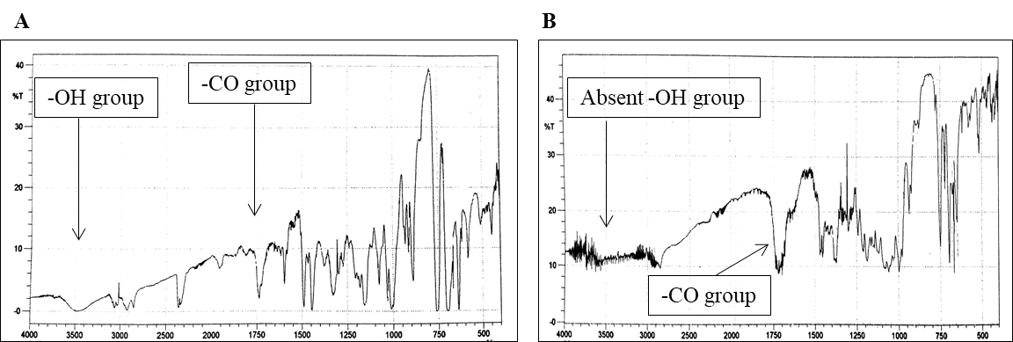

Fig. S1 FTIR spectra of: A compound 3 and B: compound 4

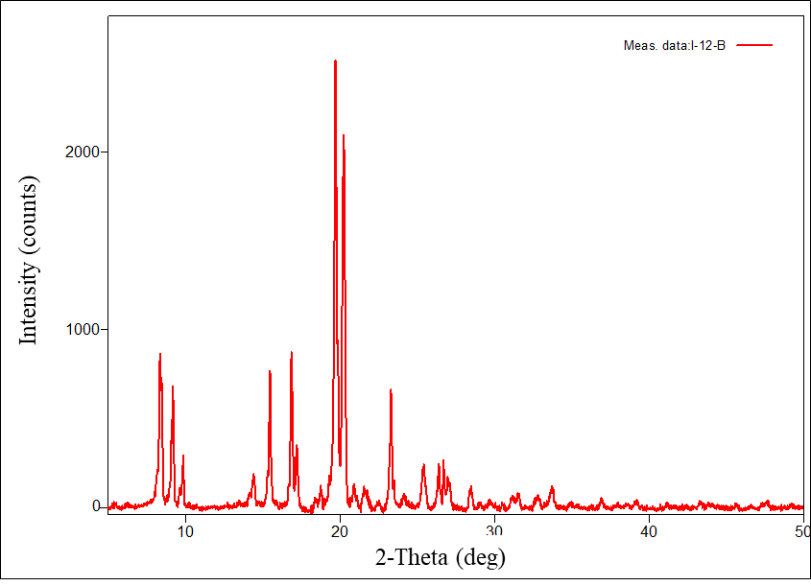

Fig. S2 X-ray diffraction peak of compound 6

Fig. S3 Zone of inhibition observed against both the Gram-positive and Gram-negative bacteria by the tested compounds

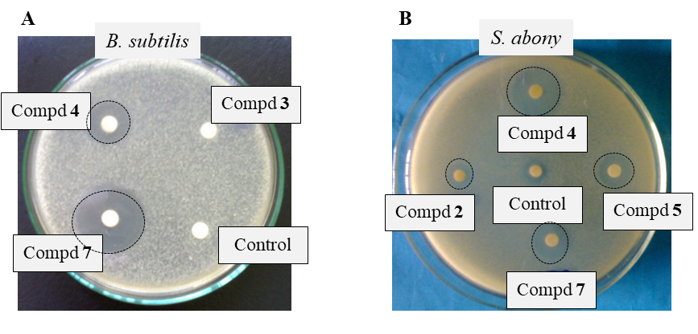

Fig. S4 Inhibition zones were observed against A) B. subtilis by compounds 3, 4, and 7; B) S. abony by compounds 2, 4, 5, and 7. Control (in DMSO) was treated as a negative control

Fig. S5 MIC values of the 4 and 7 compounds against tested organisms

Fig. S6 MBC values of the 4 and 7 compounds against tested organisms

Fig. S7 Antifungal activities of the synthesized test compounds

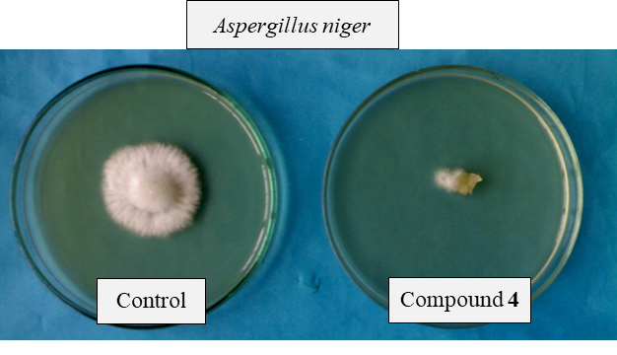

Fig. S8 Inhibition of fungal growth observed in A. niger by the compound 4

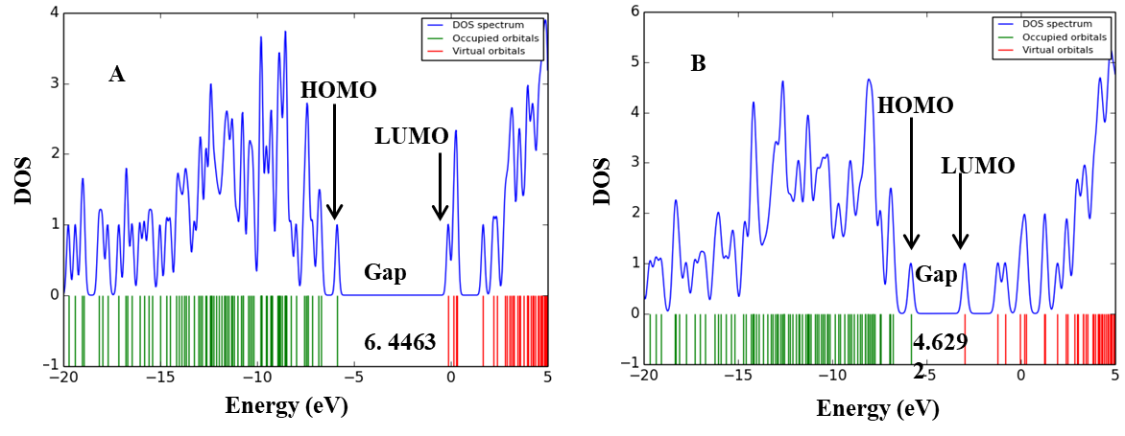

Fig.S9 (A); DOS plot of compound 3 (B); DOS plot of compound 7

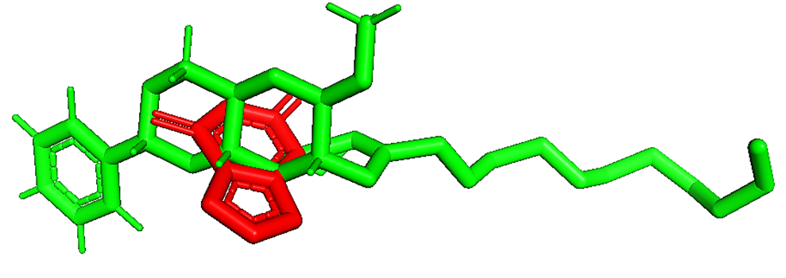

Fig. S10 Re-docking pose with the RMSD value of < 2Å (Red = Original, Green = Docked)

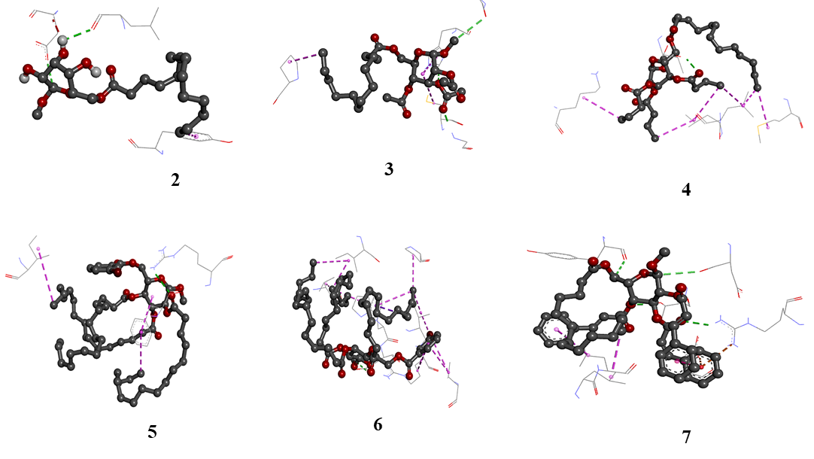

Fig. S11 Nonbonding interactions of MGB derivatives (2-7) with 1KS5 generated by Discovery Studio

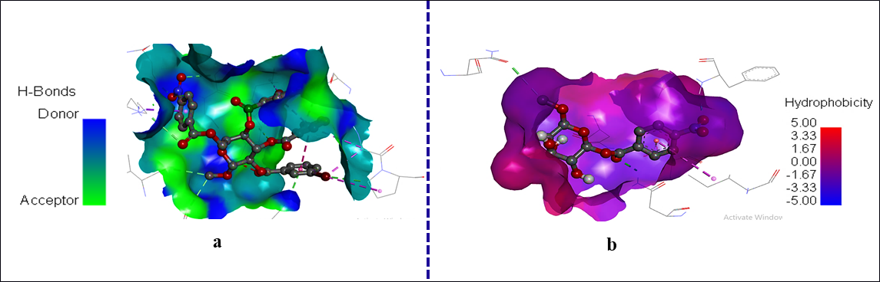

Fig. S12 (a); Hydrogen bond surface of compound 7 (b); Hydrophobic bond surface of compound 7

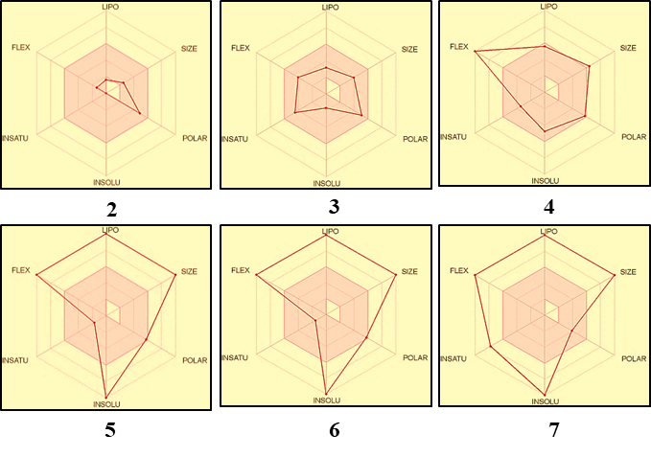
Fig. S13 Bioactivity radar charts of the MGB derivatives (2-7) where FLEX: Flexibility, LIPO: Lipophilicity, INSATU: Insaturation and INSOLU: Insolubility

Table S1 Peak list of the compound 6

No. | 2-theta(deg) | d(ang.) | FWHM(deg) | Asym. factor | Rel. int. I(a.u.)
1 | 8.450(8) | 10.455(10) | 0.17(2) | 2.2(8) | 32.96
2 | 9.196(7) | 9.609(7) | 0.179(6) | 2.7(5) | 25.05
3 | 15.453(7) | 5.729(3) | 0.109(11) | 1.1(3) | 26.23
4 | 16.834(7) | 5.262(2) | 0.122(8) | 0.56(15) | 25.32
5 | 17.171(13) | 5.160(4) | 0.174(15) | 0.9(3) | 13.30
6 | 19.673(6) | 4.5088(13) | 0.191(6) | 0.63(8) | 100.00
7 | 20.208(6) | 4.3908(13) | 0.175(6) | 0.81(11) | 89.60
8 | 23.280(6) | 3.8177(10) | 0.094(13) | 0.8(3) | 24.30
9 | 25.379(14) | 3.5065(18) | 0.269(11) | 0.99(19) | 11.23

Table S2 Zone of inhibition observed against both the Gram-positive and Gram-negative bacteria by the test chemical
 | Diameter of inhibition zone in mm
Entry | B. subtilis (+ve) | S. aureus (+ve) | E. coli  (-ve) | S. abony  (-ve) | P. aeruginosa  (-ve)
2 | NI | NI | 10±0.1 | 10±0.1 |  | NI
3 | 5±0.1 | NI | 8±0.1 | NI |  | NI
4 | **21±0.3 | *16±0.2 | 7±0.1 | **24±0.3 |  | *15±0.2
5 | NI | 10±0.1 | 5±0.1 | **20±0.3 |  | NI
6 | NI | 6±0.1 | 11±0.1 | NI |  | 10±0.1
7 | **21±0.3 | **31±0.4 | *18±0.2 | **26.5±0.4 |  | **20±0.3
Azithromycin | **19±0.2 | **18±0.2 | **17±0.2 | **19±0.2 |  | **17±0.2
Data were presented as mean ± SD and values determined for triplicate experiments. Statistically significant inhibition (p <0.05) was marked with an asterisk (*) for test compounds and a double asterisk (**) for the reference antibiotic azithromycin. NI = No inhibition

Table S3 Antifungal activities of the synthesized test chemicals in (%) of inhibition

Entry | Percentage (%) of inhibition
Entry | Aspergillus niger | Aspergillus. flavus
2 | 25.45±0.04 | NI
3 | 32.67±0.05 | 28.48±0.03
4 | *85.55±0.05 | *64.44±0.05
5  6 | *74.88±0.05 | 40.00±0.05
5  6 | *70.22±0.05 | NI
7 | *73.33±0.05 | 38.88±0.05
Nystatin | **66.4±0.05 | **63.1±0.05
Data were presented as mean ± SD and values determined for triplicate experiments. Statistically significant inhibition (p <0.05) was marked with an asterisk (*) for test compounds and a double asterisk (**) for the reference antibiotic Nystatin. NI = No inhibition.

Table S4 Prediction of antimicrobial activity of the MBG derivatives using PASS
Diameter of inhibition zone in mm
Entry | Antibacterial |  | Antifungal |  | Antioxidant |  |  | Anti-carcinogenic
Entry | Pa | Pi | Pa | Pi | Pa |  | Pi | Pa |  | Pi
2 | 0.342 | 0.011 | 0.521 | 0.012 | 0.403 | 0.041 |  |  | 0.731 |  | 0.008
3 | 0.455 | 0.014 | 0.681 | 0.010 | 0.637 | 0.005 |  |  | 0.843 |  | 0.005
4 | 0.566 | 0.011 | 0.761 | 0.010 | 0.661 | 0.004 |  |  | 0.776 |  | 0.006
5 | 0.501 | 0.013 | 0.743 | 0.008 | 0.585 | 0.005 |  |  | 0.709 |  | 0.007
6 | 0.421 | 0.013 | 0.743 | 0.008 | 0.585 | 0.005 |  |  | 0.709 |  | 0.007
7 | 0.581 | 0.011 | 0.759 | 0.005 | 0.601 | 0.004 |  |  | 0.787 |  | 0.006

Table S5 Calculated frontier molecular orbital parameters of derivatives 2-7

Entry | HOMO | LUMO | ΔE | ӀP | EA | ἠ | μ | S | Χ | ω
2 | -6.7840 | -0.3665 | 6.4175 | 6.7840 | 0.3665 | 3.2087 | -3.5753 | 0.1558 | 3.6784 | 0.9959
3 | -6.9016 | -0.4552 | 6.4463 | 6.9016 | 0.4552 | 3.2231 | -3.6784 | 0.1551 | 3.9053 | 1.0494
4 | -7.1258 | -0.6849 | 6.4409 | 7.1258 | 0.6849 | 3.2204 | -3.9053 | 0.1552 | 3.8755 | 1.1839
5 | -7.0956 | -0.6555 | 6.4401 | 7.0956 | 0.6555 | 3.2200 | -3.8755 | 0.1552 | 3.4369 | 1.1661
6 | -6.3114 | -0.5624 | 5.7489 | 6.3114 | 0.5624 | 2.8744 | -3.4369 | 0.1739 | 4.2732 | 1.0273
7 | -6.5878 | -1.9586 | 4.6292 | 6.5878 | 1.9586 | 2.3146 | -4.2732 | 0.2160 | 4.2732 | 1.9723
Gap ΔE: LUMO-HOMO, IP (-HOMO): Ionization potential, EA (-LUMO): Electron affinity, X (𝐼P+E𝐴)/2: Electronegativity, η (IP−EA/)2: Chemical hardness, S (1/2ἠ): chemical softness, μ −(IP+EA)/2: Chemical potential, ω (µ2 /2η): Electrophilic index.

Table S6 iGEMDOCK protein-ligand interactions energy of compounds with fungal and bacterial target proteins

Entry | Fungal target proteins |  | Bacterial target proteins
Entry | 1KS5  (kcal/mol) | 1R51  (kcal/mol) | 4A1J  (kcal/mol) | 5IQR  (kcal/mol)
2 | -85.94 | -84.51 | -83.15 | -103.03
3 | -108.10 | -106.05 | -108.52 | -104.54
4 | -140.86 | -116.11 | -134.80 | -121.84
5 | -136.18 | -117.41 | -149.84 | -130.56
6 | -126.71 | -112.70 | -126.75 | -122.84
7 | -126.88 | -118.50 | -115.35 | -120.40

Table S7 Calculated SwissADME parameters

Parameters | 2 | 3 | 4 | 5 | 6 | 7
MW | 282.29 | 464.59 | 674.95 | 703.00 | 706.91 | 580.75
TPSA | 77.38 | 83.45 | 89.52 | 89.52 | 72.45 | 72.45
RB | 2 | 14 | 28 | 30 | 19 | 18
HBA | 6 | 7 | 8 | 8 | 7 | 7
HBD | 2 | 1 | 0 | 0 | 0 | 0
MLogP | -0.01 | 2.63 | 5.16 | 5.50 | 5.37 | 4.02
WLogP | -0.13 | 4.34 | 9.59 | 10.37 | 9.25 | 6.97
MR | 67.49 | 125.30 | 192.72 | 202.34 | 203.37 | 164.45
GIA | High | High | Low | Low | Low | High
LipVi | 0 | 0 | 2 | 2 | 2 | 1
GhoVi | 0 | 1 | 4 | 4 | 4 | 4
MW: Molecular weight, TPSA: Topological Polar Surface Area, RB: Number of rotatable bonds, HBA: Number of hydrogen acceptors, HBD: Number of hydrogen donors, MLogP: Topological method, WLogP atomistic method octanol/water partition coefficient, MR: Molar refractivity, GIA: Gastrointestinal absorption, LipVi: Lipinski violations, GhoVi: Ghose violations.

Table S8 Strains of bacteria and fungi used for antimicrobial activity tests

Types of organisms |  | Tested organisms and strains code
Bacteria | Gram +ve | Staphylococcus aureus | ATCC 6538
Bacteria | Gram +ve | Bacillus subtilis | ATCC 6633
Bacteria | Gram -ve | Salmonella abony | NCTC 6017
Bacteria | Gram -ve | Pseudomonas aeruginosa | ATCC 9027
Bacteria | Gram -ve | Escherichia coli | ATCC 8739
Fungi |  | Aspergillus flavus | ATCC 204304
 |  | Aspergillus niger | ATCC 16404

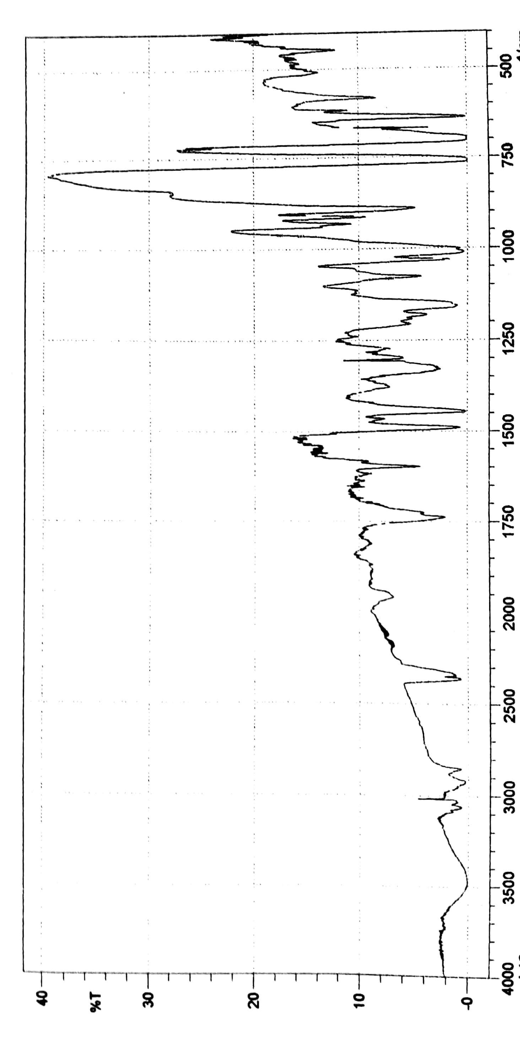

Spectrum S1. The FTIR spectrum of the compound 3

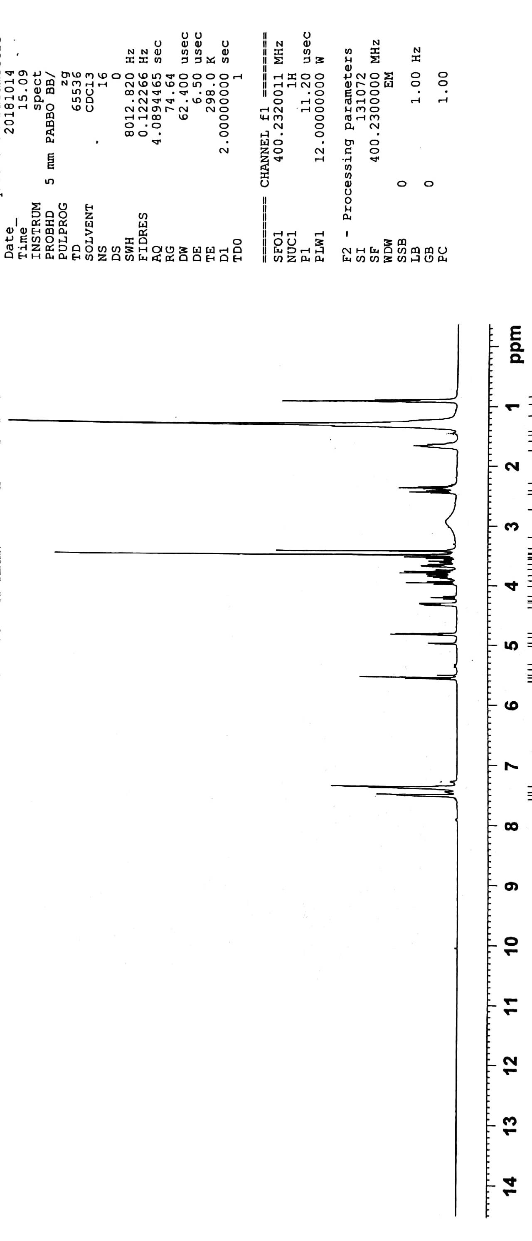

Spectrum S2. The ¹H-NMR spectrum of the compound 3

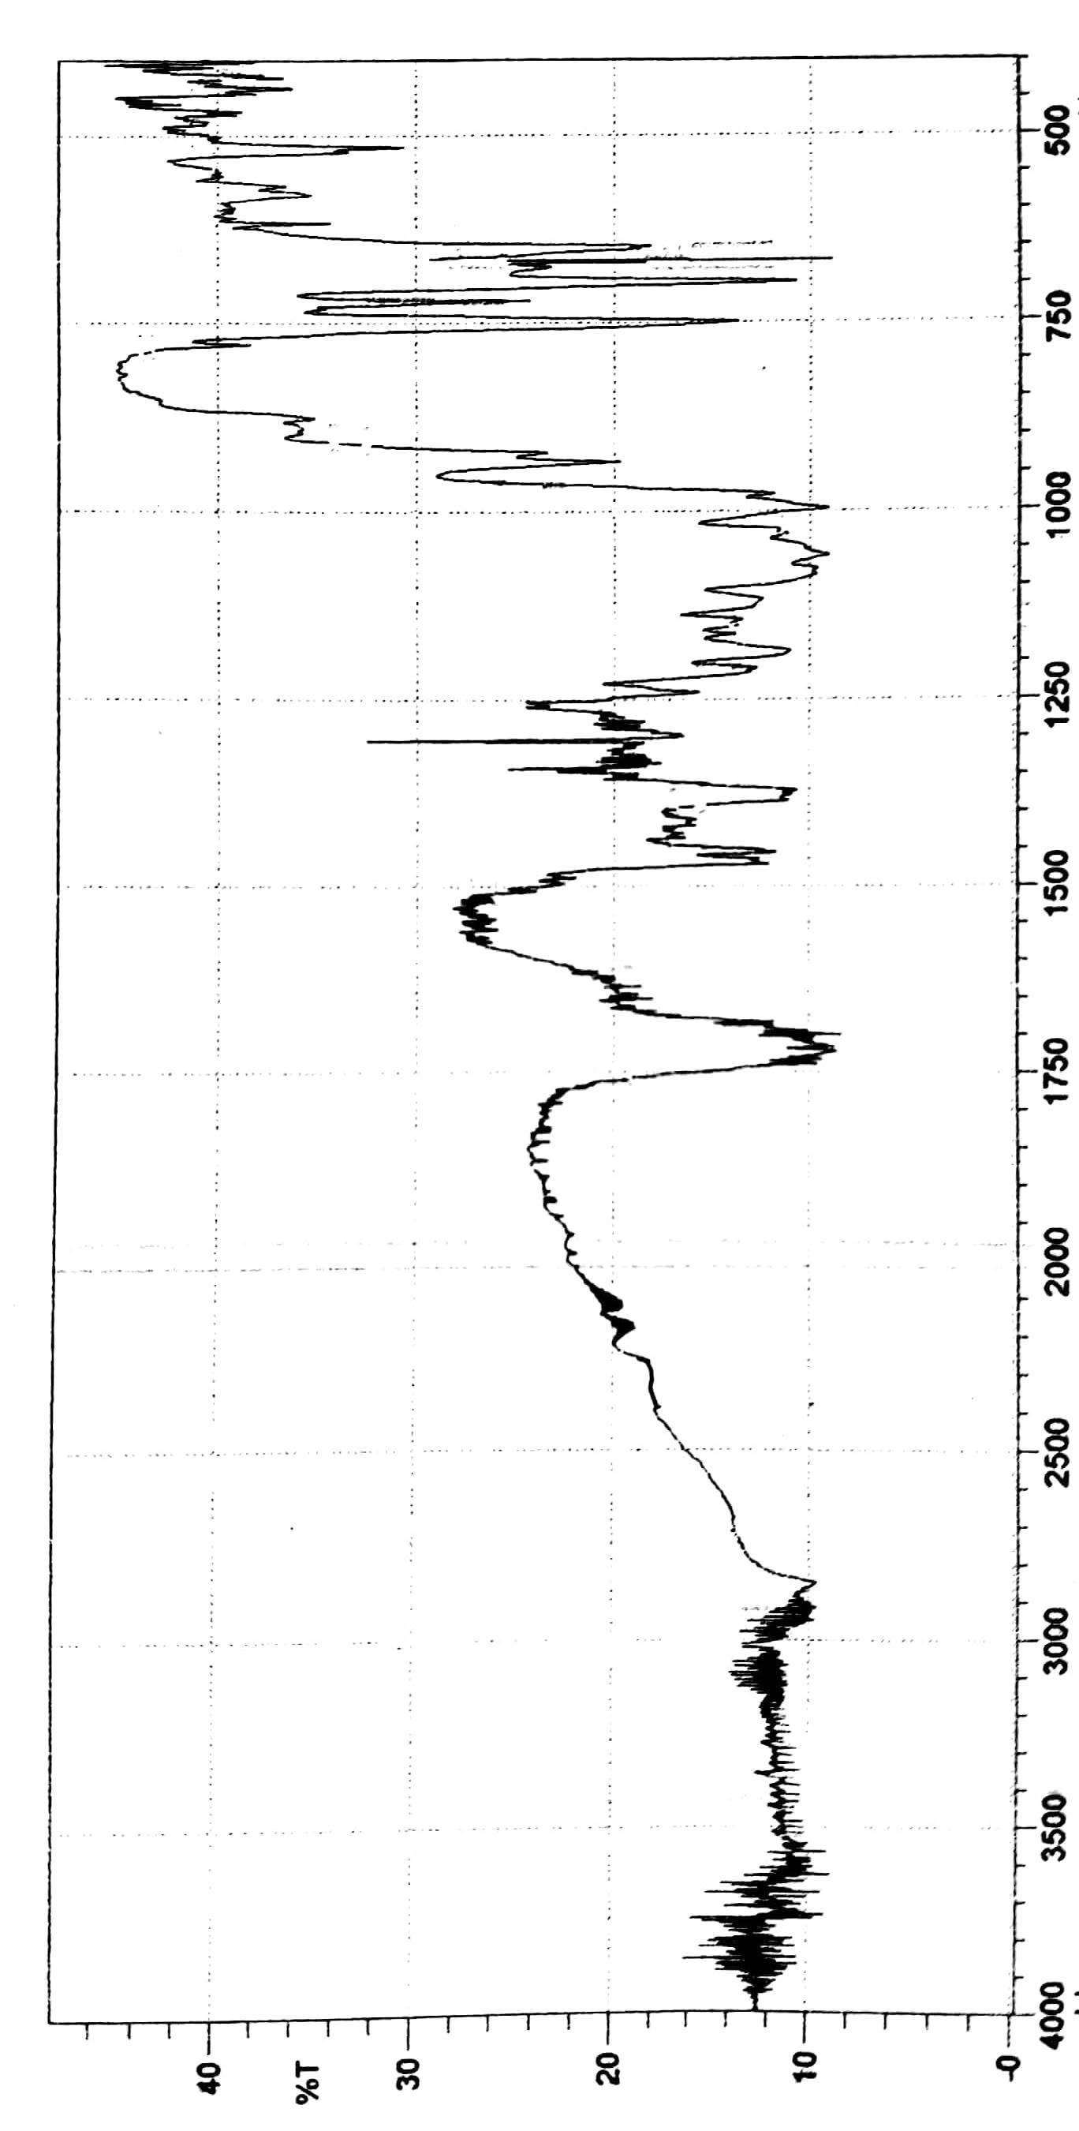

Spectrum S3. The FTIR spectrum of the compound 4

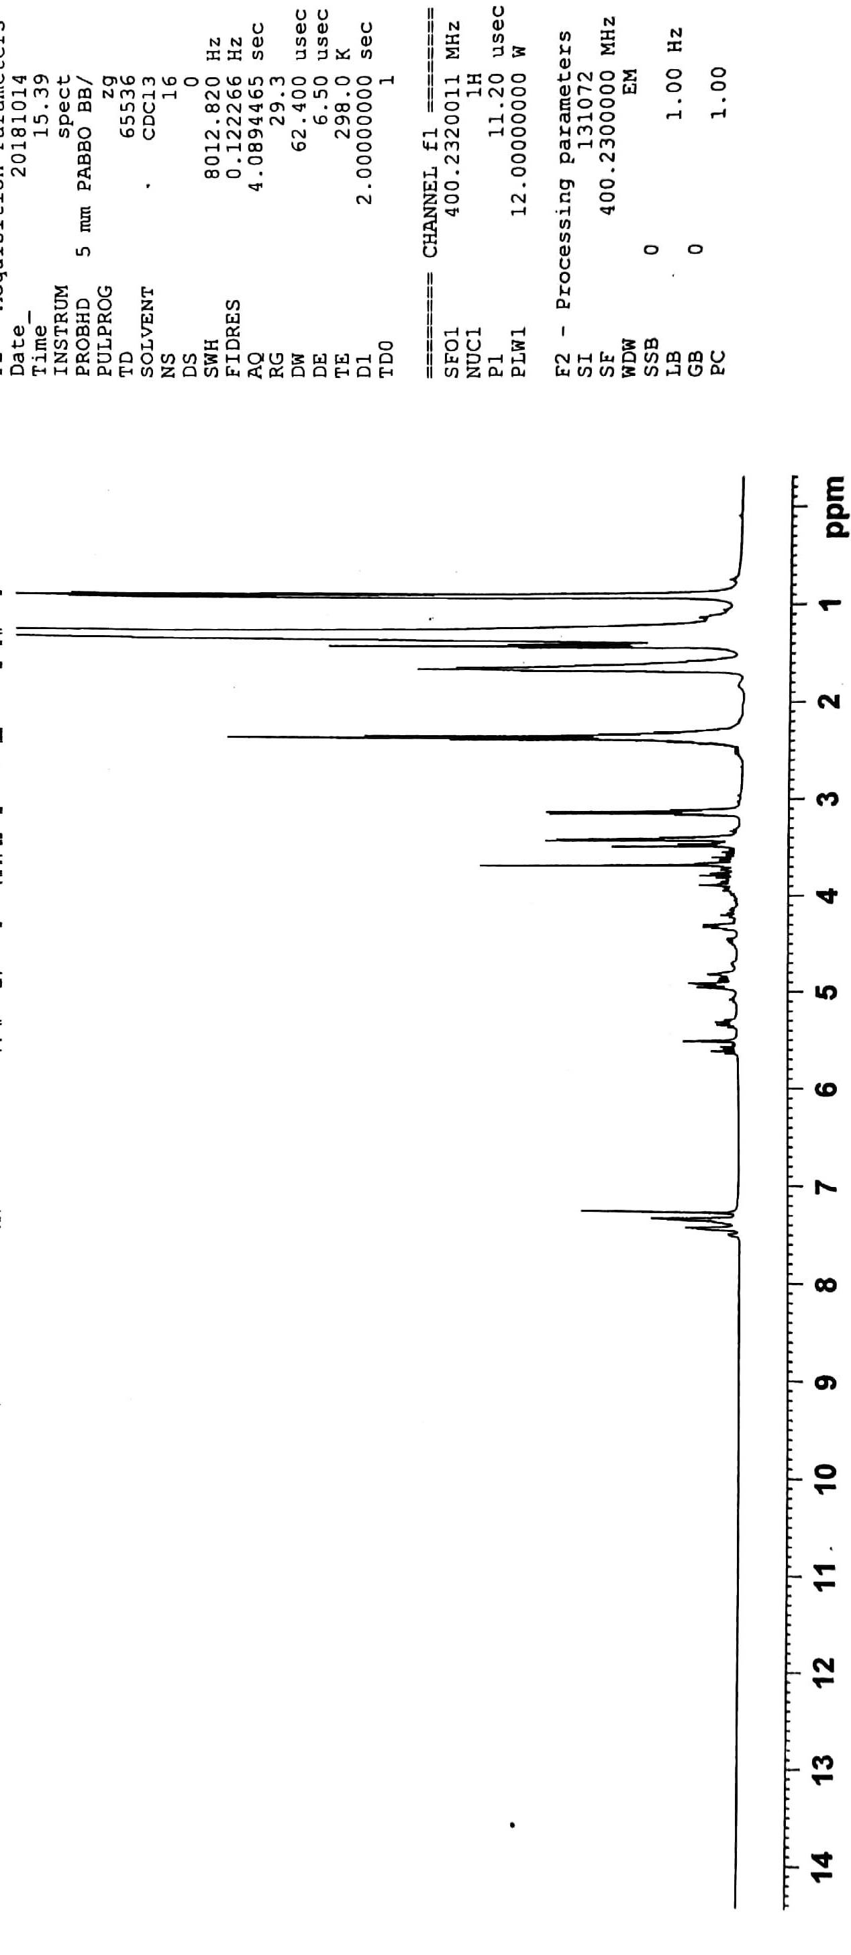

Spectrum S4.The ¹H-NMR spectrum of the compound 4

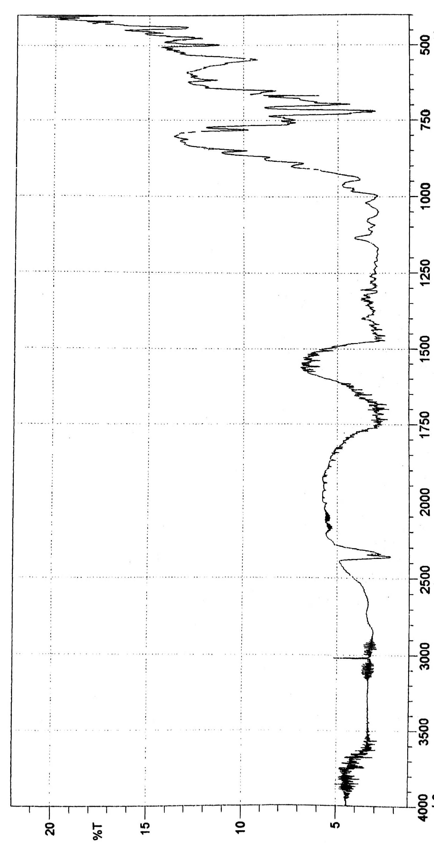

Spectrum S5. The FTIR spectrum of the compound 5

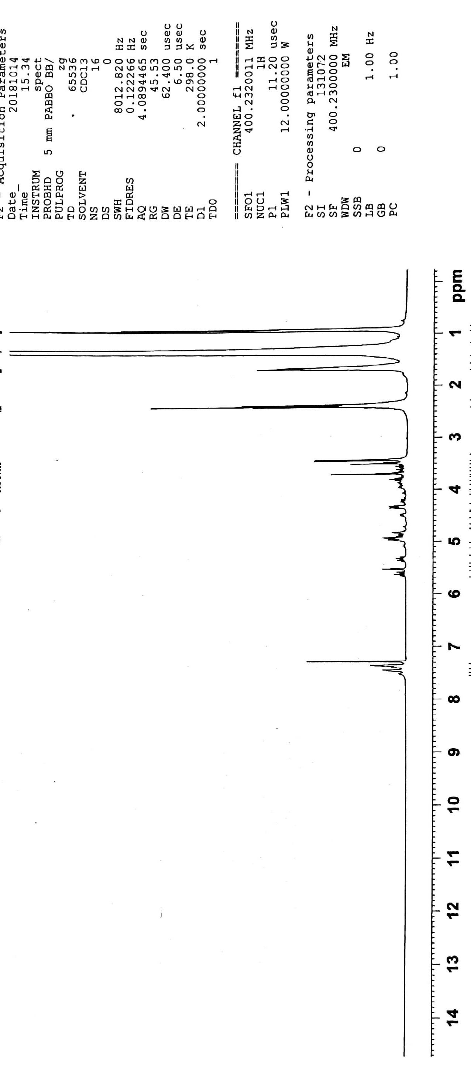

Spectrum S6. The ¹H-NMR spectrum of the compound 5

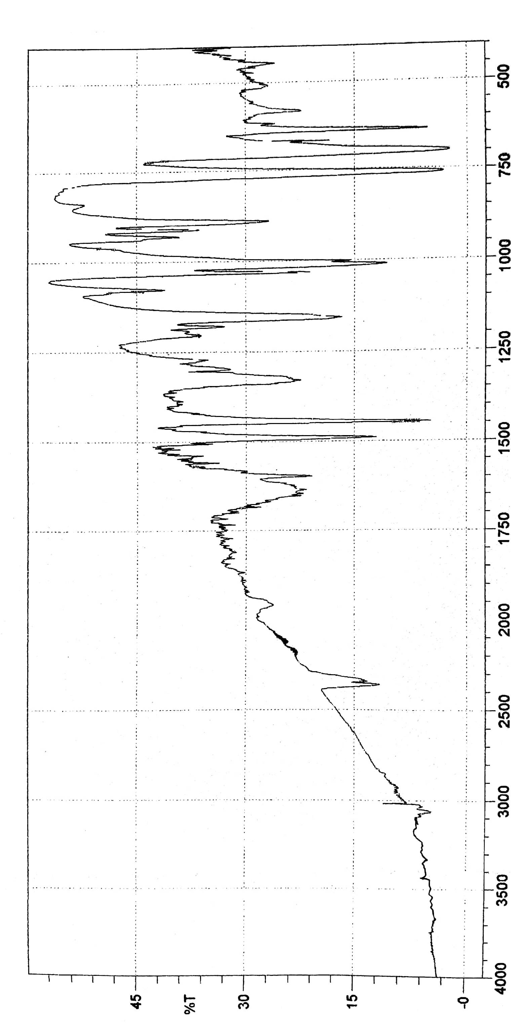

Spectrum S7. The FTIR spectrum of the compound 6

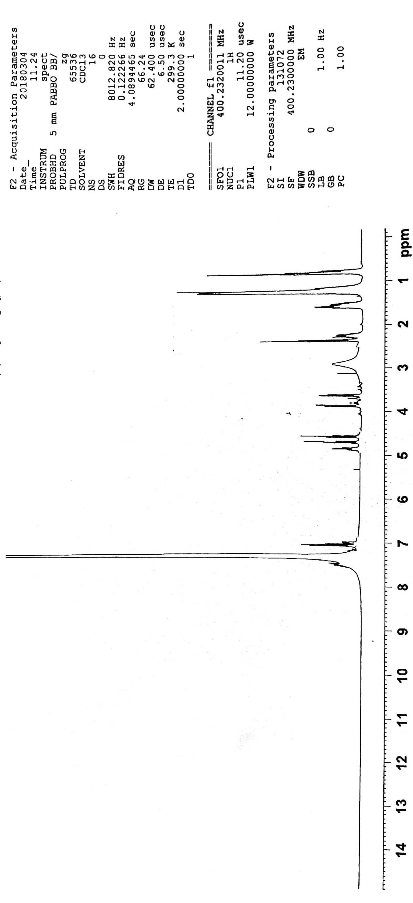

Spectrum S8. The ¹H-NMR spectrum of the compound 6

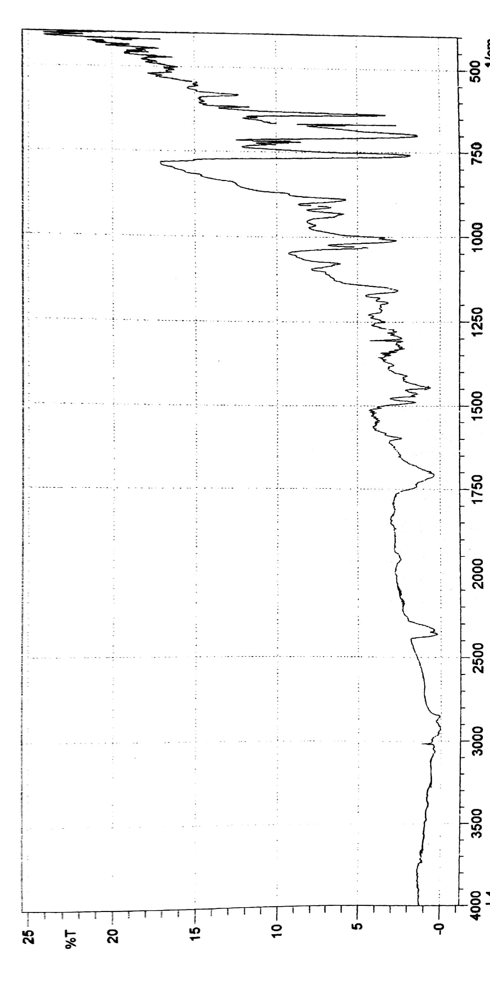

Spectrum S9. The FTIR spectrum of the compound 7

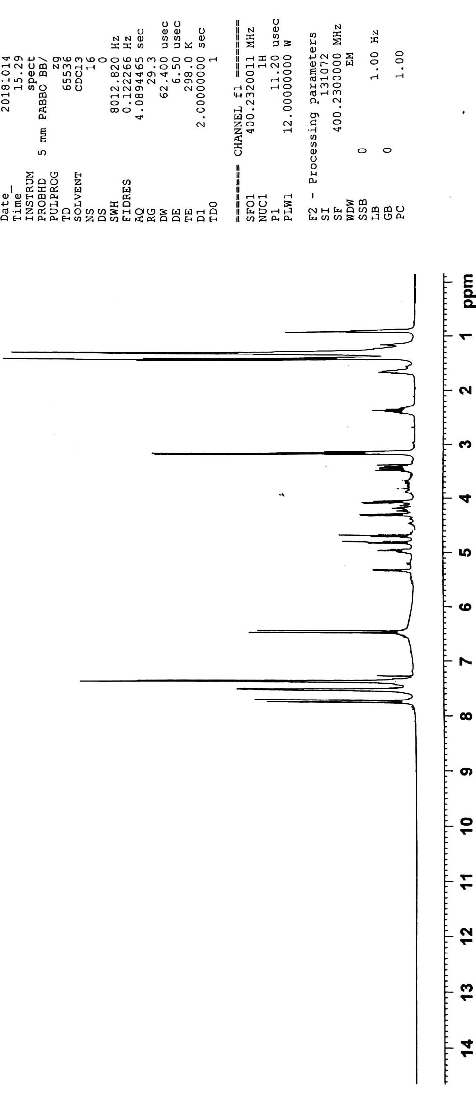

Spectrum S10. The ¹H-NMR spectrum of the compound 7

