Supplementary Data
Title
Enhancing acetate selectivity by coupling anodic oxidation in carbon monoxide electroreduction

Author list
Sean Overa¹, Bradie S. Crandall¹, Bharat Shrimant², Ding Tian², Byung Hee Ko¹, Haeun Shin¹, Chulsung Bae^{2,3}, Feng Jiao^{1,}*

Affiliations
¹Center for Catalytic Science and Technology, Department of Chemical and Biomolecular Engineering, University of Delaware, Newark, DE 19716, United States

²Department of Chemistry and Chemical Biology, Rensselaer Polytechnic Institute, Troy, NY, 12180, United States

³The Howard P. Isermann Department of Chemical and Biological Engineering, Rensselaer Polytechnic Institute, Troy, NY, 12180, United States

*Corresponding author: jiao@udel.edu

Supplementary Discussion 1: Development of durable eCOR MEA:
Before operation in semi-batch, the maximum concentration of acetate capable of being produced was measured via recirculation of a small amount of 2 M KOH in the cell until failure. It was found that after recirculation, a maximum concentration of 2.2 M acetate allowed for cell voltage to not experience a significant increase in potential (Figure S25). Long-term experiments were then completed where the anolyte was replaced every 24 hours in a semi-batch style recirculation. The cell was operated continuously for 71 hours (Figure S26a), with 3 samples collected containing 1.92, 2.3, and 2.59 M acetate. Acetate purities of 93.9, 97.1, and 98% (Figure S26b) compared to other liquid products was achieved. The acetate carbon selectivity was also maintained at >60%, achieving a maximum of 77.8% at the 71-hour sample (Figure S26c). Acetate Faradaic efficiency (FE) increases continuously from 35.7% at 24 hours to 48.7% at 71 hours, while ethylene FE decreases slowly from 39% to 23.2%. This decrease in ethylene, and conversely increase in acetate, production is attributed to the slow flooding of the Cu surface over the course of the experiment. The cell performance suffered greatly after 71 hours, and it was determined that the primary cause was the mechanical failure of FAA-3-50. This mechanical failure could be one of two things, both related to the low durability of FAA-3-50. One possibility is the exposure of FAA-3-50 to a mildly acidic environment at 71 hours, where the extreme concentration of acetate neutralized the buffering capacity of 2 M KOH to a pH of 5.9. Exposure to harsh organics from electrochemical CO reduction and alcohol partial oxidation could also play a role in the mechanical failure of FAA-3-50, as seen by the discoloration of the membrane after 71 hours. Additional experiments were attempted with 3 M KOH to avoid anolyte acidification, but the membrane failed before 50 hours of durability suggesting that the FAA-3-50 is not stable in harsh alkaline conditions (Figure S27).
To mitigate the impact of the membrane on system durability, a highly alkaline stable membrane (mTPN1-TMA), was synthesized (Supplemental Discussion 3). This membrane was used in place of FAA-3-50 due to its increased durability in the presence of concentrated KOH, removing one of the possible failure mechanisms seen with FAA-3-50.¹ The same Cu nanoparticle cathode and NiFeO_{x} anode used with FAA-3-50 were implemented. Figure S25a shows the cell performance in the 100-hour continuous CO electrolysis experiment. A stable full cell potential of 2.25 V (no iR correction applied) was achieved at a constant operating current density of 200 mA cm⁻². A maximum acetate concentration of 3.2 M was obtained at a purity of 97.8 % (Figure 25b). Additionally, a maximum acetate FE of 56.4%, assuming all acetate was produced at the cathode, was reached simultaneously, representing a carbon selectivity of 80% (Figure S25c). The conversion of CO was also maintained at over 40% for the entirety of the test (Figure S29).
Over the course of both initial durability tests, acetate concentration at some point exceeded the initial KOH concentration. As a result, there are large spikes in cell potential, which is due to the anolyte dipping below a pH of 10 (Figure S6). When the pH of the sample dips below pH 10, there is irreversible losses of Fe from the catalyst surface (Figure S30). This was demonstrated to happen immediately upon the anolyte dropping below pH 10, as evident when the electrolyzer was run for under 24 hours (Figure S6) and yet the Fe content of the anode was still completely lost (Figure S31). Therefore, it is necessary to maintain the concentration of acetate to ~1:1 with the KOH concentration. For improved anode durability in later experiments, a 0.5-0.75:1 acetate to KOH ratio was maintained to protect the NiFeO_{x} anode. Additionally, it can be seen that for both FAA-3-50 and mTPN1-TMA that there is a gradual decay in ethylene FE, with both cases losing ~50% ethylene production over the durability tests. The most likely cause of this is flooding of the microporous layer. Previous reports have shown that increasing the wet proofing in the catalyst layer improves the durability of the system.² Therefore, an improved gas diffusion layer was designed to include 20 wt% wet proofing in the catalyst layer. Lastly, both cases demonstrated a lack of stability in the membrane. FAA-3-50 ruptured after <75 hours in both 2 and 3 M KOH and suffered significant discoloration. mTPN1-TMA also decay, but to a lower degree with post reaction ¹H NMR indicating a 10% loss in functional groups throughout operation (Figure S32). Lastly, Orion Polymer’s AMX was utilized as the membrane of choice for the final durability experiment as it has better alkaline resistance and similar alcohol permeability to mTPN1-TMA (Figure S15).¹
Supplementary Discussion 2: Determination of Acetate FE from partial alcohol oxidation
As a non-negligible portion of acetate (~30% at 600 mA cm⁻²) was produced via the partial oxidation of ethanol, corrected acetate FE was determined based on the equation below.
$${FE}_{AcO,Corrected}={FE}_{Aco, Observed}-\left({FE}_{AcO,Obersved}-{FE}_{AcO,Ir}\right)+\frac{8e_{EtOH}^{-}}{{4e}_{AcO}^{-}}*({FE}_{AcO,Obersved}-{FE}_{AcO,Ir})$$
Where FE_{AcO,Corrected} represents the corrected acetate FE, FE_{AcO,Oberseved} is the measured acetate FE based on a 4e⁻ reduction, Fe_{AcO,Ir} is the FE for acetate measured with the IrO_{x}/Ti Felt anode, e⁻_{EtOH} is the electrons required to produce the ethanol that was converted to acetate, and e⁻_{AcO} is the number of electrons required to produce acetate. This equation is an estimate of the total amount of charge that was dedicated to producing acetate from eCOR. The value from this formula was used in Figure 2d for the corrected current density. While the ideal route to measure the percentage of acetate produced via ethanol oxidation is by measuring the O₂ FE from the anode, this route poses significant practical challenges. Specifically, the percent of total FE that is going towards ethanol partial oxidation at currents below 200 mA cm⁻² is between 6-10% of the anode FE. With a total operating current of 0.25 to 1 A, the actual shift in oxygen production is between 0.05 and 0.3 mL min⁻¹. This low flow rate is in the same order of magnitude within the standard error for flow meters. As a result when analyzing the anode O₂ FE, we see that at the lowest current densities there is large error associated with measuring the O₂ FE (Figure S33). However, the error is significantly reduced at higher current densities, and the percent of the predicted missing O₂ FE is >70%. As the decrease in production rate of O₂ gas is still estimated to be <1 mL min⁻¹ at these current densities, the anode O₂ measurement in is very close to what is predicted. As a result, it can be assumed that the above model is accurate as ~80% of the expected missing O₂ FE from the partial oxidation of ethanol to acetate is accounted for at higher current densities. Unless stated in the text, all reported FEs are based on the assumption that all acetate was produced at the cathode (4e⁻).
Supplementary Discussion 3: Description of mTPN1-TMA synthesis and properties
Materials
All reagents and solvents were purchased from Sigma-Aldrich, Alfa Aesar, and Acros Organics, and were used as received without further purification.
Instrumentation
¹H nuclear magnetic resonance (NMR) spectra were obtained using a Varian Unity 500 MHz spectrometer, and chemical shifts were referenced to the residual solvent peaks of CDCl₃ (7.26 ppm) or DMSO-d₆ (2.50 ppm). The average molecular weight and dispersity of mTPBr were determined by gel permeation chromatography (GPC) with a Viscotek GPC max model and TDA302 detector using THF (0.8 mL min⁻¹) as an eluent and polystyrene standards.
Experimental
Synthesis of mTPBr
mTPBr was synthesized following a procedure in our previous report.³ To a 100 mL three-neck round bottom flask equipped with a magnetic stirring bar under nitrogen atmosphere were charged with m-terphenyl (2.50 g, 10.9 mmol), 7-bromo-1,1,1-trifluoroheptan-2-one (2.95 g, 11.9 mmol), and methylene chloride (12 mL). The mixture was cooled in an ice-water bath, and trifluoromethanesulfonic acid (5.8 mL, 65.1 mmol) was added dropwise. The reaction mixture was stirred for 14 hours at room temperature and then diluted with additional methylene chloride (12 mL) followed by precipitating into methanol (150 mL). The polymer was redissolved in tetrahydrofuran (25 mL) and reprecipitated into methanol (150 mL) to afford the final product as a yellow fiber-like solid. Yield: 98%. ¹H NMR (CDCl₃): δ (ppm) 7.84 (s, 1H), 7.61 (m, 6H), 7.05 (m, 1H), 7.04 (m, 4H), 3.33 (m, 2H), 2.47 (m, 2H), 1.81 (m, 2H), 1.46 (m, 2H), 1.29 (m, 2H). GPC: M_{n} = 76 kg mol⁻¹, Ð = 3.1 (Figure S34).
Synthesis of mTPN1-TMA
In a 100 mL one-neck round bottom flask mTPBr (2.0 g, 4.4 mmol) was dissolved into N, N-dimethylacetamide (20 mL), and trimethylamine (1.74 g, 45 wt% aq. solution, 13.2 mmol) was added. The reaction mixture was stirred at room temperature for 24 h and then precipitated in tetrahydrofuran (100 mL). The polymer was washed with acetone and dried under reduced pressure at 60 ˚C. Yield: 96%. ¹H NMR (DMSO-d₆): δ (ppm) 7.99 (br, 1H), 7.83 (br, 4H), 7.71 (br, 2H), 7.58 (br, 1H), 7.41 (br, 4H), 3.23 (br, 2H), 3.01 (br, 9H), 2.57 (br, 2H), 1.63 (br, 2H), 1.30 (br, 2H), 1.24 (br, 2H) (Figure S21).
Membrane casting of mTPN1-TMA
In a glass vial mTPN1-TMA was dissolved into dimethyl sulfoxide (5 wt%) at room temperature. The solution was filtered through a syringe equipped with a short plug of cotton ball to remove any insoluble parts. The filtered solution was cast on a leveled glass plate and was dried at 80 ˚C in an oven under a slight positive air flow for 24 h.
In-plane hydroxide conductivity of mTPN1-TMA
The membrane was cut into rectangular specimen (ca. 3cm × 0.5 cm) and ion-exchanged to hydroxide form by immersing in 1M NaOH (aq.) for 24 h. The specimen was rinsed and kept in deionized water overnight inside an argon-filled glovebox. The in-plane hydroxide conductivity was measured using a four-probe electrode method with BT-512 membrane conductivity test system. Measurement was carried out under fully hydrated conditions (i.e., the cell was immersed in deionized water) at 30 and 80 ˚C. The hydroxide conductivity values were calculated using the equation below.
$$σ (mS/cm)= \frac{L}{R×W ×T}$$
Where L is the distance between two inner electrodes, R, W, T are the resistance, width, and thickness of membrane specimen, respectively (Table S4).

Supplementary Discussion 4: Acetate protonation and electrolyte recovery model
Prior to distillation, the acetate was protonated with an HCl solution to produce acetic acid. The KOH present in the electroylzer outlet was also converted to KCl in this mixing step. This KCl was then recovered out of the bottom of the first distillation column and converted back to KOH via electrolysis. Hydrogen and chlorine gas was also produced in this same electrolyzer and subsequently converted to HCl via combustion and recycled for acetate protonation. The cost of this process was estimated using the at-scale process economics of the chloroalkali industry. The typical electricity demand of NaCl electrolysis (2,500 kWh ton⁻¹) was used to determine the electricity required to regenerate the KOH electrolyte from KCl.^{4–6} Assuming an equivalent number of electron transfers per KOH and Cl⁻, the energy usage could be adjusted using the molar mass of NaCl and KCl (Table S5). It was also assumed that all K⁺ ions from KOH were bound to acetate at the CO electrolyzer outlet. To determine the total cost of the acetate protonation and electrolyte recovery process, it was assumed that electricity usage captures 50% of the total cost as reported for a typical industrial chloroalkali process.⁷

Supplementary Discussion 5: Aspen Plus simulation
The distillation costs and energy usage were studied using ASPEN Plus software with the Economic Analyzer and Energy Analyzer plugins. Operating costs were determined by linearly scaling the utility costs provided by the simulation with the desired flow rate. The final acetic acid product stream was modeled to be 89%-94% acetate by weight for each acetate concentration at the electrolyzer outlet studied. A 2-column extractive distillation scheme with a p-xylene solvent was used for acetate concentrations ranging from 1-10 M (Figure S20). However, an additional column was needed to obtain the desired acetic acid concentration when the acetate concentration at the CO electrolyzer outlet was 0.1 M (Figure S21). The third column is needed in this case as the solvent recovery column in the software could not achieve the desired final acetic acid concentration. At low concentrations, acetic acid is difficult to separate from water without the aid on an entrainer.⁷ However, a high enough concentration of acetic acid could be achieved at the outlet of the second column after the azeotrope was broken with p-xylene so that acetic acid could be separated directly from water in the third column. Alternative separation methods such as membrane separation technology are typically used at ultra-low concentrations in real-world systems. However, the concentration cut-off point at which distillation is no longer the most economically viable separation method in this process is unclear. This process is also unlikely to be commercialized without a relatively concentrated stream of product at the electrolyzer outlet where distillation is likely the most appropriate separation method. Thus, the distillation model used in this work effectively captures the relationship between acetate concentration and separation costs.
Supplementary Figures and Tables:
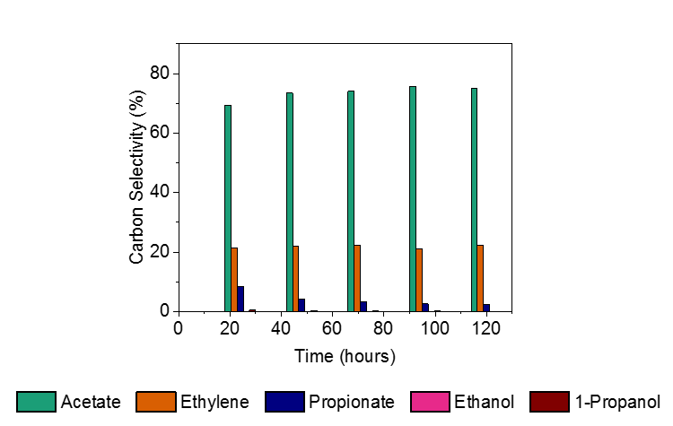
Supplementary Figure 1: Carbon selectivity of eCOR products during 120-hour durability experiment. Carbon selectivity represents the molar selectivity of the products scaled to the moles of CO needed to produce said product.
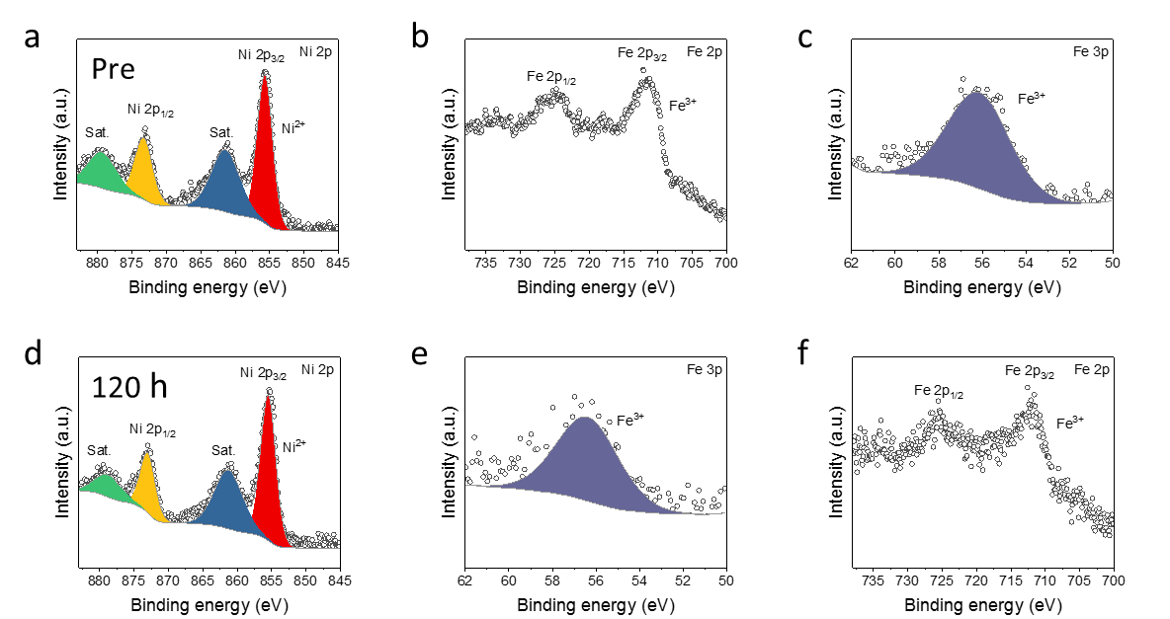
Supplementary Figure 2: Pre and Post reaction X-ray photoelectron spectroscopy of NiFeO_{x}/Ni Foam anodes during long term durability testing. (a) Ni 2p, (b) Fe 2p, and (c) Fe 3p spectrum for pre-reaction sample. (d) Ni 2p, (e) Fe 2p, and (f) Fe 3p spectrum for post-reaction sample for 120-hour experiment using AMX membrane.
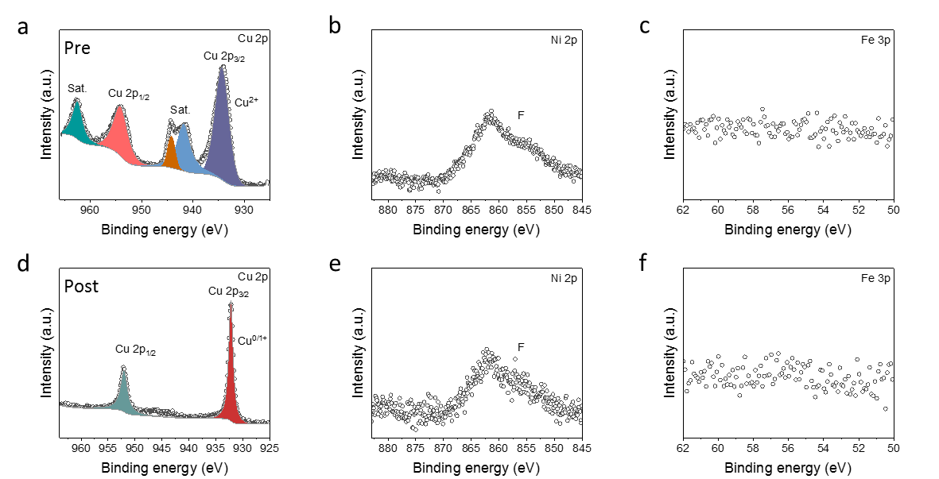
Supplementary Figure 3: Pre and Post reaction X-ray photoelectron spectroscopy for Cu cathode on gas diffusion electrode. (a) Cu 2p spectra for pre-reaction sample. Cu surface is oxidized, as sample was exposed to air. Pre-reaction spectra for (b) Ni 2p and (c) Fe 3p, indicating an absence of these metals. (d) Post-reaction Cu 2p spectra. Samples were stored under Ar gas following electrolysis causing minimal oxidation of Cu. Post-reaction spectra for (e) Ni 2p and (f) Fe 3p, indicating no metals were deposited during the durability experiment.
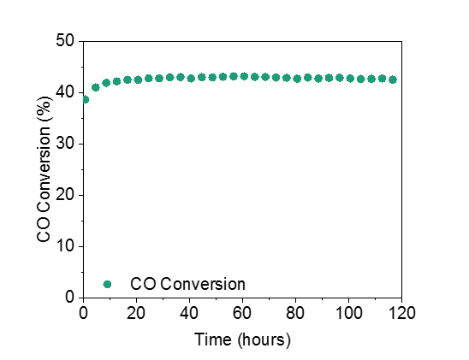
Supplementary Figure 4: Measured conversion of fed CO via eCOR during CO electrolysis during 120 hour long term operation of electrolyzer. Conversion was determined via volumetric flow rate comparison of inlet and outlet CO. The cell was operated with 3 M KOH at 200 mA cm⁻² with a fixed flow rate of 10 sccm.

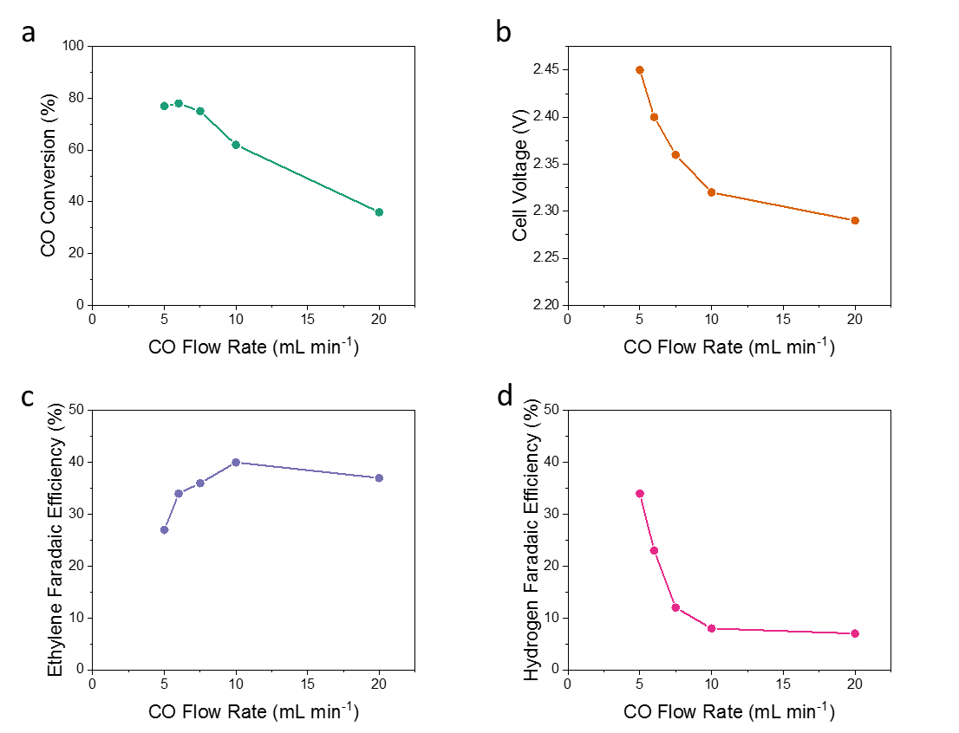
Supplementary Figure 5: Maximum achievable conversion for CO electrolyzer. Current was held at 300 mA cm⁻² as gas flow rate was stepped down every half hour. A 2 M KOH electrolyte was used with a NiFeO_{x}/Ni Foam and a Cu nanoparticle cathode. (a) Measured conversion of CO using volumetric flow rate in and out. (b) Measured cell potential after 30 minutes of stabilization at each flow rate. (c) Measured ethylene Faradaic Efficiency at each flow rate after 30 minutes of stabilization. (d) Measured hydrogen Faradaic Efficiency at each flow rate after 30 minutes of stabilization.
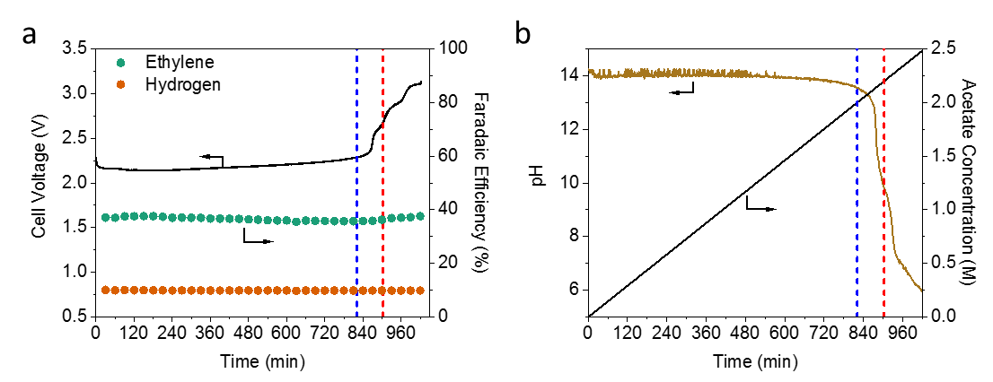
Supplementary Figure 6: Impact of acetate concentration on performance of CO electrolyzer. (a) Measured cell voltage (left) and gaseous Faradaic efficiencies (right) for CO electrolyzer. (b) Measured pH of anolyte during concentrating (left) and acetate concentration (right). 20 mL of 2 M KOH was recirculated through the anolyte, cell was held at 200 mA cm⁻² and 15 sccm CO using AMX membrane. Acetate concentration is based on the final concentration measured of 2.489 M acetate and assumed constant production. Dashed blue line indicates where the acetate to KOH ratio reaches 1:1 and the red line indicates where the ratio reaches 1.2:1.
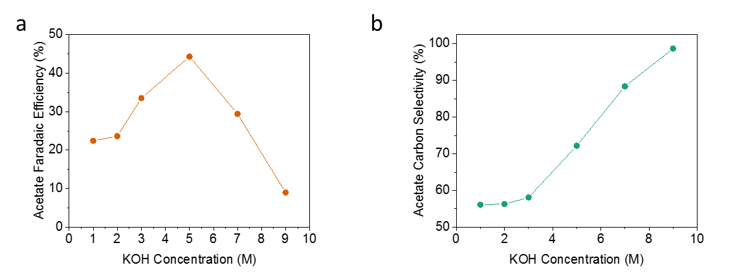
Supplementary Figure 7: Maximum concentration of acetate before degradation is observed for CO electroreduction in an MEA system using AMX membrane. (a) Measured acetate Faradaic efficiency post concentration. (b) Acetate carbon selectivity at varying initial KOH concentrations. Cell was operated at 300 mA cm⁻² and 15 sccm CO flow rate. Complete cell degradation was assumed when the cell voltage reached 2.8 V, representing a voltage increase of ~20%.
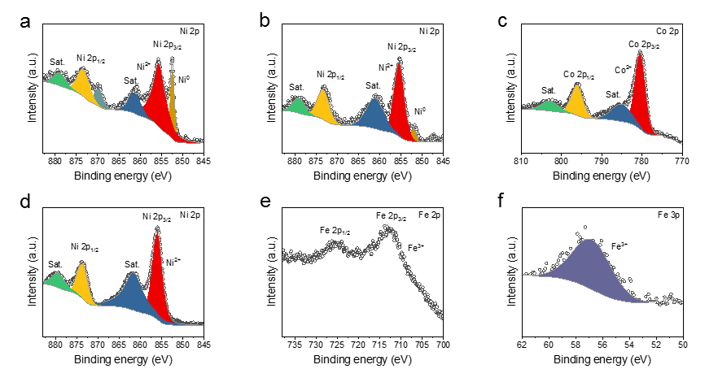
Supplementary Figure 8: X-ray photoelectron spectroscopy imaging of Ni based anodes. (a) Spectra for bare Ni foam anode in Ni 2p. (b,c) Spectra for CoO_{x}/Ni foam anode in the (b) Ni 2p and (c) Co 2p energies. CoO_{x} was measured at a loading of 7.3 atomic %. (d-f) Spectra for NiFeO_{x}/Ni foam in (d) Ni 2p, (e) Fe 2p, and (f) Fe 3p energies. Fe was loaded onto Ni foam at a loading of 8.9 atomic %.
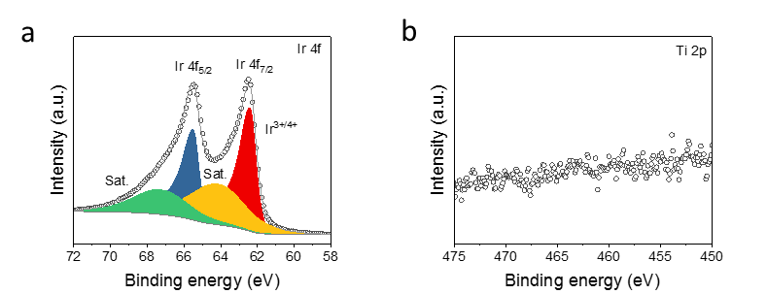
Supplementary Figure 9: X-ray photoelectron spectroscopy for IrO_{x} deposited on Ti felt. (a) Ir 4f and (b) Ti 2p spectrum. Absence of Ti signal indicates full coverage of Ti felt, exposing only IrO_{x} for activity.
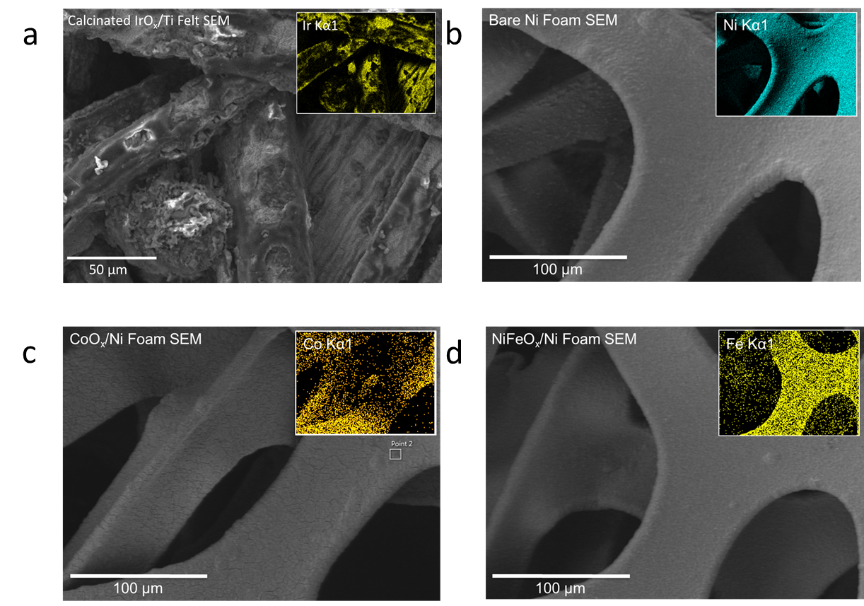
Supplementary Figure 10: Scanning electron microscopy, energy dispersive X-ray analysis for anodes. (a) Scanning electron microscopy image for calcinated IrO_{x} on titanium felt. Inlay is the energy dispersive X-ray measurement of the deposited species, Ir. (b) Scanning electron microscopy image for bare Ni foam. Inlay is the energy dispersive X-ray measurement of the bare Ni Foam. (c) Scanning electron microscopy image for electrodeposited CoO_{x} on Ni foam. Inlay is the energy dispersive x-ray measurement of deposited Co. (d) Scanning electron microscopy image of NiFeO_{x} electrodeposited on Ni foam. Inlay is the energy dispersive x-ray measurement of deposited Fe.

Supplementary Figure 11: Impact of ethanol concentration on the activity of a NiFeO_{x}/Ni Foam anode. Experiments were run in H-type cell at a scan rate of 25 mV s⁻¹ from 1 to 1.6 V vs. RHE. Supporting electrolyte was 2 M KOH and listed ethanol concentration.

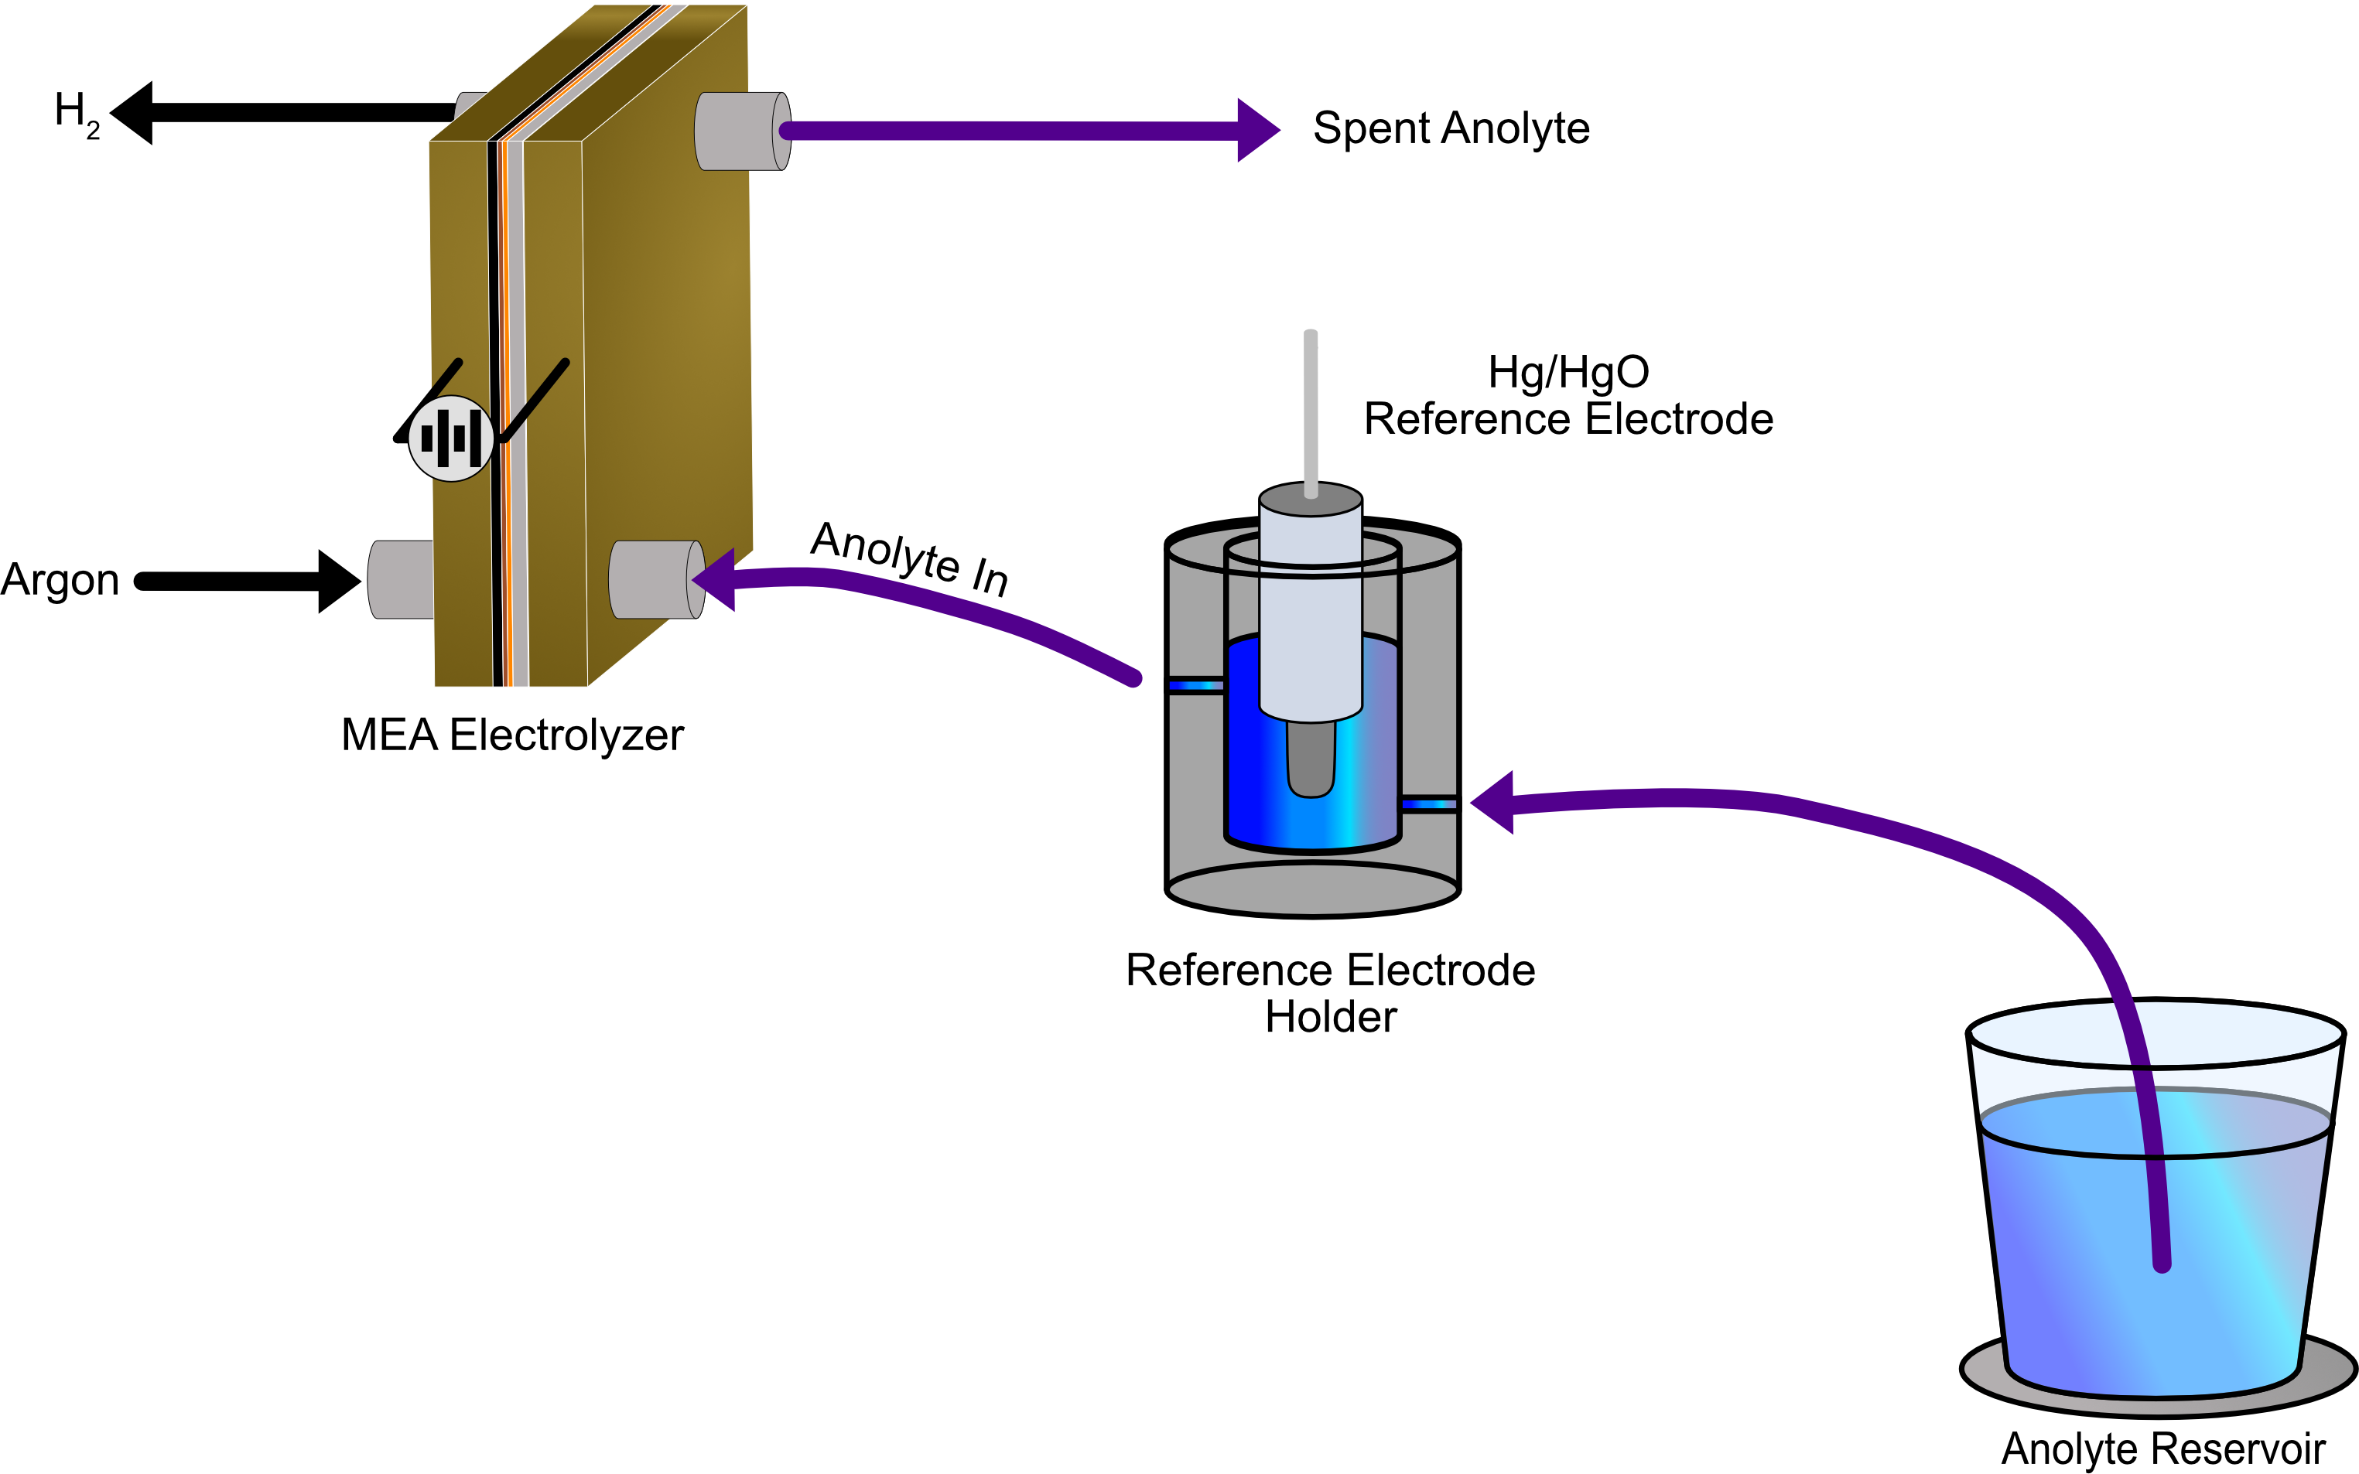
Supplementary Figure 12: Schematic for flow alcohol oxidation experiments. Anolyte (2 M KOH or 2 M KOH + 0.5 M ethanol + 0.5 M n-propanol) is fed through a reference electrode holder prior to the electrolyzer. Using a Luggin Capillary, the potential of the anode is measured in reference to a Hg/HgO electrode.
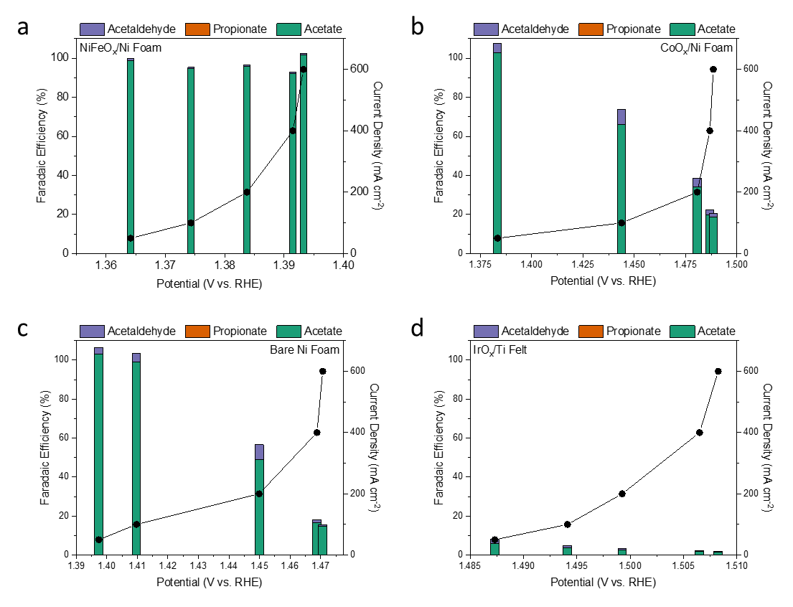
Supplementary Figure 13: Carboxylate Faradaic efficiencies, measured via ¹H-NMR for (a) NiFeO_{x}/Ni Foam, (b) CoO_{x}/Ni Foam, (c) Bare Ni foam, and (d) IrO_{x}/Ti Felt. Experiments were performed in 2 M KOH + 1 M ethanol using a Hg/HgO reference electrode and a Pt/C counter electrode. Cathodic reaction was hydrogen evolution under an argon flow at a rate of 20 sccm. Cell was divided by an FAA-3-50 membrane. Potential was 85% iR corrected.

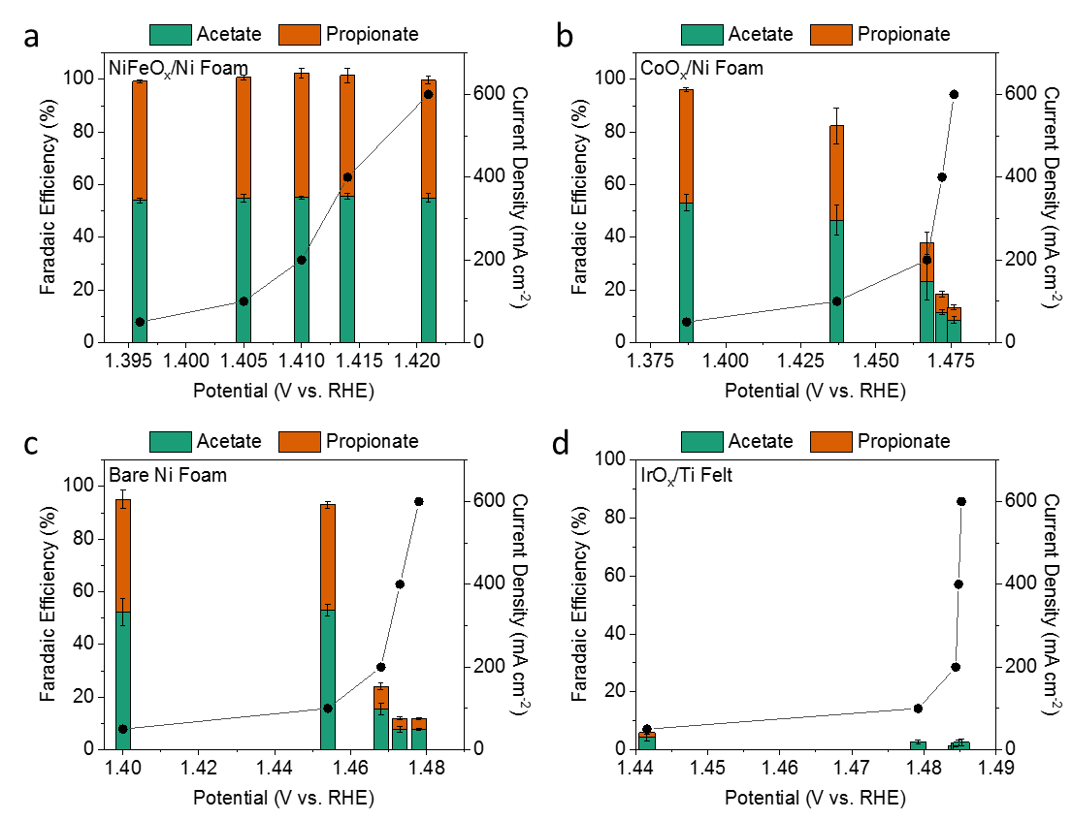
Supplementary Figure 14: Carboxylate Faradaic efficiencies, measured via ¹H-NMR for (a) NiFeO_{x}/Ni Foam, (b) CoO_{x}/Ni Foam, (c) Bare Ni Foam, and (d) IrO_{x}/Ti Felt. Experiments were performed in 2 M KOH + 0.5 M ethanol + 0.5 M n-propanol using a Hg/HgO reference electrode and a Pt/C counter electrode. Cathodic reaction was hydrogen evolution under argon atmosphere. Cell was divided by an FAA-3-50 membrane. Potential was 85% iR corrected and error bars represent standard deviation of three separate experiments.

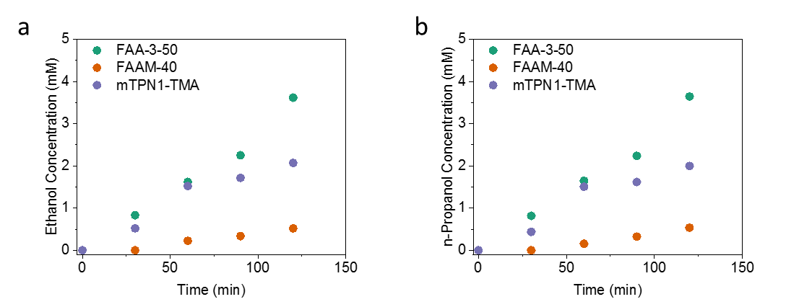
Supplementary Figure 15: Diffusion results for alcohols through varied anion exchange membranes. (a) Measured concentration of ethanol at different times. (b) Measured concentration of n-propanol at different times. The two chambers were separated with the corresponding anion exchange membrane, one containing 2 M KOH and the other 2 M KOH + 0.5 M ethanol + 0.5 M n-propanol. Alcohols were allowed to diffuse exclusively via conduction through the membrane and the concentration was measured every 30 minutes.

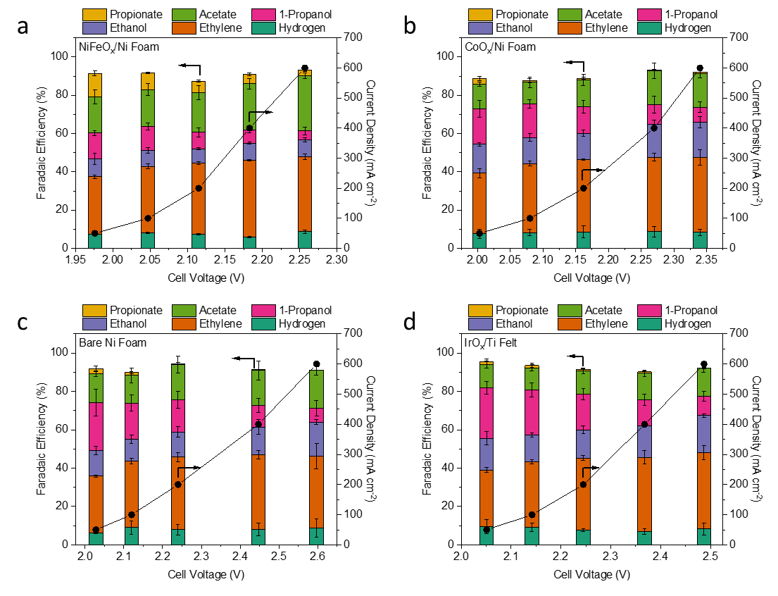
Supplementary Figure 16: Performance curves for (left) Faradaic efficiency and (right) measured current density for different anode catalysts using an FAA-3-50 membrane. All tests used the same design Cu nanoparticle catalyst and anodes were changed after each experiment to either (a) NiFeO_{x}/Ni Foam, (b) CoO_{x}/Ni Foam, (c) Bare Ni Foam, or (d) IrO_{x}/Ti Felt. All tests were performed using 20 sccm CO flow rate at ambient temperature with a set pressure of 15.5 psia. Anolyte was kept constant as 2 M KOH and fed at a rate of 0.5 mL min⁻¹, catholyte was collected in the DI water trap.

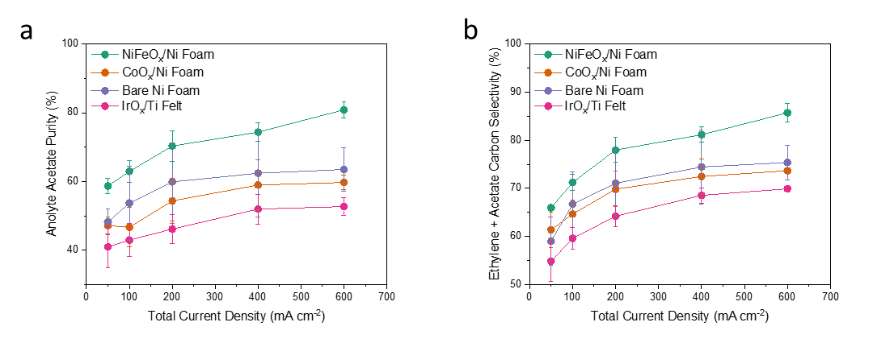
Supplementary Figure 17: (a) Single pass acetate purity in anolyte measured on a mol basis relative to other multicarbon products in the anolyte. (b) Combined carbon selectivity towards acetate and ethylene for all anodes. All experiments were performed with a Cu nanoparticle cathode, a FAA-3-50 membrane, a 2 M KOH anolyte, and a CO flow rate of 20 sccm.

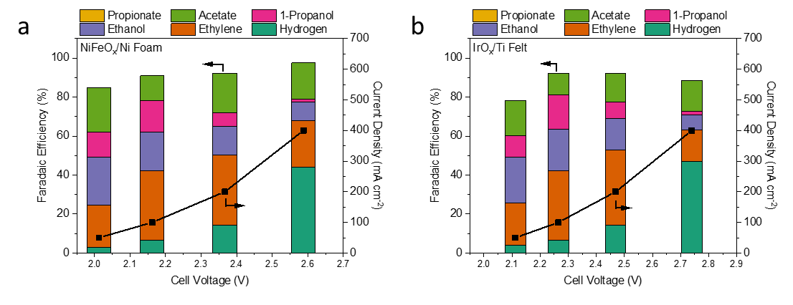
Supplementary Figure 18: Performance curves for (left) Faradaic efficiency and (right) measured current density for different anode catalysts using FAAM-40 membrane. All tests used the same design Cu nanoparticle catalyst and anodes were changed after each experiment to either (a) NiFeO_{x}/Ni Foam or (b) IrO_{x}/Ti Felt. All tests were performed using a CO flow rate of 20 sccm at ambient temperature at a fixed pressure of 15.5 psia. Anolyte was kept constant as 2 M KOH and fed at a rate of 0.5 mL min⁻¹, catholyte was collected in the DI water trap.
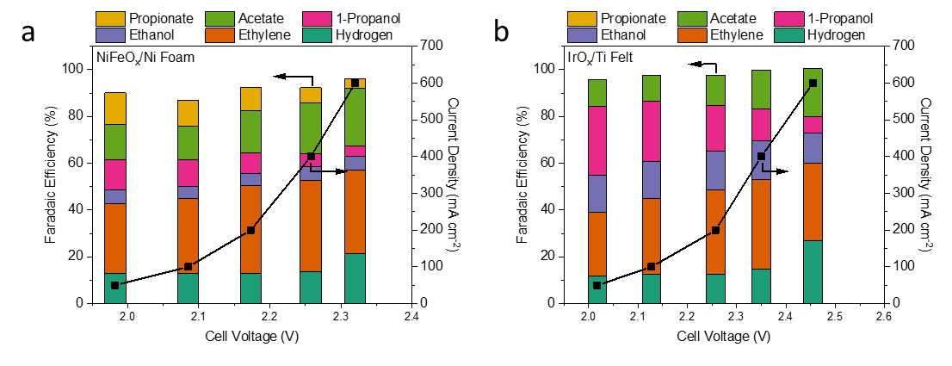
Supplementary Figure 19: Performance curves for (left) Faradaic efficiency and (right) measured current density for different anode catalysts with a mTPN1-TMA membrane. All tests used the same design Cu nanoparticle catalyst and anodes were changed after each experiment to either (a) NiFeO_{x}/Ni foam or (b) IrO_{x}/Ti felt. All tests were performed using a CO flow rate of 20 sccm at ambient temperature at a set pressure of 15.5 psia. Anolyte was kept constant as 2 M KOH and fed at a rate of 0.5 mL min⁻¹, catholyte was collected in the DI water trap.

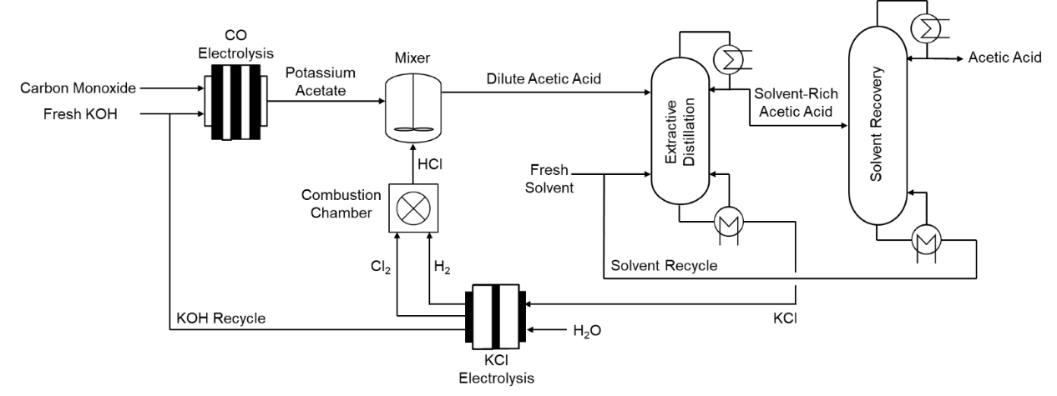
Supplementary Figure 20: Process flow diagram for 1-10 M acetate at electrolyzer outlet.

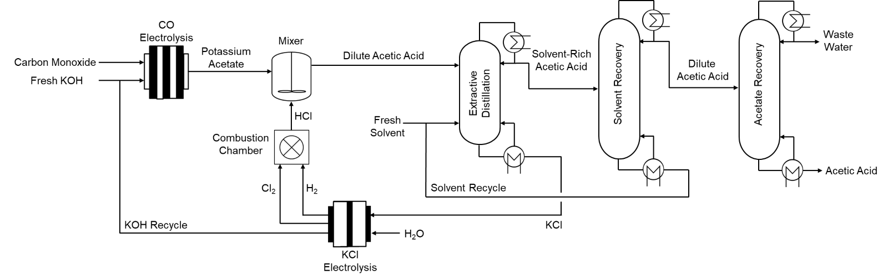
Supplementary Figure 21: Process flow diagram for 0.1 M acetate at electrolyzer outlet.

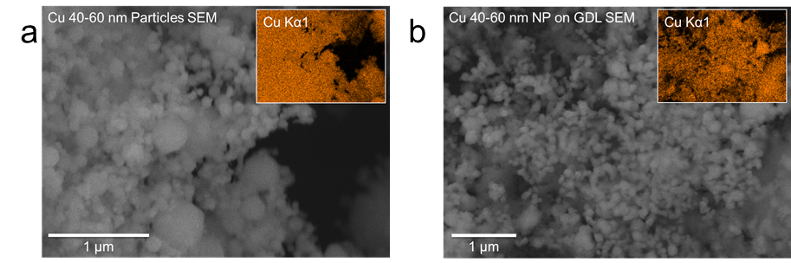
Supplementary Figure 22: Scanning electron microscopy, energy dispersive X-ray analysis for cathode. (a) Scanning electron microscopy image for commercial 40-60 nm Cu nanoparticles. Inlay is the energy dispersive X-ray measurement for Cu. (b) Scanning electron microscopy image for commercial 40-60 nm Cu nanoparticles deposited on carbon gas diffusion layer (GDL). Inlay is the energy dispersive X-ray measurement for Cu.
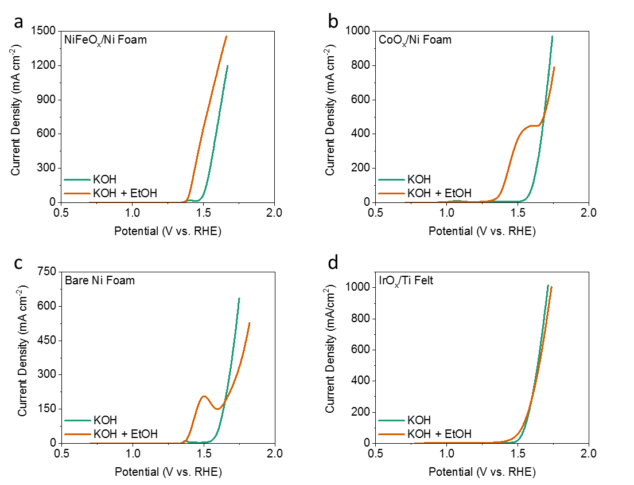
Supplementary Figure 23: Linear sweep voltammograms for anodes. Linear sweep voltammograms for (a) NiFeO_{x}/Ni Foam, (b) CoO_{x}/Ni Foam, (c) Bare Ni Foam, (d) IrO_{x}/Ti Felt. All voltammograms were recorded in either 1 M KOH (green) or 1 M KOH + 1 M ethanol (orange) at a sweep rate of 25 mV s⁻¹. An FAA-3-50 membrane was used to divide the H-cell along with a Pt wire counter electrode and a Hg/HgO reference electrode. All potentials were 85 % iR corrected based on resistance measured via i-interrupt.

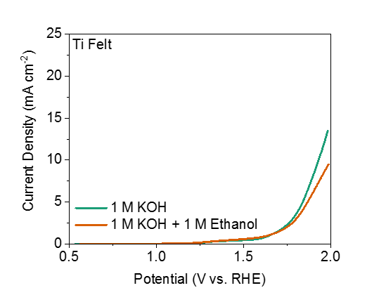
Supplementary Figure 24: Linear sweep voltammograms for anodes. Linear sweep voltammograms for bare Ti felt. Voltammogram was recorded in either 1 M KOH (green) or 1 M KOH + 1 M ethanol (orange) at a sweep rate of 25 mV s⁻¹. An FAA-3-50 membrane was used to divide the H-cell along with a Pt wire counter electrode and a Hg/HgO reference electrode. Applied potential was 85 % iR corrected based on resistance measured via i-interrupt.
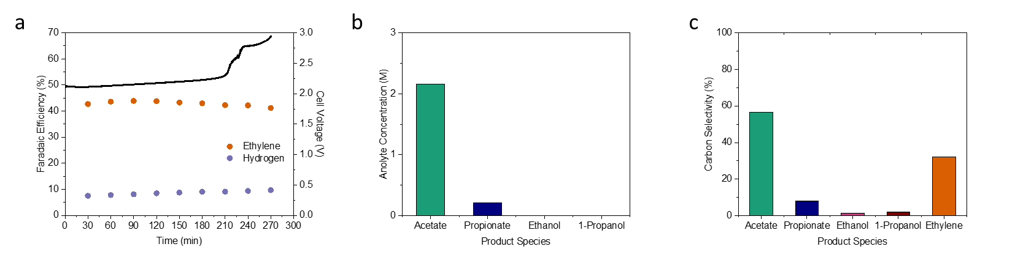
Supplementary Figure 25: Maximum concentration of acetate before degradation is observed for CO electroreduction in an MEA system. (a) Performance metrics for CO reduction electrolyzer using 2 M KOH and FAA-3-50 membrane with 10 sccm CO flow rate. (b) Carbon selectivity of all multi-carbon products from electrochemical CO reduction. (c) Maximum achieved anolyte concentration of dissolved liquid products before accelerated degradation was observed.

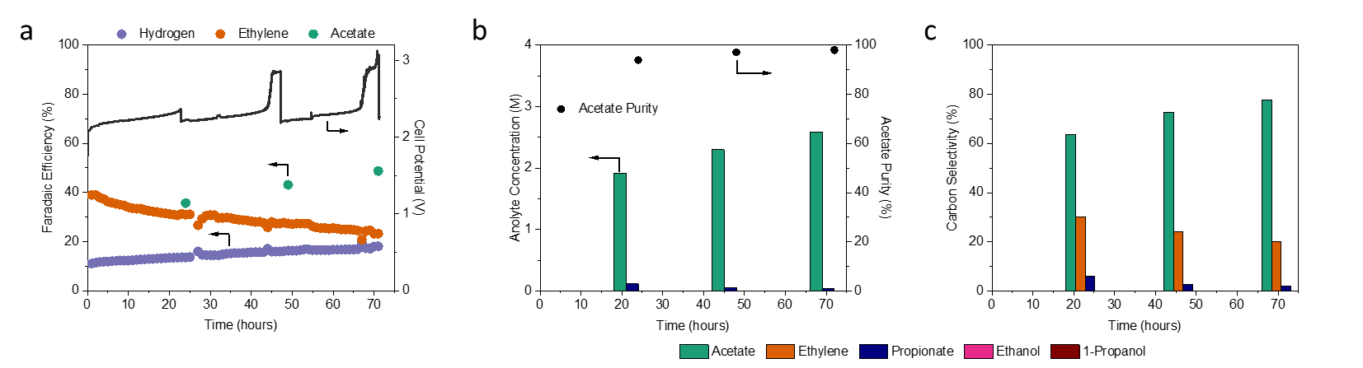
Supplementary Figure 26: Production of concentrated acetate streams via eCOR using FAA-3-50 membrane. (a) Performance of eCOR system, Faradaic efficiency (left) of acetate hydrogen and ethylene and total cell voltage measured (right). (b) Measure of anolyte concentrations (left) and purity (right) of all liquid products detected. (c) Carbon selectivity of all multi-carbon products, ethylene is the average over the period in which the anolyte was collected. Experiments were performed using 2 M KOH, 10 sccm CO feed, and 50 mL recirculated electrolyte. Cell current was held constant at 200 mA cm⁻² and anolyte was replaced every 24 hours. Membrane was ruptured after 71 hours allowing oxygen to cross over, causing cell failure.
Supplementary Figure 27: Durability of CO electroreduction in an MEA using FAA-3-50 membrane and 3 M KOH. Experiment was done using a 50 mL electrolyte replaced every 24 hours, NiFeO_{x}/Ni Foam anode, Cu nanoparticle cathode, and a CO flow rate of 10 sccm. Current density was fixed at 200 mA cm⁻². Pink arrow indicated where membrane rupture occurred, leading to instability in cell voltage and crossover of oxygen, indicated by a loss of cathode detected Faradaic efficiency and sudden drop in cell potential.

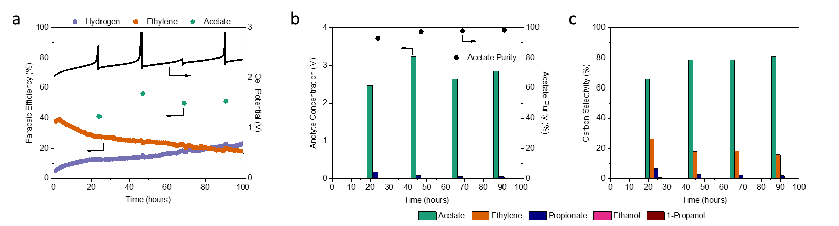
Supplementary Figure 28: Production of concentrated acetate streams via eCOR using mTPN1-TMA membrane. (a) Performance of eCOR system, Faradaic efficiency (left) of acetate hydrogen and ethylene and total cell voltage measured (right). (b) Measure of anolyte concentrations (left) and purity (right) of all liquid products detected. (c) Carbon selectivity of all multi-carbon products, ethylene is the average over the period in which the anolyte was collected. Experiments were performed using 3 M KOH, 10 sccm CO feed, and 50 mL recirculated electrolyte. Cell current was held constant at 200 mA cm⁻² and anolyte was replaced every 24 hours.
Supplementary Figure 29: Measured conversion of fed CO via eCOR during CO electrolysis in long term operation of electrolyzer. Conversion was determined via volumetric flow rate comparison of inlet and outlet CO. The cell was operated with 3 M KOH at 200 mA cm⁻² with a fixed flow rate of 10 sccm using mTPN1-TMA membrane in 100 hour durability experiment.
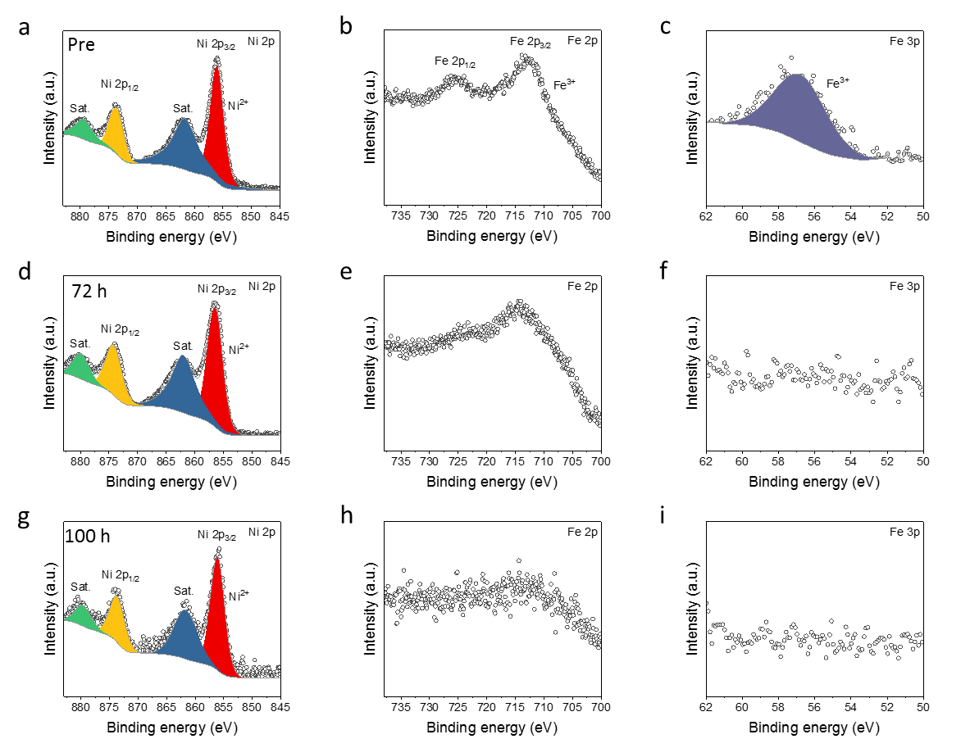
Supplementary Figure 30: Pre and Post reaction X-ray photoelectron spectroscopy of NiFeO_{x}/Ni Foam anodes during long term durability testing. (a) Ni 2p, (b) Fe 2p, and (c) Fe 3p spectrum for pre-reaction sample. (d) Ni 2p, (e) Fe 2p, and (f) Fe 3p spectrum for post-reaction sample for 72-hour experiment using FAA-3-50 membrane. (g) Ni 2p, (h) Fe 2p, and (i) Fe 3p spectrum for post-reaction sample for 100-hour durability test using mTPN1-TMA membrane.
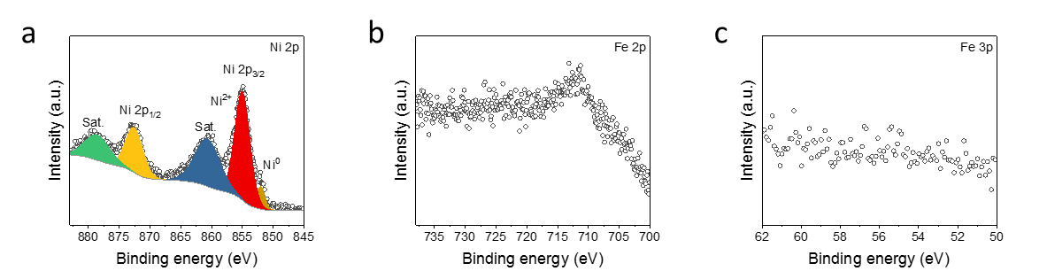
Supplementary Figure 31: Post reaction X-ray photoelectron spectroscopy of NiFeO_{x}/Ni Foam anodes during acidification experiment. (a) Ni 2p, (b) Fe 2p, and (c) Fe 3p spectrum for acidified sample using AMX membrane. It is evident that all Fe content is lost.

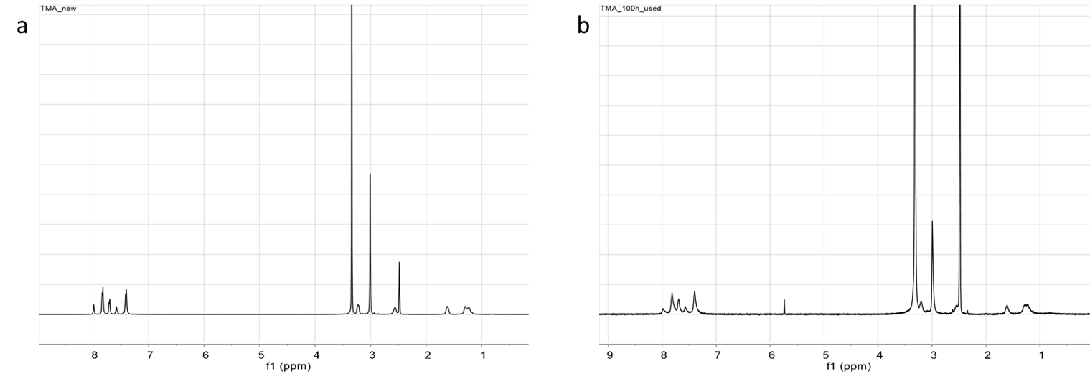
Supplementary Figure 32: Pre and Post reaction ¹H NMR of mTPN1-TMA membrane. (a) Pre reaction, i.e. fresh, mTPN1-TMA, (b) post-reaction ¹H NMR. Change in functional group peak height shows a 10% loss in functionality of the membrane.
Supplementary Figure 33: Measurement of O₂ Faradaic Efficiency from anode. Measured O₂ Faradaic Efficiency (left) and the percent of the expected shift (right) compared to values determined from comparison of NiFeO_{x}/Ni and IrO_{x}/Ti anodes. Values shown are for NiFeO_{x}/Ni anode. At >200 mA cm⁻² over 80% of expected missing O₂ FE is detected.

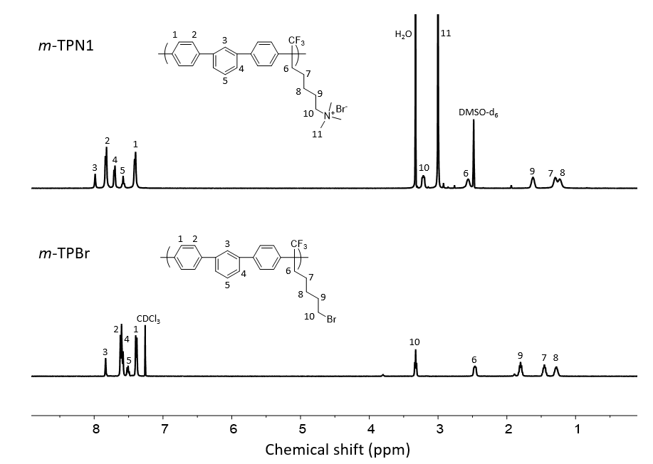
Supplementary Figure 34: ¹H NMR spectra of mTPN1-TMA (top) and mTPBr (bottom).

Supplementary Table 1: Summary of recent CO reduction systems performance
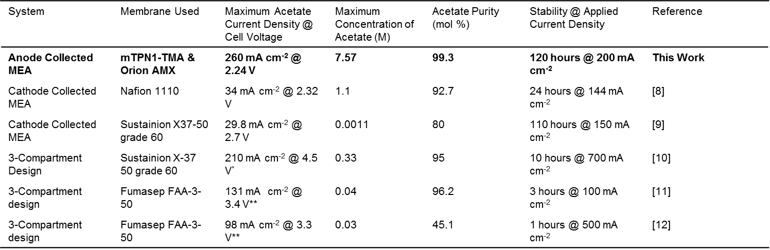
* iR-compensated full cell voltage
** Estimated full cell voltage based off comparison of half-cell and full cell potential using electrolyzer design

Supplementary Table 2: Key membrane properties for those used in experiments (information provided by manufacturer).
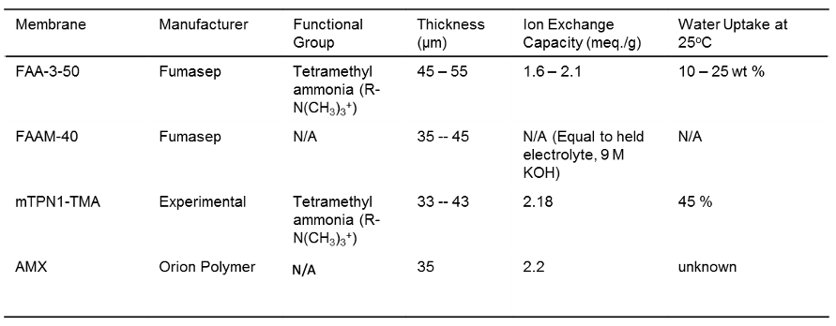

Supplementary Table 3: Adjusted parameters from previously published electrochemical production model.¹³
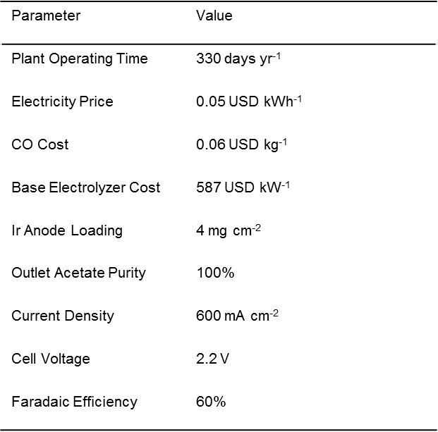
Supplementary Table 4: In-plane hydroxide conductivity of mTPN1-TMA in water
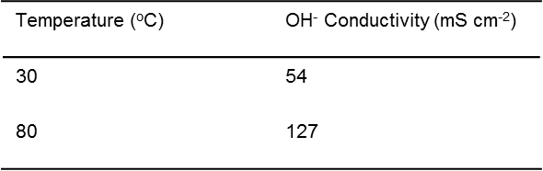

Supplementary Table 5: Estimation of KOH regeneration/acetate protonation costs with an electricity cost of $0.05/kWh
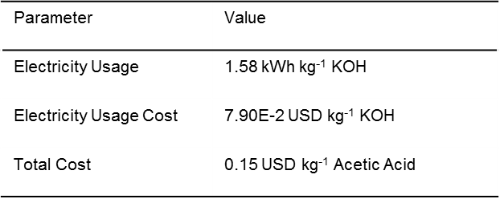

References:
1. Meek, K. M. et al. High-Throughput Anion Exchange Membrane Characterization at NREL. ECS Trans. 92, 723–731 (2019).
2. Kim, B., Hillman, F., Ariyoshi, M., Fujikawa, S. & Kenis, P. J. A. Effects of composition of the micro porous layer and the substrate on performance in the electrochemical reduction of CO₂ to CO. J. Power Sources 312, 192–198 (2016).
3. Lee, W. H. et al. Poly(terphenylene) Anion Exchange Membranes: The Effect of Backbone Structure on Morphology and Membrane Property. ACS Macro Lett. 6, 566–570 (2017).
4. Eurochlor. The European Chlor-Alkali industry: an electricity intensive sector exposed to carbon leakage. (2010).
5. U.S. Department of Energy, O. of E. E. and R. E. Advanced Chlor-Alkali Technology. Industrial Technologies Program. (2004).
6. Kiros, Y. & Bursell, M. Low energy consumption in chlor-alkali cells using oxygen reduction electrodes. Int. J. Electrochem. Sci. 3, 444–451 (2008).
7. Eurochlor. The Electrolysis process and the real costs of production. (2018).
8. Ripatti, D. S., Veltman, T. R. & Kanan, M. W. Carbon Monoxide Gas Diffusion Electrolysis that Produces Concentrated C₂ Products with High Single-Pass Conversion. Joule 3, 240–256 (2019).
9. Ozden, A. et al. Cascade CO₂ electroreduction enables efficient carbonate-free production of ethylene. Joule 5, 706–719 (2021).
10. Zhu, P. et al. Direct and continuous generation of pure acetic acid solutions via electrocatalytic carbon monoxide reduction. PNAS 118, e2010868118 (2021)
11. Luc, W. et al. Two-dimensional copper nanosheets for electrochemical reduction of carbon monoxide to acetate. Nat. Catal. 2, 423–430 (2019).
12. Jouny, M., Luc, W. & Jiao, F. High-rate electroreduction of carbon monoxide to multi-carbon products. Nat. Catal. 1, 748–755 (2018).
13. Shin, H., Kentaro, H. & Jiao, F. Techno-economic assessment of low-temperature carbon dioxide electrolysis. Nat. Sustain. 4, 911–919 (2021).

