Supplementary Material

Supplementary Table 1. Effects of socket wear time on the outcome metrics during the three-hour testing. Bold text indicates statistical significance.
 | Outcome Metric | Slope | R² | t-value | p-value
LEFT ARM
BBT | Number of Blocks | 4.80 x 10⁻³ | 0.154 | 0.954 | 0.038
BBT | Number of Transient Bouts | 2.26 x 10⁻² | 0.108 | 0.778 | 0.472
BBT | Percent of Frames Classified as Point | 2.00 x 10⁻⁴ | 0.001 | 0.177 | 0.868
tBBT | Completion Time (seconds) | -1.37 x 10⁻² | 0.139 | -0.897 | 0.411
tBBT | Number of Transient Bouts | -2.86 x 10⁻² | 0.332 | -1.576 | 0.176
tBBT | Percent of Frames Classified as Point | 6.07 x 10⁻⁴ | 0.076 | -0.641 | 0.550
Rainbow | Completion Time (seconds) | -6.96 x 10⁻² | 0.610 | -2.797 | 0.381
Rainbow | Number of Transient Bouts | 3.45 x 10⁻² | 0.657 | 3.095 | 0.027
Rainbow | Percent of Frames Classified as Point | 4.82 x 10⁻³ | 0.169 | 1.008 | 0.360
RIGHT ARM
BBT | Number of Blocks | 1.070 x 10⁻² | 0.052 | 0.523 | 0.632
 | Number of Transient Bouts | 3.810 x 10⁻² | 0.129 | 0.861 | 0.429
 | Percent of Frames Classified as Point | 5.360 x 10⁻⁴ | 0.375 | 1.732 | 0.144
tBBT | Completion Time (seconds) | -2.950 x 10⁻² | 0.753 | -3.902 | 0.011
 | Number of Transient Bouts | 4.880 x 10⁻² | 0.557 | 2.509 | 0.054
 | Percent of Frames Classified as Point | 7.140 x 10⁻⁴ | 0.375 | 1.732 | 0.144
Rainbow | Completion Time (seconds) | -2.120 x 10⁻² | 0.559 | -2.519 | 0.053
 | Number of Transient Bouts | 1.310 x 10⁻² | 0.140 | 0.902 | 0.408
 | Percent of Frames Classified as Point | 3.330 x 10⁻⁴ | 0.037 | 0.438 | 0.680

Supplementary Figure 1. Locations of the seven positions used during static training. Dimensions were measured from the center of each 10 x 10 cm square. The rows were located at the participant's head height, sternum height, and anterior superior iliac spine (ASIS) height. The columns were separated by a distance equivalent to the participant's shoulder width (30.5 cm).

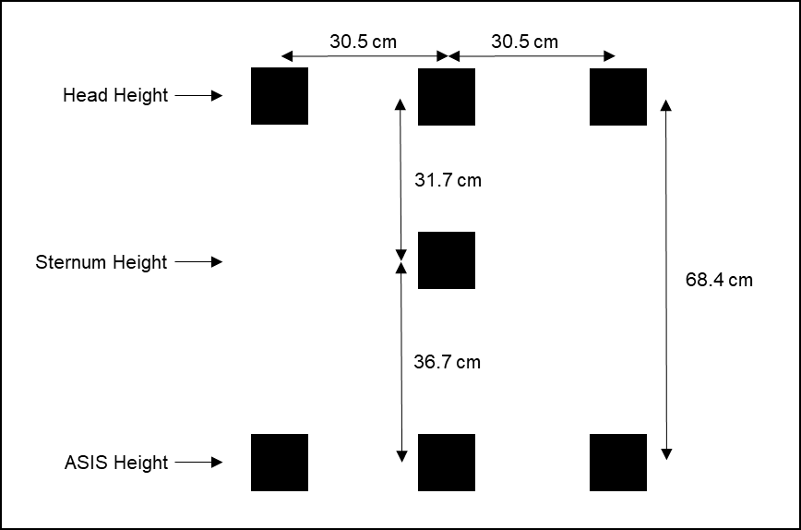
Supplementary Figure 2. Dimensions for the Rainbow Test were measured from the center of each 7.62 x 7.62 cm square. The collection box was placed at the height of the participant's anterior superior iliac spine.
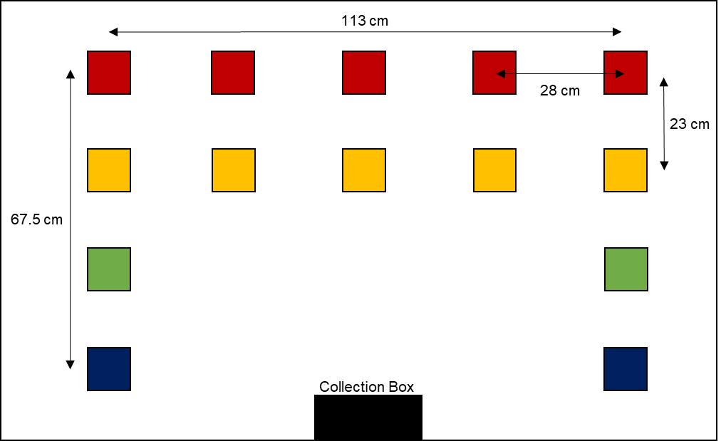

Supplementary Figure 3. Total latency from volitional muscle activation to TASKA prosthesis activation was approximated using two accelerometers. One accelerometer was placed on an able-bodied individual’s index finger and the other was placed on TASKA hand’s index finger in similar orientations. A classifier was trained on index finger flexion and the time difference between movement onsets was obtained from the z-axis acceleration based on visual inspection. A sample latency point extracted from the data is shown in plot.
