Table 1. Characteristics of included studies.
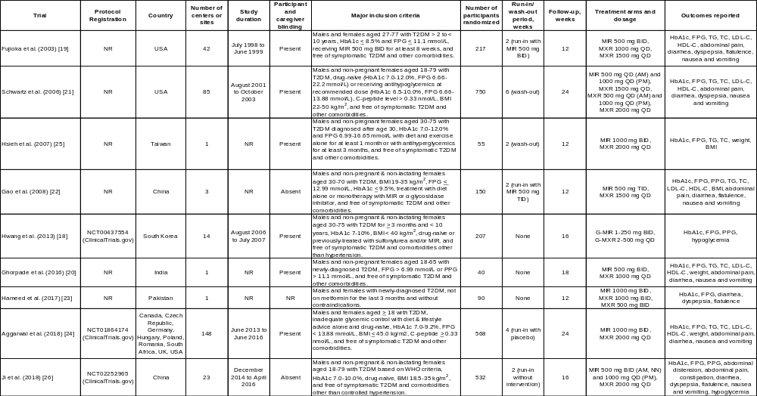
Abbreviations: AM, morning; BID, twice daily; BMI, body mass index; FPG, fasting plasma sugar; G-MIR, glimepiride-metformin immediate-release combination; G-MXR, glimepiride-metformin extended-release combination; HbA1c, hemoglobin A1c; MIR, metformin immediate-release; MXR, metformin extended-release; NN, noontime; NR, not reported; PM, evening; QD, once daily; T2DM, type 2 diabetes mellitus; UK, United Kingdom; USA, United States of America.

Table 2. Baseline characteristics of participants in the included studies.
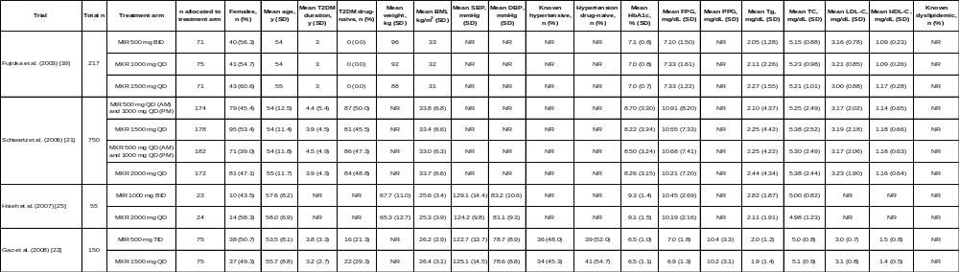
Abbreviations: BID, twice daily; BMI, body mass index; DBP, diastolic blood pressure; FPG, fasting plasma sugar; HbA1c, hemoglobin A1c; HDL-C, serum high-density lipoprotein-cholesterol; LDL-C, serum low-density lipoprotein-cholesterol; MIR, metformin immediate-release; MXR, metformin extended-release; NR, not reported; PM, evening; PPG, post-prandial plasma glucose at 2 hours; QD, once daily; SBP, systolic blood pressure; SD, standard deviation; TC, serum total cholesterol; Tg, serum triglycerides; T2DM, type 2 diabetes mellitus; y, year.

Table 2. Baseline characteristics of participants in the included studies (continued).
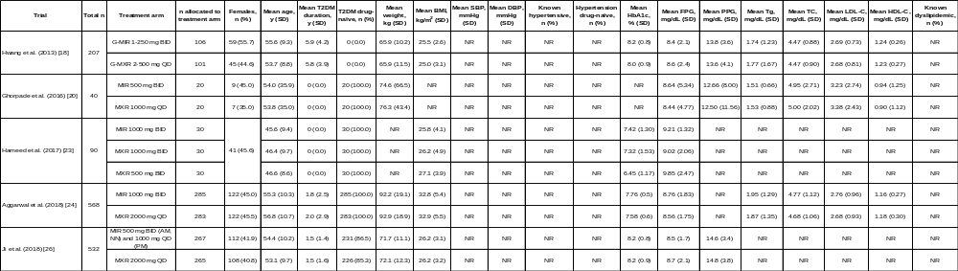
Abbreviations: BID, twice daily; BMI, body mass index; DBP, diastolic blood pressure; FPG, fasting plasma sugar; G-MIR, glimepiride-metformin immediate-release combination; G-MXR, glimepiride-metformin extended-release combination; HbA1c, hemoglobin A1c; HDL-C, high-density lipoprotein-cholesterol; LDL-C, low-density lipoprotein-cholesterol; MIR, metformin immediate-release; MXR, metformin extended-release; NN, noontime; NR, not reported; PM, evening; PPG, post-prandial glucose at 2 hours; QD, once daily; SBP, systolic blood pressure; SD, standard deviation; TC, total cholesterol; Tg, triglyceride; T2DM, type 2 diabetes mellitus; y, year.

Table 3. Summary of findings.
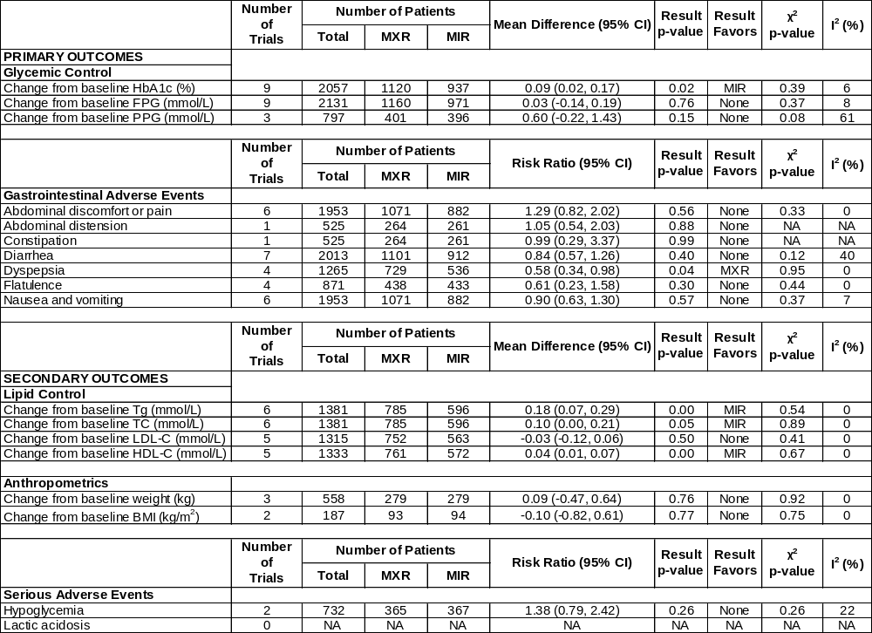
Abbreviations: BMI, body mass index; FPG, fasting plasma sugar; HbA1c, hemoglobin A1c; HDL-C, serum high-density lipoprotein-cholesterol; LDL-C, serum low-density lipoprotein-cholesterol; MIR, metformin immediate-release; MXR, metformin extended-release; PPG, post-prandial glucose at 2 hours; NA, not available; TC, serum total cholesterol; Tg, serum triglycerides.

