SUPPLEMENTARY MATERIAL

Abrilla AA, Pajes ANNI, Jimeno CA. Metformin extended-release versus metformin immediate-release for adults with type 2 diabetes mellitus: a systematic review and meta-analysis of randomized controlled trials.

Supplement 1: Original Protocol

Supplement 2: Protocol Deviations

Supplement 3: Search Strategy

Supplement 4: Impact of Standard Deviation Imputations Involving Schwartz et al. (2006) [1]

Supplement 5: Risk of Bias (RoB) Assessment

Supplement 6: Funnel Plot

Supplement 7: Forest Plots for Considered Outcomes

Supplement 8: Sensitivity Analyses

Supplementary Material References

SUPPLEMENT 1: ORIGINAL PROTOCOL

Protocol location:
Aedrian Abrilla, A. Nico Nahar Pajes, Cecilia Jimeno. Metformin extended-release versus metformin immediate-release for type 2 diabetes mellitus in adults: a systematic review and meta-analysis. PROSPERO 2019 CRD42019148008 Available from: https://www.crd.york.ac.uk/prospero/display_record.php?ID=CRD42019148008.

Review question
Among adults with type 2 diabetes mellitus, does metformin extended-release provide metabolic control similar to that of metformin immediate-release?

Among adults with type 2 diabetes mellitus, is metformin extended-release as safe and/or tolerable as metformin immediate-release?

Searches
MEDLINE, The Cochrane Library, and ClinicalTrials.gov will be searched for bibliographic details of studies. Unpublished results will be sought by contacting the authors. Medical subject heading (MeSH) and free-text terms will be used in each database with terms related to the aforementioned intervention. Bibliographic lists of selected studies will also be screened for eligible reports. There will be no date, language and study design restriction in the search.

A manual search will be performed to identify relevant references from selected articles and published reviews. Free-hand searching inside and outside the electronic databases will also be performed. Print-only journals and conference proceedings of related fields will be sought.

Types of study to be included
Randomized controlled trials

Condition or domain being studied
Type 2 diabetes mellitus

Participants/population
Studies of adults (18 years old and above) diagnosed with type 2 diabetes mellitus through any standard criteria will be considered. Studies involving subjects with end-stage organ diseases will be excluded.

Intervention(s), exposure(s)
Metformin extended-release with or without co-intervention

Comparator(s)/control
Metformin immediate-release with or without co-intervention

Main outcome(s)
Primary outcomes will include glycemic control parameters such as glycated hemoglobin or hemoglobin A1c (HbA1c) and fasting and post-prandial blood glucose levels, and gastrointestinal (GI) adverse events such as abdominal distension, abdominal pain, constipation, diarrhea, dyspepsia, flatulence, and nausea and vomiting. These outcomes will not be a part of the eligibility criteria.

* Measures of effect
At least 12 weeks

Additional outcome(s)
Secondary outcomes will include lipid profile; anthropometric parameters such as weight and body mass index (BMI); and serious adverse events such as hypoglycemia and lactic acidosis.

* Measures of effect
At least 12 weeks

Data extraction (selection and coding)
Items in the initial search will be scanned through titles and abstracts to remove irrelevant articles and duplicates. Two reviewers will review, select and exclude studies independently. The criteria for selection will be extracted and documented. Disagreements between the two will be resolved by discussion or through a third party if necessary. The selection process will be illustrated in the final report using a Preferred Reporting Items for Systematic Reviews and Meta-Analysis (PRISMA) flow diagram.

The following data will be sought from each included study, as prescribed in the Cochrane Handbook for Systematic Reviews of Interventions:
• Source: study ID by the review authors, citation, contact details
• Eligibility: confirmation of eligibility for review or reason for exclusion
• Methods: study design, total study duration, sequence generation, allocation sequence concealment, blinding, other concerns about bias
• Participants: total number, setting, diagnostic criteria, age, sex, country, co-morbidity, socio-demographics, ethnicity, date of study
• Interventions: total number of intervention groups; for each intervention group: specific intervention, intervention details
• Outcomes: outcomes and time points collected and reported; for each outcome of interest: outcome definition, unit of measurement
• Results: number of participants allocated to each intervention group; for each outcome of interest: sample size, missing participants, summary date for each intervention group, estimate of effect with confidence interval with reported p-value, subgroup analyses if any

Any missing information will be sought through correspondence with the study authors. Two reviewers will independently extract data from included studies, with disagreements resolved through discussion or through a third party, if necessary.

Risk of bias (quality) assessment
The review authors will independently assess, with discrepancies resolved through discussion or through a third party, the risk of bias in each selected studies using the Cochrane Collaboration’s tool for the said purpose. The results of the assessment will be illustrated through summary figures generated with Review Manager (RevMan) version 5.3.5.

Strategy for data synthesis
Qualitative synthesis of data will be performed in narrative writing, with focus on pertinent data sought from the studies. Quantitative analysis, particularly meta-analysis using a random effects model, will be performed should sufficient homogeneity in design is assessed throughout the included studies. Review Manager (RevMan) version 5.3.5 will be used for these purposes.

For dichotomous (binary) outcomes, the odds ratio (OR) will be generated. For continuous outcomes, mean difference (MD) of change from baseline values with the effect size and the 95% confidence interval (CI) will be generated.

Aggregated outcome data, from each participant in the studies as the unit of analysis, will be used.

Heterogeneity in effect measures in included studies will be evaluated using both the χ² and I² tests. For the latter, a cut-off point of 50% will be set to indicate substantial heterogeneity.

Reporting bias will be evaluated using funnel plots and Egger's test, especially if the number of included studies for quantitative analysis reaches at least ten.

To evaluate the robustness of findings, a sensitivity analysis will be conducted based on (1) quality components, including full-text publications versus abstracts-only, preliminary results versus mature results, published data versus unpublished data, (2) risk of bias (high risk, unclear risk, low risk) per particular domain, (3) and random-effects versus fixed-effect models. The robustness of the pooled mean differences will also be assessed by eliminating one included study at a time. Post-hoc sensitivity analyses, if any, will be explicitly specified as such in the final report.

Analysis of subgroups or subsets
Subgroup analysis will be performed to explore possible sources of heterogeneity, based on the following: daily total metformin dose and presence (or absence) of co-intervention. Post-hoc subgroup analyses and investigations of heterogeneity, if any, will be explicitly specified as such in the final report.

SUPPLEMENT 2: PROTOCOL DEVIATIONS

1. Review Manager version 5.4.0, rather than version 5.3.5, was used in the final analyses.

2. The measure of association between two dichotomous or dichotomous variables used was relative risk or risk ratio (RR), rather than odds ratio (OR). We made this change since RR is easier to interpret, more appropriate because the temporal sequence between intervention and measured outcomes can be established, and does not unnecessarily “pull” the estimate value farther to the null compared to OR.

3. Egger test was not performed, since the number of included studies did not reach ten. The funnel plot generated was deemed inconclusive for publication bias as well.

4. A priori sensitivity analyses in terms of quality components (full-text versus abstracts-only, preliminary versus mature results, published versus unpublished) and meta-analytical models (fixed-effect versus random effects models) were not performed, since (1) all included studies were published, with full-text versions available, reporting mature data and (2) random effects model was decided to be more appropriate given the heterogeneity found in at least some of the outcomes analyzed. No post-hoc sensitivity analysis was performed.

5. Imputation techniques for study standard deviation values that are either missing or deemed too large were sought and finalized after the original protocol was published.

SUPPLEMENT 3: SEARCH STRATEGY

- Search string for PubMed and ClinicalTrials.gov:
("metformin") AND ("extended release" OR "XR" OR "sustained release" OR "slow release" OR "SR" OR "gastric retention" OR "GR")

- Search string for The Cochrane Library:
“metformin” AND “release”
Supplement 4: Impact of Standard Deviation IMPUTATIONS INVOLVING Schwartz et al. (2006) [1]

Table S4.1. Comparison of results for the outcome: mean difference (MD) in change from baseline hemoglobin A1c (HbA1c) without and with SD imputation for Schwartz et al. (2006) [1].
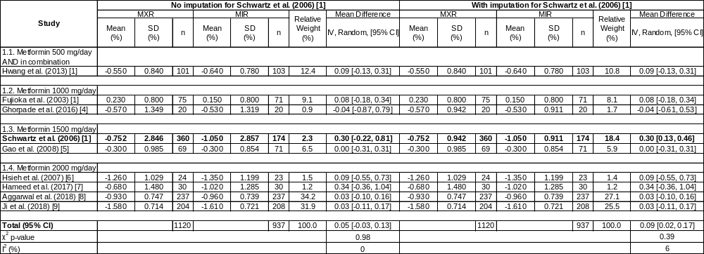
Abbreviations: CI, confidence interval; IV, inverse variance; MIR, metformin immediate-release; MXR, metformin extended-release; SD, standard deviation.

Table S4.2. Comparison of results for the outcome: MD in change from baseline fasting plasma glucose (FPG) without and with SD imputation for Schwartz et al. (2006) [1].
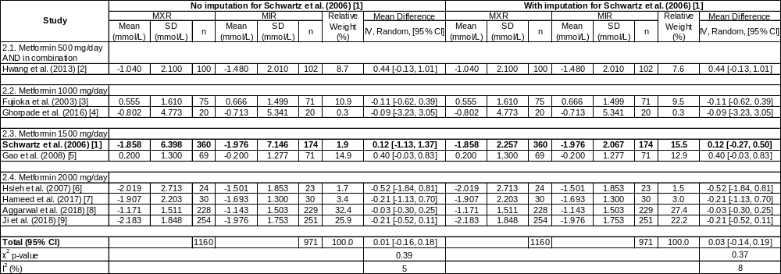
Abbreviations: CI, confidence interval; IV, inverse variance; MIR, metformin immediate-release; MXR, metformin extended-release; SD, standard deviation.

Table S4.3. Comparison of results for the outcome: MD in change from baseline serum triglycerides (Tg) without and with SD imputation for Schwartz et al. (2006) [1].
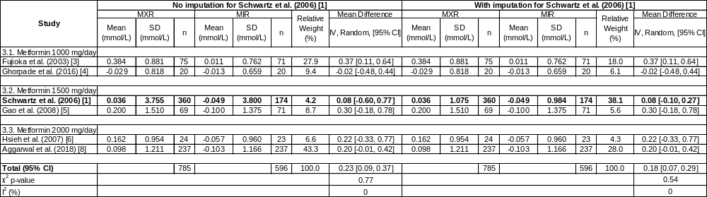
Abbreviations: CI, confidence interval; IV, inverse variance; MIR, metformin immediate-release; MXR, metformin extended-release; SD, standard deviation.

Table S4.4. Comparison of results for the outcome: MD in change from baseline serum total cholesterol (TC) without and with SD imputation for Schwartz et al. (2006) [1].
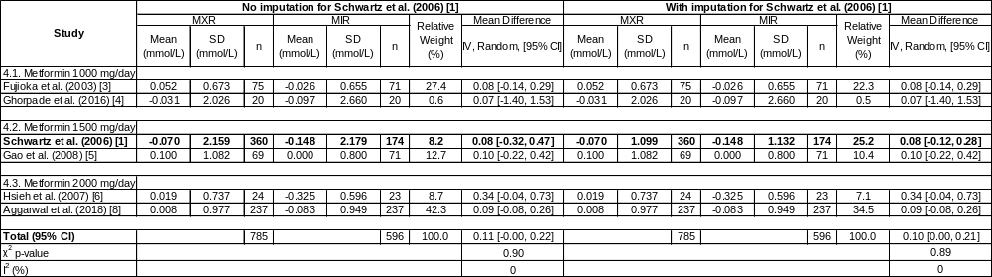
Abbreviations: CI, confidence interval; IV, inverse variance; MIR, metformin immediate-release; MXR, metformin extended-release; SD, standard deviation.

Table S4.5. Comparison of results for the outcome: MD in change from baseline serum low-density lipoprotein-cholesterol (LDL-C) without and with SD imputation for Schwartz et al. (2006) [1].
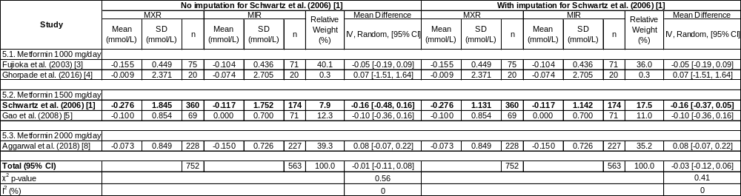
Abbreviations: CI, confidence interval; IV, inverse variance; MIR, metformin immediate-release; MXR, metformin extended-release; SD, standard deviation.

Table S4.6. Comparison of results for the outcome: MD in change from baseline serum high-density lipoprotein-cholesterol (HDL-C) without and with SD imputation for Schwartz et al. (2006) [1].
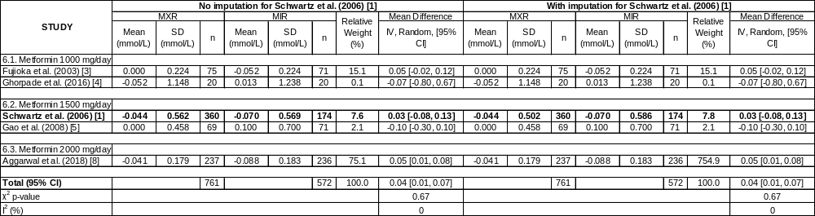
Abbreviations: CI, confidence interval; IV, inverse variance; MIR, metformin immediate-release; MXR, metformin extended-release; SD, standard deviation.

SUPPLEMENT 5: RISK OF BIAS (RoB) ASSESSMENT

Trial | Cochrane Collaboration RoB [10] Item |  |  |  |  |  |  |  | Overall RoB
Trial | Random sequence generation (selection bias) | Allocation concealment (selection bias) | Blinding of participants and personnel (performance bias) | Blinding of outcome assessment: laboratory parameters (detection bias) | Blinding of outcome assessment: adverse events and anthropometrics (detection bias) | Incomplete outcome data (attrition bias) | Selective reporting (reporting bias) | Other bias | Overall RoB
Fujioka et al. (2003) [3] | Unclear  Not specified | Unclear  Not specified | Low  “To ensure that double-blinding was maintained, all patients received a similar number of tablets daily; placebo tablets were indistinguishable from MIR and MXR tablets.” | Low  “Laboratory measurements were performed by a central laboratory…”  “… laboratory personnel remained blinded to treatment assignment when assessing… laboratory findings.” | Low  “Investigators… remained blinded to treatment assignment when assessing clinical adverse events…” | Unclear  Attrition with respect to treatment arms was not specified. | High  Weight was measured at baseline and during follow-up period but was not reported.  Protocol was not available for review. | Low  No other concern found. | High
Schwartz et al. (2006) [1] | Unclear  Not specified | Unclear  Not specified | Low  “Eligible patients were randomly assigned… together with appropriate placebo tablets to maintain the study blind.” | Unclear  Not specified | Unclear  Not specified | High  “… fewer patients discontinued treatment due to lack of efficacy in the 2000-mg [MXR] group (1.8%) than in the [MIR] group (8.0%) (p = 0.007).” | Unclear  Protocol was not available for review. | Low  No other concern found. | High

SUPPLEMENT 5: RISK OF BIAS (RoB) ASSESSMENT (CONTINUED)
Trial | Cochrane Collaboration RoB [10] Item |  |  |  |  |  |  |  | Overall RoB
Trial | Random sequence generation (selection bias) | Allocation concealment (selection bias) | Blinding of participants and personnel (performance bias) | Blinding of outcome assessment: laboratory parameters (detection bias) | Blinding of outcome assessment: adverse events and anthropometrics (detection bias) | Incomplete outcome data (attrition bias) | Selective reporting (reporting bias) | Other bias | Overall RoB
Hsieh et al. (2007) [6] | Unclear  Not specified | Unclear  Not specified | Unclear  “Double-blind” was indicated but was not elaborated. | Unclear  Not specified | Unclear  Not specified | Low  “Four from the [MXR] group and 4 from the [MIR] group were withdrawn from the trial mainly because of gastrointesti-nal side effects.” | High  HDL-C & LDL-C and adverse events were assessed but not reported.  Protocol was not available for review. | Low  No other concern found. | High
Gao et al. (2008) [5] | Unclear  Not specified | Unclear  Not specified | High  Explicitly open-label trial | Unclear  Not specified | High  Explicitly open-label trial | Low  Attrition was noted and specified for both arms and is unlikely to favor one trial arm. | Unclear  Protocol was not available for review. | Low  No other concern found. | High
Hwang et al. (2013) [2] | Unclear  Not specified | Unclear  Not specified | Unclear  “Double-blind” was indicated but was not elaborated. | Unclear  Not specified | Unclear  Not specified | Unclear  Attrition with respect to treatment arms was specified and similar, but reasons were not elaborated. | High  Protocol was available for review, but (1) lipid control parameters and (2) sepa-rate adverse events at fo-llow-up were not reported. | Low  No other concern found. | High
SUPPLEMENT 5: RISK OF BIAS (RoB) ASSESSMENT (CONTINUED)
Trial | Cochrane Collaboration RoB [10] Item |  |  |  |  |  |  |  | Overall RoB
Trial | Random sequence generation (selection bias) | Allocation concealment (selection bias) | Blinding of participants and personnel (performance bias) | Blinding of outcome assessment: laboratory parameters (detection bias) | Blinding of outcome assessment: adverse events and anthropometrics (detection bias) | Incomplete outcome data (attrition bias) | Selective reporting (reporting bias) | Other bias | Overall RoB
Ghorpade et al. (2016) [4] | Unclear  Not specified | Unclear  Not specified | Unclear  “Double-blind” was indicated but was not elaborated. | Unclear  Not specified | Unclear  Not specified | Low  No attrition was noted. | High  SDs for the main outcome (change from baseline HbA1c) and a secondary outcome (change from baseline weight) were not reported. PPG at endpoint in both arms were not reported.  Protocol was not available for review. | Low  No other concern found. | High
Hameed et al. (2017) [7] | Unclear  Not specified | Unclear  Not specified | Unclear  Not specified | Unclear  Not specified | Unclear  Not specified | Low  No attrition was noted. | Unclear  Protocol was not available for review. | Low  No other concern found. | Unclear

SUPPLEMENT 5: RISK OF BIAS (RoB) ASSESSMENT (CONTINUED)
Trial | Cochrane Collaboration RoB [10] Item |  |  |  |  |  |  |  | Overall RoB
Trial | Random sequence generation (selection bias) | Allocation concealment (selection bias) | Blinding of participants and personnel (performance bias) | Blinding of outcome assessment: laboratory parameters (detection bias) | Blinding of outcome assessment: adverse events and anthropometrics (detection bias) | Incomplete outcome data (attrition bias) | Selective reporting (reporting bias) | Other bias | Overall RoB
Aggarwal et al. (2018) [8] | Unclear  Not specified | Unclear  Not specified | Unclear  Not specified | Unclear  Not specified | Unclear  Not specified | Low  Attrition was noted and specified for both arms and is unlikely to favor one trial arm. | Low  Protocol was available for review and all pre-specified outcomes were reported comprehen-sively. | Low  No other concern found. | Unclear
Ji et al.  (2018) [10] | Unclear  Not specified | Unclear  Not specified | High  Explicitly open-label trial | Unclear  Not specified | High  Explicitly open-label trial | Low  Attrition was noted and specified for both arms and is unlikely to favor one trial arm. | Low  Protocol was available for review and all pre-specified outcomes were reported comprehen-sively. | Low  No other concern found. | High
Abbreviations: HbA1c, hemoglobin A1c; HDL-C, serum high-density lipoprotein-cholesterol; LDL-C, serum low-density lipoprotein-cholesterol; MIR, metformin immediate-release; MXR, metformin extended-release; PPG, post-prandial plasma glucose at 2 hours; RoB, risk of bias; SD, standard deviation.

SUPPLEMENT 6: FUNNEL PLOT

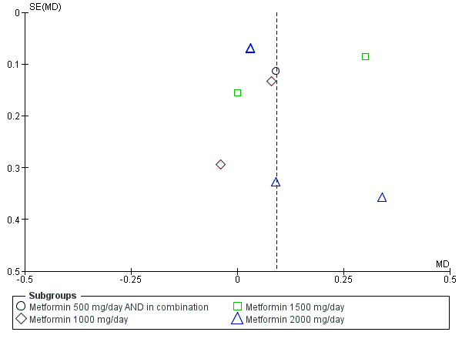

Figure S6. Funnel plot for outcome: change from baseline HbA1c (%).
SUPPLEMENT 7: FOREST PLOTS FOR CONSIDERED OUTCOMES

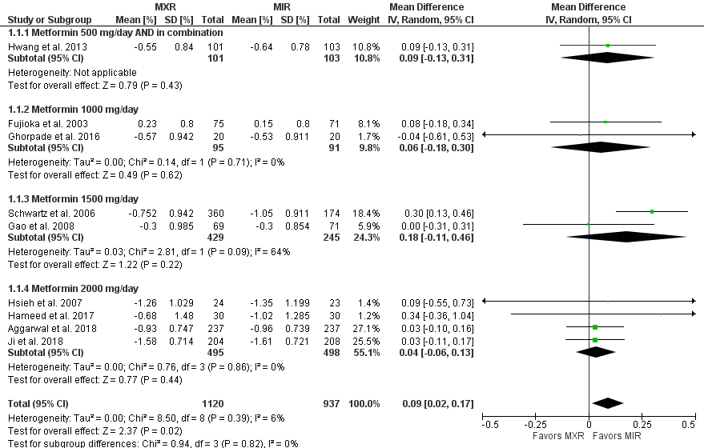
Figure S7.1. Forest plot for outcome: change from baseline glycated hemoglobin (HbA1c, %).

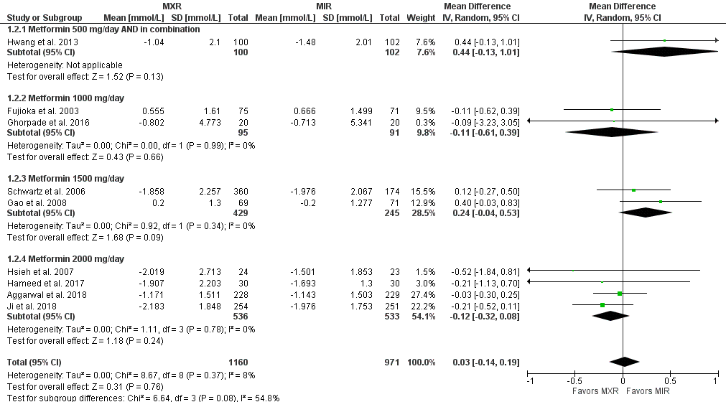
Figure S7.2. Forest plot for outcome: change from baseline fasting plasma glucose (FPG, mmol/L).
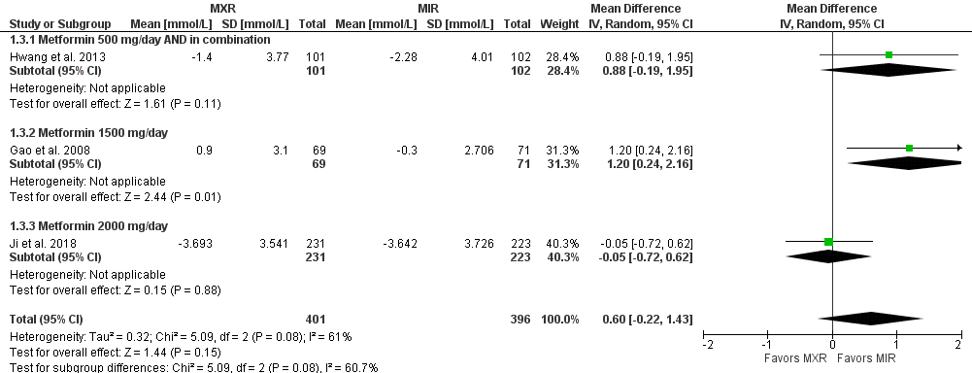
Figure S7.3. Forest plot for outcome: change from baseline post-prandial plasma glucose at 2 hours (PPG, mmol/L).

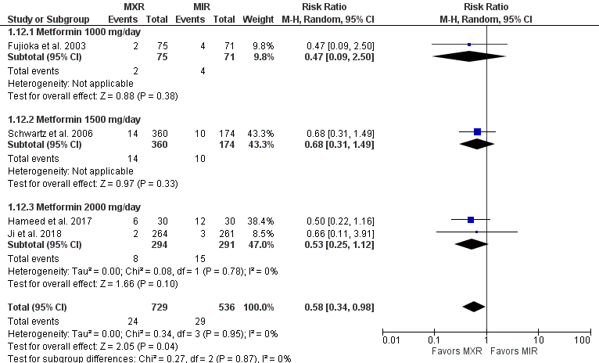
Figure S7.4. Forest plot for outcome: dyspepsia.

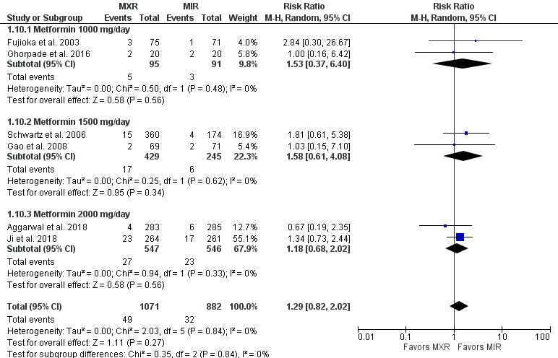
Figure S7.5. Forest plot for outcome: abdominal discomfort or pain.

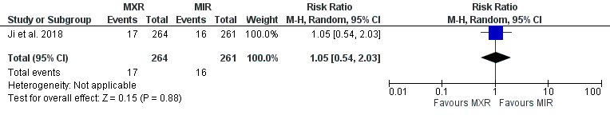Figure S7.6. Forest plot for outcome: abdominal distension.

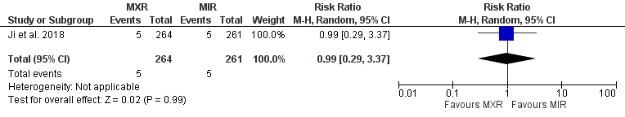
Figure S7.7. Forest plot for outcome: constipation.

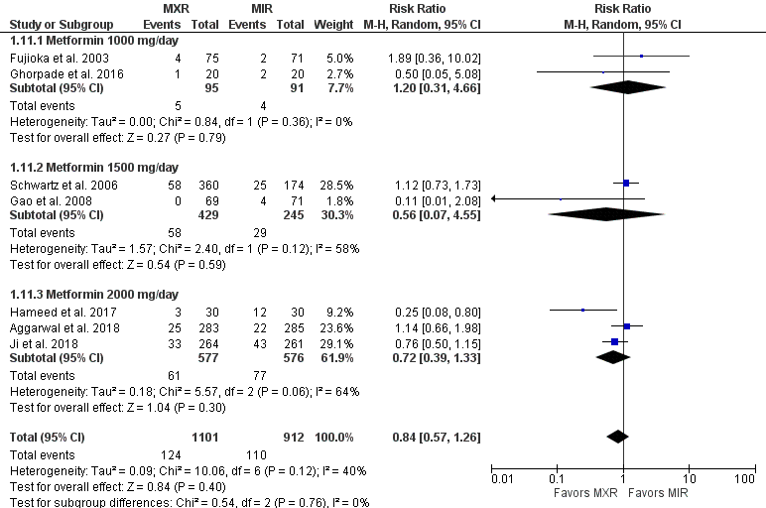
Figure S7.8. Forest plot for outcome: diarrhea.

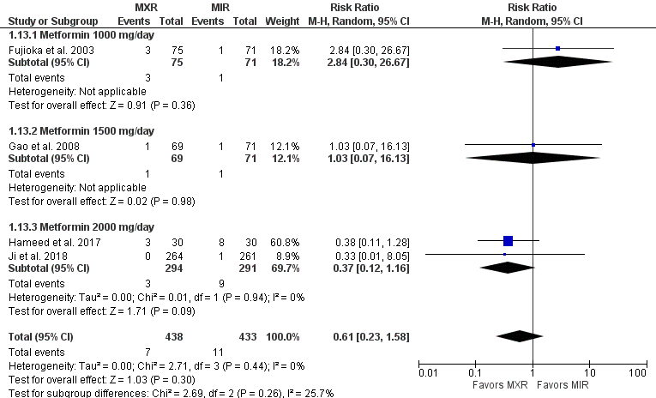
Figure S7.9. Forest plot for outcome: flatulence.

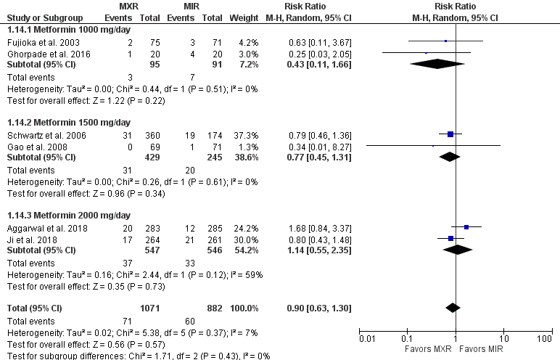
Figure S7.10. Forest plot for outcome: nausea and vomiting.
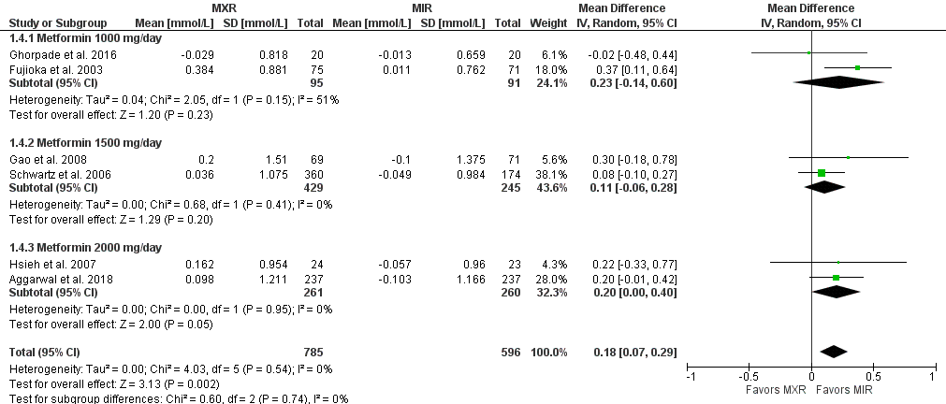
Figure S7.11. Forest plot for outcome: change from baseline serum triglycerides (Tg, mmol/L).

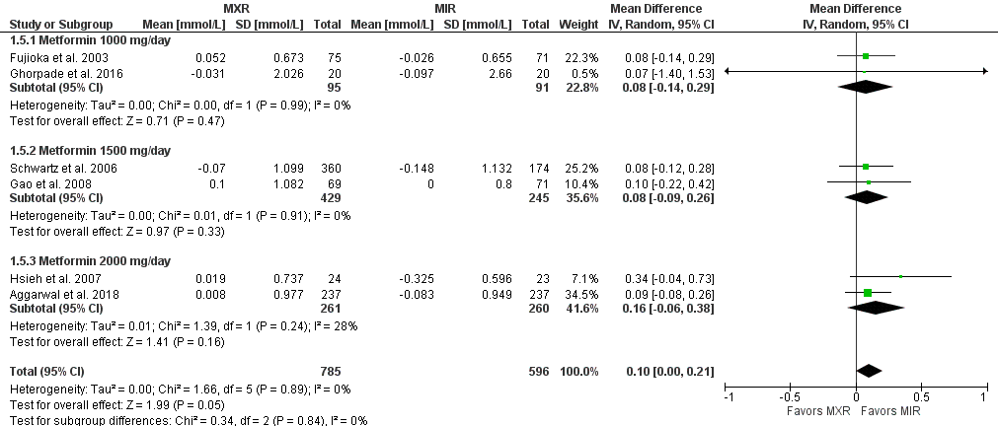
Figure S7.12. Forest plot for outcome: change from baseline serum total cholesterol (TC, mmol/L).

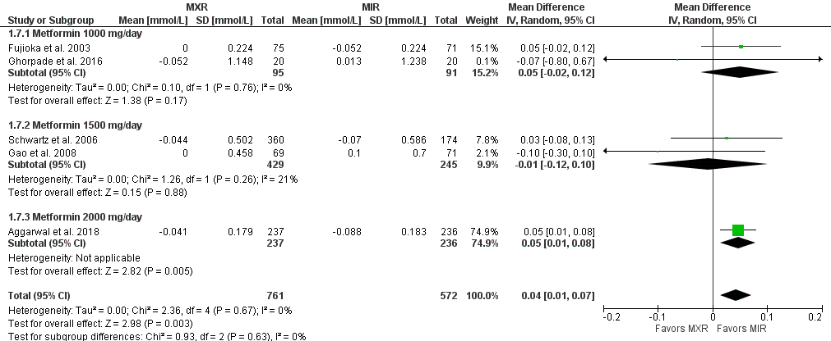
Figure S7.13. Forest plot for outcome: change from baseline serum high-density lipoprotein-cholesterol (HDL-C, mmol/L).

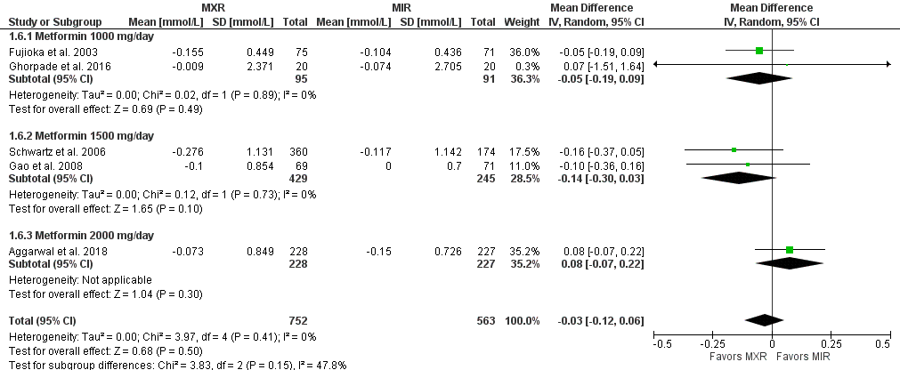
Figure S7.14. Forest plot for outcome: change from baseline serum low-density lipoprotein-cholesterol (LDL-C, mmol/L).

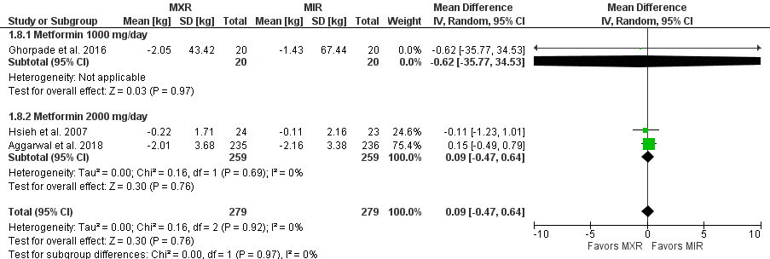
Figure S7.15. Forest plot for outcome: change from baseline weight (kg).

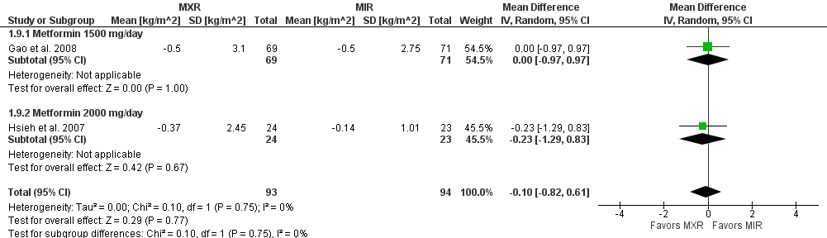
Figure S7.16. Forest plot for outcome: change from baseline body mass index (BMI, kg/m²).

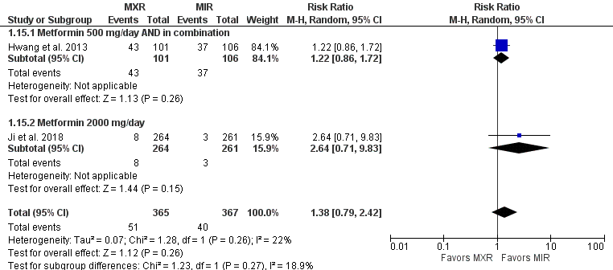
Figure S7.17. Forest plot for outcome: hypoglycemia.
SUPPLEMENT 8: SENSITIVITY ANALYSES

Table S8.1. Sensitivity analysis for outcome: change from baseline HbA1c.
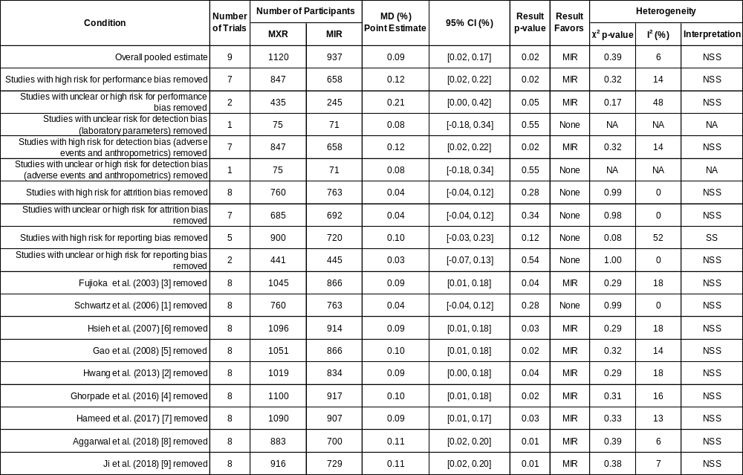
Abbreviations: CI, confidence interval; MD, mean difference; MIR, metformin-immediate release; MXR, metformin extended-release; NA, not appropriate; NSS, neither significant nor substantial; SS, significant and substantial.
Table S8.2. Sensitivity analysis for outcome: change from baseline FPG.
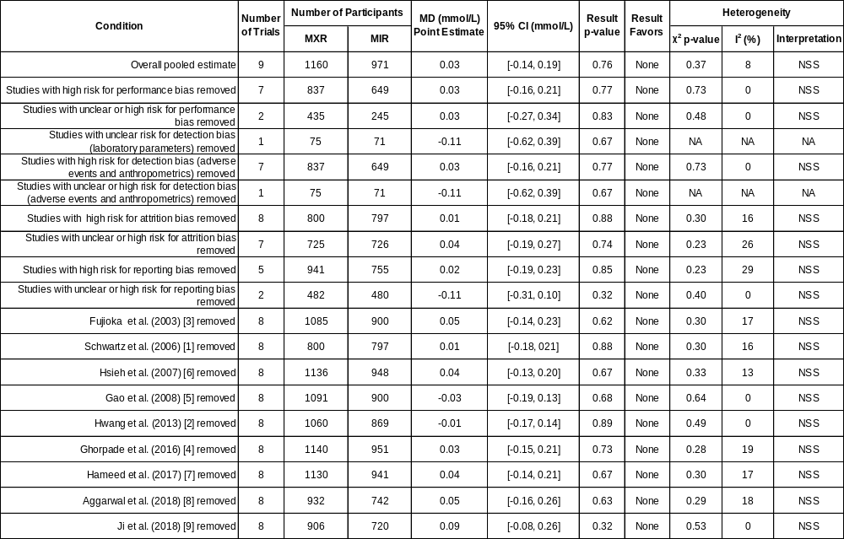
Abbreviations: CI, confidence interval; MD, mean difference; MIR, metformin-immediate release; MXR, metformin extended-release; NA, not appropriate; NSS, neither significant nor substantial; SS, significant and substantial.
Table S8.3. Sensitivity analysis for outcome: change from baseline PPG.
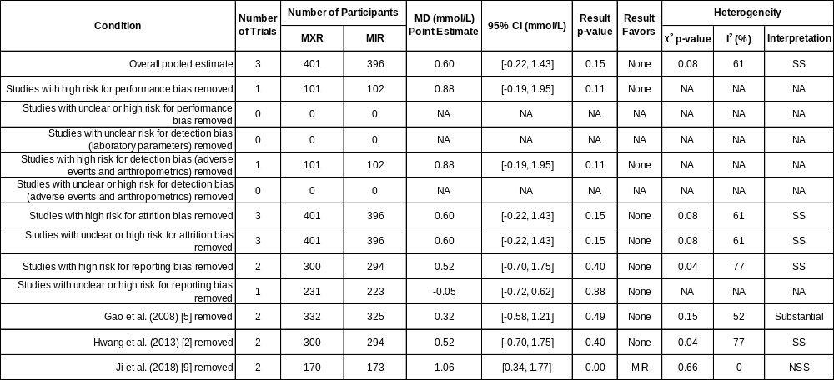
Abbreviations: CI, confidence interval; MD, mean difference; MIR, metformin-immediate release; MXR, metformin extended-release; NA, not appropriate; NSS, neither significant nor substantial; SS, significant and substantial.

Table S8.4. Sensitivity analysis for outcome: dyspepsia.
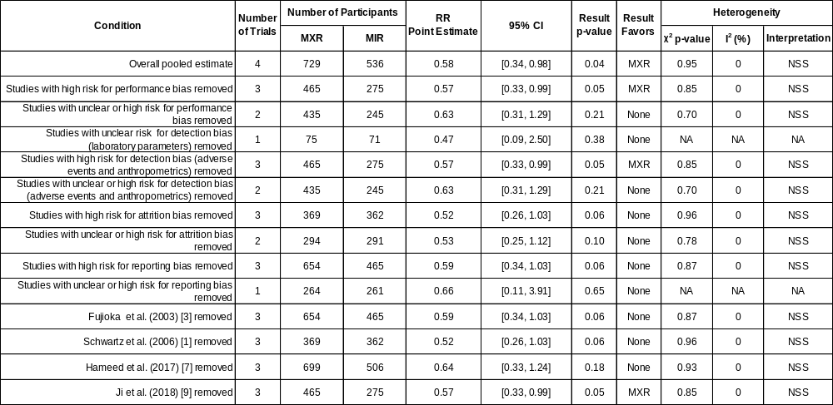
Abbreviations: CI, confidence interval; MIR, metformin-immediate release; MXR, metformin extended-release; NA, not appropriate; NSS, neither significant nor substantial; RR, risk ratio; SS, significant and substantial.

Table S8.5. Sensitivity analysis for outcome: abdominal discomfort or pain.
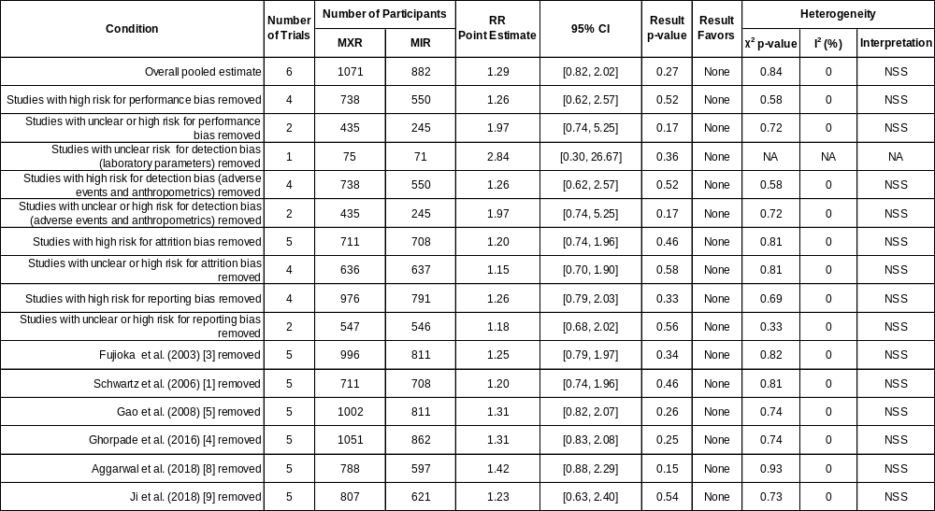
Abbreviations: CI, confidence interval; MIR, metformin-immediate release; MXR, metformin extended-release; NA, not appropriate; NSS, neither significant nor substantial; RR, risk ratio; SS, significant and substantial.

Table S8.6. Sensitivity analysis for outcome: diarrhea.
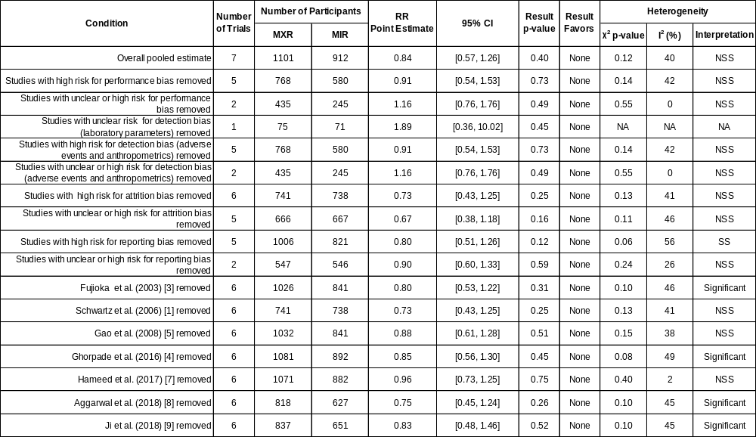
Abbreviations: CI, confidence interval; MIR, metformin-immediate release; MXR, metformin extended-release; NA, not appropriate; NSS, neither significant nor substantial; RR, risk ratio; SS, significant and substantial.
Table S8.7. Sensitivity analysis for outcome: flatulence.
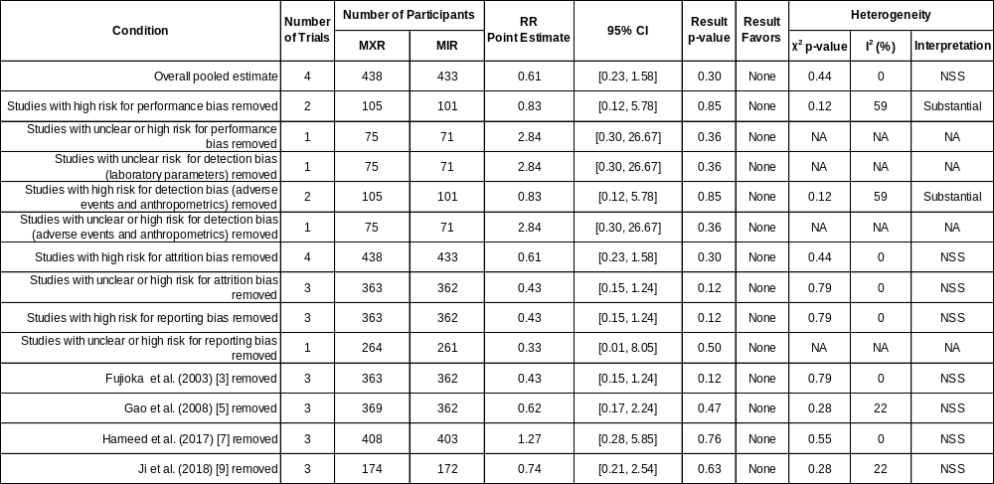
Abbreviations: CI, confidence interval; MIR, metformin-immediate release; MXR, metformin extended-release; NA, not appropriate; NSS, neither significant nor substantial; RR, risk ratio; SS, significant and substantial.

Table S8.8. Sensitivity analysis for outcome: nausea and vomiting.
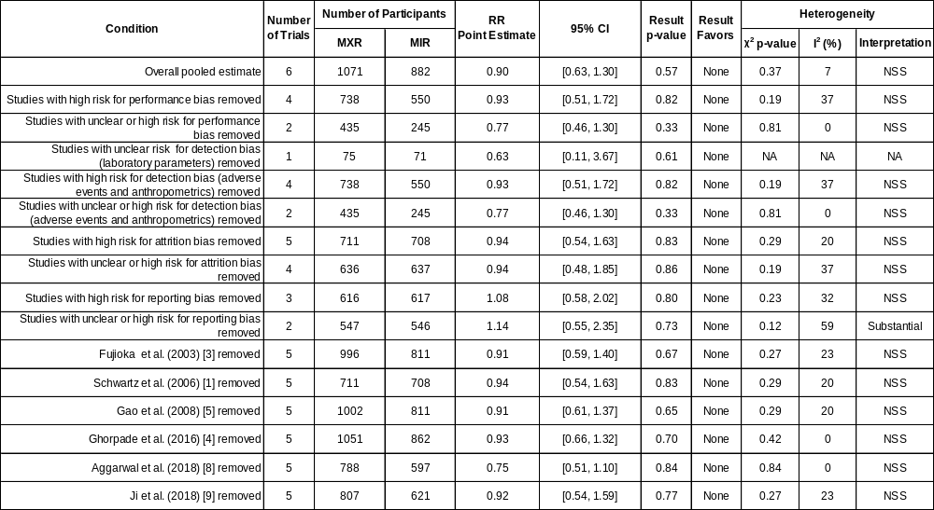
Abbreviations: CI, confidence interval; MIR, metformin-immediate release; MXR, metformin extended-release; NA, not appropriate; NSS, neither significant nor substantial; RR, risk ratio; SS, significant and substantial.

Table S8.9. Sensitivity analysis for outcome: change from baseline Tg.
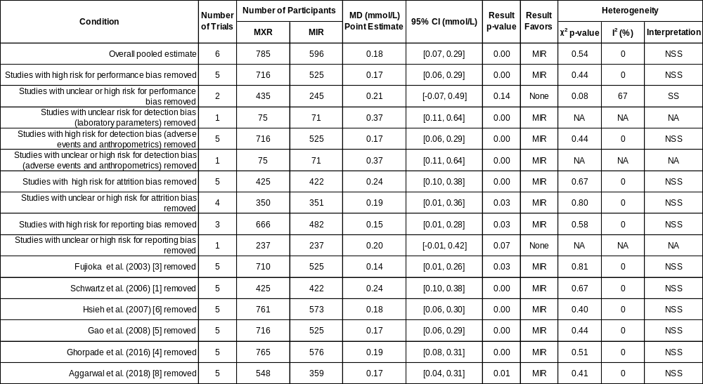
Abbreviations: CI, confidence interval; MD, mean difference; MIR, metformin-immediate release; MXR, metformin extended-release; NA, not appropriate; NSS, neither significant nor substantial; SS, significant and substantial.

Table S8.10. Sensitivity analysis for outcome: change from baseline TC.
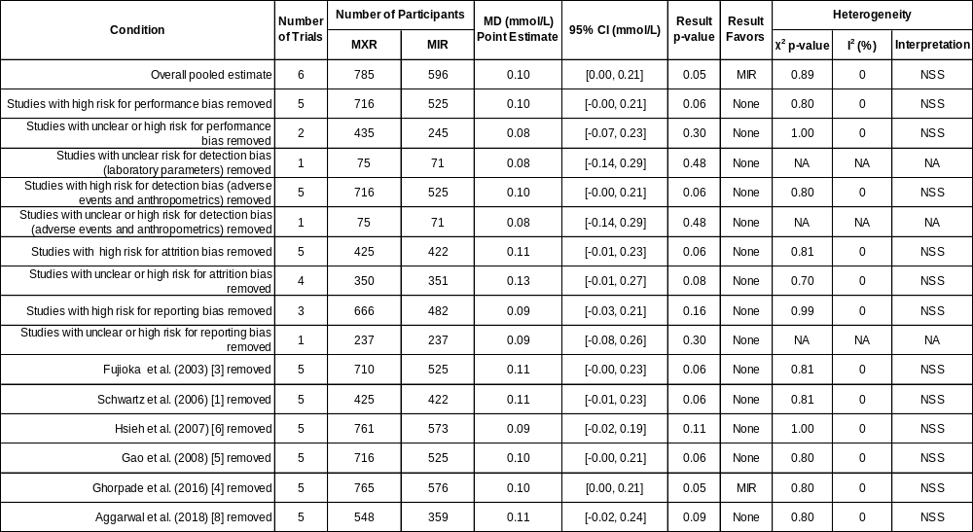
Abbreviations: CI, confidence interval; MD, mean difference; MIR, metformin-immediate release; MXR, metformin extended-release; NA, not appropriate; NSS, neither significant nor substantial; SS, significant and substantial.

Table S8.11. Sensitivity analysis for outcome: change from baseline HDL-C.
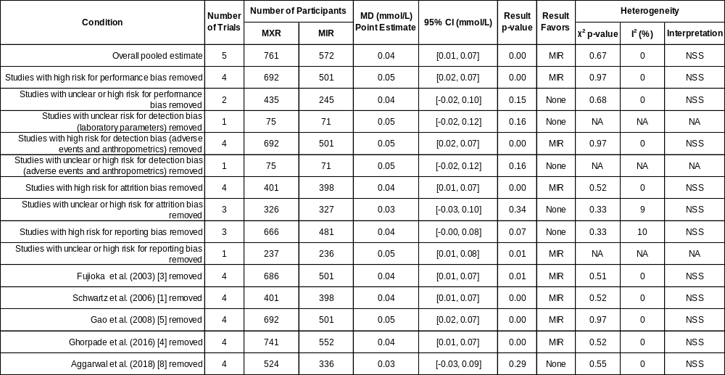
Abbreviations: CI, confidence interval; MD, mean difference; MIR, metformin-immediate release; MXR, metformin extended-release; NA, not appropriate; NSS, neither significant nor substantial; SS, significant and substantial.

Table S8.12. Sensitivity analysis for outcome: change from baseline LDL-C.
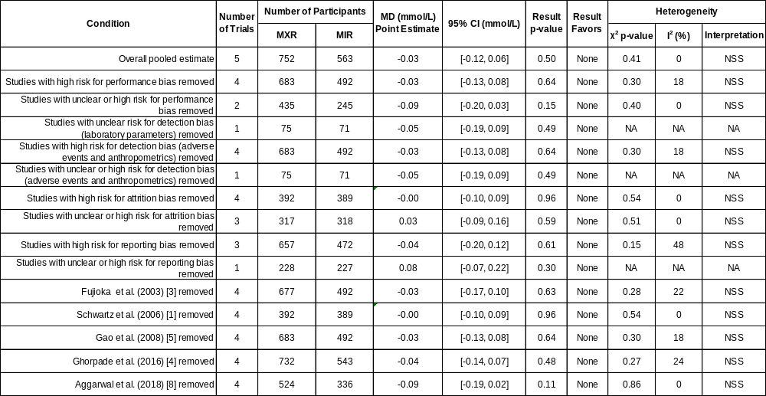
Abbreviations: CI, confidence interval; MD, mean difference; MIR, metformin-immediate release; MXR, metformin extended-release; NA, not appropriate; NSS, neither significant nor substantial; SS, significant and substantial.

Table S8.13. Sensitivity analysis for outcome: change from baseline weight.
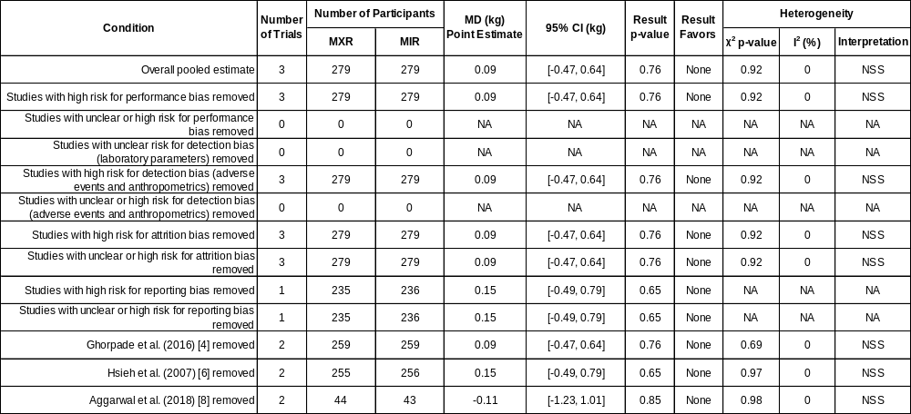
Abbreviations: CI, confidence interval; MD, mean difference; MIR, metformin-immediate release; MXR, metformin extended-release; NA, not appropriate; NSS, neither significant nor substantial; SS, significant and substantial.

Table S8.14. Sensitivity analysis for outcome: change from baseline BMI.
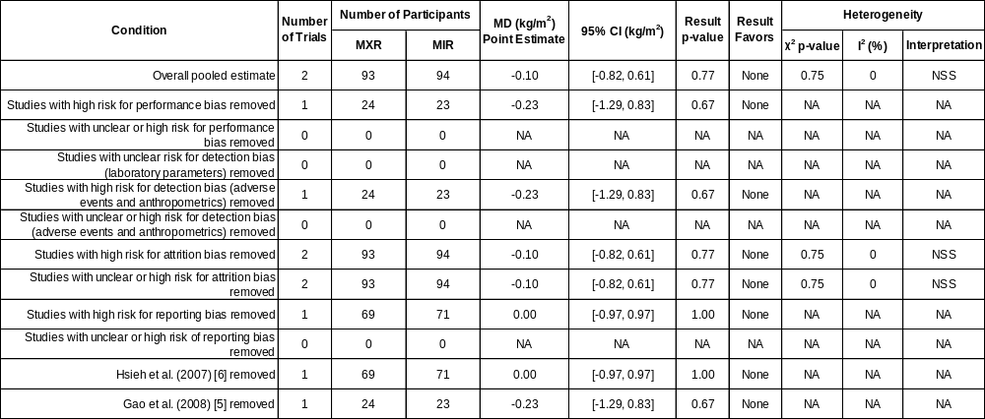
Abbreviations: CI, confidence interval; MD, mean difference; MIR, metformin-immediate release; MXR, metformin extended-release; NA, not appropriate; NSS, neither significant nor substantial; SS, significant and substantial.

Table S8.15. Sensitivity analysis for outcome: hypoglycemia.
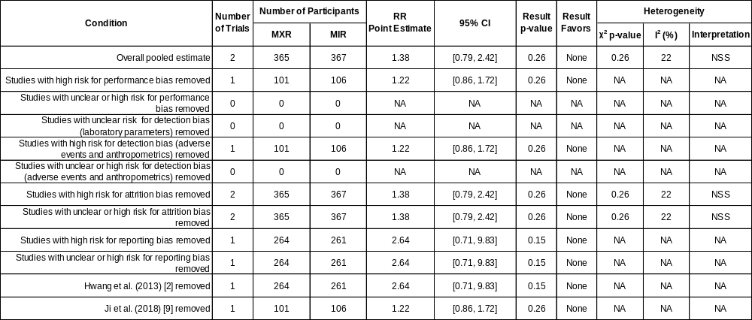
Abbreviations: CI, confidence interval; MIR, metformin-immediate release; MXR, metformin extended-release; NA, not appropriate; NSS, neither significant nor substantial; RR, risk ratio; SS, significant and substantial.

SUPPLEMENTARY MATERIAL REFERENCES

1. Schwartz S, Fonseca V, Berner B, Cramer M, Chiang Y-K, Lewin A (2006) Efficacy, tolerability, and safety of a novel once-daily extended-release metformin in patients with type 2 diabetes. Diabetes Care 29(4):759–764. https://doi.org/10.2337/diacare.29.04.06.dc05-1967
2. Hwang Y-C, Kang M, Ahn CW, et al (2013) Efficacy and safety of glimepiride/metformin sustained release once daily vs. glimepiride/metformin twice daily in patients with type 2 diabetes. Int J Clin Pract 67(3):236–243. https://doi.org/10.1111/ijcp.12071
3. Fujioka K, Pans M, Joyal S (2003) Glycemic control in patients with type 2 diabetes mellitus switched from twice-daily immediate-release metformin to a once-daily extended-release formulation. Clin Ther 25(2):515–529. https://doi.org/10.1016/S0149-2918(03)80093-0
4. Ghorpade V, Hiray R, Daswani B, Ghongane B (2016) Comparison of conventional and sustained-release formulation of metformin in type 2 diabetics. Int J Basic Clin Pharmacol 5(2):274–280. https://doi.org/10.18203/2319-2003.ijbcp20160654
5. Gao H, Xiao W, Wang C, et al (2008) The metabolic effects of once daily extended-release metformin in patients with type 2 diabetes: a multicentre study: Effects of metformin XR in patients with type 2 diabetes. Int J Clin Pract 62(5):695–700. https://doi.org/10.1111/j.1742-1241.2008.01733.x
6. Hsieh C-H, He C-T, Lee C-H, Wu L-Y, Hung Y-J (2007) Both slow-release and regular-form metformin improve glycemic control without altering plasma visfatin level in patients with type 2 diabetes mellitus. Metabolism 56(8):1087–1092. https://doi.org/10.1016/j.metabol.2007.03.018
7. Hameed M, Khan K, Salman S, Mehmood N (2017) Dose comparison and side effect profile of metformin extended release versus metformin immediate release. J Ayub Med Coll Abbottabad 29(2):225–9
8. Aggarwal N, Singla A, Mathieu C, et al (2018) Metformin extended-release versus immediate-release: an international, randomized, double-blind, head-to-head trial in pharmacotherapy-naïve patients with type 2 diabetes. Diabetes Obes Metab 20(2):463–467. https://doi.org/10.1111/dom.13104
9. Ji L, Liu J, Yang J, et al (2018) Comparative effectiveness of metformin monotherapy in extended release and immediate release formulations for the treatment of type 2 diabetes in treatment-naïve Chinese patients: Analysis of results from the CONSENT trial. Diabetes Obes Metab 20(4):1006–1013. https://doi.org/10.1111/dom.13190
10. Higgins JPT, Altman DG, Gotzsche PC, et al (2011) The Cochrane Collaboration’s tool for assessing risk of bias in randomised trials. BMJ 343:d5928. https://doi.org/10.1136/bmj.d5928

