Supplementary Table 1 Identification of 43 Coffea canephora genotypes. Nova Venécia, ES - Brazil.
Code | Name | Code | Name | Code | Name
1 | Verdim R | 16 | Pirata | 30 | A1
2 | B01 | 17 | Peneirão | 31 | Cheique
3 | Bicudo | 18 | Z39 | 32 | P2
4 | Alecrim | 19 | Z35 | 33 | Emcapa 02
5 | 700 | 20 | Z40 | 34 | Emcapa 153
6 | CH1 | 21 | Z29 | 35 | P1
7 | Imbigudinho | 22 | Z38 | 36 | LB1
8 | AD1 | 23 | Z18 | 37 | 122
9 | Graudão HP | 24 | Z37 | 38 | Verdim D
10 | Valcir P | 25 | Z21 | 39 | Sementes
11 | Beira Rio 8 | 26 | Z36 | 40 | Emcapa 143
12 | Tardio V | 27 | Ouro Negro | 41 | Ouro negro 1
13 | AP | 28 | 18 | 42 | Ouro negro 2
14 | L80 | 29 | Tardio C | 43 | Clementino
15 | Bamburral
Genotype 33 belongs to cv. Emcapa 8111 and genotypes 34 and 39 to cv. Emcapa 8131 (Bragança et al., 2001). Genotypes 1, 11, 15, 16, 30 and 43 belong to cv. Tributun (Partelli et al., 2020) and 30 and 35 to cv. Andina (Partelli et al., 2019).

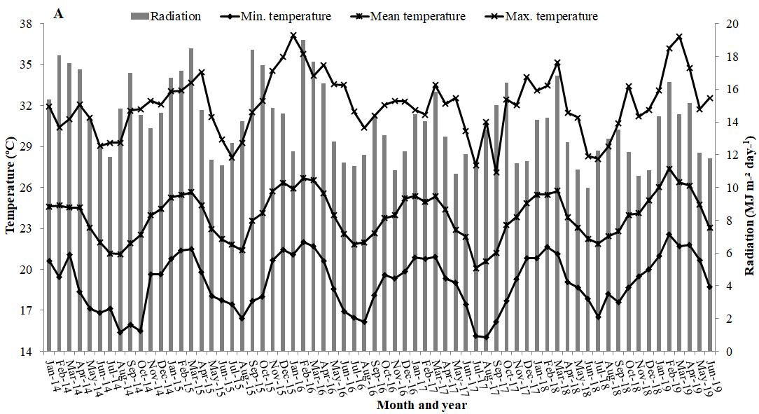
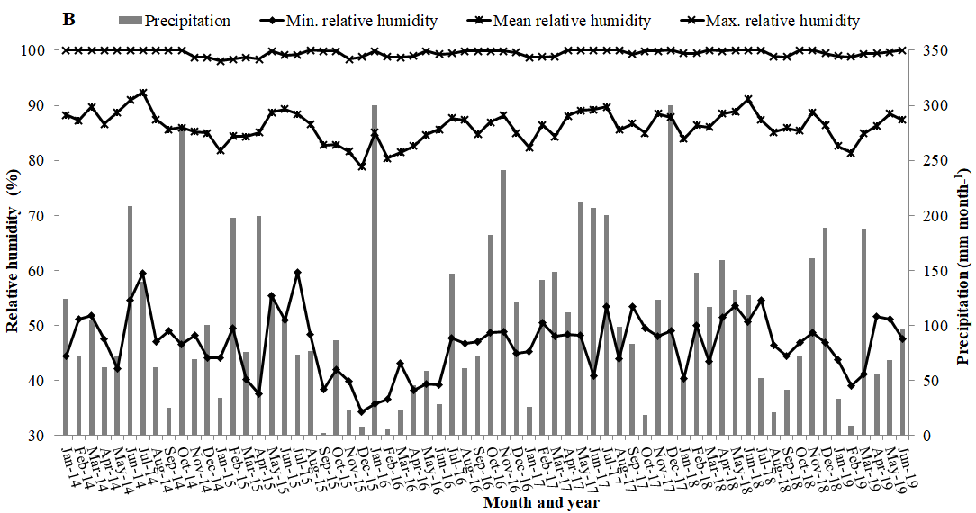
Supplementary Figure 1 Average, maximum and minimum meteorological data referring to temperature, radiation, relative humidity and precipitation at the site of the experiments, during the evaluation period of coffee genotypes C. canephora from January 2014 to June 2019, for modeling adaptability and stability.

