Biocompatible carbon dot decorated α-FeOOH nanohybrid for an effective fluorometric sensing of Cr (VI) in wastewater and living cells
Bidisha Ghosh^{1#}, Shubham Roy^{1#}, Souravi Bardhan¹, Dhananjoy Mondal¹, Ishita Saha², Saheli Ghosh¹, Ruma Basu³, Parimal Karmakar², Kaustuv Das^{1*}, Sukhen Das^{1*}

¹ Department of Physics, Jadavpur University, Kolkata-700032, India
² Department of Life Science and Biotechnology, Jadavpur University, Kolkata-700032, India
³ Department of Physics, Jogamaya Devi College, Kolkata- 700026, India

Supporting information

*Corresponding Authors:
Prof. Sukhen Das
sdasphysics@gmail.com (+91 9433091337)

Dr. Kaustuv Das
kaustuv12@gmail.com (+ 91 9433116177)

# These two authors have contributed equally in this work.
Table S1: Microstructural information obtained from Rietveld refinement
Parameters | Values
a (Å) | 10.00903
b (Å) | 2.9612691
c (Å) | 4.510796
V (Å^{^3}) | 133.697
Size ( Å) | 598.5741
Microstrain | 1.25x10⁻³
R_{p} (%) | 0.03
R_{wp} (%) | 0.04
χ2 | 1.33

Table S2: Comparative range of sensing activity of other sensors
Probe | Method of synthesis | Linear Range | LOD | Ref
1.C dots from Poria cocos polysaccaride as an effective “’on off” fluorescence sensor for chromium (VI) detection. (2021) | Hydrothermal, 200°C for 5hrs | 1-100 µM | 0.25µM | [51]
2. Nitrogen Carbon dot decorated natural microcline an ameliorative dual fluorescent probe for Fe³⁺ and Cr⁶⁺ detection (2020) | Hydrothermal 190°C for 12hrs | 0-68µM | 4µM | [36]
3. A fluorometric paper test for chromium (VI) based on the use of N-doped C-dots. (2019) | Microwave synthesis,900watts,90s | 80-1000µM | 140µM | [52]
4.C-Dots with red emission as a fluorescent and colorimetric dual read out probe for detection of chromium (VI) and cysteine and its logic gate operation. (2018) | Hydrothermal, 180°C, 4hrs | 0.5-263µM | 0.26µM | [53]
5.Green and facile synthesis of water-soluble carbon dots from ethanolic shallot extract for chromium ion sensing in milk, fruit juices and waste water samples (2020) | Hydrothermal,180°C,4hrs | 20-100µM | 3-5µM | [54]
6. Biocompatible carbon dot decorated α-FeOOH nanohybrid for an effective fluorometric sensing of Cr (VI) in wastewater and living cells  . | Hydrothermal, 180°C, 2.5hrs | 0-10µM | 81nM | This work

Table S3: Physical parameters of the collected water samples
Type of Water | pH | TDS (ppm)
Drinking Water | 8.22 | 85
Tap Water | 7.76 | 675
Pond water | 8.64 | 897
Waste Water | 2.86 | 1894

Table S4: ICP-AES data of the collected wastewater
Constituents | Amount (ppm)
Cadmium | Not Found
Iron | 8.76
Chromium | 16.53
Lead | 0.14

Additional figures:
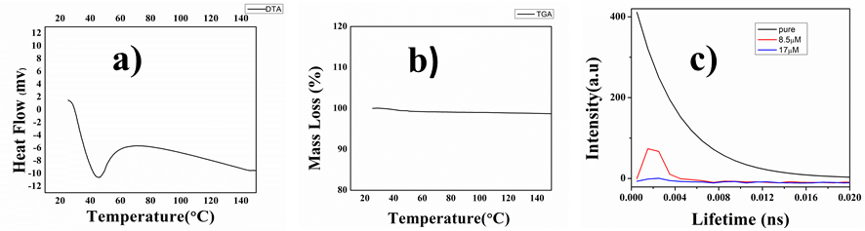
Figure S1 a) DTA and b) TGA data; c) graph showing fluorescence lifetime data of the synthesized probe

