Supplementary Data

Copper supported on cellulosic beads as a potential catalyst for environmental remediation reactions

Alejandra Devardª, M. Claudia Taleb^{b}, Graciela V. Olmos^{b}, F. Albana Marchesiniª, Laura B. Gutierrez^{a*}

ªInstituto de Investigaciones en Catálisis y Petroquímica, INCAPE, (FIQ, UNL-CONICET), Santiago del Estero 2829, S3000 Santa Fe, Argentina
^{b}Instituto de Tecnología Celulósica, ITC, (FIQ, UNL), Santiago del Estero 2654, S3000 Santa Fe, Argentina

Reaction processes observed during the CuNPs formation
The pH of the copper (II) acetate monohydrate solution was adjusted to 5-7 because at this point the Acid Ascorbic (AA) presents an optimal reducing effect. In this step the solution is slightly blue (Fig. S1-a). When the AA solution was added to the RC support, the pH dropped to 3.2 and the solution turned to yellow (Fig. S1-b), this is associated with the reduction of Cu²⁺ to the Cu₂O intermediate species (Eq. 3). Afterwards, Cu⁺ was reduced to metallic copper (Eq. 4) and the solution became reddish (Fig. S1-c). After a few minutes the vessel content ended dark red (Fig. S1-d). Meanwhile, the AA was oxidized to dehydroascorbic acid (Eq. 5) giving rise to more H⁺ reducing entities. It should be taken into account that the presence of aldehyde groups in the RC supports could also promote the copper reduction [1].
Eq. 1 2 (Cu(CH₃COO)₂ $→$ 2 Cu²⁺ + 4 CH₃COO- + 2 H⁺)
Eq. 2 4 (CH₃COO⁻ + H₂O $→$ CH₃COOH + OH⁻)
Eq. 3 2 Cu²⁺ + 2e⁻ + H₂O $→$ Cu₂O + 2H⁺
Eq. 4 Cu₂O + 2e⁻ + 2H⁺ $→$ 2 Cu⁰ + H₂O
Eq. 5 2 (C₆H₈O₆ $→$ C₆H₆O₆ + 2H⁺ + 2e-)
Resulting
Eq.6 2 Cu(CH₃COOH)₂ + 2 C₆H₈O₆ $→$ 2H⁺ + 4 CH₃COOH + 2 Cu⁰ + 2 C₆H₆O₆

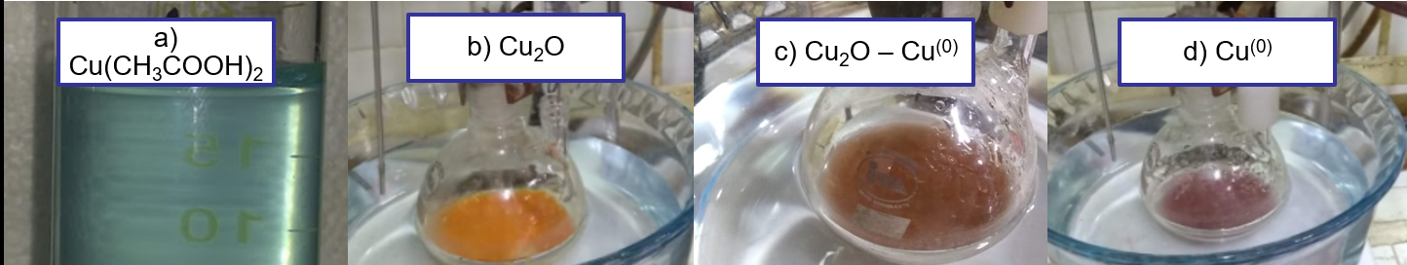
Figure S1. Colour evolution during the in situ CuNPs synthesis on the cellulose beads.

Table S1. Preliminary reported and not-reported own results
Catalysts | Phenol conversion (%) | TOC conversion (%) | Cu content (%) | References
NPs/Cu/SiO₂ 500⁽¹⁾ | 100 | 73.0 | 0.85 | Unpublished results
NPs/Cu/Al₂O₃ 500⁽¹⁾ | 100 | 56.0 | 0.30 | Unpublished results
Cu/Al₂O₃ 400⁽²⁾ | 100 | 87.0 | 4.20 | [2]
Cu/Al₂O₃ 650⁽³⁾ | 100 | 91.0 | 5.00 | [2]
Cu/Al₂O₃ 900⁽⁴⁾ | 100 | 86.5 | 5.60 | [2]
Cu/UiO-66 | 100 | 83.3 | 10.00 | [3]
- Calcined 500° C. Pre-formed copper NPs prepared as Gioria et al. supported on SiO₂ [4].
- calcined 400 ° C, wet impregnation method
- Calcined 650° C, wet impregnation method
- Calcined 900° C, wet impregnation method
Reaction conditions: T = 70ºC, phenol: 50 mL 1000 ppm, H₂O₂: 5 mL 8.8 M.
XPS Spectra of the prepared catalysts
Figure S2: XPS spectra of CuNPs cellulose supported catalysts: A: Cu 2p3/2 region, B: Cu L3M4 and Cu5M4,5 regions

Figure S3: FTIR spectra of regenerated cellulose supports and the corresponding catalysts.

References
1. Eremenko, A. M., Petrik, I. S., Smirnova, N. P., Rudenko, A. V., & Marikvas, Y. S. Antibacterial and Antimycotic Activity of Cotton Fabrics, Impregnated with Silver and Binary Silver/Copper Nanoparticles. Nanoscale Res. Lett., 11(1) (2016). doi:10.1186/s11671-016-1240-0
2. A. Devard, P. Brussino, F.A. Marchesini, M.A. Ulla, Cu(5%)/Al₂O₃ catalytic performance on the phenol wet oxidation with H2O2: Influence of the calcination temperature, J. Environ. Chem. Eng. 7 (2019). https://doi.org/10.1016/j.jece.2019.103201.
3. L.A. Lozano, A. Devard, M.A. Ulla, J.M. Zamaro, Cu/UiO-66: A novel nanocatalyst obtained by a microwave-assisted protocol in DMF-free media for the efficient phenol removal via catalytic wet peroxide oxidation, J. Environ. Chem. Eng. 8 (2020) 104332. https://doi.org/10.1016/j.jece.2020.104332.
4. E. Gioria, F.A. Marchesini, A. Soldati, A. Giorello, J. Hueso, L.B. Gutierrez, Green Synthesis of a Cu/SiO2 Catalyst for Efficient H2-SCR of NO, Appl. Sci. 9 (2019) 4075. https://doi.org/10.3390/app9194075.

