Magnetic cryogels as a shape-selective and customizable platform for hyperthermia-mediated drug delivery
Ayomi S. Perera*¹, Richard J. Jackson^{,2}, Reece M. D. Bristow¹ and Chinyere A. White¹
1 Department of Chemical and Pharmaceutical Sciences, Kingston University London, Penrhyn Road, Kingston upon Thames, KT1 2EE, UK, a.perera@kingston.ac.uk, k1607738@kingston.ac.uk, chinyere.white@gmail.com
2 Department of Mechanical Engineering, University College London, Torrington Place, London WC1E 7JE, UK, r.jackson@ucl.ac.uk

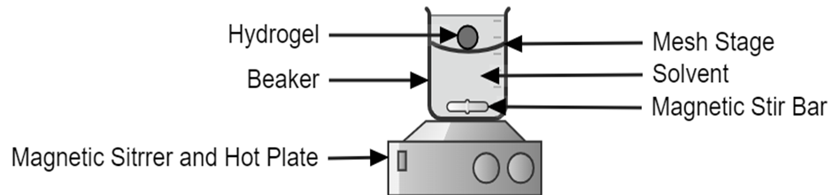
Figure S1. Schematic representation of the apparatus for the drug release studies of acetaminophen from PVA-MNP cryogels.
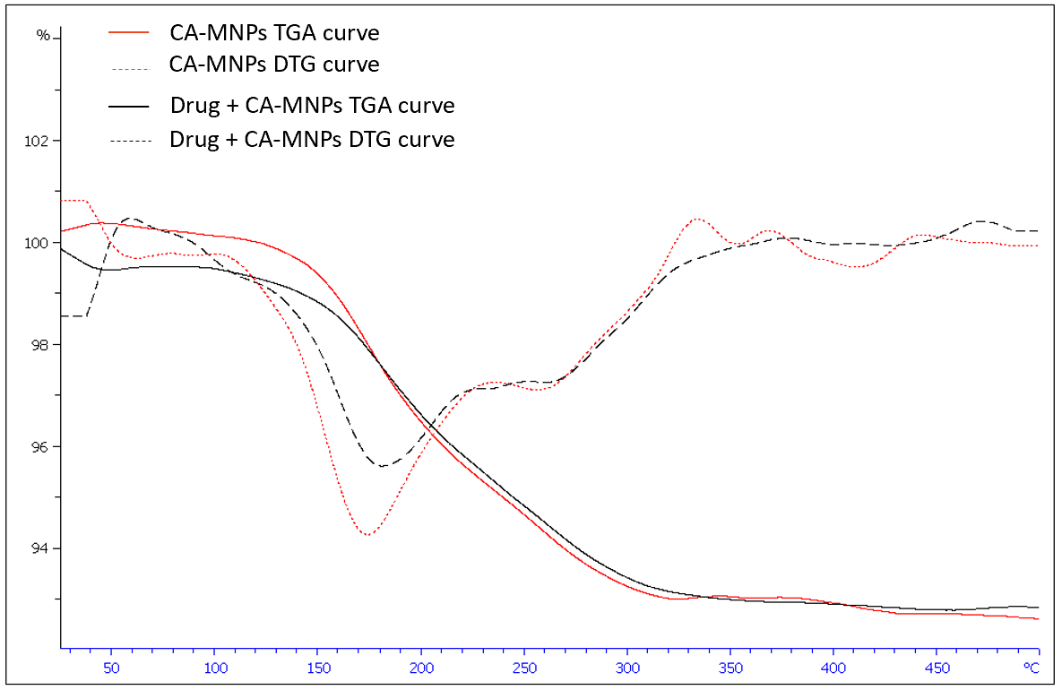
Figure S2. The TGA and DTG curves of citric acid-coated MNPs and drug + citric acid-coated MNPs.

Table S1. Shrinkage/expansion testing of spherical cap shaped cryogels in various mixtures of ethanol : water.

Figure S3. UV-vis absorbance scan for acetaminophen indicating a strong peak at 248 nm and a broad shoulder at 285 nm.

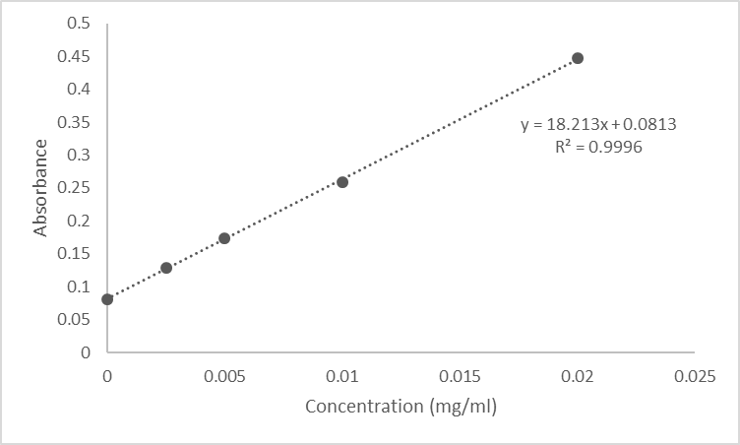
Figure S4. The calibration curve used in the determination of the concentration of acetaminophen in IMS (25%) for the drug release studies.

Section 1. Surface area calculations of disc and spherical cap gels
Disc shaped gels:
Disc radius = 1.1 cm
Disc volume = 2 ml
V_{disc} = πr²h
h = 0.53 cm
A_{disc} = 2 πrh + 2πr² = 11.26 cm²

Spherical cap shaped gels
Cap radius = 1.25 cm
Cap Volume = 2 ml
V_{cap} = (πh(3r_{cap}² + h²))/6
h = 0.7 cm
A_{cap} = π(r_{cap}² + h²) + πr_{cap}² = 11.35 cm²
The difference in surface areas are <0.01% as evidenced as:
[(11.35 – 11.26) / 11.35] * 100% = 0.79%
Or
[(11.35 – 11.26) / 11.26] * 100% = 0.80%

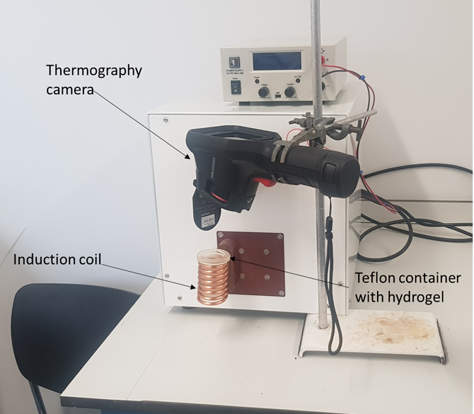
Figure S5. The assembly of the apparatus for the hyperthermia experiments of PVA-MNP cryogels.

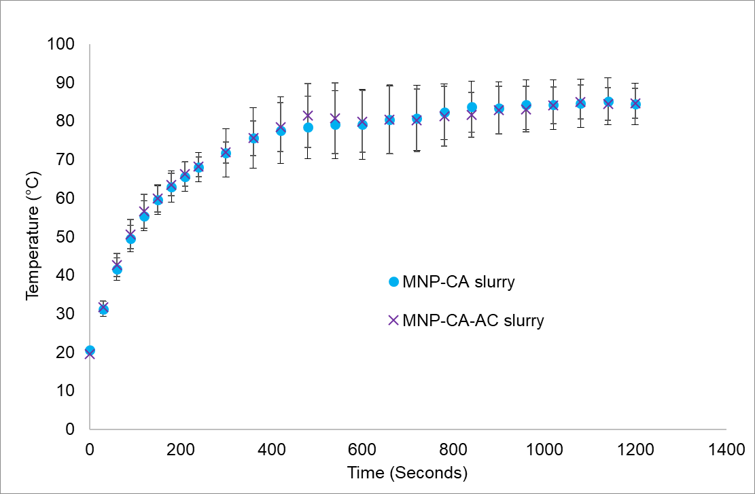
Figure S6. Comparison of temperature increase in slurries (i.e., PVA-MNP mixtures without any gel formation) with and without acetaminophen coating of MNPs during magnetic hyperthermia.

