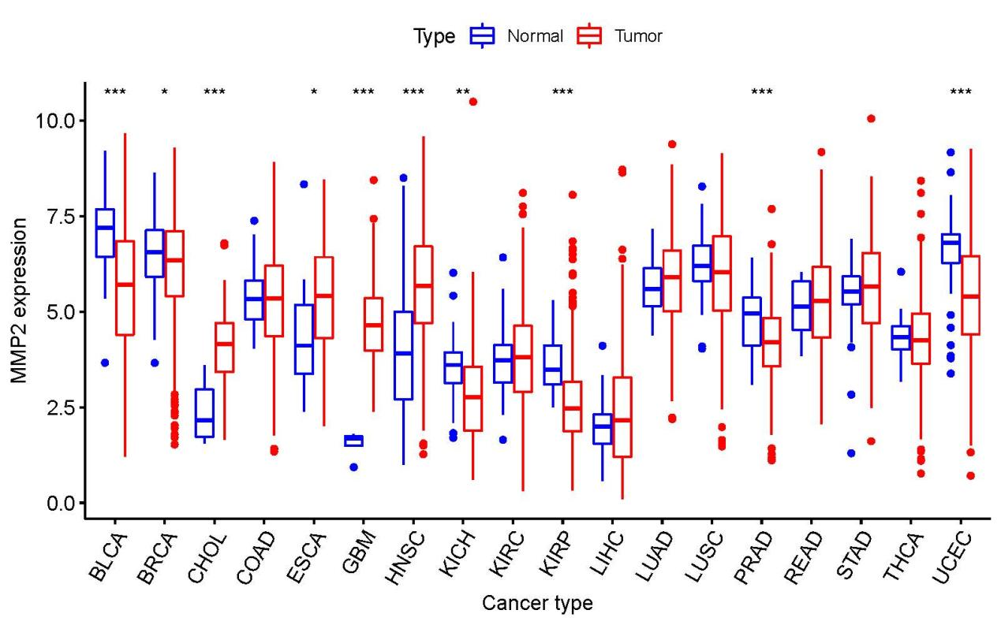
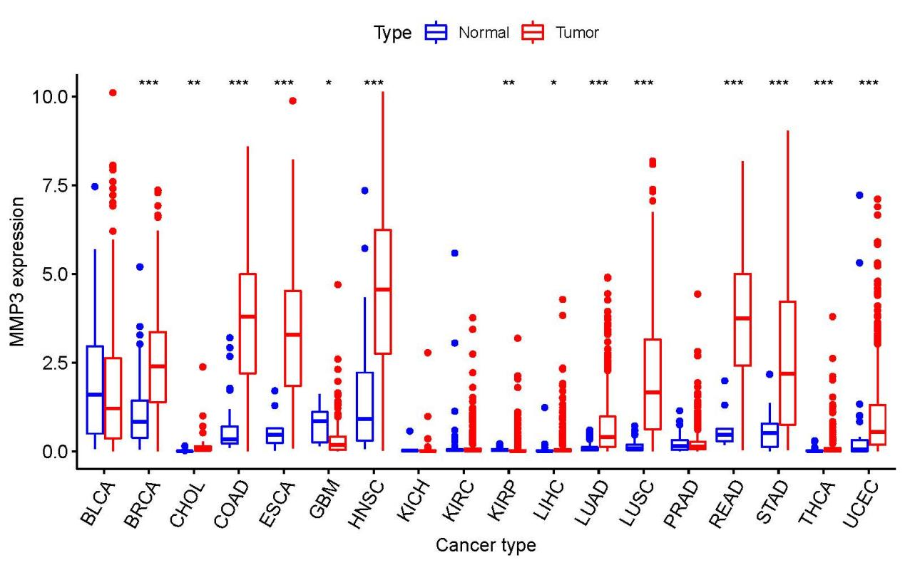
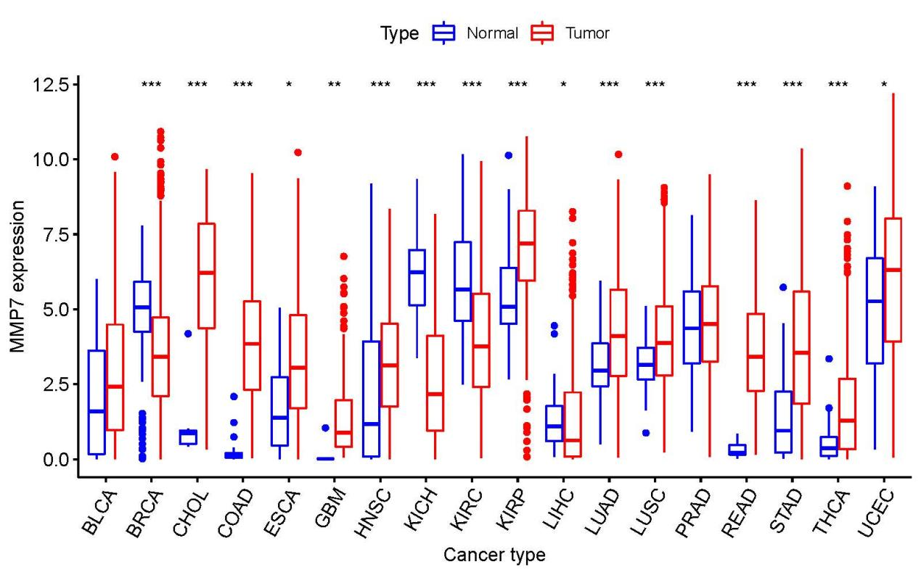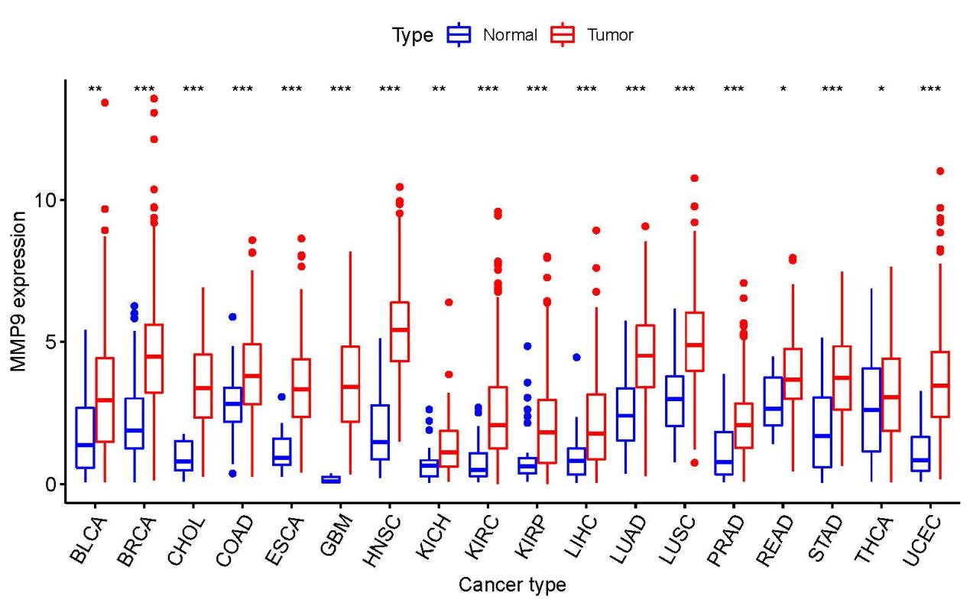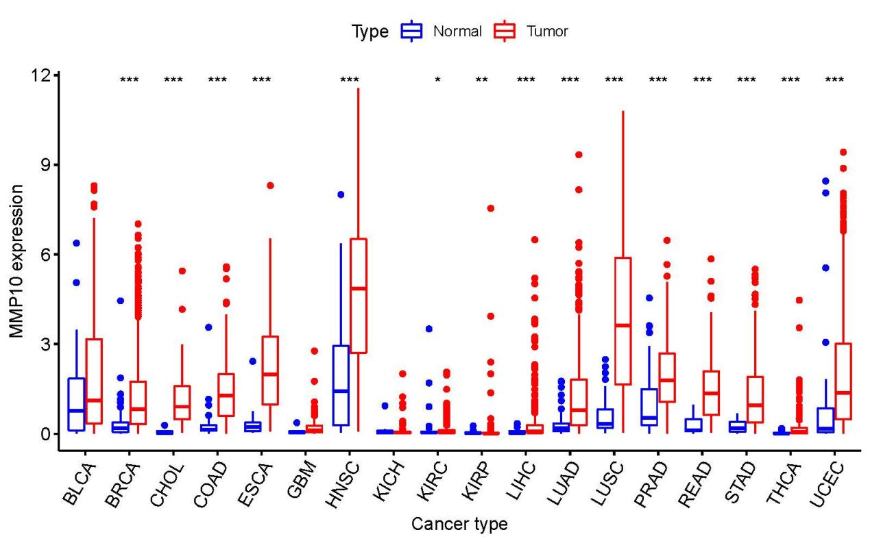
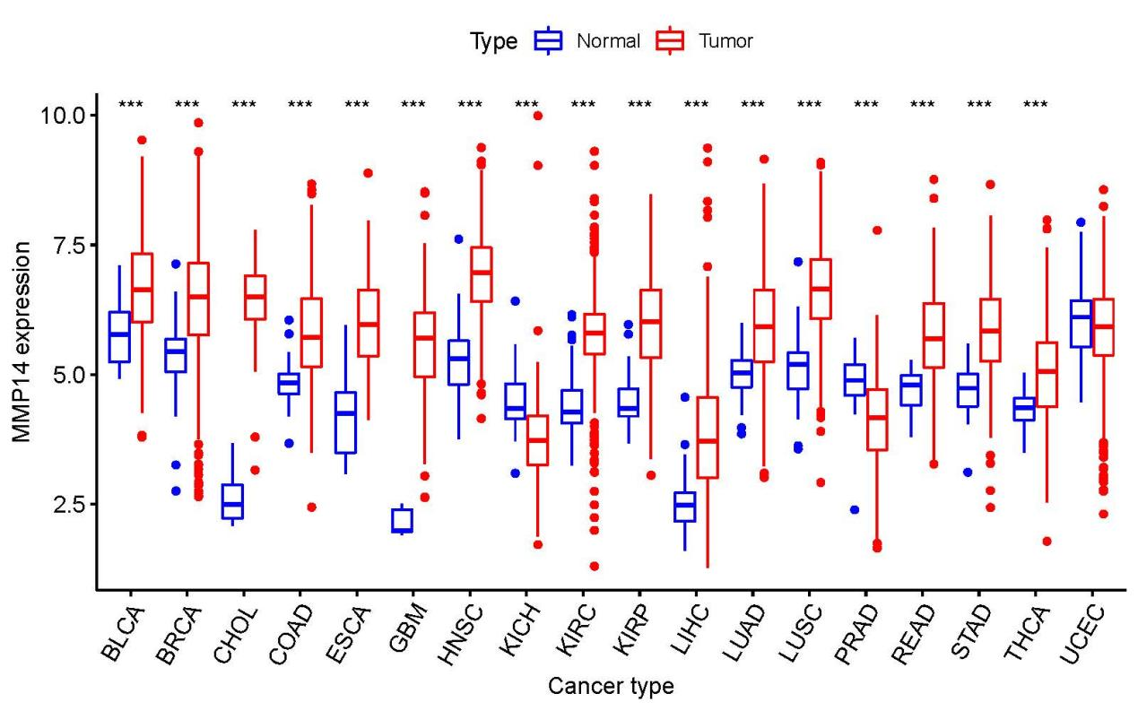
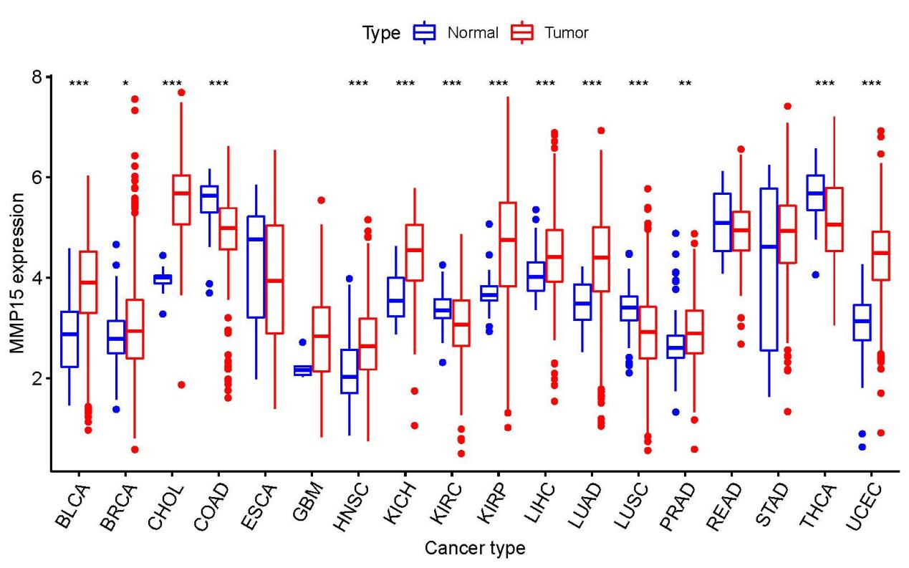
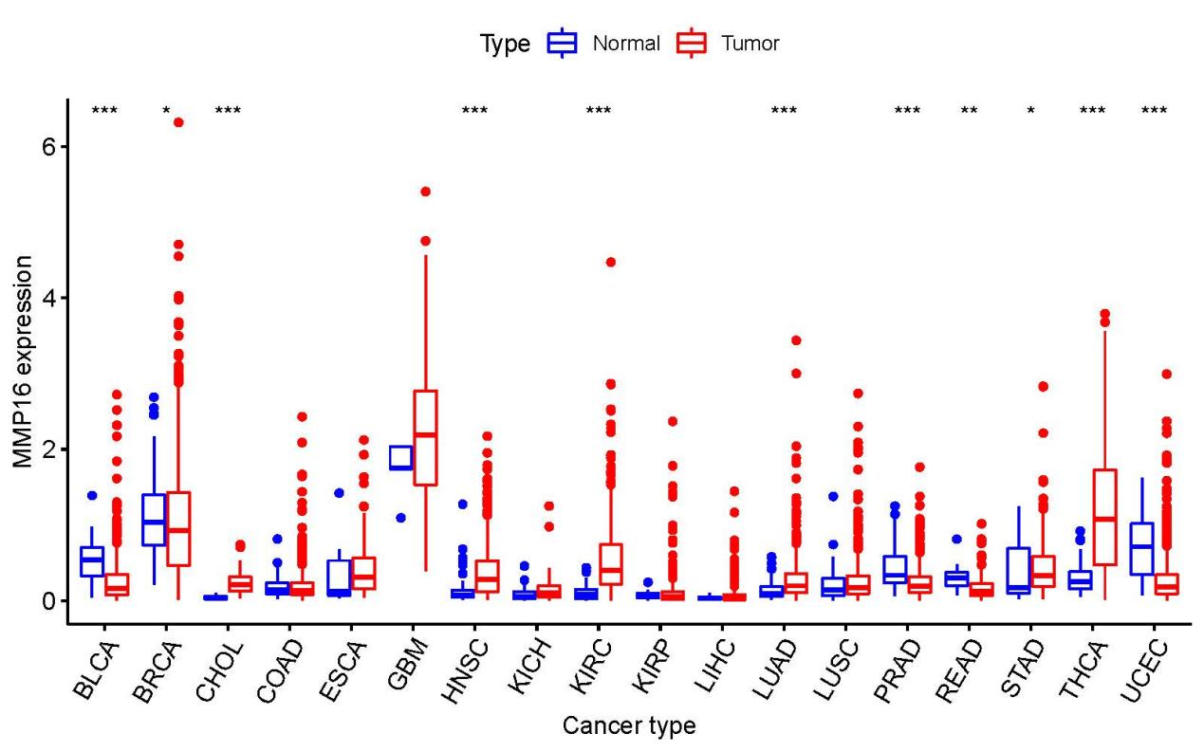
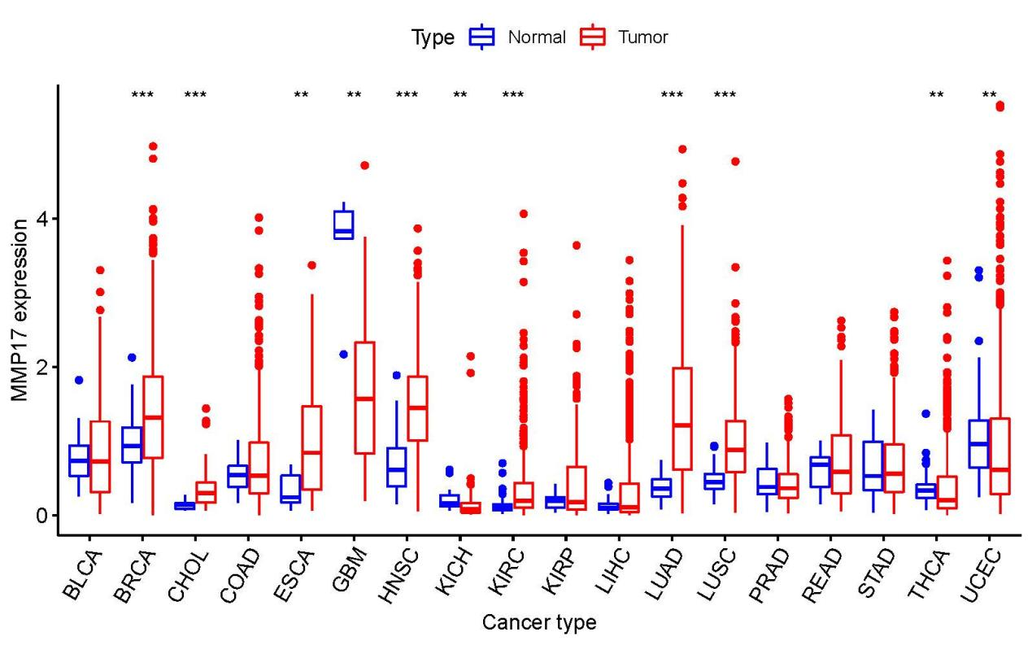
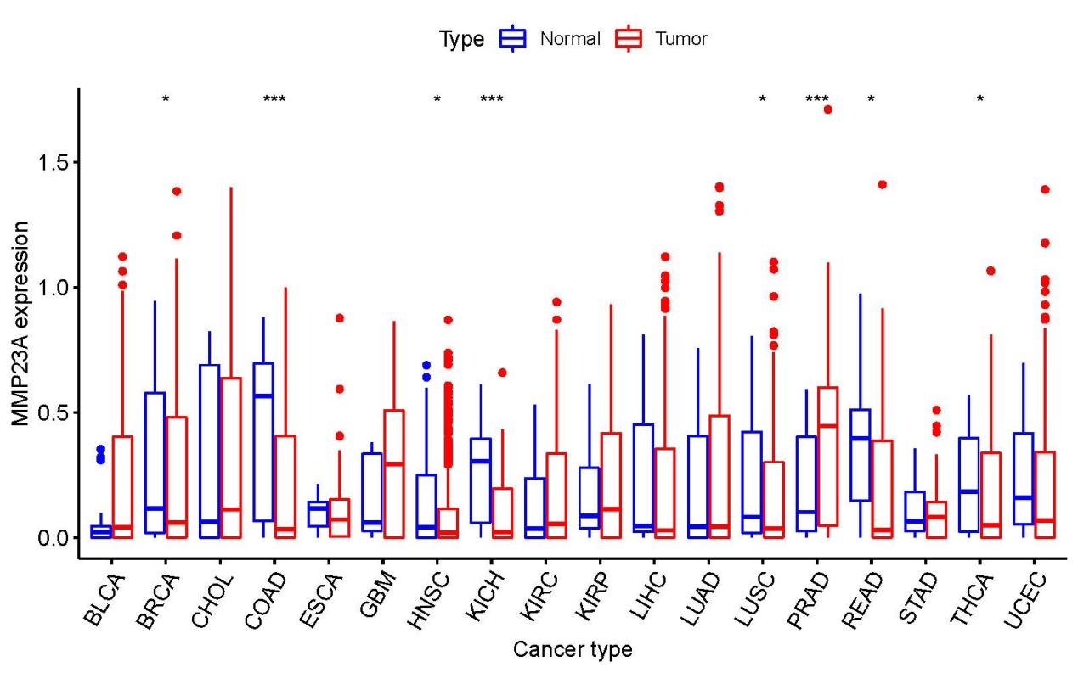
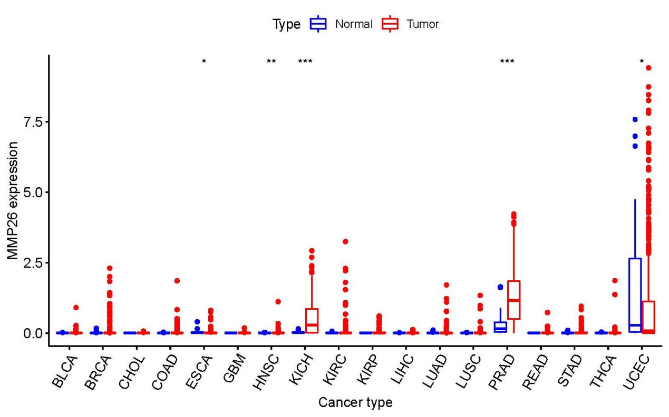
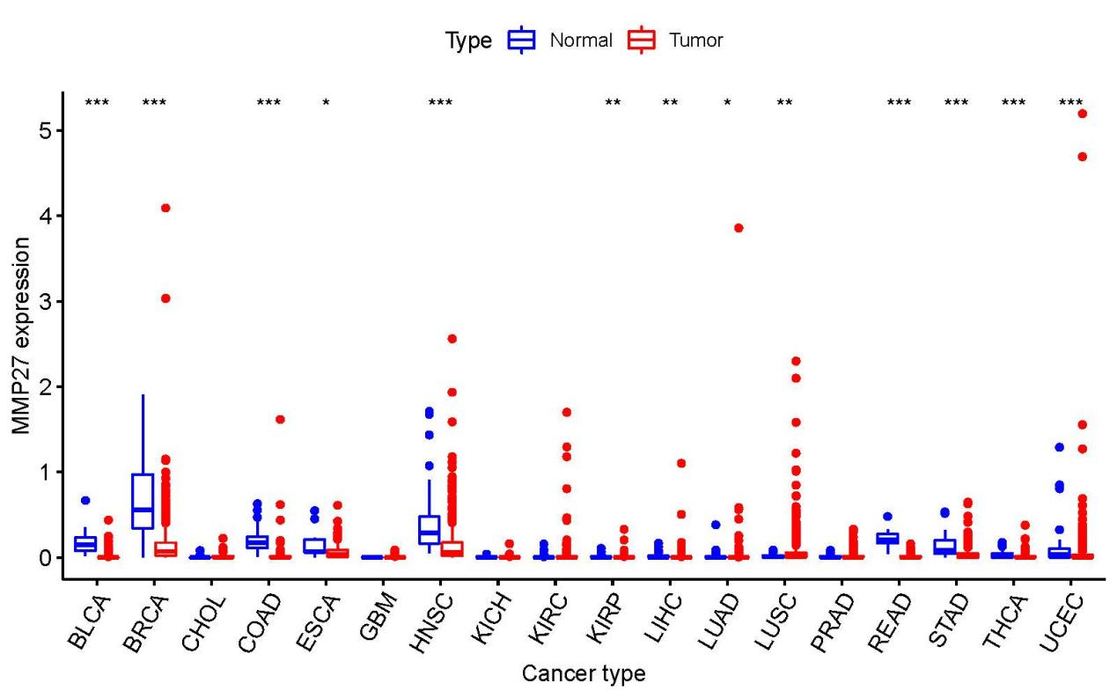
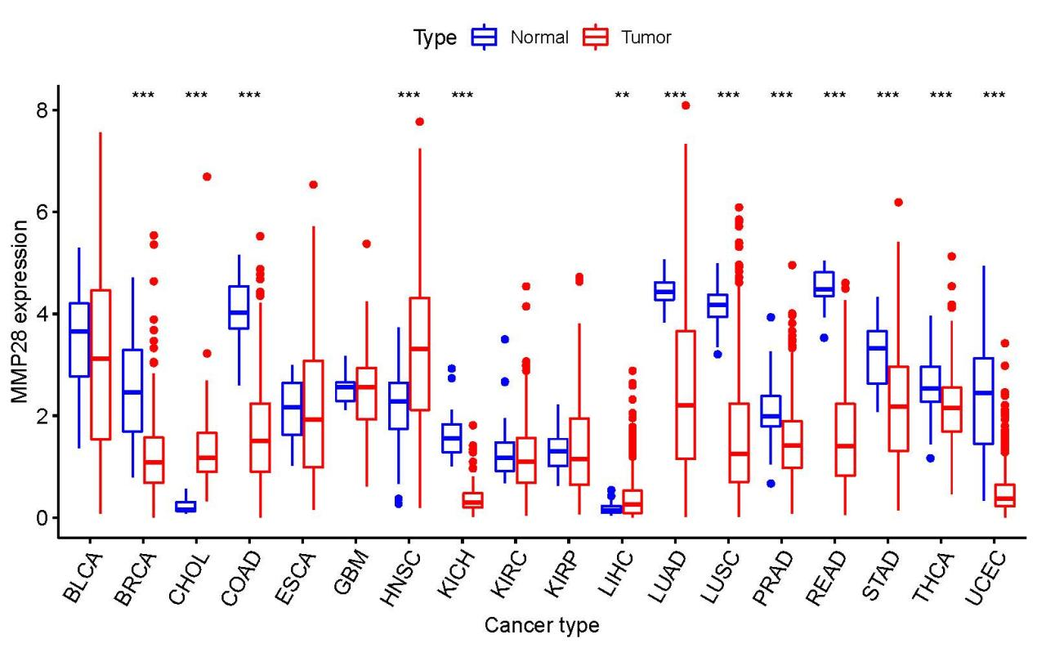

Supplementary Figure 1 Differential gene expression of MMPs, including MMP2, MMP3, MMP7, MMP9, MMP10, MMP14, MMP15, MMP16, MMP17, MMP23A, MMP26, MMP27, and MMP28 in different cancer types. P-values and Fold change were obtained through comparison of control tissue to tumor tissue.

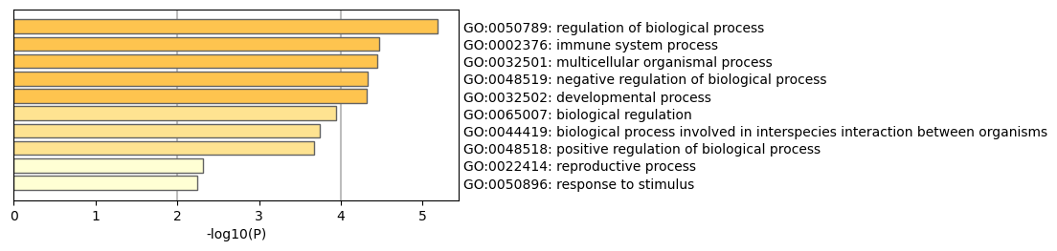
Supplementary Figure 2 GO functional enrichment analysis of marker genes of clusters 0, 1, and 3.

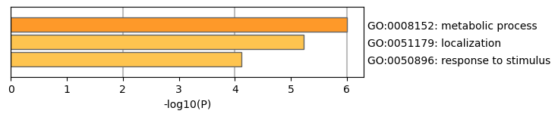
Supplementary Figure 3 GO functional enrichment analysis of marker genes of 8 and 10 were defined as metabolic-related cells.

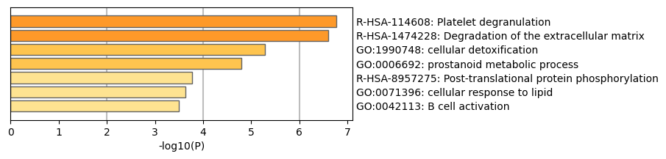
Supplementary Figure 4 GO functional enrichment analysis of marker genes of
GO functional enrichment analysis of marker genes of cluster 12, 14, and 15.

