Supplementary figure 5
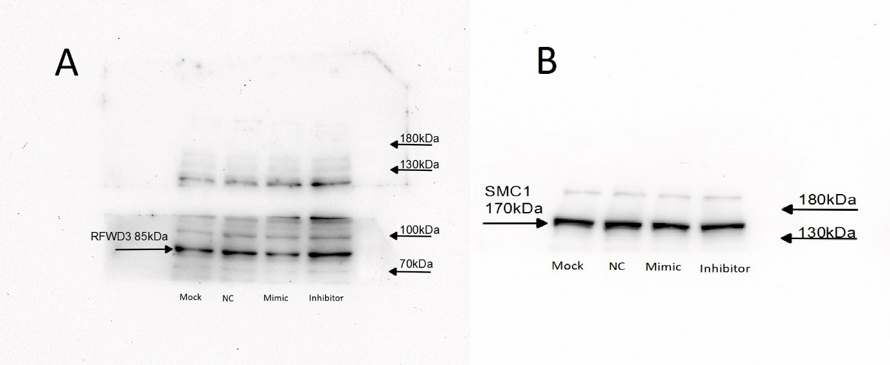
Supplementary figure 5: Original uncropped westernblots of RFWD3 and SMC1. A) The original blot of RFWD3. B) The original blot of SMC1.

