Supplement
Table S1: Summary statistics of the US7 score at baseline, w6, w12, w24 and w52
 | N | Median (min-max, IQR) | p-value
US7 Greyscale Synovitis score
baseline | 28 | 11.0 (4-22, 8.25)
w6 | 28 | 10.5 (3-22, 6.00) | 0.108
w12 | 28 | 11.0 (3-20, 5.25) | 0.269
w24 | 26 | 11.0 (3-19, 5.00) | 0.051
w52 | 18 | 8.5 (0-16, 5.75) | 0.082
US7 Power Doppler Synovitis score
baseline | 28 | 2.0 (0-17, 3.00)
w6 | 28 | 2.5 (0-10, 3.50) | 0.548
w12 | 28 | 1.5 (0-16, 5.00) | 0.212
w24 | 26 | 1.5 (0-90, 2.75) | 0.018
w52 | 18 | 0.5 (0-40, 2.00) | 0.252
US7 Greyscale Tenosynovitis score
baseline | 28 | 0.5 (0-3, 1)
w6 | 28 | 0.0 (0-3, 1) | 0.393
w12 | 28 | 0.0 (0-3, 1) | 0.308
w24 | 26 | 0.0 (0-4, 1) | 0.039
w52 | 18 | 0.0 (0-2, 0) | 0.023
US7 Power Doppler Tenosynovitis score
baseline | 28 | 0.0 (0-2, 1.00)
w6 | 28 | 0.0 (0-3, 0.25) | 1.0
w12 | 28 | 0.0 (0-3, 0.00) | 0.746
w24 | 26 | 0.0 (0-4, 0.75) | 0.890
w52 | 18 | 0.0 (0-2, 0.00) | 0.710
IQR=interquartile range, significance level of p<0.05
Figure S1:
Pairwise correlation of FOIAS, MSUS Scores and clinical outcome parameters

A) Correlation at baseline

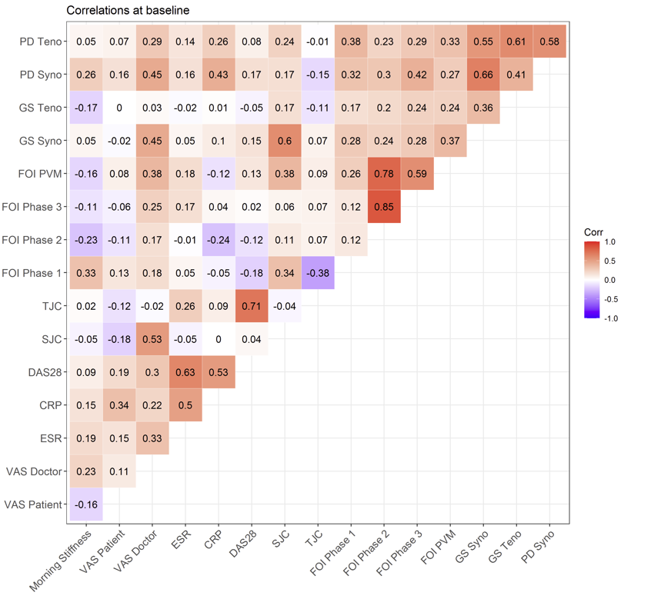

B) Correlations (change from baseline) at w24 and w52

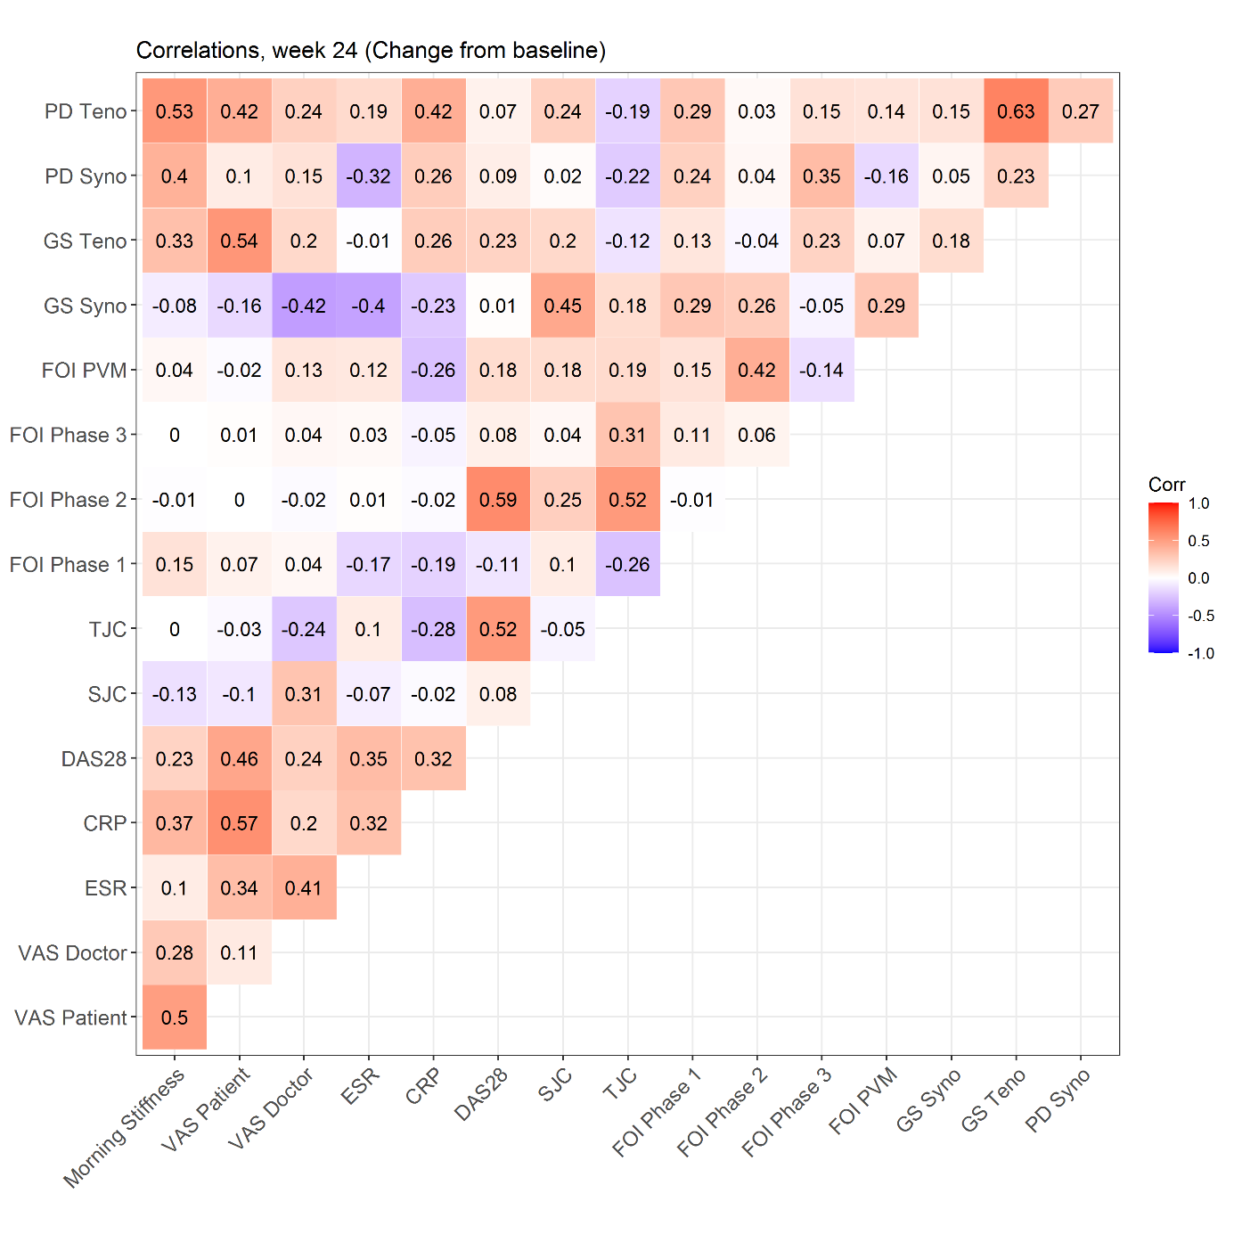

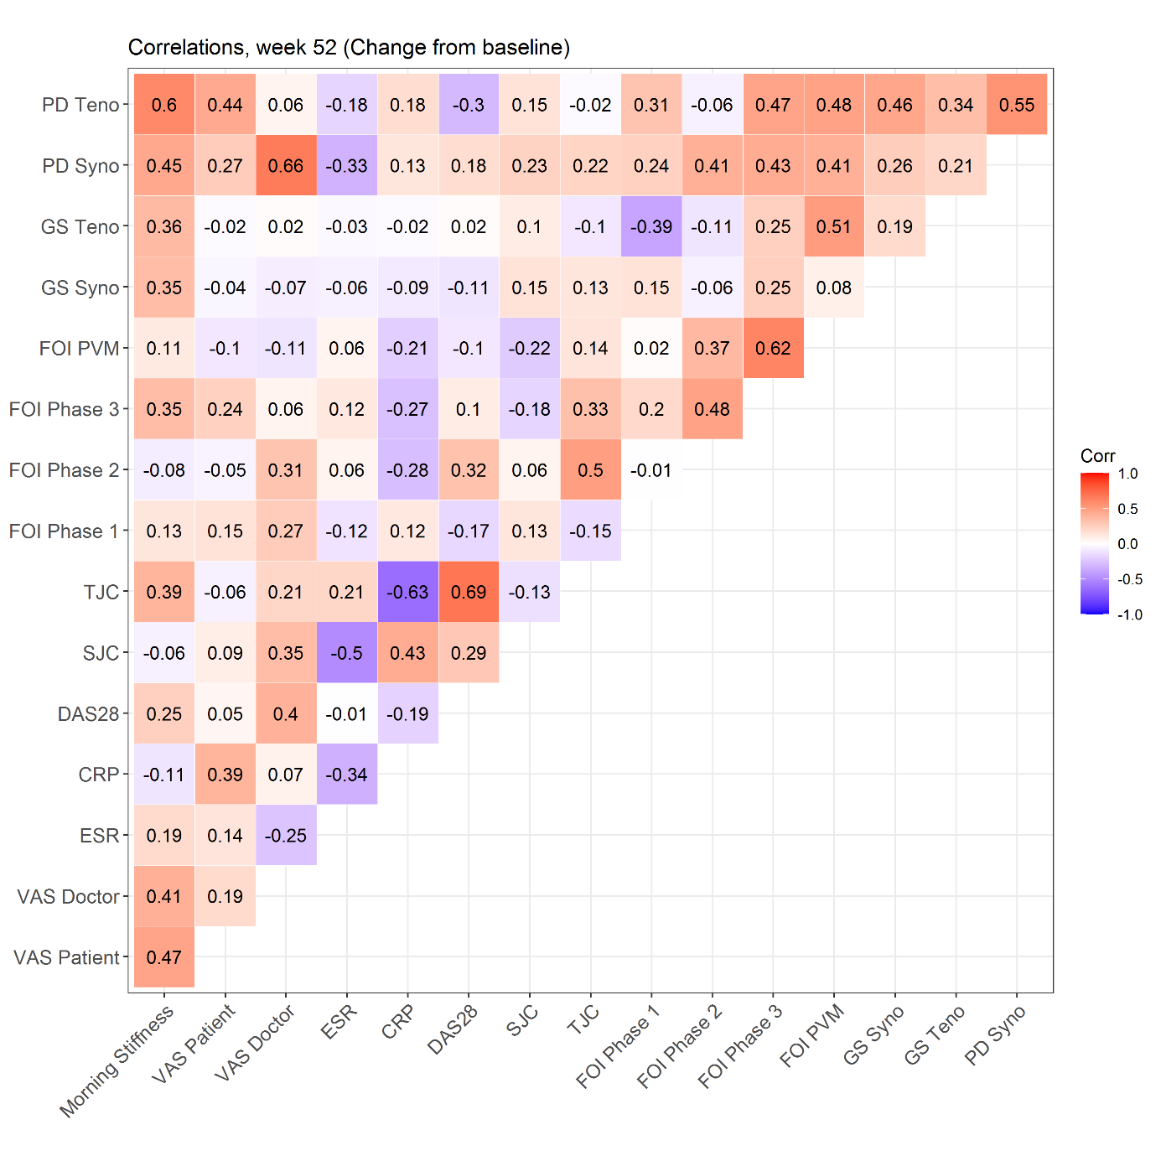

Figure S2: Box plots of DAS28, FOIAS P1, US7PD/US7GS synovitis and SJC/TJC scores at baseline, w6, w12, w24 and w52

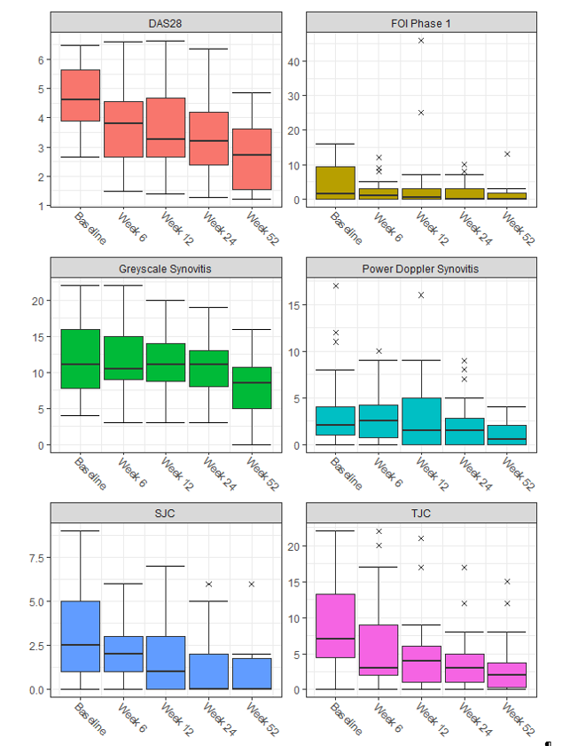
Boxes represent the interquartile rang (25th to 75th percentile) The black lines in the box depicts the median (50th percentile). “X” are the outliers.

