Supplementary information

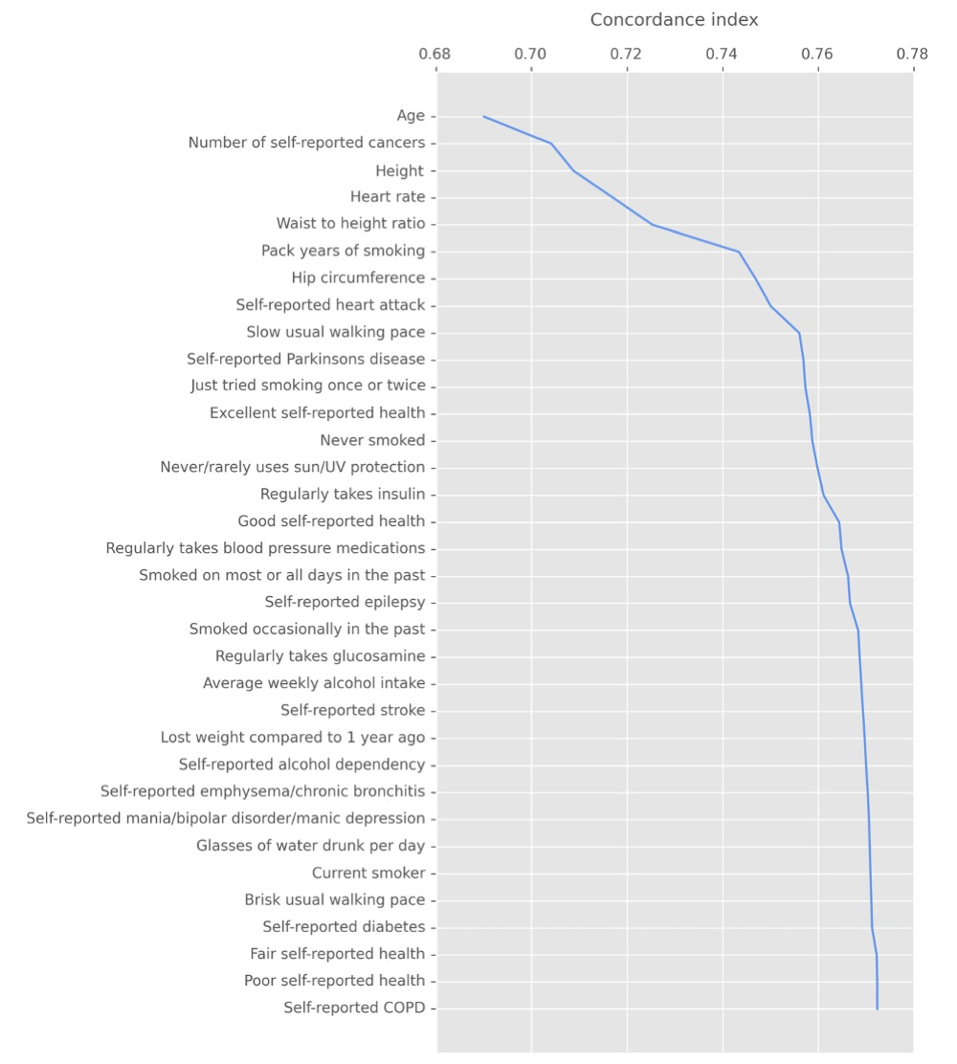
Supplementary Figure 1: Contribution of features to the final model concordance index. Features were added stepwise from the top, in the order of permutation importance (i.e. age, being the most important feature, was added first, self-reported COPD last to complete the feature set and achieve the final concordance index).

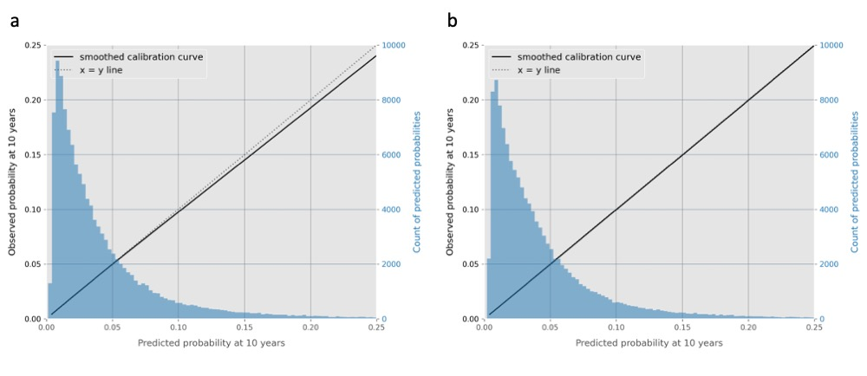
Supplementary Figure 2: Model calibration at 10 years. Results from the baseline (a) and final (b) CPH models evaluated on the test dataset are shown. Smoothed calibration curve is shown in solid line. Histogram of the predicted probabilities of incident death at 10 years for the participants in the test dataset are shown in blue.

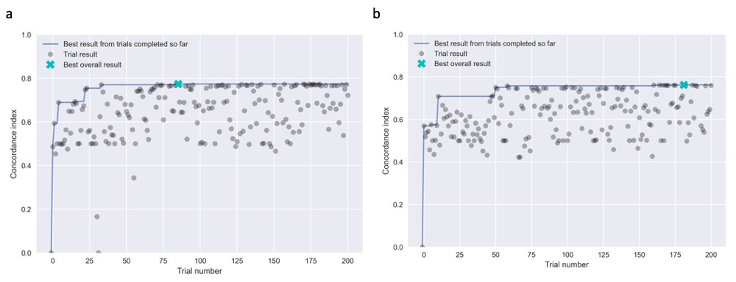
Supplementary Figure 3: Performance achieved in the 200 trials of TPE hyperparameter search for the baseline (a) and final (b) model. Trials with the best overall results are indicated with a cyan cross.

Supplementary Table 1: List of features selected during the data-driven feature selection process. Source UK Biobank field along with any data preprocessing methods are shown. Features fixed during the feature selection process are marked with an asterisk. Three features were removed during manual review and the reasons are summarised in the last column.

Feature | UKB Field | Processing | Manual review
Age | 21022 | - | -
Average weekly alcohol intake* | 1558, 1568, 1578, 1598, 5364 | Missing values were imputed with mean, summary variable created by summing all variables | -
Brisk usual walking pace | 924 | One-hot encoded (value 3) | -
Current smoker | 20116 | One-hot encoded (value 2) | -
Excellent self-reported health* | 2178 | One-hot encoded (value 1) | -
Experienced headache in the past month | 6159 | One-hot encoded (value 1) | No clear clinical explanation for negative coefficient
Fair self-reported health* | 2178 | One-hot encoded (value 3) | -
Glasses of water drunk per day | 1528 | Value -10 (less than 1) changed to 0.5, mean imputation for missing values | -
Good self-reported health* | 2178 | One-hot encoded (value 2) | -
Heart rate* | 102 | Mean of two measurements taken, mean imputation for missing values | -
Height | 50 | Participants with missing values excluded | -
Hip circumference | 49 | Participants with missing values excluded | -
Just tried smoking once or twice | 1249 | One-hot encoded (value 3) | -
Lost weight compared to 1 year ago | 2306 | One-hot encoded (value 3) | -
Never smoked | 1249 | One-hot encoded (value 4) | -
Never/rarely uses sun/UV protection | 2267 | One-hot encoded (value 1) | -
Number of cigarettes per day* | 3456 | Missing values converted to 0 | Not contributing (Cox coefficient -close to 0)
Number of self-reported cancers | 134 | - | -
Pack years of smoking | 20161 | Missing values converted to 0 | -
Poor self-reported health* | 2178 | One-hot encoded (value 4) | -
Regularly takes blood pressure medications | 6177, 6153 | Sex-specific fields merged, one-hot encoded (value 2) | -
Regularly takes glucosamine | 6179 | One-hot encoded (value 2) | -
Regularly takes insulin | 6177, 6153 | Sex-specific fields merged, one-hot encoded (value 3) | -
Self-reported COPD | 20002 | One-hot encoded (value 1112) | -
Self-reported Parkinson's disease | 20002 | One-hot encoded (value 1262) | -
Self-reported alcohol dependency | 20002 | One-hot encoded (value 1408) | -
Self-reported diabetes | 20002 | One-hot encoded (value 1220) | -
Self-reported emphysema/chronic bronchitis | 20002 | One-hot encoded (value 1113) | -
Self-reported epilepsy | 20002 | One-hot encoded (value 1264) | -
Self-reported heart attack | 20002 | One-hot encoded (value 1075) | -
Self-reported mania/bipolar disorder/manic depression | 20002 | One-hot encoded (value 1291) | -
Self-reported stroke | 20002 | One-hot encoded (value 1081) | -
Sleep duration* | 1160 | Participants with missing values excluded | Not contributing (Cox coefficient close to 0)
Slow usual walking pace | 924 | One-hot encoded (value 1) | -
Smoked occasionally in the past | 1249 | One-hot encoded (value 2) | -
Smoked on most or all days in the past | 1249 | One-hot encoded (value 1) | -
Waist to height ratio* | 48, 50 | Ratio of waist and height taken | -

Supplementary Table 2: DeepSurv hyperparameter search space. Tree-Structured Parzen Estimator algorithm^{A} from the Optuna library^{B} was used to find the optimal set of parameters within the search space.

Hyper-Parameter | Search Space
Hidden Layers topology* | 8, 32, 256, 32x32, 64x64, 128x128, 64x16, 256x32, 32x32x32, 64x64x64
Activation | LeakyReLU^{C}, ReLU^{D} and SELU^{E}
Drop-Out*^{F} | [0, 0.9]
Weight-Decay*^{G} | [0, 20]
Batch Normalisation^{H} | Yes/No
Optimizer | Stochastic Gradient Descent (SGD), Adam^{J}
Momentum*^{K} | [0,1]
Learning Rate | Log distribution on [1e-5, 1]

*Uniform distributions

^{A} Bergstra J, Bardenet R, Bengio Y, Kégl B. Algorithms for hyper-parameter optimization. In: 25th annual conference on neural information processing systems (NIPS 2011). Neural Information Processing Systems Foundation; 2011.
^{B} Akiba T, Sano S, Yanase T, Ohta T, Koyama M. Optuna: A next-generation hyperparameter optimization framework. In: Proceedings of the 25th ACM SIGKDD international conference on knowledge discovery & data mining. 2019. p. 2623–31.
^{C} Maas AL, Hannun AY, Ng AY. Rectifier nonlinearities improve neural network acoustic models. In: Proc icml. Citeseer; 2013. p. 3.
^{D} Glorot X, Bordes A, Bengio Y. Deep sparse rectifier neural networks. In: Proceedings of the fourteenth international conference on artificial intelligence and statistics. JMLR Workshop and Conference Proceedings; 2011. p. 315–23.
^{E} Klambauer G, Unterthiner T, Mayr A, Hochreiter S. Self-normalizing neural networks. ArXiv Prepr ArXiv170602515. 2017.
^{F} Hinton GE, Srivastava N, Krizhevsky A, Sutskever I, Salakhutdinov RR. Improving neural networks by preventing co-adaptation of feature detectors. ArXiv Prepr ArXiv12070580. 2012.
^{G} Moody J, Hanson S, Krogh A, Hertz JA. A simple weight decay can improve generalization. Adv Neural Inf Process Syst. 1995;4(1995):950–7.
^{H} Ioffe S, Szegedy C. Batch normalization: Accelerating deep network training by reducing internal covariate shift. In: International conference on machine learning. PMLR; 2015. p. 448–56.
^{J} Kingma DP, Ba J. Adam: A method for stochastic optimization. ArXiv Prepr ArXiv14126980. 2014;
^{K} Rumelhart DE, Hinton GE, Williams RJ. Learning representations by back-propagating errors. nature. 1986;323(6088):533–6.

Supplementary Table 3: Statistical comparison of the train and test datasets. Features selected into the final model are shown in alphabetical order. Last column shows p-value after comparing the incident death group with the no-death group. Comparisons were performed using the Chi-squared test for categories and Kruskal-Wallis test for continuous variables.

 | Overall | Train dataset | Test dataset | p-value (adjusted)
n | 497712 | 373284 | 124428
Death (outcome), n (%) | 29615 (5.95) | 22211 (5.95) | 7404 (5.95) | 1.000
Follow-up time, median [Q1, Q3] | 11.60 [10.88,12.32] | 11.60 [10.88,12.32] | 11.60 [10.88,12.32] | 1.000
Age, median [Q1,Q3] | 58.00 [50.00,63.00] | 58.00 [50.00,63.00] | 58.00 [50.00,63.00] | 0.298
Average weekly alcohol intake, median [Q1,Q3] | 11.48 [6.04,12.00] | 11.48 [6.04,12.00] | 11.48 [6.04,12.00] | 1.000
Brisk usual walking pace, n (%) | 193135 (38.80) | 144893 (38.82) | 48242 (38.77) | 1.000
Current smoker, n (%) | 52401 (10.53) | 39320 (10.53) | 13081 (10.51) | 1.000
Excellent self-reported health, n (%) | 81486 (16.37) | 61223 (16.40) | 20263 (16.28) | 1.000
Fair self-reported health, n (%) | 104277 (20.95) | 78037 (20.91) | 26240 (21.09) | 1.000
Glasses of water drunk per day, median [Q1,Q3] | 2.00 [1.00,4.00] | 2.00 [1.00,4.00] | 2.00 [1.00,4.00] | 1.000
Good self-reported health, n (%) | 287268 (57.72) | 215412 (57.71) | 71856 (57.75) | 1.000
Heart rate, median [Q1,Q3] | 69.00 [62.00,75.50] | 69.00 [62.00,75.50] | 69.00 [62.00,75.50] | 1.000
Height, median [Q1,Q3] | 168.00 [162.00,175.00] | 168.00 [161.50,175.00] | 168.00 [162.00,175.00] | 1.000
Hip circumference, median [Q1,Q3] | 102.00 [97.00,108.00] | 102.00 [97.00,108.00] | 102.00 [97.00,108.00] | 0.278
Just tried smoking once or twice, n (%) | 72575 (14.58) | 54525 (14.61) | 18050 (14.51) | 1.000
Lost weight compared to 1 year ago, n (%) | 75218 (15.11) | 56147 (15.04) | 19071 (15.33) | 0.542
Never smoked, n (%) | 199306 (40.04) | 149424 (40.03) | 49882 (40.09) | 1.000
Never/rarely uses sun/UV protection, n (%) | 50190 (10.08) | 37600 (10.07) | 12590 (10.12) | 1.000
Number of self-reported cancers, median [Q1,Q3] | 0.00 [0.00,0.00] | 0.00 [0.00,0.00] | 0.00 [0.00,0.00] | 1.000
Pack years of smoking, median [Q1,Q3] | 0.00 [0.00,7.12] | 0.00 [0.00,7.00] | 0.00 [0.00,7.50] | 1.000
Poor self-reported health, n (%) | 22209 (4.46) | 16745 (4.49) | 5464 (4.39) | 1.000
Regularly takes blood pressure medications, n (%) | 102974 (20.69) | 77097 (20.65) | 25877 (20.80) | 1.000
Regularly takes glucosamine, n (%) | 93995 (18.89) | 70339 (18.84) | 23656 (19.01) | 1.000
Regularly takes insulin, n (%) | 5482 (1.10) | 4108 (1.10) | 1374 (1.10) | 1.000
Self-reported COPD, n (%) | 1644 (0.33) | 1219 (0.33) | 425 (0.34) | 1.000
Self-reported Parkinson's disease, n (%) | 840 (0.17) | 628 (0.17) | 212 (0.17) | 1.000
Self-reported alcohol dependency, n (%) | 737 (0.15) | 542 (0.15) | 195 (0.16) | 1.000
Self-reported diabetes, n (%) | 21387 (4.30) | 16055 (4.30) | 5332 (4.29) | 1.000
Self-reported emphysema/chronic bronchitis, n (%) | 6744 (1.36) | 5087 (1.36) | 1657 (1.33) | 1.000
Self-reported epilepsy, n (%) | 3975 (0.80) | 2977 (0.80) | 998 (0.80) | 1.000
Self-reported heart attack, n (%) | 11352 (2.28) | 8473 (2.27) | 2879 (2.31) | 1.000
Self-reported mania/bipolar disorder/manic depression, n (%) | 1400 (0.28) | 1030 (0.28) | 370 (0.30) | 1.000
Self-reported stroke, n (%) | 6546 (1.32) | 4905 (1.31) | 1641 (1.32) | 1.000
Slow usual walking pace, n (%) | 40144 (8.07) | 30131 (8.07) | 10013 (8.05) | 1.000
Smoked occasionally in the past, n (%) | 64998 (13.06) | 48888 (13.10) | 16110 (12.95) | 1.000
Smoked on most or all days in the past, n (%) | 120108 (24.13) | 89981 (24.11) | 30127 (24.21) | 1.000
Waist to height ratio, median [Q1,Q3] | 0.53 [0.48,0.58] | 0.53 [0.48,0.58] | 0.53 [0.48,0.58] | 0.149

Supplementary Table 4: Analysis of the most common causes of death in the dataset. ICD10 codes belonging in each group are listed in the second column. Number and percentage of participants who died during follow-up are shown, along with 3 most common ICD10 codes in each group.

 | ICD10 codes | Number (%) of participants | Top 3 ICD10 codes
Any cause | any | 29615  (100 %) | C34 Malignant neoplasm of bronchus and lung  I25 Chronic ischaemic heart disease  I21 Acute myocardial infarction
Neoplasms | C00–C97  D10–D48 | 15790  (53.32 %) | C34 Malignant neoplasm of bronchus and lung  C50 Malignant neoplasm of breast  C25 Malignant neoplasm of pancreas
Diseases of the circulatory system | I05–I89 | 6085  (20.55 %) | I25 Chronic ischaemic heart disease  I21 Acute myocardial infarction  I64 Stroke, not specified as haemorrhage or infarction
Diseases of the respiratory system | J09–J99 | 2157  (7.28 %) | J44 Other chronic obstructive pulmonary disease  J84 Other interstitial pulmonary diseases  J18 Pneumonia, organism unspecified
Diseases of the nervous system | G00–G99 | 1442  (4.87 %) | G30 Alzheimer's disease  G12 Spinal muscular atrophy and related syndromes  G20 Parkinson's disease
Diseases of the digestive system | K20–K93 | 1125  (3.80 %) | K70 Alcoholic liver disease  K55 Vascular disorders of intestine  K74 Fibrosis and cirrhosis of liver
External causes of morbidity and mortality | V01–V97  W00–W99  X00–X99  Y10–Y89 | 861  (2.91 %) | X70 Intentional self-harm by hanging, strangulation and suffocation  W19 Unspecified fall  Y83 Surgical operation and other surgical procedures as the cause of abnormal reaction of the patient, or of later complication, without mention of misadventure at the time of the procedure
Mental and behavioural disorders | F00–F89 | 568  (1.92 %) | F03 Unspecified dementia  F01 Vascular dementia  F10 Mental and behavioural disorders due to use of alcohol
Other unknown or unspecified causes | R00–R99  U00–U49 | 460  (1.55 %) | U07 Emergency use of U07  R99 Other ill-defined and unspecified causes of mortality  U50 Level of care administered to neonates
Endocrine, nutritional and metabolic diseases | E00–E90 | 337  (1.14 %) | E11 Non-insulin-dependent diabetes mellitus  E14 Unspecified diabetes mellitus  E85 Amyloidosis
Certain infectious and parasitic diseases | A00–A99  B00–B99 | 264  (0.89 %) | A41 Other septicaemia  A81 Atypical virus infections of central nervous system  A09 Diarrhoea and gastro-enteritis of presumed infectious origin
Diseases of the genitourinary system | N00–N98 | 189  (0.64 %) | N39 Other disorders of urinary system  N18 Chronic renal failure  N17 Acute renal failure
Diseases of the musculoskeletal system and connective tissue | M00–M90 | 168  (0.57 %) | M06 Other rheumatoid arthritis  M35 Other systemic involvement of connective tissue  M34 Systemic sclerosis
Diseases of the blood and blood-forming organs and certain disorders involving the immune mechanism | D55–D89 | 69  (0.23 %) | D86 Sarcoidosis  D70 Agranulocytosis  D61 Other aplastic anaemias
Diseases of the skin and subcutaneous tissue | L00–L99 | 49  (0.17 %) | L03 Cellulitis  L97 Ulcer of lower limb, not elsewhere classified  L08 Other local infections of skin and subcutaneous tissue
Congenital malformations, deformations and chromosomal abnormalities | Q00–Q99 | 48  (0.16 %) | Q87 Other specified congenital malformation syndromes affecting multiple systems  Q24 Other congenital malformations of heart  Q61 Cystic kidney disease
Diseases of the ear and mastoid process | H65–H75 | 2  (0.01 %) | H70 Mastoiditis and related conditions
Pregnancy, childbirth and the puerperium | O00–O99 | 1  (0.00 %) | O30 Multiple gestation

Supplementary Table 5: Summary of demographic characteristics of the studied cohort grouped by the outcomes. Features selected into the final model are shown in alphabetical order. Last column shows p-value after comparing the incident death group with the no-death group. Comparisons were performed using the Chi-squared test for categories and Kruskal-Wallis test for continuous variables.

 | Overall | No death during follow-up | Death during follow-up | p-value (adjusted)
n | 497712 | 468097 | 29615
Age, median [Q1,Q3] | 58.00 [50.00,63.00] | 57.00 [50.00,63.00] | 63.00 [58.00,67.00] | <0.001
Average weekly alcohol intake, median [Q1,Q3] | 11.48 [6.04,12.00] | 11.48 [6.04,12.00] | 11.48 [8.00,13.04] | <0.001
Brisk usual walking pace, n (%) | 193135 (38.80) | 185802 (39.69) | 7333 (24.76) | <0.001
Current smoker, n (%) | 52401 (10.53) | 46615 (9.96) | 5786 (19.54) | <0.001
Excellent self-reported health, n (%) | 81486 (16.37) | 78779 (16.83) | 2707 (9.14) | <0.001
Fair self-reported health, n (%) | 104277 (20.95) | 95291 (20.36) | 8986 (30.34) | <0.001
Glasses of water drunk per day, median [Q1,Q3] | 2.00 [1.00,4.00] | 2.00 [1.00,4.00] | 2.00 [1.00,4.00] | <0.001
Good self-reported health, n (%) | 287268 (57.72) | 273596 (58.45) | 13672 (46.17) | <0.001
Heart rate, median [Q1,Q3] | 69.00 [62.00,75.50] | 69.00 [62.00,75.00] | 69.50 [63.50,78.50] | <0.001
Height, median [Q1,Q3] | 168.00 [162.00,175.00] | 168.00 [161.20,175.00] | 169.00 [162.00,176.00] | <0.001
Hip circumference, median [Q1,Q3] | 102.00 [97.00,108.00] | 102.00 [97.00,108.00] | 103.00 [98.00,109.00] | <0.001
Just tried smoking once or twice, n (%) | 72575 (14.58) | 69887 (14.93) | 2688 (9.08) | <0.001
Lost weight compared to 1 year ago, n (%) | 75218 (15.11) | 69944 (14.94) | 5274 (17.81) | <0.001
Never smoked, n (%) | 199306 (40.04) | 190784 (40.76) | 8522 (28.78) | <0.001
Never/rarely uses sun/UV protection, n (%) | 50190 (10.08) | 45305 (9.68) | 4885 (16.50) | <0.001
Number of self-reported cancers, median [Q1,Q3] | 0.00 [0.00,0.00] | 0.00 [0.00,0.00] | 0.00 [0.00,0.00] | <0.001
Pack years of smoking, median [Q1,Q3] | 0.00 [0.00,7.12] | 0.00 [0.00,6.00] | 0.00 [0.00,27.30] | <0.001
Poor self-reported health, n (%) | 22209 (4.46) | 18246 (3.90) | 3963 (13.38) | <0.001
Regularly takes blood pressure medications, n (%) | 102974 (20.69) | 92102 (19.68) | 10872 (36.71) | <0.001
Regularly takes glucosamine, n (%) | 93995 (18.89) | 89125 (19.04) | 4870 (16.44) | <0.001
Regularly takes insulin, n (%) | 5482 (1.10) | 4374 (0.93) | 1108 (3.74) | <0.001
Self-reported COPD, n (%) | 1644 (0.33) | 1194 (0.26) | 450 (1.52) | <0.001
Self-reported Parkinson's disease, n (%) | 840 (0.17) | 541 (0.12) | 299 (1.01) | <0.001
Self-reported alcohol dependency, n (%) | 737 (0.15) | 562 (0.12) | 175 (0.59) | <0.001
Self-reported diabetes, n (%) | 21387 (4.30) | 18143 (3.88) | 3244 (10.95) | <0.001
Self-reported emphysema/chronic bronchitis, n (%) | 6744 (1.36) | 5353 (1.14) | 1391 (4.70) | <0.001
Self-reported epilepsy, n (%) | 3975 (0.80) | 3551 (0.76) | 424 (1.43) | <0.001
Self-reported heart attack, n (%) | 11352 (2.28) | 9065 (1.94) | 2287 (7.72) | <0.001
Self-reported mania/bipolar disorder/manic depression, n (%) | 1400 (0.28) | 1213 (0.26) | 187 (0.63) | <0.001
Self-reported stroke, n (%) | 6546 (1.32) | 5314 (1.14) | 1232 (4.16) | <0.001
Slow usual walking pace, n (%) | 40144 (8.07) | 33927 (7.25) | 6217 (20.99) | <0.001
Smoked occasionally in the past, n (%) | 64998 (13.06) | 61624 (13.16) | 3374 (11.39) | <0.001
Smoked on most or all days in the past, n (%) | 120108 (24.13) | 110119 (23.52) | 9989 (33.73) | <0.001
Waist to height ratio, median [Q1,Q3] | 0.53 [0.48,0.58] | 0.53 [0.48,0.58] | 0.56 [0.51,0.61] | <0.001

Supplementary Table 6: Summary of the final Cox Proportional Hazards model. The table displays coefficients = log(HR) with 95% confidence intervals and -log2(p-value). All columns were statistically significant (where p < 0.05 and null hypothesis states that the coefficient is equal to 0) except “Poor self-reported health” where the p-value was 0.662.

Covariate | log(HR) | CI log(HR)  lower 95% | CI log(HR)  upper 95% | -log2  (p-value)
Self-reported Parkinson's disease | 1.134 | 0.999 | 1.27 | 198.556
Self-reported alcohol dependency | 0.73 | 0.558 | 0.901 | 53.581
Age | 0.711 | 0.693 | 0.729 | inf
Self-reported mania/bipolar disorder/manic depression | 0.625 | 0.46 | 0.79 | 43.031
Regularly takes insulin | 0.47 | 0.391 | 0.549 | 101.393
Self-reported heart attack | 0.398 | 0.345 | 0.451 | 161.631
Self-reported epilepsy | 0.383 | 0.27 | 0.496 | 34.844
Self-reported emphysema/chronic bronchitis | 0.327 | 0.263 | 0.392 | 74.581
Self-reported COPD | 0.324 | 0.214 | 0.435 | 26.947
Slow usual walking pace | 0.32 | 0.281 | 0.359 | 191.24
Self-reported stroke | 0.293 | 0.225 | 0.361 | 55.281
Current smoker | 0.281 | 0.211 | 0.351 | 47.974
Never/rarely uses sun/UV protection | 0.191 | 0.154 | 0.228 | 78.043
Number of self-reported cancers | 0.185 | 0.177 | 0.194 | inf
Waist to height ratio | 0.171 | 0.15 | 0.193 | 177.742
Height | 0.159 | 0.145 | 0.173 | 354.709
Lost weight compared to 1 year ago | 0.152 | 0.117 | 0.187 | 56.116
Heart rate | 0.122 | 0.109 | 0.134 | 277.067
Self-reported diabetes | 0.12 | 0.07 | 0.171 | 18.208
Regularly takes blood pressure medications | 0.101 | 0.07 | 0.132 | 32.753
Pack years of smoking | 0.092 | 0.081 | 0.102 | 213.582
Average weekly alcohol intake | 0.047 | 0.037 | 0.057 | 64.139
Glasses of water drunk per day | 0.041 | 0.027 | 0.054 | 29.596
Poor self-reported health | 0.031 | -0.106 | 0.167 | 0.595
Brisk usual walking pace | -0.14 | -0.173 | -0.106 | 52.037
Regularly takes glucosamine | -0.173 | -0.21 | -0.137 | 67.106
Hip circumference | -0.178 | -0.198 | -0.157 | 213.233
Smoked on most or all days in the past | -0.251 | -0.325 | -0.176 | 34.061
Smoked occasionally in the past | -0.305 | -0.384 | -0.226 | 44.52
Fair self-reported health | -0.342 | -0.475 | -0.208 | 20.855
Never smoked | -0.377 | -0.457 | -0.296 | 63.873
Just tried smoking once or twice | -0.447 | -0.535 | -0.359 | 75.06
Good self-reported health | -0.606 | -0.74 | -0.473 | 60.612
Excellent self-reported health | -0.741 | -0.881 | -0.601 | 81.447

