Supplementary data

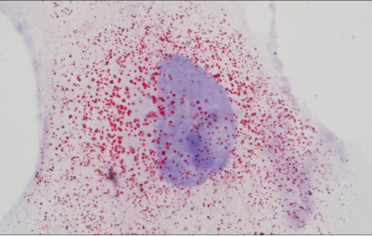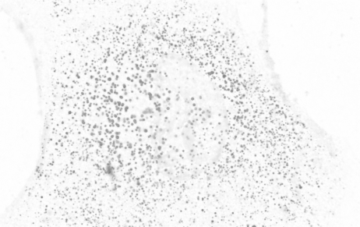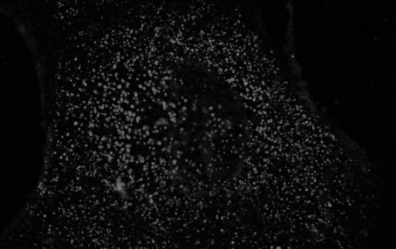
A B C
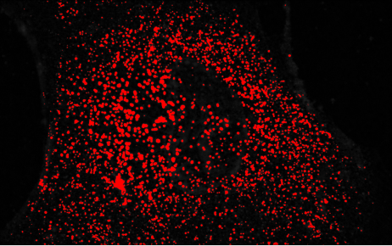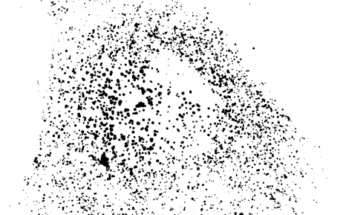
D E

Figure 1. Processing of oil red O-stained lipids for LD number and size determination. (A) Brightfield image taken at after oil red O and haematoxylin staining. (B) Image after converting RGB image form to 8-bit and subtraction of background. (C) Inverted image of B (D) Automatic thresholding of image in C. (E) Thresholded image used to determine average LD number and area per astrocyte cell body.

Table 1. Shapiro Wilk test to determine normal distribution testing for data on astrocytes treated with Aβ for 24h

Variable | Experimental  group | n | Test statistic  (W) | p-value
CCK-8 assay (24h) | 0 | 6 | 0.9364 | 0.6306
CCK-8 assay (24h) | 1 | 6 | 0.8211 | 0.0902
CCK-8 assay (24h) | 2.5 | 6 | 0.8166 | 0.0824
CCK-8 assay (24h) | 5.0 | 6 | 0.9038 | 0.3971
CCK-8 assay (24h) | 10 | 6 | 0.9705 | 0.8961
CCK-8 assay (24h) | 20 | 6 | 0.8355 | 0.1197
24h 5µM Aβ42 treatment
GFAP (immunofluorescence) | No Aβ | 6 | 0.9522 | 0.7300
GFAP (immunofluorescence) | Aβ | 6 | 0.8644 | 0.2761
C3 (immunofluorescence) | No Aβ | 6 | 0.9096 | 0.4334
C3 (immunofluorescence) | Aβ | 6 | 0.8953 | 0.3708
GFAP (western blotting) | No Aβ | 6 | 0.9449 | 0.5474
GFAP (western blotting) | Aβ | 6 | 0.9974 | 0.9020
Lipid droplet size | No Aβ | 12 | 0.8943 | 0.1339
Lipid droplet size | Aβ | 12 | 0.6498 | 0.0003
Lipid droplet number | No Aβ | 12 | 0.9545 | 0.7029
Lipid droplet number | Aβ | 11 | 0.8750 | 0.0898
Filipin III staining | No Aβ | 6 | 0.8509 | 0.1600
Filipin III staining | Aβ | 6 | 0.9652 | 0.8584
Fatty acid uptake | No Aβ | 6 | 0.9592 | 0.7737
Fatty acid uptake | Aβ | 6 | 0.8976 | 0.4195
ApoE | No Aβ | 6 | 0.9368 | 0.5146
ApoE | Aβ | 6 | 0.9879 | 0.7895
mTOR (7C10) | No Aβ | 6 | 0.9537 | 0.5859
mTOR (7C10) | Aβ | 6 | 0.9682 | 0.6574
p-mTOR (Ser2448) | No Aβ | 6 | 0.9679 | 0.6559
p-mTOR (Ser2448) | Aβ | 6 | 0.9899 | 0.8082
ULK1 | No Aβ | 6 | 1.0000 | 0.9929
ULK1 | Aβ | 6 | 0.9944 | 0.8574
p62 | No Aβ | 6 | 0.9730 | 0.6848
p62 | Aβ | 6 | 0.9061 | 0.4052
LC3B-II/LC3B-I | No Aβ | 6 | 0.9576 | 0.6039
LC3B-II/LC3B-I | Aβ | 6 | 1.000 | 0.9904

Table 2. Shapiro Wilk test to determine normal distribution testing for data on astrocytes treated with Aβ for 48h

48h 5µM Aβ42 treatment
Variable | Experimental  group | N | Test statistic  (W) | p-value
CCK-8 assay (48h) | 0 | 6 | 0.9160 | 0.5149
CCK-8 assay (48h) | 1 | 6 | 0.9628 | 0.7966
CCK-8 assay (48h) | 2.5 | 6 | 0.9456 | 0.6088
CCK-8 assay (48h) | 5.0 | 6 | 0.9008 | 0.4353
CCK-8 assay (48h) | 10 | 6 | 0.9597 | 0.7767
CCK-8 assay (48h) | 20 | 6 | 0.9299 | 0.5935
GFAP (immunofluorescence) | No Aβ | 4 | 0.9522 | 0.7300
GFAP (immunofluorescence) | Aβ | 4 | 0.7978 | 0.2761
C3 (immunofluorescence) | No Aβ | 3 | 0.9570 | 0.7598
C3 (immunofluorescence) | Aβ | 3 | 0.8274 | 0.1612
GFAP (western blotting) | No Aβ | 3 | 0.9246 | 0.4688
GFAP (western blotting) | Aβ | 3 | 0.8796 | 0.3232
Lipid droplet size | No Aβ | 22 | 0.9474 | 0.2797
Lipid droplet size | Aβ | 16 | 0.7963 | 0.0024*
Lipid droplet number | No Aβ | 17 | 0.8879 | 0.0427*
Lipid droplet number | Aβ | 13 | 0.8194 | 0.0117*
Filipin III staining | No Aβ | 6 | 0.9025 | 0.4240
Filipin III staining | Aβ | 6 | 0.9434 | 0.6903
Fatty acid uptake | No Aβ | 6 | 0.8464 | 0.2148
Fatty acid uptake | Aβ | 6 | 0.8464 | 0.2148
ApoE | No Aβ | 6 | 0.9999 | 0.9816
ApoE | Aβ | 6 | 0.9842 | 0.7596
mTOR (7C10) | No Aβ | 6 | 0.8572 | 0.2600
mTOR (7C10) | Aβ | 6 | 0.9955 | 0.8711
p-mTOR (Ser2448) | No Aβ | 6 | 0.9051 | 0.4081
p-mTOR (Ser2448) | Aβ | 6 | 0.7904 | 0.0917
ULK1 | No Aβ | 6 | 0.9727 | 0.6827
ULK1 | Aβ | 6 | 0.8641 | 0.2788
p62 | No Aβ | 6 | 0.9730 | 0.6848
p62 | Aβ | 6 | 0.7778 | 0.0625
LC3B-II/LC3B-I | No Aβ | 6 | 0.9997 | 0.9657
LC3B-II/LC3B-I | Aβ | 6 | 0.8708 | 0.2978
 |  |  | 0.8635 | 0.2771

Table 3. Shapiro Wilk test to determine normal distribution testing for data on astrocytes treated with rapamycin or 3-methyladenine for 24h and 48h

24h rapamycin and 3-methyladenine treatment
Variable | Experimental  group | N | Test statistic  (W) | p-value
p62 | Control | 6 | 0.9817 | 0.9598
p62 | Rapamycin | 6 | 0.9544 | 0.7757
p62 | 3-MA | 6 | 0.9807 | 0.9550
LC3B-II/LC3B-I | Control | 6 | 0.8180 | 0.0847
 | Rapamycin | 6 | 0.8410 | 0.1330
 | 3-MA | 6 | 0.9508 | 0.7466
Lipid droplet size | Control | 21 | 0.8168 | 0.0012 *
 | Rapamycin | 15 | 0.8276 | 0.0085 *
 | 3-MA | 19 | 0.9116 | 0.0793
Lipid droplet number | Control | 21 | 0.9424 | 0.2915
 | Rapamycin | 15 | 0.9565 | 0.6316
 | 3-MA | 19 | 0.8686 | 0.0090
Filipin III staining | Control | 6 | 0.9092 | 0.4630
 | Rapamycin | 6 | 0.9016 | 0.4189
 | 3-MA | 6 | 0.8117 | 0.1006
ApoE | Control | 6 | 0.9627 | 0.8401
 | Rapamycin | 6 | 0.9951 | 0.9979
 | 3-MA | 6 | 0.9874 | 0.9820
Fatty acid uptake | Control | 6 | 0.9441 | 0.6797
 | Rapamycin | 6 | 0.8877 | 0.3728
 | 3-MA | 6 | 0.9438 | 0.6774
48h rapamycin and 3-methyladenine treatment
Variable | Experimental  group | N | Test statistic  (W) | p-value
p62 | Control | 6 | 0.9475 | 0.7199
 | Rapamycin | 6 | 0.9745 | 0.9214
 | 3-MA | 6 | 0.9483 | 0.7266
LC3B-II/LC3B-I | Control | 6 | 0.9443 | 0.6934
 | Rapamycin | 6 | 0.9365 | 0.6311
 | 3-MA | 6 | 0.9870 | 0.9807
Lipid droplet size | Control | 13 | 0.7992 | 0.0067
 | Rapamycin | 16 | 0.8835 | 0.0440
 | 3-MA | 18 | 0.7552 | 0.0004
Lipid droplet number | Control | 13 | 0.8315 | 0.0166
 | Rapamycin | 16 | 0.6206 | <0.0001
 | 3-MA | 18 | 0.9350 | 0.2375
Filipin III staining | Control | 6 | 0.9628 | 0.7967
 | Rapamycin | 6 | 0.9507 | 0.7203
 | 3-MA | 6 | 0.9508 | 0.7208
ApoE | Control | 6 | 0.9627 | 0.8401
 | Rapamycin | 6 | 0.9951 | 0.9979
 | 3-MA | 6 | 0.9874 | 0.9820
Fatty acid uptake | Control | 6 | 0.7880 | 0.0824
 | Rapamycin | 6 | 0.8485 | 0.2214
 | 3-MA | 6 | 0.9724 | 0.8564

Table 4. Shapiro Wilk test to determine normal distribution testing for data on Aβ-treated astrocytes treated with rapamycin or 3-methyladenine for 24h and 48h

Treatment of Aβ astrocytes with rapamycin or 3-MA
Variable | Experimental  group | N | Test statistic  (W) | p-value
C3 (immunofluorescence) | 48h No Aβ | 6 | 0.9169 | 0.4416
 | Mock-treated Aβ | 6 | 0.9806 | 0.7333
 | Rapamycin-treated Aβ | 6 | 0.8001 | 0.1148
 | 3-MA treated Aβ | 6 | 0.9376 | 0.5178
 | 48h Aβ | 6 | 0.8514 | 0.2441
GFAP (western blotting) | 48h No Aβ | 6 | 0.9586 | 0.6087
 | Mock-treated Aβ | 6 | 0.9165 | 0.4402
 | Rapamycin-treated Aβ | 6 | 0.99389 | 0.5228
 | 3-MA treated Aβ | 6 | 0.9346 | 0.5060
 | 48h Aβ | 6 | 0.9231 | 0.4633
Lipid droplet size | 48h No Aβ | 28 | 0.8089 | 0.0002
 | Mock-treated Aβ | 27 | 0.8496 | 0.0014
 | Rapamycin-treated Aβ | 23 | 0.8581 | 0.0038
 | 3-MA treated Aβ | 34 | 0.8384 | 0.0002
 | 48h Aβ | 18 | 0.9069 | 0.0757
Lipid droplet number | 48h No Aβ | 28 | 0.7869 | <0.0001
 | Mock-treated Aβ | 27 | 0.5946 | <0.0001
 | Rapamycin-treated Aβ | 23 | 0.7244 | <0.0001
 | 3-MA treated Aβ | 34 | 0.8413 | 0.0002
 | 48h Aβ | 18 | 0.9706 | 0.8097
Filipin III staining | 48h No Aβ | 6 | 0.9249 | 0.5619
 | Mock-treated Aβ | 6 | 0.9467 | 0.7136
 | Rapamycin-treated Aβ | 6 | 0.8934 | 0.3744
 | 3-MA treated Aβ | 6 | 0.9450 | 0.7017
 | 48h Aβ | 6 | 0.9521 | 0.7519
Fatty acid uptake | 48h No Aβ | 6 | 0.9012 | 0.4370
 | Mock-treated Aβ | 6 | 0.9447 | 0.6830
 | Rapamycin-treated Aβ | 6 | 0.9330 | 0.6122
 | 3-MA treated Aβ | 6 | 0.8654 | 0.2801
 | 48h Aβ | 6 | 0.9396 | 0.6517
ApoE | 48h No Aβ | 6 | 0.7883 | 0.0870
 | Mock-treated Aβ | 6 | 0.9940 | 0.8514
 | Rapamycin-treated Aβ | 6 | 0.8436 | 0.2235
 | 3-MA treated Aβ | 6 | 0.8987 | 0.3813
 | 48h Aβ | 6 | 0.9239 | 0.4662
mTOR (7C10) | 48h No Aβ | 6 | 0.9617 | 0.7895
 | Mock-treated Aβ | 6 | 0.9311 | 0.6011
 | Rapamycin-treated Aβ | 6 | 0.9309 | 0.5997
 | 3-MA treated Aβ | 6 | 0.8360 | 0.1841
 | 48h Aβ | 6 | 0.9835 | 0.9222
p-mTOR (Ser2448) | 48h No Aβ | 6 | 0.9527 | 0.5814
 | Mock-treated Aβ | 6 | 0.9450 | 0.5478
 | Rapamycin-treated Aβ | 6 | 0.9127 | 0.4272
 | 3-MA treated Aβ | 6 | 0.9575 | 0.6036
 | 48h Aβ | 6 | 0.9361 | 0.5118
ULK1 | 48h No Aβ | 6 | 0.9501 | 0.7169
 | Mock-treated Aβ | 6 | 0.9634 | 0.8002
 | Rapamycin-treated Aβ | 6 | 0.9625 | 0.7949
 | 3-MA treated Aβ | 6 | 0.7815 | 0.0730
 | 48h Aβ | 6 | 0.8853 | 0.3618
p62 | 48h No Aβ | 6 | 0.9298 | 0.4880
 | Mock-treated Aβ | 6 | 0.9872 | 0.7834
 | Rapamycin-treated Aβ | 6 | 0.9570 | 0.6010
 | 3-MA treated Aβ | 6 | 0.9867 | 0.7792
 | 48h Aβ | 6 | 0.8828 | 0.3328
LC3B-II/LC3B-I | 48h No Aβ | 6 | 0.9111 | 0.4216
 | Mock-treated Aβ | 6 | 0.9770 | 0.7094
 | Rapamycin-treated Aβ | 6 | 0.9525 | 0.5804
 | 3-MA treated Aβ | 6 | 0.9619 | 0.6249
 | 48h Aβ | 6 | 0.9662 | 0.6470

24h
z
y
x
y
z
x
z
y
x
z
x
y
+
+
+
-
-
-
-
-
-
+
+
+
-
-
-
+
+
+
p62 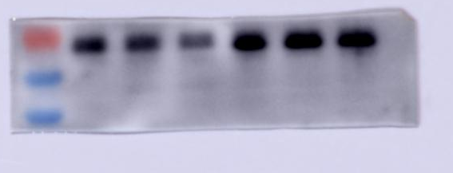
p-mTOR
(Ser2448)
150kDa
250kDa
55kDa
70kDa
LC3B 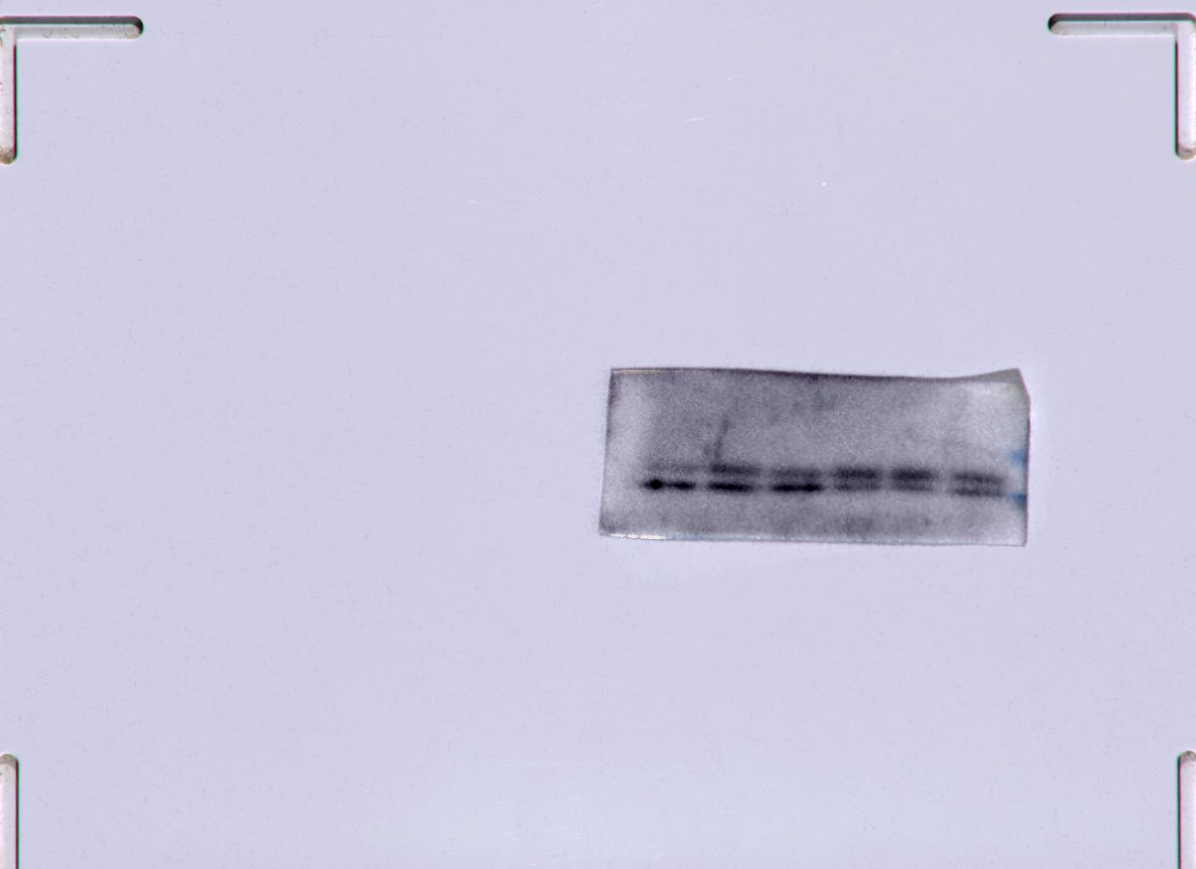 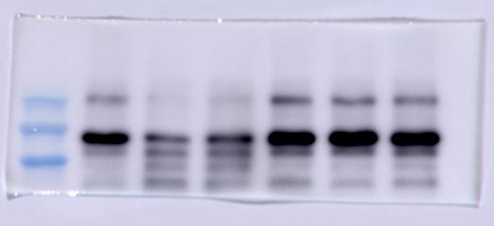
100kDa
150kDa
250kDa
mTOR
ULK1
20kDa
15kDa
ApoE 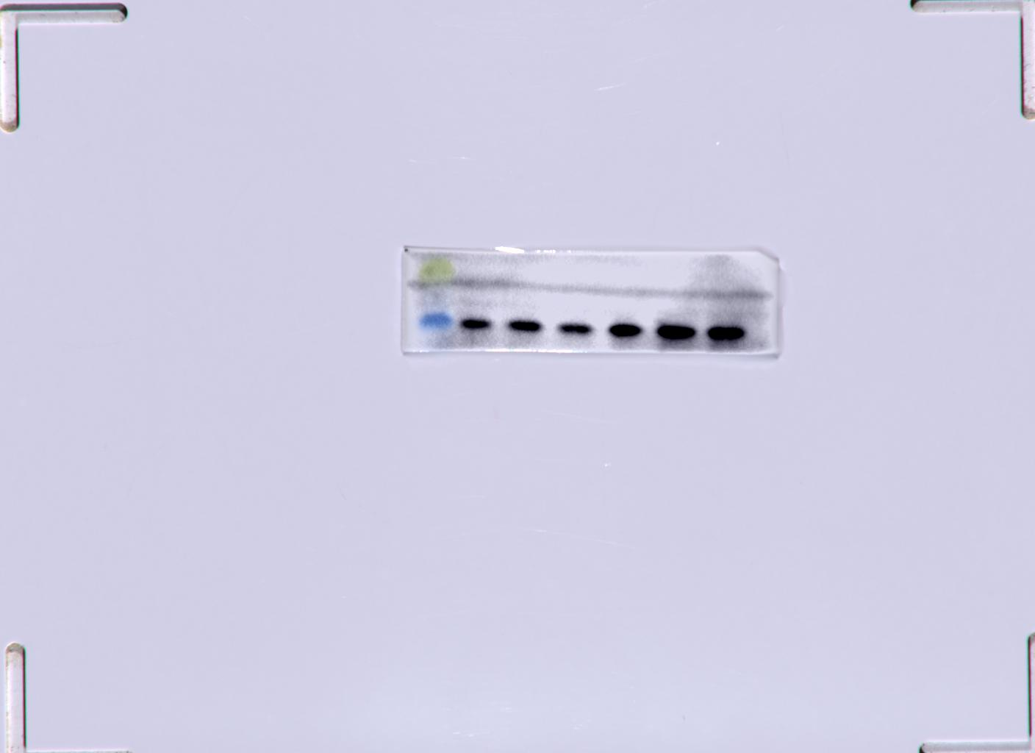
35kDa
25kDa
70kDa
GFAP 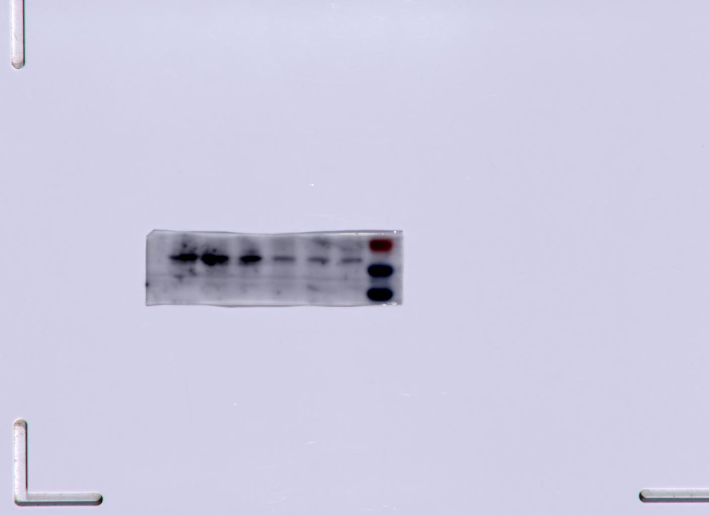
50kDa
70kDa
β-actin
40kDa
50kDa

Figure 2. Effect of Aβ42 on autophagy, ApoE, and GFAP

+
+
+
-
-
-
z
y
X
z
y
X
p62 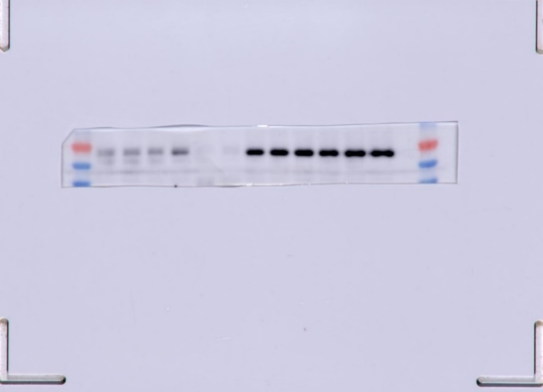
z
y
X
z
y
X
70kDa
50kDa
LC3B
40 kDa
+
+
+
-
-
-
z
y
x
z
y
x
15kDa
20 kDa
ApoE 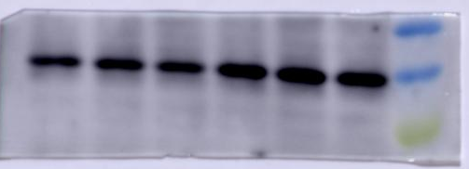
35 kDa
+
+
+
-
-
-
p-mTOR (Ser 2448)
z
y
x
z
y
x
250 kDa
p-mTOR (Ser 2448)
ULK1
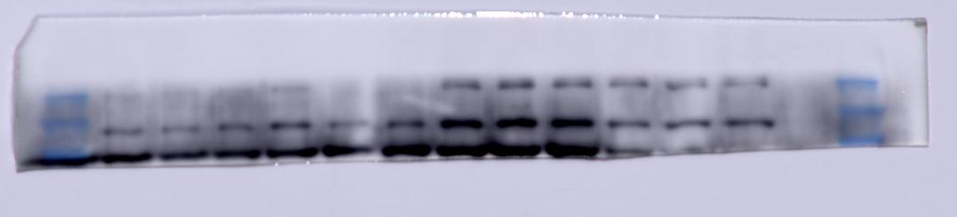
150 kDa
100 kDa
250 kDa
-
+
+
+
-
-
z
y
x
y
z
X
β-actin 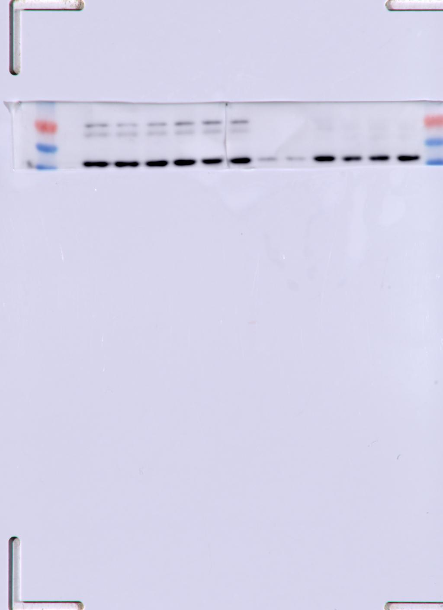
50 kDa
40kDa
z
y
x
x
z
y
x
mTOR (7C10) 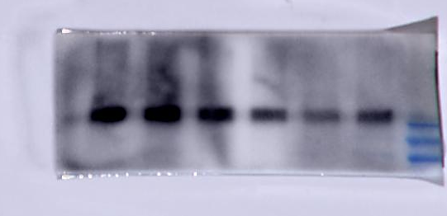
250 kDa
+
+
z
y
x
z
y
x
+
-
-
-
GFAP
+
+
+
-
-
-
40 kDa
50 kDa
70 kDa
β-actin

Figure 3. Effect of 48h Aβ42 treatment on autophagy, ApoE, and GFAP

24h 48h
+
-
-
-
-
-
-
-
-
+
+
+
3-MA
Rapa
-
-
+
+
-
-
-
-
-
-
+
+
3MA
Rapa
LC3B 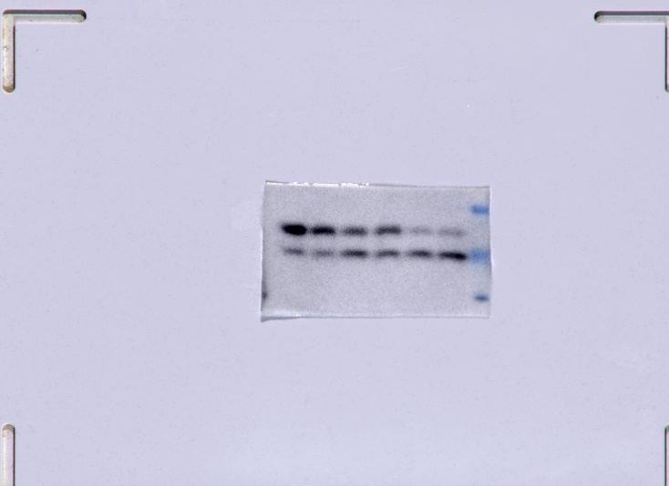 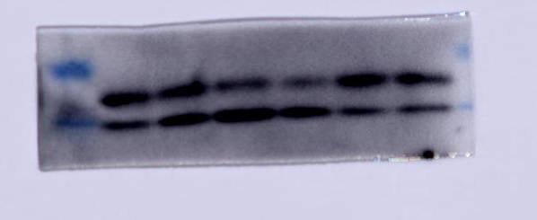
-
-
-
-
+
+
+
+
-
-
-
-
Rapa
20 kDa
15kDa
LC3B
+
-
-
-
-
+
Rapa
20kDa
15kDa
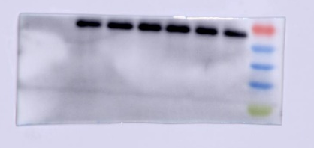
50kDa
70kDa
3-MA
-
-
+
+
-
-
3MA
p62 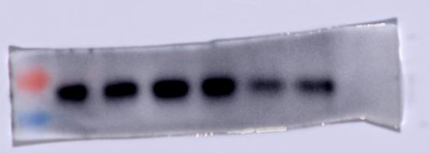
-
-
+
+
-
-
Rapa
p62
-
-
-
-
+
+
Rapa
50kDa
70kDa
+
+
-
-
-
-
3-MA
40kDa
+
+
-
-
-
-
3-MA
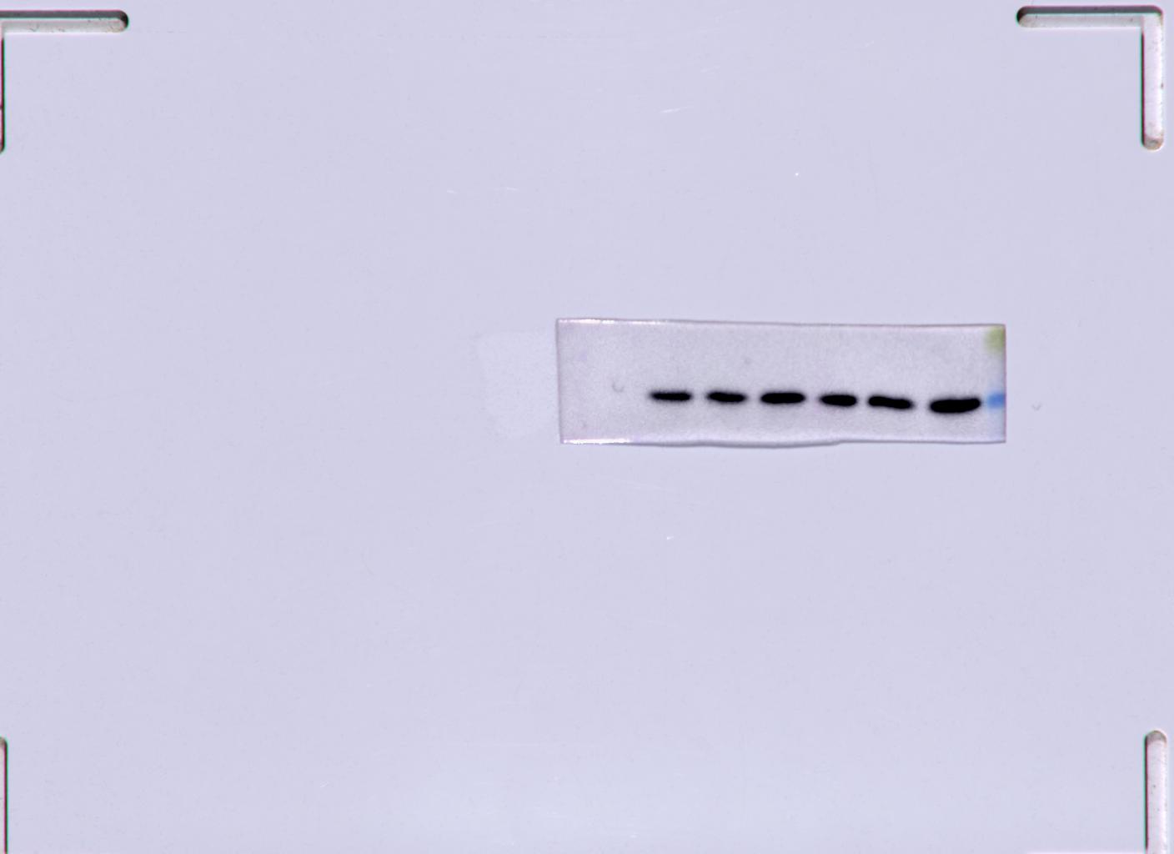
ApoE 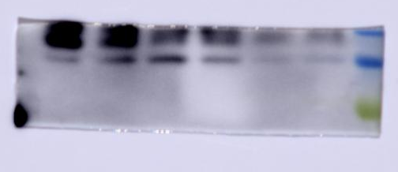 ApoE
-
-
+
+
-
-
Rapa
25kDa
35kDa
-
-
-
-
+
+
Rapa
35 kDa
+
+
-
-
-
-
3-MA
+
+
-
-
-
-
3-MA
β-actin 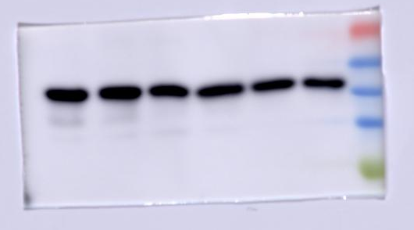 β-actin
40kDa
50kDa
40kDa
50kDa

Figure 4. Effect of rapamycin and 3-methyladenine on autophagy proteins and ApoE

B
A
-
+
+
+
+
24h Aβ
48h Aβ
48h Aβ
+
-
-
+
-
Rapa
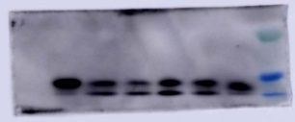
24h Aβ
+
+
+
-
-
+
-
-
-
+
3-MA
LC3B
Rapa
3-MA
-
-
+
-
-
-
20kDa
15kDa
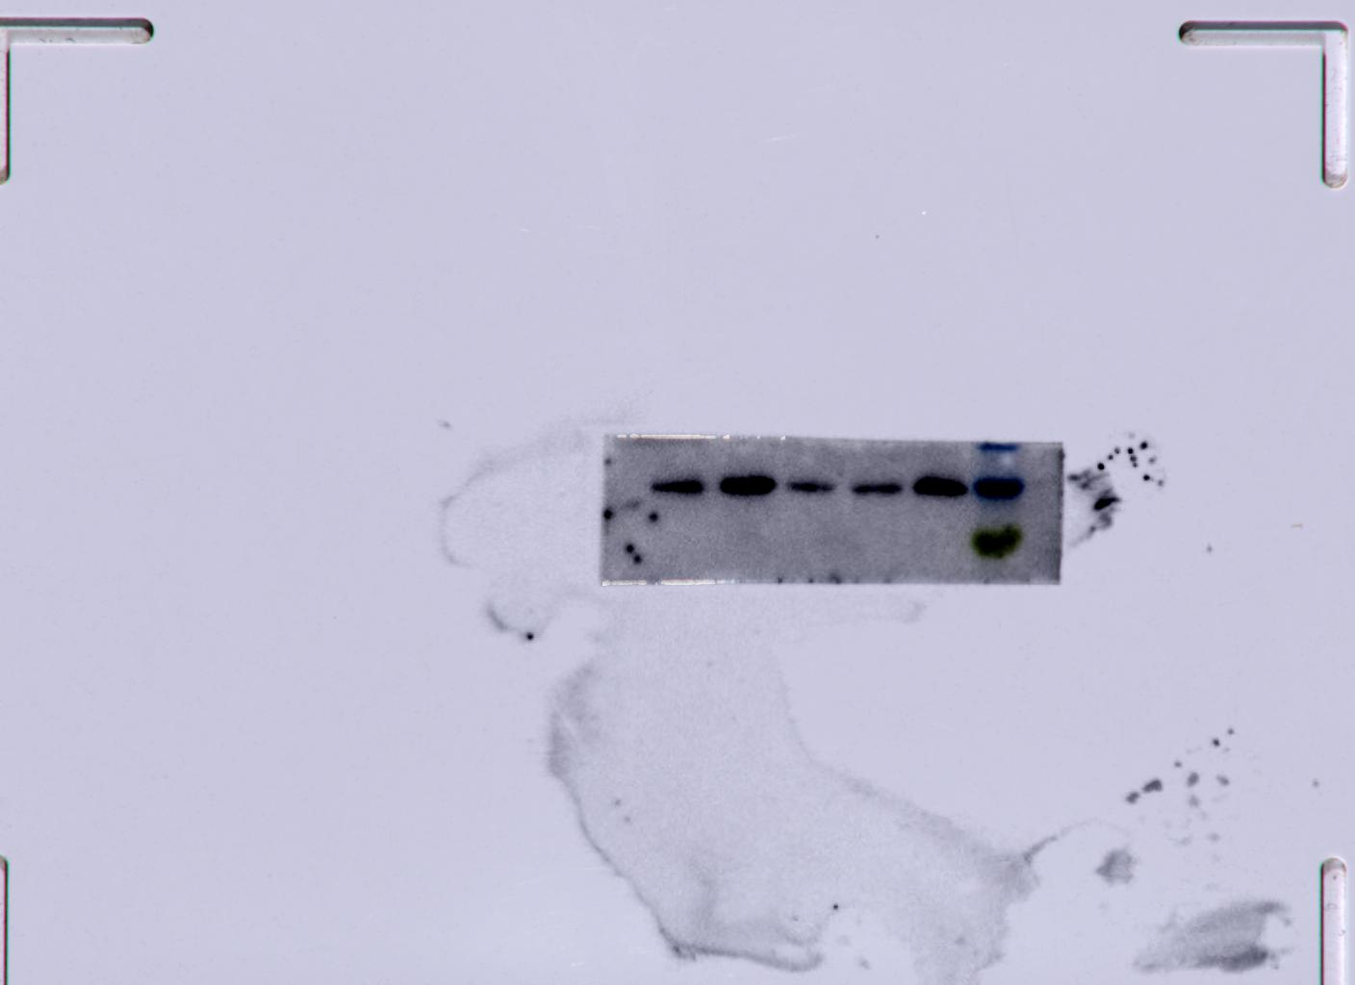
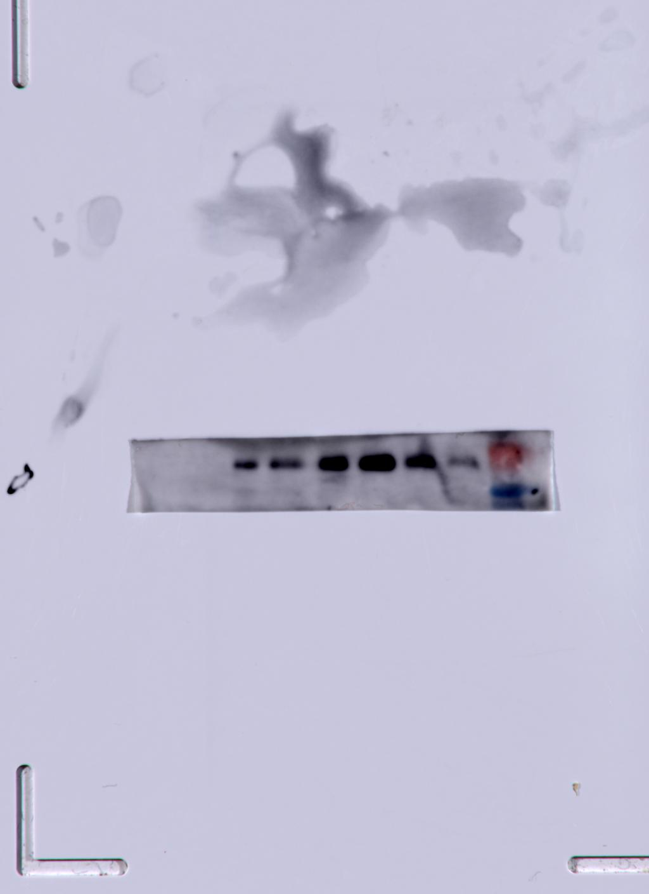
40kDa
70kDa
p62
35kDa
50kDa
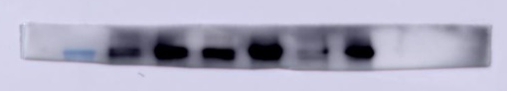
ApoE
p-mTOR
(Ser2448)
250kDa
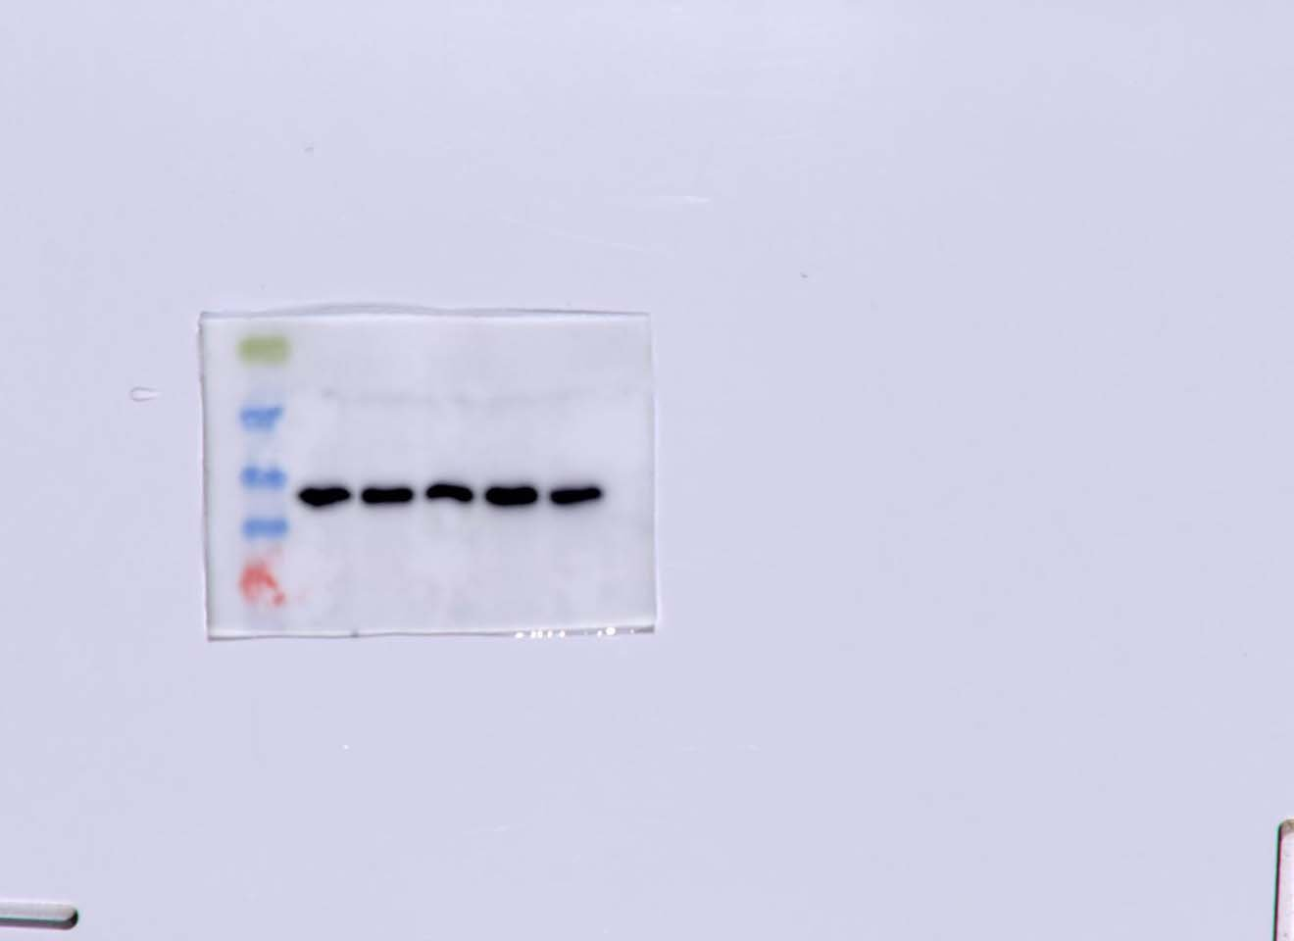
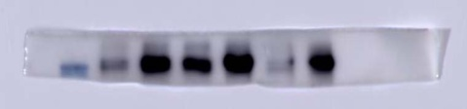
β-actin
40kDa
50kDa
250kDa
mTOR (7C10)
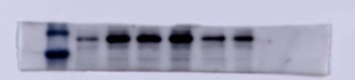
100kDa
150kDa
ULK1
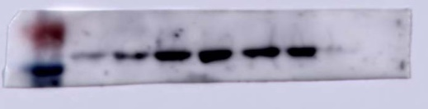
GFAP
50kDa
70kDa

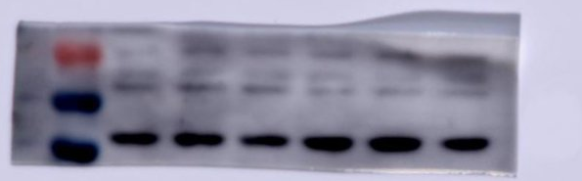
50kDa
β-actin
40kDa

Figure 5. Effect of rapamycin and 3-methyladenine (3MA) on autophagy proteins (LC3B, p62, mTOR, p-mTOR (Ser2448), ULK1), GFAP (inflammation-related variable) and ApoE (lipid-related variable) in Aβ-treated astrocyte.

