Supplementary information

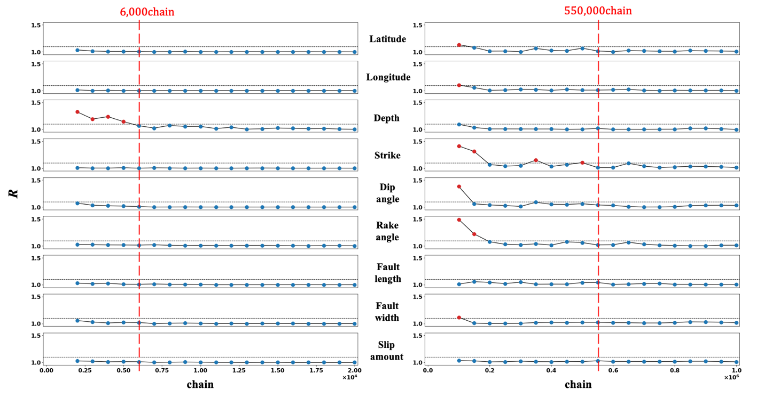

Figure S1. Results of the convergence test. The Hamiltonian Monte Carlo (HMC) and Metropolis-Hastings (M-H) results are shown in the left and right columns, respectively. Indices of Gelman-Rubin diagnostic $R$ calculated by the method in Gelman (1996) for nine model parameters (latitude, longitude, depth, strike, dip angle, rake angle, fault length, fault width, slip amount) are shown from the top in both columns. Convergence test is carried out after every 5 % throughout the chain after the burn-in phase. In each figure, the blue and red points represent the presence or absence of the diagnostic of convergence. Both results indicate that the HMC and M-H's sampling converge in all parameters until the 6,000th and 550,000th chain, respectively (red broken line).

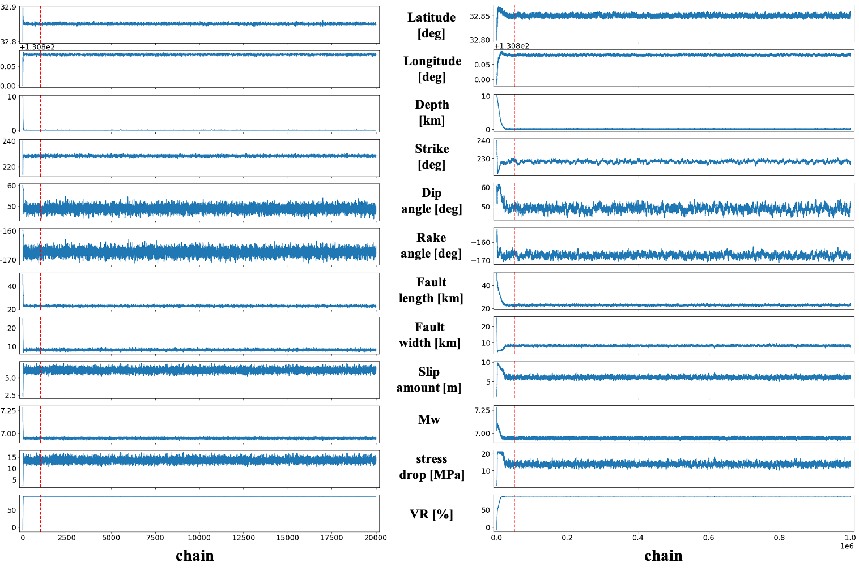

Figure S2. Trace plots of entire chains. The HMC and the M-H results are shown in the left and right columns, respectively. Trace plots for nine model parameters (latitude, longitude, depth, strike, dip angle, rake angle, fault length, fault width, slip amount) and three calculated parameters (Mw, VR, stress drop) are shown from the top in both columns. Red broken lines indicate the boundary of the burn-in phase.

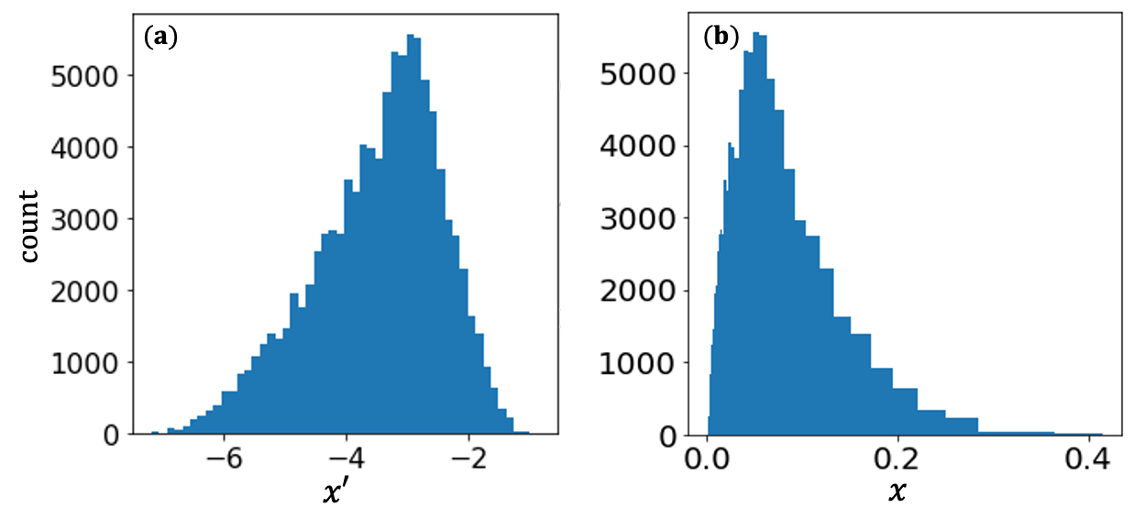

Figure S3. Example of the expression of posterior PDF for variable changed parameters. (a) The posterior PDF of parameter $x'$ which is changed from a fault parameter $x$ using logarithmic function. (b) The posterior PDF to display regarding the original parameter $x$ (discussed in section 3.1). The adjustment of only the histogram bins maintains the count of each bin for both figures.

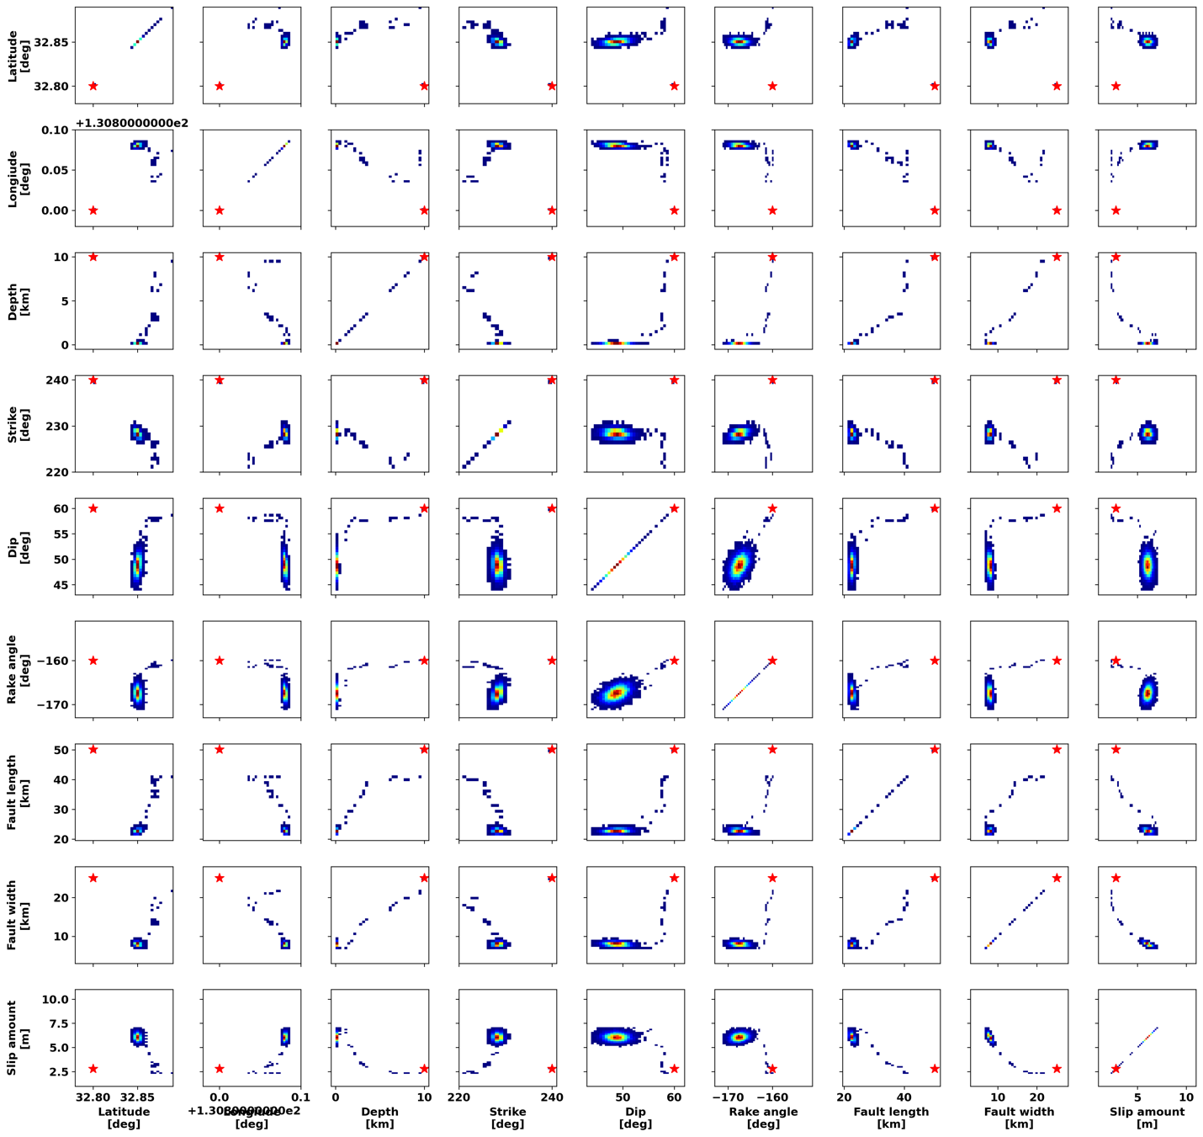

Figure S4. Two dimensional (2D)-marginal posterior PDFs of the HMC sampling including the Burn-in phase. The results of nine model parameters (latitude, longitude, depth, strike, dip angle, rake angle, fault length, fault width, slip amount) are shown from the top or left. Red star in each figure represents the initial value of the exploration. Note that the warmer color indicates the higher probability.

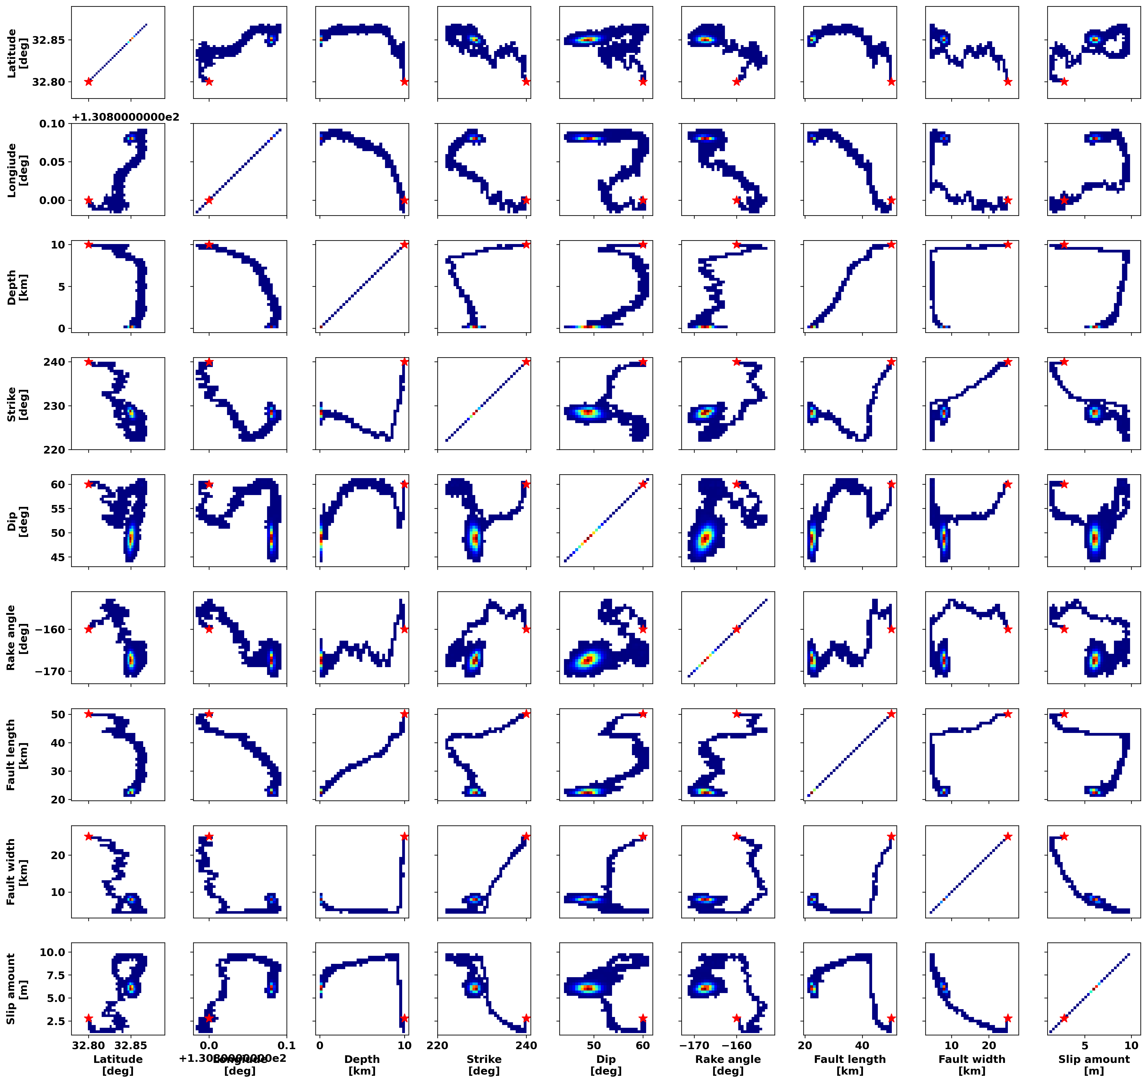

Figure S5. 2D-marginal posterior PDFs of the M-H sampling including the burn-in phase. The results of nine model parameters (latitude, longitude, depth, strike, dip angle, rake angle, fault length, fault width, slip amount) are shown from the top or left. Red star in each figure represents the initial value of the exploration. Note that the warmer color indicates the higher probability.

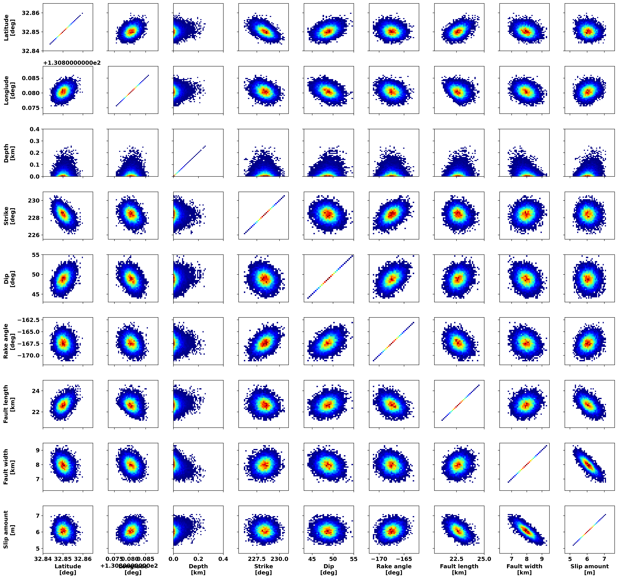

Figure S6. 2D-marginal posterior PDFs of the HMC sampling excluding the Burn-in phase. The results of nine model parameters (latitude, longitude, depth, strike, dip angle, rake angle, fault length, fault width, slip amount) are shown from the top or left. Note that the warmer color indicates the higher probability.

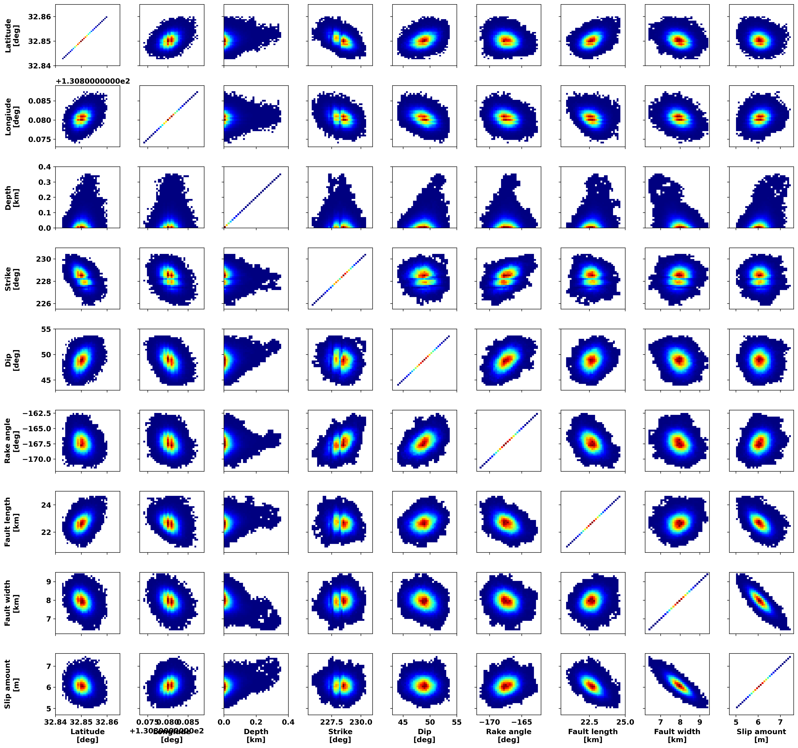

Figure S7. 2D-marginal posterior PDFs of the M-H sampling excluding the burn-in phase. The results of nine model parameters (latitude, longitude, depth, strike, dip angle, rake angle, fault length, fault width, slip amount) are shown from the top or left. Note that the warmer color indicates the higher probability.

