Supplementary Materials

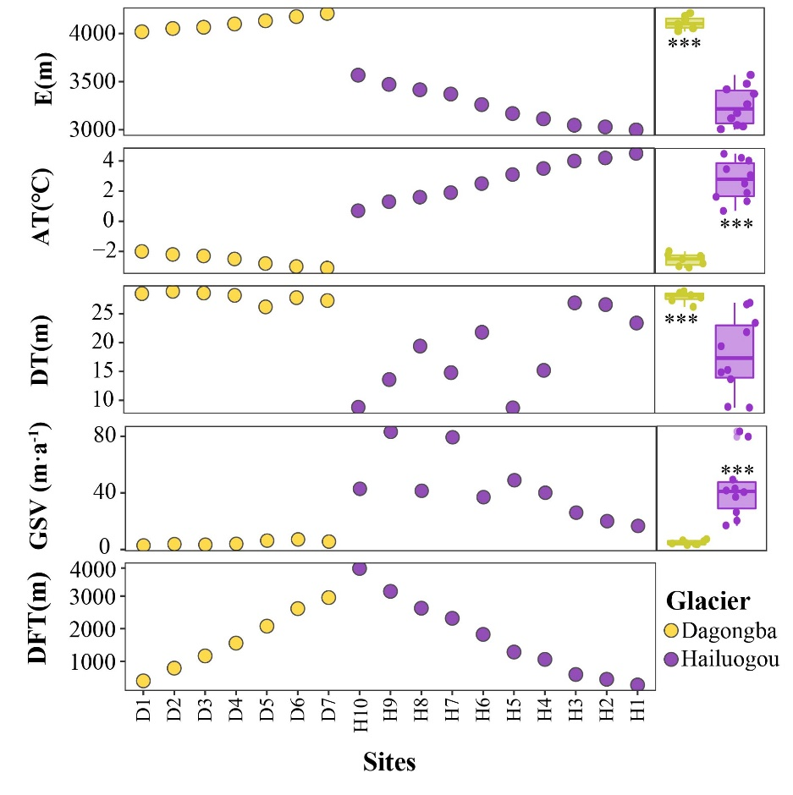
Figure S1 The glaciological parameters across glaciers and sites. E:elevation(m), AT: average annual termerature(℃), DT: debris thickness(m), GSV:glacier surface velocity(m·a⁻¹), DFT: distance from the glacier terminus(m). “*”, “**” and “***” indicate significant difference at “P < 0.05”, “P < 0.01”, and “P < 0.001” based on Wilcoxon rank sum exact test, respectively.

Table S1 Location and geographical parameter of the sampling sites
Sites | Glacier | Orientation | longitude(E) | latitude(N) | Elevation | Distance from the glacier terminus
D1 | Dagongba | west | 101.7891944 | 29.57645278 | 4018 | 403
D2 | Dagongba | west | 101.7932833 | 29.57674722 | 4052 | 793
D3 | Dagongba | west | 101.7971583 | 29.57678611 | 4065 | 1167
D4 | Dagongba | west | 101.8012139 | 29.57711667 | 4099 | 1559
D5 | Dagongba | west | 101.8065194 | 29.57731667 | 4132 | 2079
D6 | Dagongba | west | 101.8119556 | 29.57543611 | 4176 | 2616
D7 | Dagongba | west | 101.8151389 | 29.57404444 | 4209 | 2954
H10 | Hailuogou | east | 101.9569694 | 29.56335556 | 3567 | 3847
H9 | Hailuogou | east | 101.9621889 | 29.55883889 | 3471 | 3145
H8 | Hailuogou | east | 101.9671056 | 29.55703056 | 3415 | 2630
H7 | Hailuogou | east | 101.96985 | 29.55811111 | 3371 | 2319
H6 | Hailuogou | east | 101.9748528 | 29.55997222 | 3261 | 1826
H5 | Hailuogou | east | 101.9779139 | 29.56404722 | 3168 | 1286
H4 | Hailuogou | east | 101.9797167 | 29.56541111 | 3113 | 1061
H3 | Hailuogou | east | 101.9843722 | 29.56633056 | 3047 | 599
H2 | Hailuogou | east | 101.9858722 | 29.56688889 | 3029 | 452
H1 | Hailuogou | east | 101.987725 | 29.56742222 | 2998 | 278

Table S2 Sequences of primer sets used to amplify the partial bacterial small-subunit ribosomal RNA genes (region V1-V3 of 16S) and the fungal internal transcribed spacers genes (region ITS-2).
Gene region | primers
Bacteria  (16S rRNA V3-V4) | 343F | 5'- TACGGRAGGCAGCAG -3';
Bacteria  (16S rRNA V3-V4) | 798R | 5'- AGGGTATCTAATCCT-3'
Fungi  (ITS1) | ITS1F | 5'- CTTGGTCATTTAGAGGAAGTAA-3'
Fungi  (ITS1) | ITS2 | 5'- GCTGCGTTCTTCATCGATGC-3'

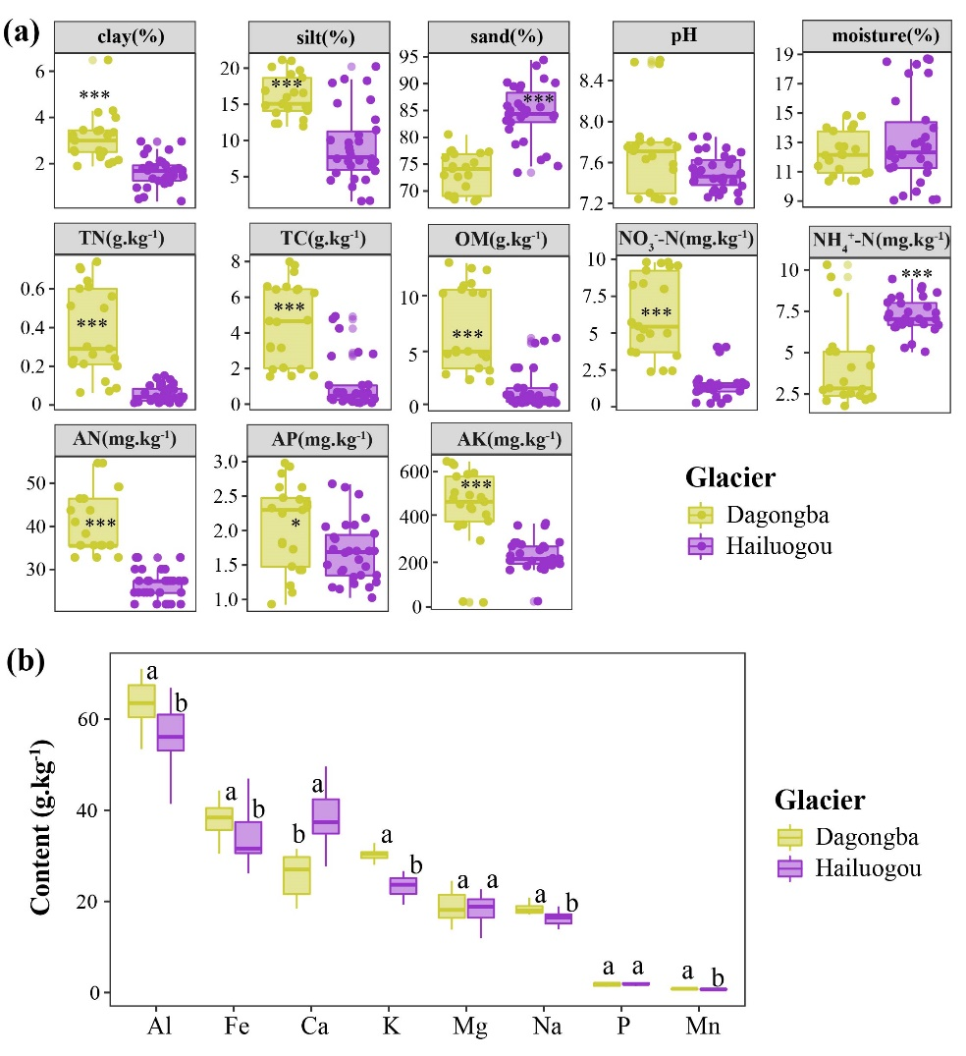

Figure S2 The physiochemical characteristics of debris samples across glaciers. TN: total nitrogen, TC: total carbon, OM: organic matter, NH₄⁺–N: Ammonium nitrogen, NO₃—N: nitrate nitrogen, AN: available nitrogen, AP: available phosphorus; AK: available potassium. The Al, Fe, Ca, K, Mg, Na, P and Mn were the elemental metals included Al: Aluminium, Fe: Iron, Ca: Calcium, K: Potassium, Mg: Magnesium, Na: Sodium, P: Phosphorus, Mn: Manganese. “*”, “**” and “***” indicate significant difference at “P < 0.05”, “P < 0.01”, and “P < 0.001” based on Wilcoxon rank sum exact test, respectively. Different letters indicate significant (P < 0.05) differences among glaciers based on Wilcoxon rank sum exact test.

Table S3 Physio-chemical characteristics of the supraglacial debris samples
Samples | Clay  (%) | Silt  (%) | Sand  (%) | Moisture  (%) | pH | TN  (g.kg⁻¹) | TC  (g.kg⁻¹) | OM  (g.kg⁻¹) | NO₃⁻-N  (mg.kg⁻¹) | NH₄⁺-N  (mg.kg⁻¹) | AN  (mg.kg⁻¹) | AP  (mg.kg⁻¹) | AK  (mg.kg⁻¹)
D1 | 2.37 | 13.74 | 78.31 | 11.56 | 7.23 | 0.07 | 1.56 | 2.18 | 2.40 | 9.50 | 33.67 | 1.08 | 111.87
D2 | 4.16 | 16.66 | 72.79 | 13.96 | 7.58 | 0.54 | 6.35 | 10.18 | 8.18 | 4.55 | 42.77 | 2.41 | 467.89
D3 | 2.55 | 15.25 | 74.62 | 10.63 | 7.71 | 0.25 | 3.16 | 4.74 | 3.60 | 2.49 | 36.40 | 1.44 | 367.99
D4 | 2.98 | 12.18 | 77.15 | 12.65 | 7.77 | 0.72 | 7.73 | 12.57 | 9.62 | 1.99 | 47.32 | 2.63 | 496.96
D5 | 3.91 | 14.50 | 73.79 | 10.55 | 7.82 | 0.18 | 1.97 | 3.03 | 5.46 | 2.69 | 35.49 | 1.78 | 428.46
D6 | 2.88 | 19.16 | 68.96 | 12.00 | 8.58 | 0.26 | 4.65 | 4.61 | 4.86 | 5.10 | 34.58 | 2.33 | 587.58
D7 | 2.82 | 20.73 | 68.28 | 14.54 | 7.26 | 0.60 | 6.53 | 10.80 | 9.59 | 2.66 | 52.78 | 2.81 | 639.76
H10 | 1.08 | 16.20 | 77.83 | 14.76 | 7.57 | 0.01 | 0.24 | 0.11 | 0.57 | 5.26 | 27.30 | 1.33 | 148.38
H9 | 0.45 | 9.83 | 85.67 | 17.96 | 7.70 | 0.04 | 0.06 | 0.05 | 0.23 | 6.92 | 21.84 | 1.24 | 188.40
H8 | 1.41 | 18.96 | 74.76 | 18.54 | 7.81 | 0.02 | 0.63 | 0.85 | NA | 8.60 | 32.76 | 1.98 | 215.52
H7 | 1.44 | 5.30 | 89.50 | 12.17 | 7.37 | 0.04 | 0.15 | 0.25 | 1.06 | 8.79 | 26.39 | 1.65 | 193.40
H6 | 1.79 | 10.92 | 83.35 | 12.82 | 7.46 | 0.01 | 0.33 | 0.26 | 1.36 | 6.83 | 30.03 | 1.42 | 215.13
H5 | 1.54 | 4.64 | 90.50 | 9.25 | 7.41 | 0.05 | 0.28 | 0.32 | 1.19 | 7.53 | 24.57 | 1.70 | 166.48
H4 | 1.73 | 4.18 | 90.20 | 9.55 | 7.65 | 0.06 | 0.62 | 0.78 | 1.57 | 7.05 | 27.30 | 1.70 | 256.25
H3 | 2.83 | 7.11 | 84.03 | 12.35 | 7.49 | 0.12 | 4.64 | 5.81 | 1.50 | 8.27 | 28.21 | 2.61 | 271.31
H2 | 1.79 | 7.79 | 83.78 | 11.18 | 7.26 | 0.09 | 1.06 | 1.49 | 1.67 | 6.60 | 24.57 | 2.10 | 363.91
H1 | 2.27 | 7.15 | 84.96 | 11.88 | 7.30 | 0.13 | 2.79 | 3.32 | 3.92 | 6.61 | 21.84 | 1.12 | 284.84

Table S4 Metal ion content of the supraglacial debris samples
Samples | Al  (g.kg⁻¹) | Fe  (g.kg⁻¹) | Ca  (g.kg⁻¹) | K  (g.kg⁻¹) | Mg  (g.kg⁻¹) | Na  (g.kg⁻¹) | P  (g.kg⁻¹) | Mn  (g.kg⁻¹)
D1 | 62047 | 30843 | 19050 | 30723 | 14053 | 18063 | 1283 | 608
D2 | 65627 | 36540 | 20540 | 30753 | 16890 | 19417 | 1418 | 681
D3 | 69123 | 43067 | 25950 | 31813 | 23583 | 19490 | 1971 | 889
D4 | 66470 | 40257 | 30010 | 30517 | 21750 | 18350 | 2124 | 853
D5 | 58077 | 38907 | 30337 | 29970 | 21640 | 17360 | 2186 | 876
D6 | 54210 | 35540 | 27130 | 29940 | 16277 | 17490 | 1778 | 739
D7 | 65393 | 39960 | 29780 | 27900 | 18590 | 17660 | 1971 | 827
H10 | 62767 | 32157 | 42820 | 26127 | 21470 | 17063 | 2206 | 688
H9 | 54490 | 27103 | 35677 | 24713 | 17810 | 18247 | 2007 | 642
H8 | 62547 | 31657 | 36087 | 26370 | 20290 | 17570 | 1968 | 665
H7 | 41613 | 29653 | 29647 | 20090 | 12293 | 14190 | 1763 | 538
H6 | 50853 | 30767 | 36123 | 24400 | 14003 | 16647 | 2114 | 647
H5 | 55520 | 31047 | 34403 | 25393 | 19653 | 16513 | 1798 | 675
H4 | 55973 | 32253 | 38330 | 23363 | 20360 | 15897 | 2204 | 776
H3 | 58273 | 57997 | 48090 | 13343 | 21683 | 13940 | 1426 | 1003
H2 | 63677 | 37517 | 38020 | 21620 | 18063 | 16580 | 1838 | 664
H1 | 53703 | 45093 | 47123 | 22080 | 16080 | 15520 | 1787 | 870

Table S5 The bacterial and fungal tags data from high-throughput sequencing.
Samples | Clean tags |  | Valid tags |  | Valid percent |  | Valid mean length(bp) |  | OUT counts
Samples | bacteria | fungi | bacteria | fungi | bacteria | fungi | bacteria | fungi | bacteria | fungi
D1 | 90205 | 71432 | 65502 | 70973 | 72.61% | 99.36% | 416.02 | 269.94 | 5158 | 435
D2 | 91194 | 71191 | 71622 | 70664 | 78.54% | 99.26% | 415.39 | 277.18 | 5896 | 630
D3 | 89616 | 70772 | 71421 | 70172 | 79.70% | 99.15% | 414.73 | 252.58 | 6067 | 700
D4 | 87144 | 72025 | 53281 | 71464 | 61.14% | 99.22% | 414.2 | 266.33 | 4440 | 570
D5 | 91893 | 75283 | 69884 | 74635 | 76.05% | 99.14% | 415.57 | 271.22 | 5393 | 458
D6 | 90238 | 64556 | 69236 | 63975 | 76.73% | 99.10% | 416.09 | 272.07 | 5056 | 397
D7 | 88626 | 72807 | 69756 | 72172 | 78.71% | 99.13% | 414.99 | 284.84 | 5382 | 485
H10 | 87340 | 63698 | 66665 | 63168 | 76.33% | 99.17% | 418.99 | 270.04 | 3615 | 773
H9 | 88949 | 67773 | 70551 | 67242 | 79.32% | 99.22% | 418.01 | 274.59 | 4021 | 608
H8 | 89212 | 68724 | 69882 | 68213 | 78.33% | 99.26% | 418.13 | 246.56 | 4573 | 583
H7 | 89548 | 69509 | 72675 | 69062 | 81.16% | 99.36% | 419.36 | 264.47 | 4471 | 699
H6 | 87619 | 63394 | 65357 | 62974 | 74.59% | 99.34% | 418.81 | 247.61 | 5044 | 719
H5 | 81315 | 66776 | 63689 | 66298 | 78.32% | 99.28% | 418.61 | 246.52 | 4508 | 752
H4 | 88057 | 51066 | 68675 | 50301 | 77.99% | 98.50% | 419.47 | 263 | 4423 | 724
H3 | 88373 | 73047 | 80092 | 72220 | 90.63% | 98.87% | 416.24 | 258.49 | 4567 | 939
H2 | 88072 | 65030 | 67046 | 64410 | 76.13% | 99.05% | 415.8 | 280.9 | 5492 | 685
H1 | 88591 | 67820 | 69316 | 67373 | 78.24% | 99.34% | 416.99 | 268.75 | 6219 | 691
Total |  |  |  |  |  |  |  |  | 18965 | 4440
D: Dagongba glacier; H: Hailuogou glacier

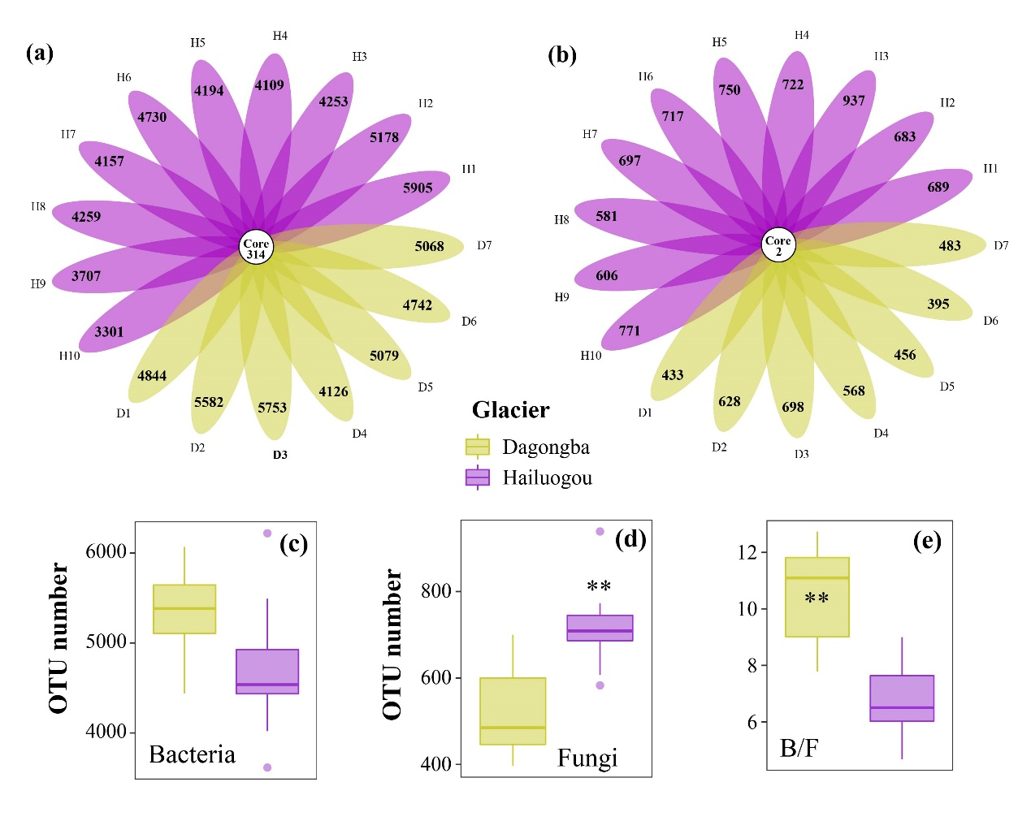
Figure S3 The numbers of identified Bacterial (a) and fungal (b) OTUs across sites and their differences among glaciers (c-e). B/F represent the ratio of bacterial OTU to fungal OUT. “*”, “**” and “***” indicate significant difference at “P < 0.05”, “P < 0.01”, and “P < 0.001” based on Wilcoxon rank sum exact test, respectively.

Table S6 The dominant (relative abundance >%1) bacteria and fungi phyla and their cumalative occupation in all sequences
Bacteria(phylum) | Hailuogou glacier | Dagongba glacier | All sites | Cumulative
Proteobacteria | 0.59 | 0.409 | 0.515 | 0.515
Bacteroidetes | 0.192 | 0.253 | 0.217 | 0.732
Actinobacteria | 0.088 | 0.145 | 0.112 | 0.844
Gemmatimonadetes | 0.03 | 0.078 | 0.05 | 0.894
Acidobacteria | 0.03 | 0.05 | 0.038 | 0.932
Firmicutes | 0.02 | 0.018 | 0.019 | 0.951
Nitrospirae | 0.019 | 0.01 | 0.015 | 0.966
others |  |  |  | 1
Fungi(phylum) | Hailuogou glacier | Dagongba glacier | All sites | Cumulative
Ascomycota | 0.558 | 0.411 | 0.497 | 0.497
Basidiomycota | 0.166 | 0.508 | 0.307 | 0.804
Zygomycota | 0.049 | 0.033 | 0.042 | 0.846
Chytridiomycota | 0.045 | 0.007 | 0.030 | 0.876
others | 0.167 | 0.038 | 0.114 | 1.000

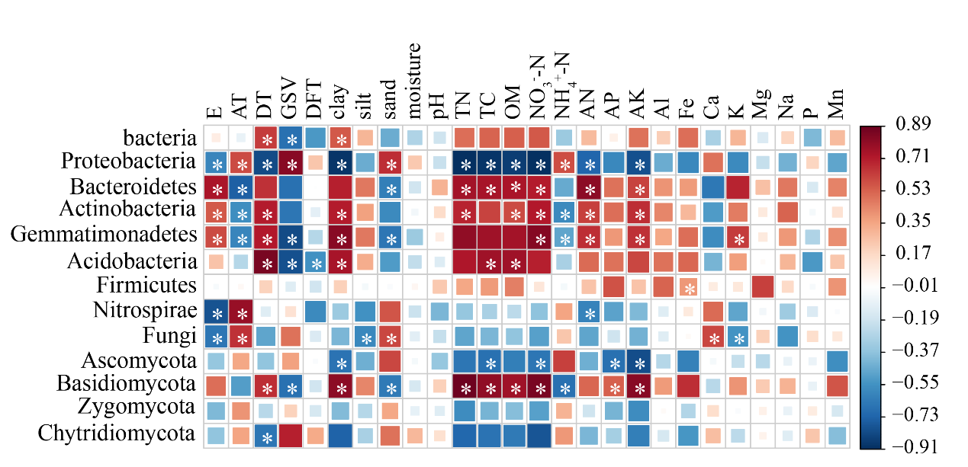

Figure S4 Relationship between the dominant microbial phyla and environmental viriables. E:elevation(m), AT: average annual termerature(℃), DT: debris thickness(m), GSV:glacier surface velocity(m·a⁻¹), DFT: distance from the glacier terminus(m). TN: total nitrogen, TC: total carbon, OM: organic matter, NH₄⁺–N: Ammonium nitrogen, NO₃⁻–N: nitrate nitrogen, AN: available nitrogen, AP: available phosphorus; AK: available potassium. The Al, Fe, Ca, K, Mg, Na, P and Mn were the elemental metals included Al: Aluminium, Fe: Iron, Ca: Calcium, K: Potassium, Mg: Magnesium, Na: Sodium, P: Phosphorus, Mn: Manganese. “*”, indicate significant difference at “P < 0.01” based on Wilcoxon rank sum exact test, respectively.

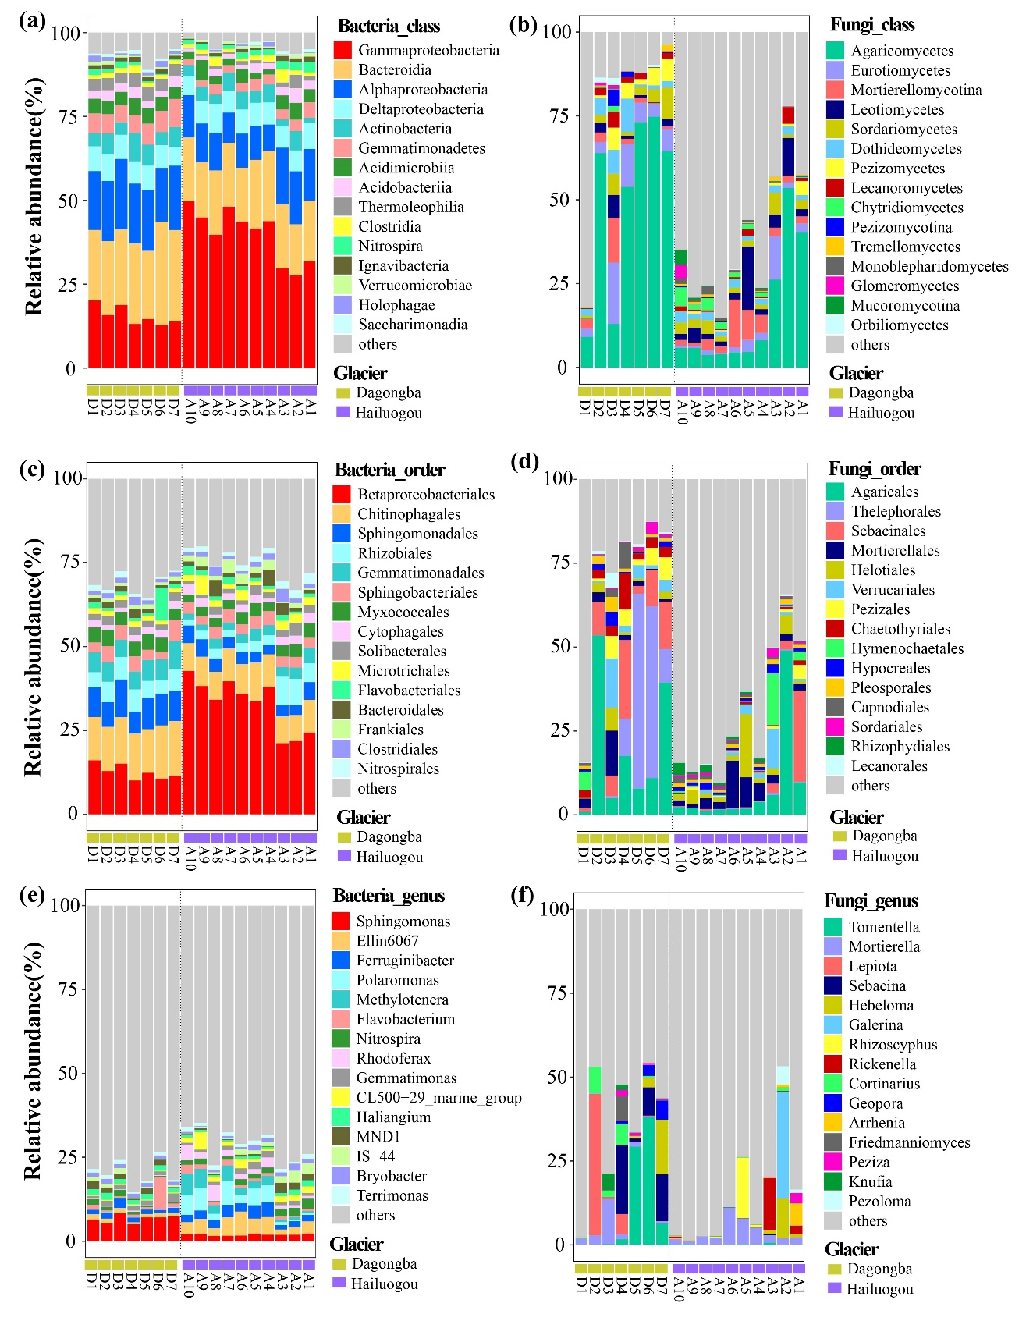

Figure S5 The relative abundance of dominant bacterial and fungal taxa in class (a, b), order (c, d), and genus (e, f) level across supraglacial debris samples.

Table S7 The alpha diversity of bacterial and fungal communities across supraglacial debris sites.
Sites | Goods coverage |  |  | Observed species |  |  | chao1 |  |  | Shannon |  |  | Simpson
Sites | bacteria | fungi |  | bacteria | fungi |  | bacteria | fungi |  | bacteria | fungi |  | bacteria | fungi
D1 | 0.97 | 0.998 |  | 4873.9 | 400.8 |  | 6103.56 | 468.35 |  | 10.33 | 2.14 |  | 1.00 | 0.43
D2 | 0.97 | 0.998 |  | 5450.2 | 594.9 |  | 6684.11 | 671.21 |  | 10.67 | 4.60 |  | 1.00 | 0.81
D3 | 0.97 | 0.998 |  | 5568.6 | 670.9 |  | 7018.35 | 732.80 |  | 10.43 | 6.53 |  | 1.00 | 0.97
D4 | 0.98 | 0.998 |  | 4434.3 | 531.2 |  | 5619.19 | 638.55 |  | 10.31 | 5.28 |  | 1.00 | 0.93
D5 | 0.97 | 0.998 |  | 5008.2 | 418.8 |  | 6236.50 | 504.08 |  | 10.28 | 4.49 |  | 1.00 | 0.87
D6 | 0.97 | 0.998 |  | 4682.9 | 371.9 |  | 5928.37 | 468.32 |  | 9.68 | 4.33 |  | 0.99 | 0.85
D7 | 0.97 | 0.998 |  | 4988.8 | 450.4 |  | 6107.48 | 520.17 |  | 10.14 | 4.83 |  | 1.00 | 0.91
H10 | 0.98 | 0.999 |  | 3364.6 | 755.0 |  | 4463.57 | 807.46 |  | 8.98 | 6.47 |  | 0.99 | 0.96
H9 | 0.98 | 0.999 |  | 3705.4 | 584.3 |  | 4691.21 | 672.55 |  | 9.15 | 5.99 |  | 0.99 | 0.93
H8 | 0.97 | 0.999 |  | 4219.4 | 569.3 |  | 5444.11 | 615.21 |  | 9.76 | 7.03 |  | 1.00 | 0.98
H7 | 0.98 | 0.998 |  | 4065.4 | 672.9 |  | 5159.35 | 735.90 |  | 9.51 | 5.48 |  | 0.99 | 0.90
H6 | 0.97 | 0.998 |  | 4744.5 | 699.0 |  | 5974.79 | 782.30 |  | 9.98 | 6.38 |  | 1.00 | 0.96
H5 | 0.97 | 0.998 |  | 4258.6 | 725.9 |  | 5498.92 | 792.67 |  | 9.83 | 5.97 |  | 1.00 | 0.94
H4 | 0.97 | 0.998 |  | 4080.7 | 723.4 |  | 5368.38 | 823.67 |  | 9.54 | 6.57 |  | 1.00 | 0.96
H3 | 0.98 | 0.997 |  | 4129.0 | 889.4 |  | 5128.52 | 993.50 |  | 10.16 | 5.70 |  | 1.00 | 0.92
H2 | 0.97 | 0.997 |  | 5126.4 | 647.7 |  | 6548.21 | 767.16 |  | 10.38 | 4.99 |  | 1.00 | 0.88
H1 | 0.97 | 0.998 |  | 5764.7 | 658.3 |  | 7119.85 | 790.88 |  | 10.52 | 5.14 |  | 1.00 | 0.89

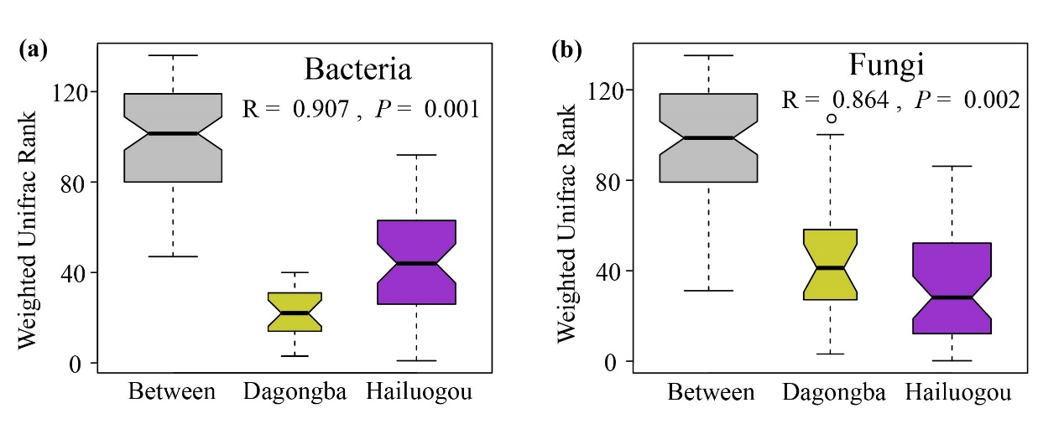
Figure. S6 Analysis of similarities (ANOSIM) for bacterial(a) and fungal(b) beta diversity across glaciers.

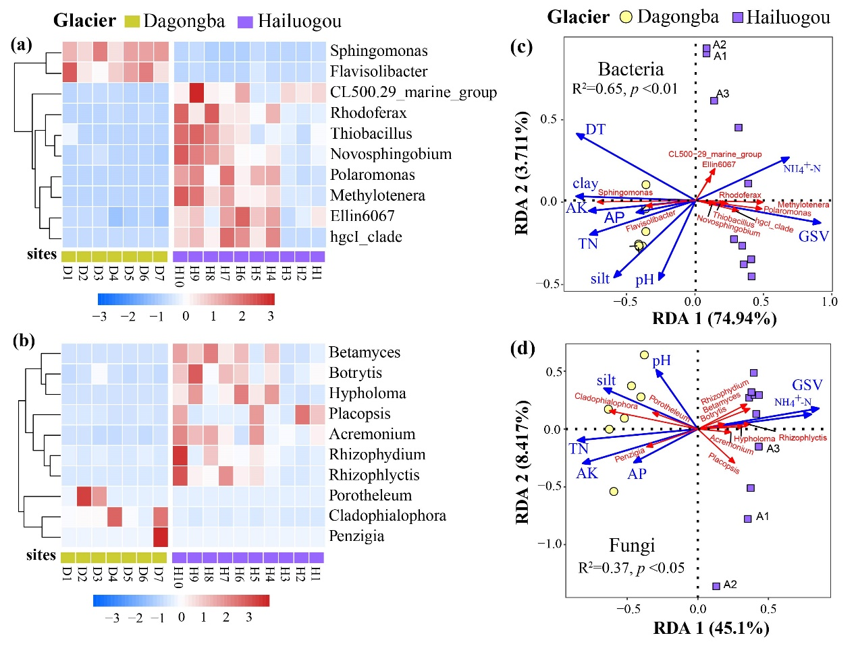
Figure S7. Heatmap of different bacterial(a) and fungal(c) genera across two glaciers, redundancy analysis (RDA) for their driving factors (c&d). D(D1-D7): Dagongaba glacier, H(H1-H10): Hailuogou glacier; DT: debris thickness; GSV: glacier surface velocity; clay: percentage of clay (%), silt: percentage of silt (%); TN: total nitrogen; AP: available phosphorus; AK: available potassium; NH₄⁺–N: ammonium nitrogen.
[Based on Wilcox test, it identified the microbial taxa (genus level) that were significantly different in richness between two glaciers, and visualized the top 10 taxa. Specifically, Dagongba glacier were abundant in the Sphingomonas, Flavisolibacter, Hailuogou glacier were abundant in Rhodoferax, Thiobacillus, Novosphingobium, Polaromonas, Methylotenera, Ellin6070, except the three sites (H1, H2 and H3) near the terminus. For fungi, Hailuogou glacier abundant in Betamyces, Botrytis, Hypholoma, placopsis, Acremonium, Rhizophydium, and Phizophlyctis, except the three sites (H1, H2 and H3) near the terminus. Redundancy analysis (RDA) were used to identified the environmental variables that driving the difference. DT, GSV, pH, clay, silt, TN, AP, AK, NH₄⁺–N explained a total of 78.7% of the variables for bacterial genera, while GSV, pH, silt, TN, AP, AK, NH₄⁺–N explained a total of 53.5% of the variables for fungal genera. Bacterial communities (adjust R²: 0.65, p< 0.01) were explained more by environmental factors compared with fungal communities (adjust R²: 0.37, p< 0.05).]

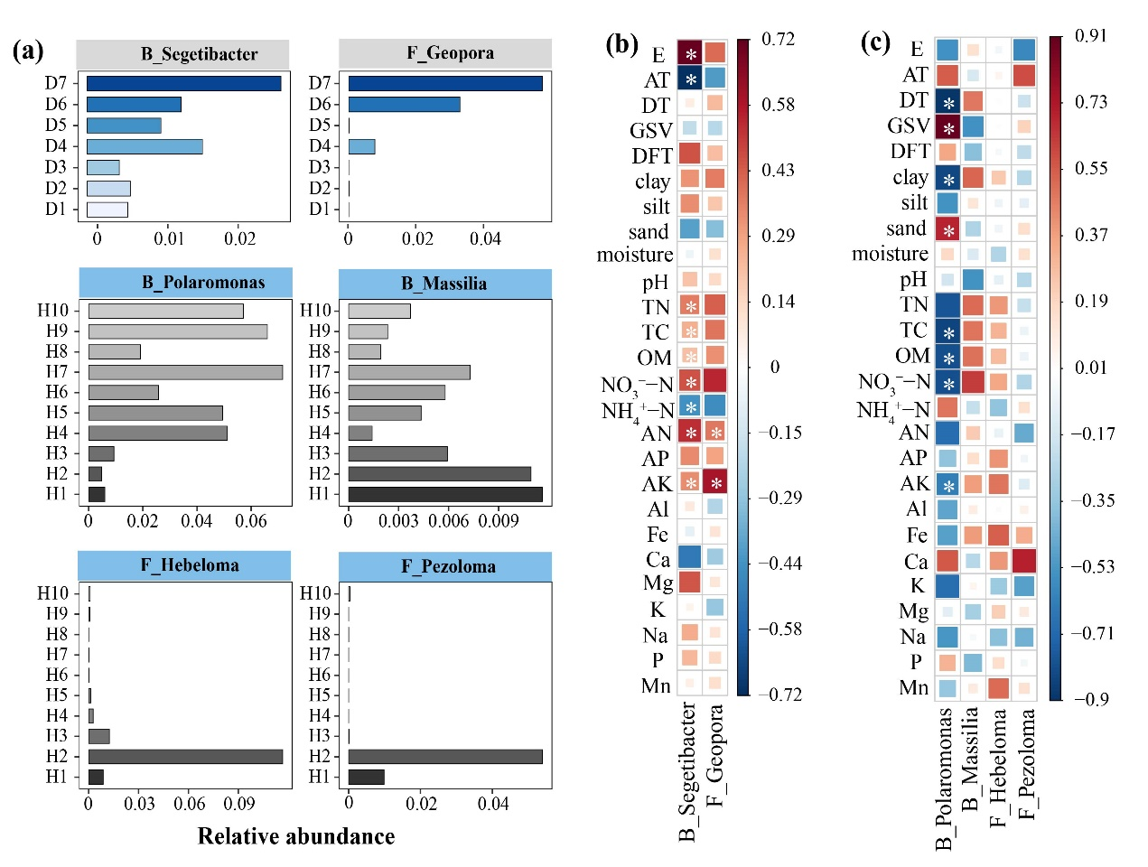
Figure S8. Relationships between keystone microbial taxa and environmental variables. “*” indicate significant at level of “P < 0.01”.

