Figure 1B
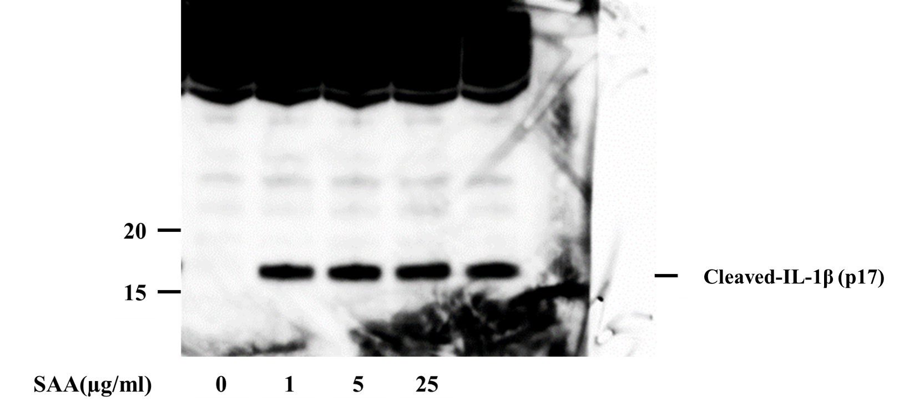

SAA induces cleaved IL-1β secretion from neutrophils
Neutrophils (2×106/ml) were incubated with the indicated concentrations of SAA for 16 hr and supernatants were analyzed by immunoblot for the presence of cleaved IL-1β (p17).
Three experiments were performed using different neutrophils and a representative result is shown.

Figure 3A
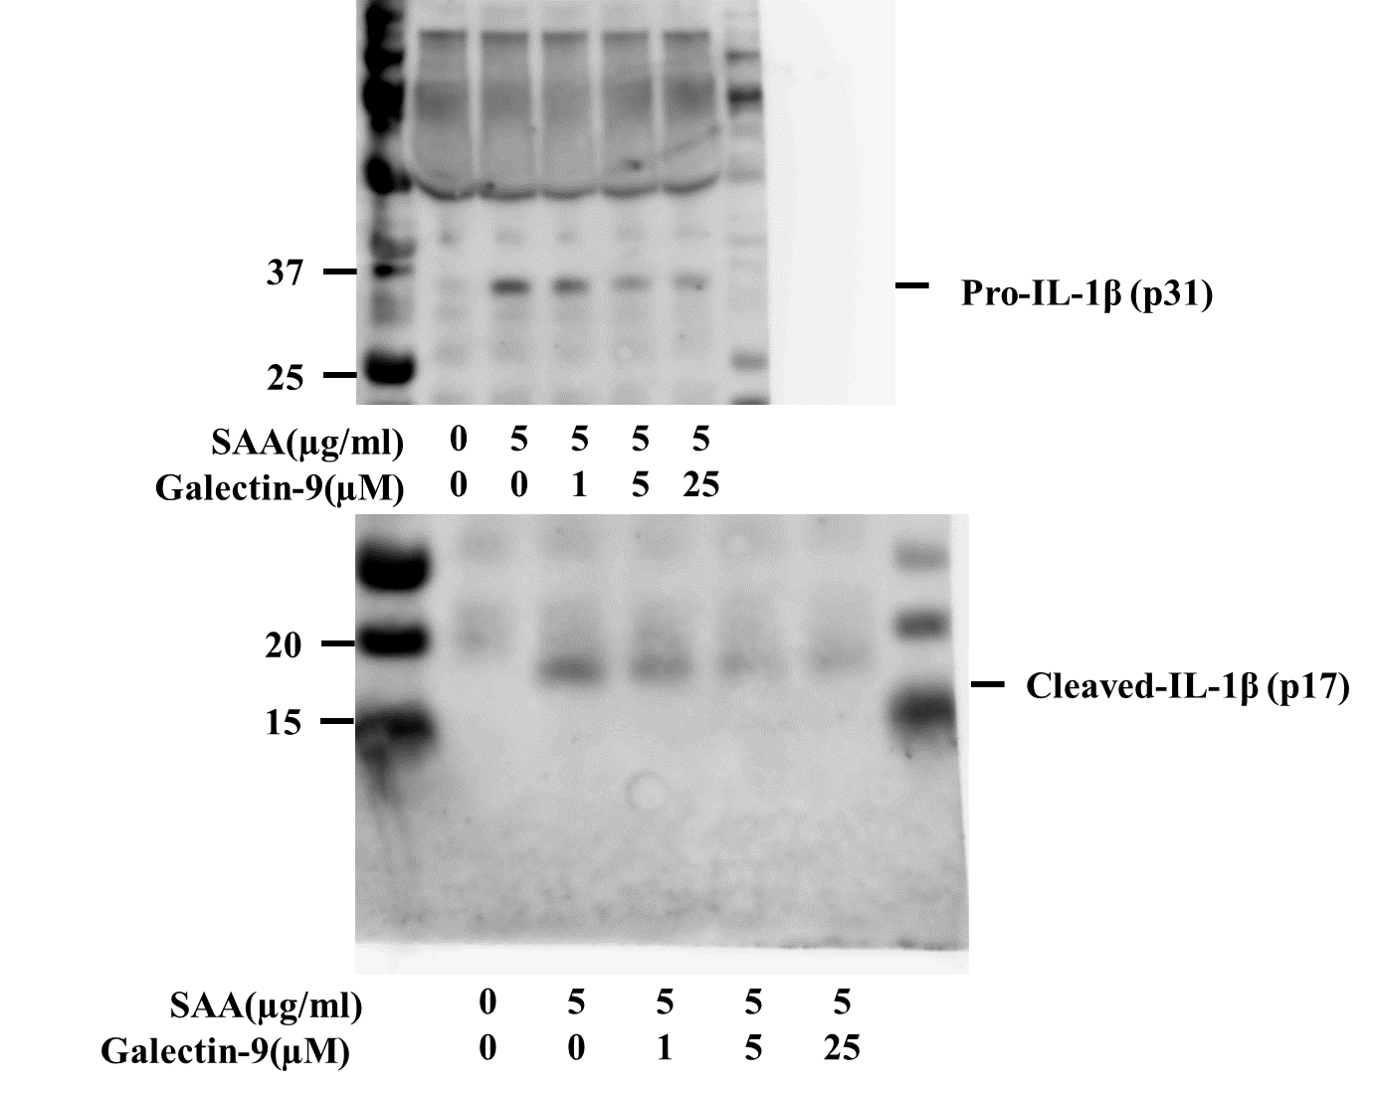

Effects of Galectin-9 on pro-IL-1β or cleaved IL-1β secretion from SAA−stimulated neutrophils
Neutrophils were pretreated or untreated with the indicated concentrations of galectin-9 for 1 hr. After pretreatment, the cells were stimulated with of SAA (5µg/ml) for 16 h and supernatants were analyzed by immunoblot for the presence of pro-IL-1β and of cleaved IL-1β (p17). Three experiments were performed using different neutrophils and a representative result is shown.

Figure 3B
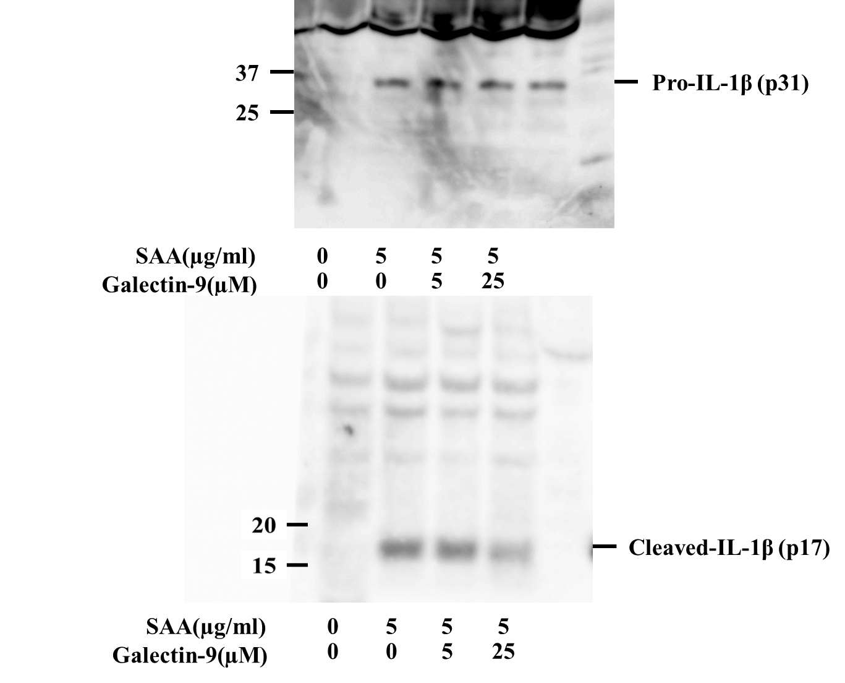

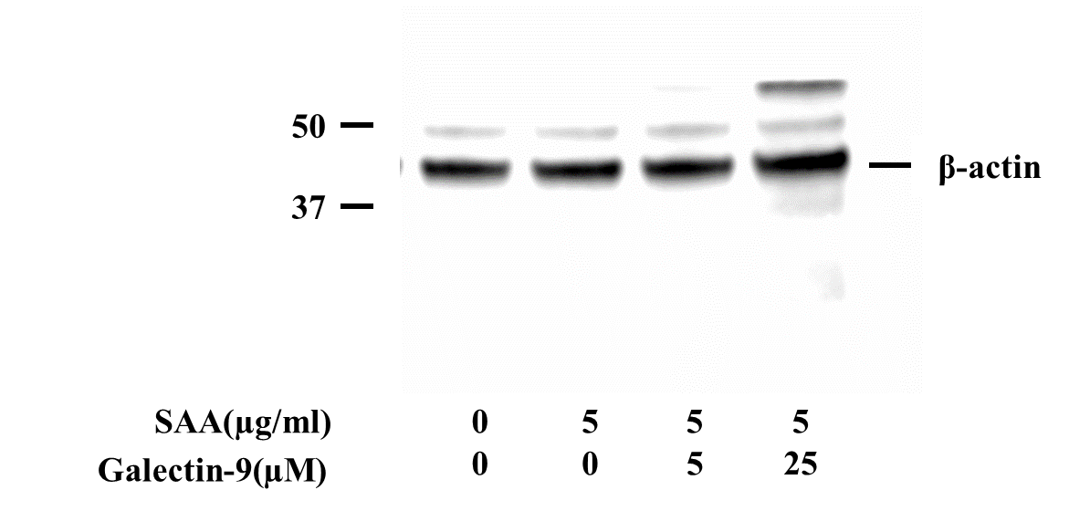

Figure 3B IL-1β immunoblot analysis using the cellular lysates of SAA-stimulated neutrophils
Neutrophils were pretreated or untreated with the indicated concentrations of galectin-9 for 1 hr. After pretreatment, the cells were stimulated with of SAA (5μg/ml) for 16 hr. Cellular lysates were analyzed by immunoblotting with either antibodies that recognize pro-IL-1β or cleaved IL-1β (p17). β-actin was the loading control. Three experiments were performed using different neutrophils and a representative result is shown.

Figure 3C

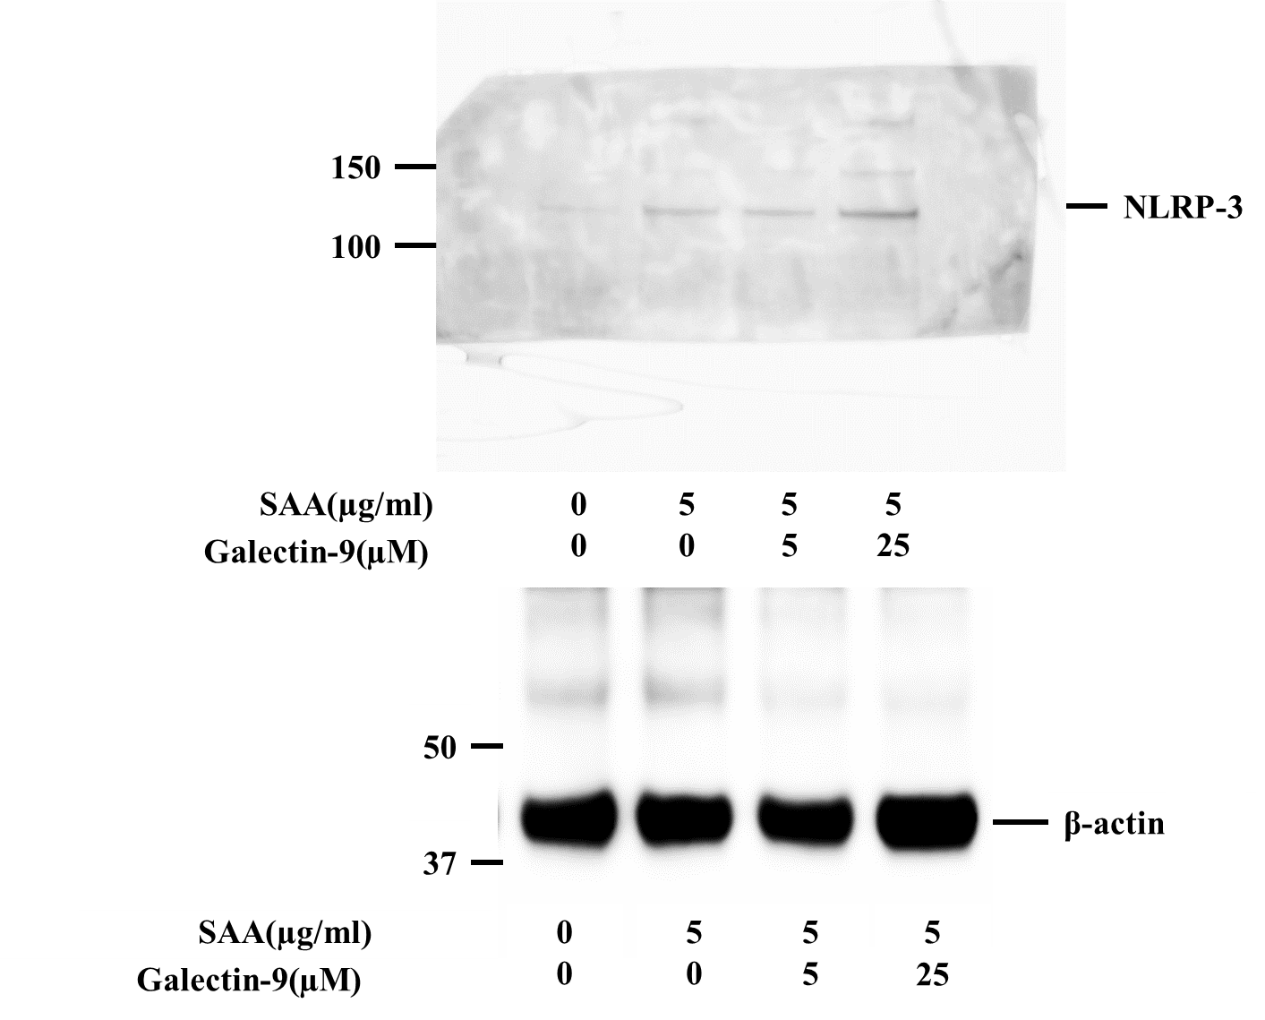

Figure 3C Effects of Galectin-9 on NLRP3 expression in SAA-stimulated neutrophils
Neutrophils were pretreated or untreated with the indicated concentrations of galectin-9 for 1 hr. After pretreatment, the cells were stimulated with of SAA (5µg/ml) for 16 h. Cellular lysates were analyzed by immunoblotting using anti-NLRP3. β-actin was the loading control. Three experiments were performed using different neutrophils and a representative result is shown.

