Supplementary information for:
Stroboscopic operando spectroscopy of the dynamics in heterogeneous catalysis by event-averaging

Jan Knudsen^{1,2}, Tamires Gallo¹, Virgínia Boix¹, Marie Døvre Strømsheim⁵, Giulio D'Acunto¹, Christopher Goodwin³, Harald Wallander¹, Suyun Zhu², Markus Soldemo³, Patrick Loemker⁴, Filippo Cavalca², Mattia Scardamaglia², David Degermann³, Anders Nilsson³, Peter Amann³, Andrey Shavorskiy², Joachim Schnadt^{1,2}

¹Division of Synchrotron Radiation Research, Department of Physics, Lund University, Sweden
²MAX IV Laboratory, Lund University, Sweden
³Department of Physics, Stockholm University, Sweden
⁴Deutsches Elektronen-Synchrotron DESY, Germany
⁵ Department of Chemical Engineering, Norwegian University of Science and Technology (NTNU), Norway

Materials and methods:
Experiments at HIPPIE, MAX IV: The data shown in figure 1 in the main text, in figures S1 – S5 and movies M1, M2, M4, M5, and M6 were all collected at the HIPPIE beamline during one single beamtime. For these measurements the Pd(100) single crystal was mounted on a transferrable 304L stainless steel sample plate. An IR laser in closed loop operation was used to heat the crystal and the temperature was monitored with a type K thermocouple spot welded to the side of the crystals to ensure a precise temperature measurement. Before the experiments the crystal was cleaned by 1 kV Ar⁺ sputtering followed by annealing to 1070 K. The cleanness of the surfaces was confirmed by XPS survey scans. For all measurements at the HIPPIE beamline the R4000-HIPP-3 electron analyser was operated in fixed acquisition mode using a 17 Hz camera. C 1s and Pd 3d_{5/2} spectra were measured with a photon energy of 410 eV, while O 1s spectra were measured with a photon energy of 650 eV. A large pass energy of 200 eV was used both for O 1s and C 1s, while 100 eV was used for Pd 3d_{5/2} such that the entire binding energy range (approximately 10% of the pass energy) could be covered by the electron analyser in fixed acquisition mode. The frequencies stated in the paper were calibrated from the known pulsing period (i.e. from the known time difference between two CO pulses), since the actual pulsing framerate was lower 17 Hz in the experiments.
Instrument oxygen (5.0 N) and CO (3.8 N) was used for the experiments. Commercial Pall gas cleaners (GLP2OXPVMM4 for O₂ and GLP2SIPVMM4 for CO) were used on both gas lines. In particular this is important for the CO line, as nickel carbonyls are known to form in the CO bottle. The gases were dosed with mass flow controllers (Brooks GF125) controlled by software written by the MAX IV. The stated flow values in sccm units refers to standard conditions of 20 °C and 14.696 psia (1 bar). The pressures stated in the paper were measured with a capacitance manometer mounted at the outlet of the cell.
Experiments at POLARIS, DESY: The POLARIS instrument equipped with a R4000-HiPP-2 electron analyser, situated at the P22 beamline at Petra III synchrotron, was used to collect the data presented in Figures 2 and S6 as well as movies M3 and M7. This instrument takes advantage of a virtual cell design and allows for fast gas switching in combination with usage of hard x-rays. Gases of CO (purity 4.7), O₂ (purity 5.0) and He (purity 5.0) were used and further cleaned using gas purifiers obtained from SAES (O₂ gas, model Nr. 906; He gas, model Nr. 902). To avoid the formation of Ni carbonyls, a combination of Cu piping and gas purifier for CO (PALL, GLP8SIPVMM4) was used. A calibration of the pressure measurement was performed in direct connection to the beamtime using the method described in Ref [1].
The precleaned sample was transferred through air and introduced into the POLARIS instrument where it was treated by repeated cycles of oxidizing / reducing conditions under elevated pressure and temperature conditions. Judging from XPS, this procedure created a clean surface with a minor SiO₂ contamination. The Pd crystal was mounted on a stainless-steel sample holder and heated from the backside using a fully enclosed ceramic heater (model 101275-28K, Heat Wave Labs). Type N thermocouples were mounted on the backside of the crystal and the temperature was stabilized using a remote controllable PID loop.
The data were collected at a grazing x-ray incidence angle of 0.7° at a photon energy of 4.6 keV using the Si (311) monochromator settings. In this combination the effective probing depth of ca. 17 Å is expected based on the method from Jach et al. [2], wherein the penetration depth of the x-rays at and below the critical angle, as well as the escape of the electrons at those depths, is used to characterize the signal from the surface.
The photon energy band with is ca. 130 meV. Using a slit of 0.8 mm and 200 eV pass energy, the combined experimental resolution is ca. 430 meV.

Data analysis: All data analysis was performed in Igor Pro 8 using purpose-written scripts. Polynomial background subtraction was carried out for each spectrum by fitting a polynomial to the datapoints where no components were visible. To determine the datapoint range for fitting the background subtraction the sum spectrum of all time resolved data was used (to ensure that the background subtraction did not remove any weak components). In this work we did not correct for the different electron transmissions in the electron analyser, which can affect the intensity. After background subtraction, all spectra were curve fitted with asymmetric pseudo-Voigt functions with as little free parameters as possible. For example, a common work function shift parameter was used for all gas phase components. These constraints made the curve fitting procedure very robust.

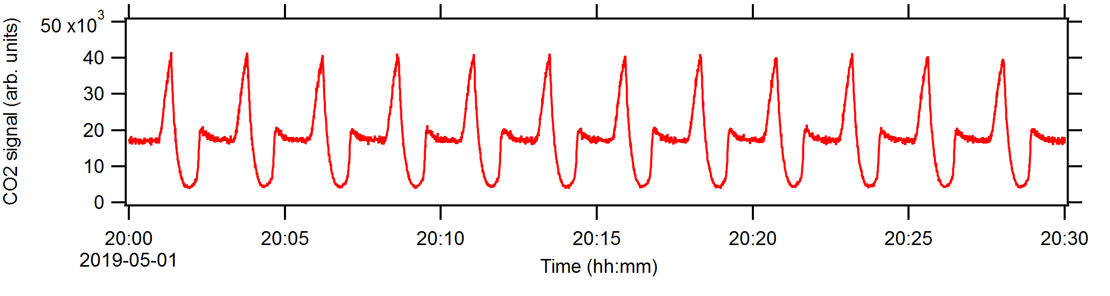
Figure S1: CO₂ signal that shows the oscillations induced by the gas-composition modulation recorded with the mass spectrometer through the 0.3 mm nozzle of the electron analyser. A fraction of the gas pumped through the nozzle was leaked into a dedicated mass spectrometer chamber equipped with a Hiden (HAL/3F PIC) mass spectrometer, to ensure rapid response to gas composition changes and a low baseline signal. The base pressure of the mass spectrometer chamber was ∼ 1⋅10⁻⁹ mbar and ∼ 5⋅10⁻⁸ mbar during the experiments.

Movie M1: The movie M1.mp4 illustrates the event-averaging of 10 pulses using the stamp-image shown in the dotted red box. The O 1s raw data in the movie were recorded with 6.75 Hz and are shown as a running movie in the top left panel of the movie file. To reduce the file size, the movie was rendered with 8 frames per second and 20 spectra displacement between two subsequent frames. Thus, the time in the movie is accelerated with a factor of ∼ 25.
The bottom panel in the movie shows the absolute difference of the stamp signal frame referenced to the value when the movie was started. In more detail, the absolute difference is calculated as the integral over the absolute difference of each pixel point and its initial value within the rectangle. In the bottom panel the integral value is plotted at the time value read by the lower edge of the dotted square in the top left panel of the movie. Once a minimum is found in the absolute difference signal corresponding to a matching image within the dotted square the entire image displayed in the top left panel is added to the top right panel. Finally, the colour scale in top right image is divided by the number of images added.
While the movie was rendered with 20 spectra displacement between two subsequent frames, the real analysis was done with single spectra displacements. The time values of each minimum in the lower panel were determined by fitting an appropriate polynomial around each minimum. This results in a very accurate determination of the time for each matching event as demonstrated by figure S2 below.

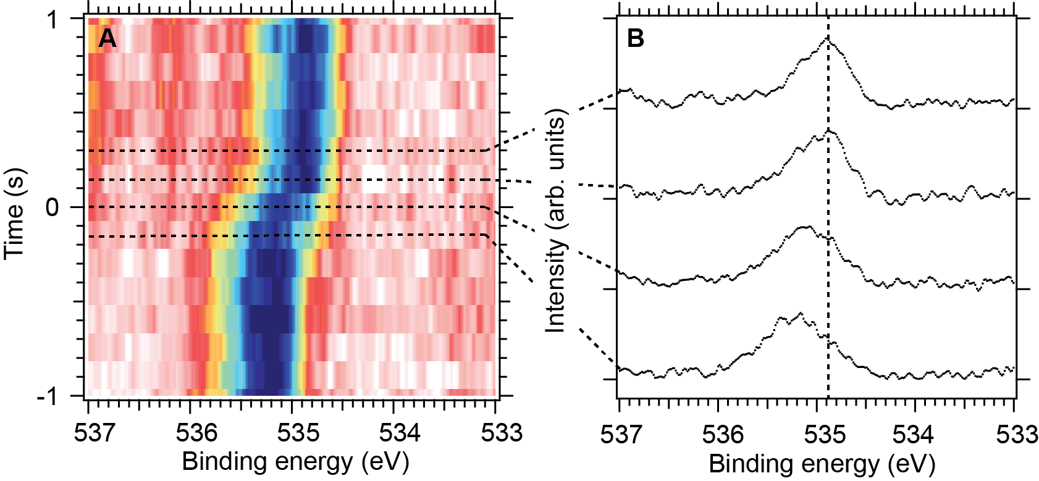
Figure S2: O 1s image plot of the event-averaged stamp signal (A) corresponding to a zoom-in of figure 1C of the main text and single event-averaged spectra (B) recorded along the dotted lines. The work function transition happens between t = 0 s and t = 0.148 s. The fact that the event-averaged spectrum shows a sharp transition is clear evidence that we maintained a time-resolution close to 148 ms also after event-averaging.

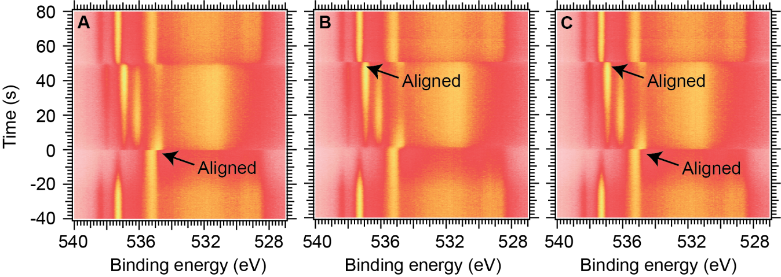
Figure S3: Comparison of the event-averaged raw images before background removal using the front (A) and end (B) of the CO pulse, respectively, as described in the main text (compare also with figure 1). When the stamp signal at the front of the pulse indicated with a black arrow in panel A is used to generate the timing signal for formation of the event-averaged images a sharp contrast is observed at the front of the pulse (t = 0 s) both for gas phase components and surface components (compare with figure 1 for peak assignment). However, the contrast is less sharp at the end of pulse at t = 50 s. The exact opposite behaviour is observed when the stamp signal at the end of the pulse is used for event-averaging (panel B). Finally, panel C demonstrates how a sharp contrast can be obtained by merging the two event-averaging images, which are averaged to the front and end of the CO pulse respectively.

Movie M2: The movie M2.mp4 demonstrates and documents how the curve fitting of figure 1C and the integrated values shown in figure 1E have been obtained.
Movie M3: The movie M3.mp4 demonstrates and documents how the curve fitting of figure 2C and the integrated values shown in figure 2E have been obtained.

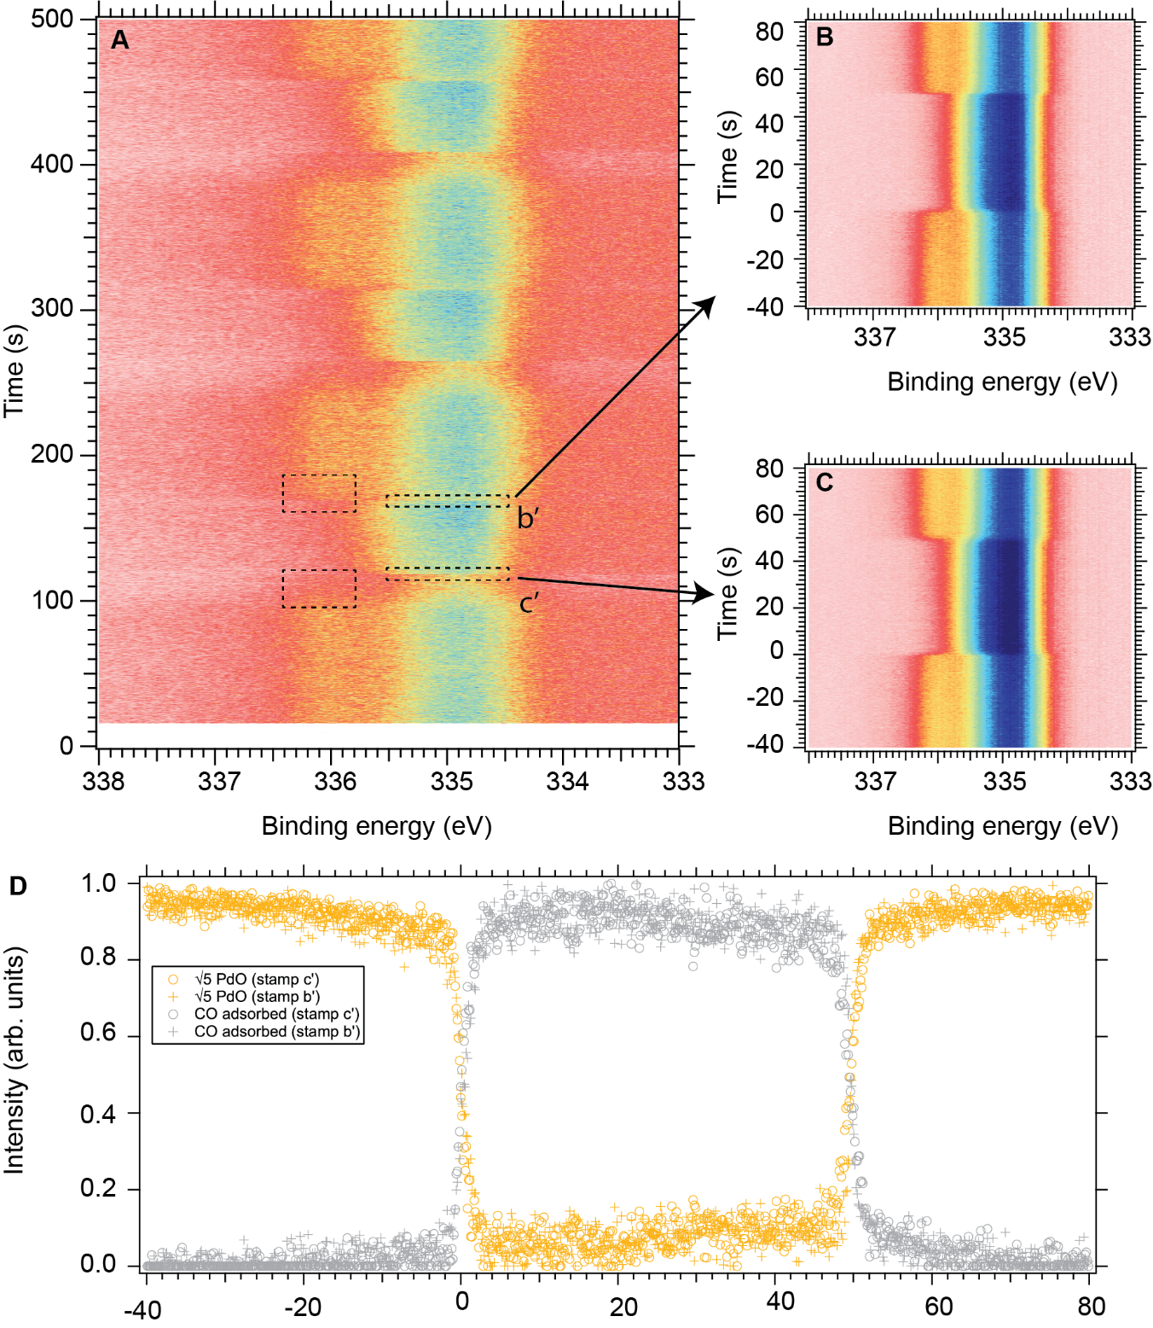
Figure S4: Comparison of Pd 3d_{5/2} raw data acquired with 7 Hz and a photon energy of 410 eV shown in panel A and event-averaged image plots of 58 pulses shown in B and C (840 spectra) using the stamp signals marked with b’ and c’, respectively. To account for different electron transmission through the gas phase, the image plots in panels B and C were normalized to the total Pd 3d_{5/2} intensity. Panel D shows the curve fitted intensities of the √5 oxide and adsorbed CO normalized to the maximum value. In contrast to figure 1E and figure S5D the transition between the √5 oxide covered surface and CO covered surface is gradual taking approximately 2 s referring to panel D here. This apparent discrepancy is caused by the weak stamp signals that make it difficult to achieve a unique timing signal of the transition event on the surface. Many different time signals were tested (examples shown with dotted squares in panel A), but the quality of the data does not allow a similar quality as the C 1s and O 1s data. Movie M4.mp4 demonstrates and documents how the curve fitting of figure S4C is done.
Movie M4: The movie M4.mp4 demonstrates and documents how the curve fitting of figure S4C and the integrated values shown in figure S4D were obtained.

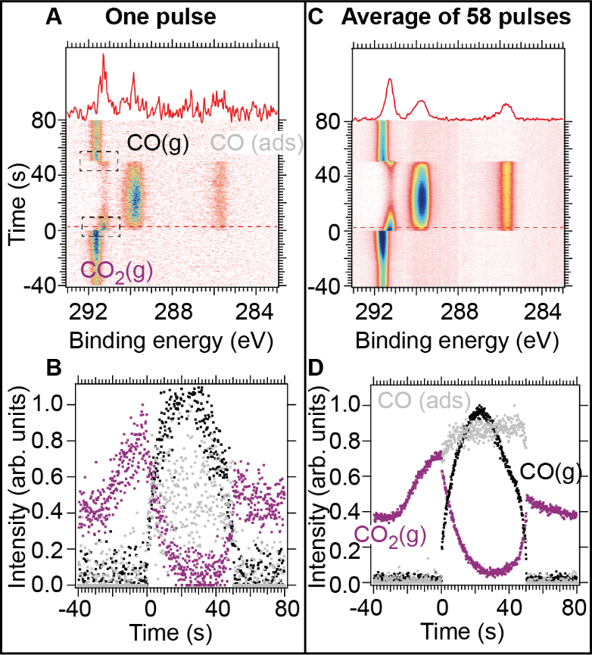
Figure S5: Comparison of time-resolved C 1s data recorded with 6.16 Hz (739 single spectra) before (left) and after (right) event averaging recorded during one CO pulse. A and C show C 1s image plots acquired over a single pulse and averaged over 58 pulses, respectively using a photon energy of 410 eV. The relative CO and CO₂ signals and relative CO coverage derived from the image plots in A and C are shown in panel B and D, repectively. The reason that relative concentrations rather than partial pressures are shown in the plot is that the O₂ pressure is unknown from the C 1s data. The curve fitting of all spectra is shown in movie M5.mp4 and M6.mp4.

Movies M5 and M6: The movies M5.mp4 (no event-averaging) and M6.mp4 (with event-averaging) demonstrate and document how the curve fitting of figure S5A and C and the integrated values shown in panel B and D have been obtained.

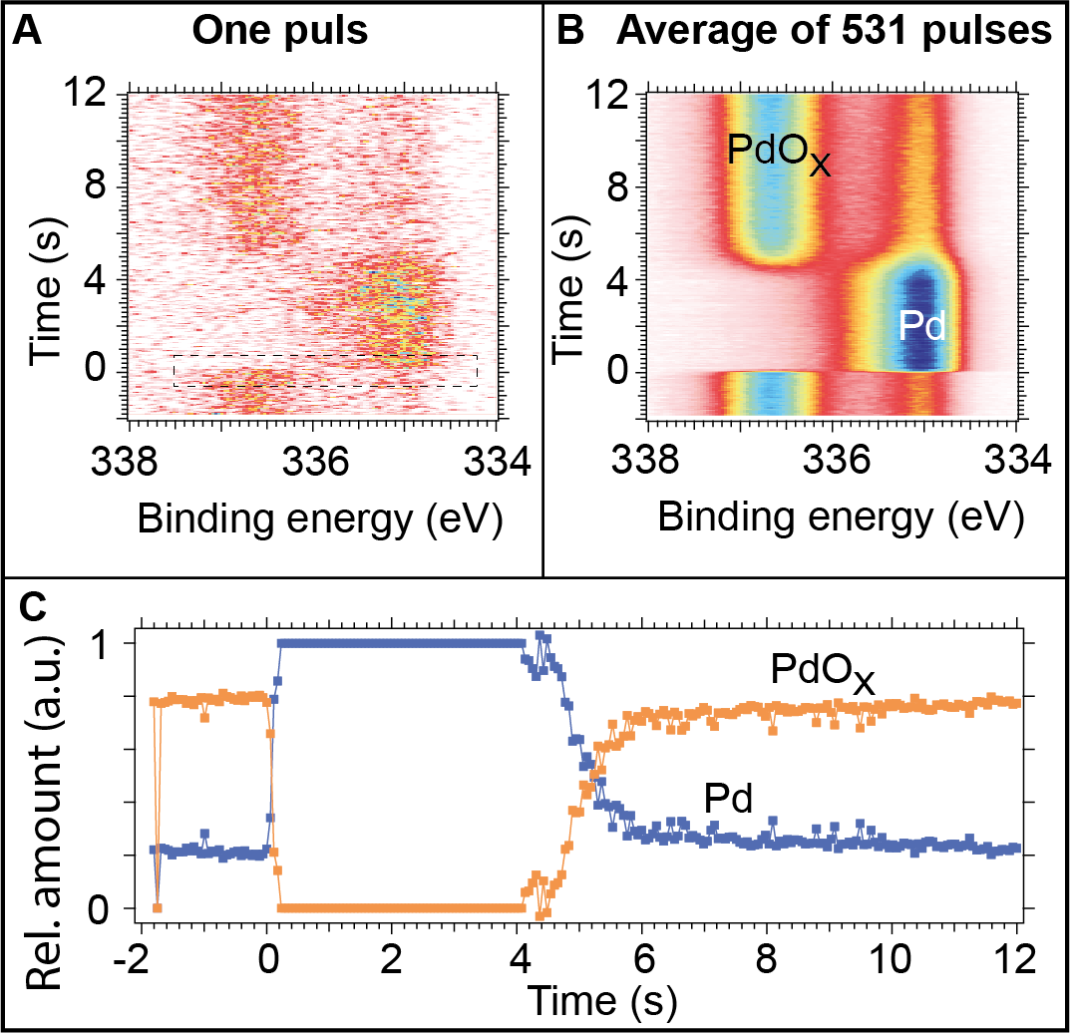
Figure S6: Pd 3d_{5/2} data recorded with 17 Hz and acquired with a photon energy of 4.6 keV before (A) and after (B) event-averaging of 531 pulses and the result of the quantitative analysis (C) obtained by curve fitting .Panel A and B shows 240 spectra each. To account for different electron transmission through the gas phase caused by the He pulses, the image plot in panel B were normalized to the total Pd 3d_{5/2} intensity. Pulsing parameters were identical to figure 2 of the main text. To account for different electron transmission through the gas phase caused by the He pulses, the image plot in panel B was normalized to the total Pd 3d_{5/2} intensity. The curve fitting of all spectra are shown in movie M7.mp4 in the supplementary information.
The thickness of the PdO_{X} film is estimated to be at the order of 25 Å from the relative intensity of the PdO_{X} component of 0.8 shown in figure S6 using the method shown in Goodwin et al. [3]. In brief, this method incorporates the x-ray attenuation due to grazing incidence into standard XPS intensity equations. Expected XPS intensities were calculated for Pd oxide thicknesses from 0 to 100 Å, and the experimental data was then compared to the simulated results. To simulate the XPS intensity bulk densities of Pd and PdO were assumed, 12.03 and 8.3 respectively, each layer is assumed to have no roughness and no mixing. TTP-2M model was used for electron mean free path [4] and the Sergey Stepanov x-ray server [5, 6] was used to calculate x-ray field intensity within the material using the Henke model [7].

Movie M7: The movie M7.mp4 demonstrates and documents how the curve fitting of figure S6B and the integrated values shown in figure S6C have been obtained.

[1] P. Amann et al., “A high-pressure x-ray photoelectron spectroscopy instrument for studies of industrially relevant catalytic reactions at pressures of several bars,” Rev. Sci. Instrum., vol. 90, no. 10, Oct. 2019, doi: 10.1063/1.5109321.
[2] T. Jach, J. Gormley, and S. Thurgate, “Grazing incidence X-ray photoemission spectroscopy of SiO2 on Si,” Spectrochim. acta, Part B At. Spectrosc., vol. 54, no. 10, pp. 1539–1544, Oct. 1999, doi: 10.1016/S0584-8547(99)00103-2.
[3] C. M. Goodwin et al., “Grazing-incidence high-pressure XPS to determine the structure of Pd during catalytic CO oxidization,” To be Submitted, 2021.
[4] Standard Reference Data, N. NIST Standard Reference Database 71. 1999, DOI:10.18434/T48C78.
[5] Sergey Stepanov’s X-ray Server https://x-server.gmca.aps.anl.gov/ (accessed December 10, 2020)
[6] Stepanov, S. A. X-Ray Server: An Online Resource for Simulations of x-Ray Diffraction and Scattering. In Advances in Computational Methods for X-Ray and Neutron Optics; Sanchez del Rio, M., Ed.; SPIE: Denver, 2004; Vol. 5536, pp 16–26, DOI:10.1117/12.557549
[7] Henke, B. L.; Gullikson, E. M.; Davis, J. C. X-Ray Interactions: Photoabsorption, Scattering, Transmission, and Reflection at E = 50-30, 000 EV, Z = 1-92. Atomic Data and Nuclear Data Tables 1993, 54, 181–342, DOI:10.1006/adnd.1993.1013.

