Supporting Information
Table S1. Ambient and individual temperature of four groups in each period
 | Period 0 | Day 1 | Day 2 | Day 3 | Day 4 | Day 5
AT_{max} | 29.4 | 34.7 | 33.7 | 35.1 | 34.5 | 33.5
T_{mean1} | 28.7 | 30.9 | 31.2 | 30.8 | 30.4 | 30.4
T_{mean2} | 28.5 | 28.2 | 28.7** | 28.6* | 28.6* | 28.1**
T_{mean3} | 28.2 | 29.4 | 29.3 | 28.8* | 28.9** | 29.0*
T_{mean4} | 28.5 | 30.5* | 30.8 | 30.5 | 30.3 | 29.7**
*T_{mean1}, T_{mean2}, T_{mean3}, and T_{mean4} represent the average personal exposure temperature of control group, education group, subsidy support group, and cooling-spray group, respectively; AT_{max} means the maximum air temperature of the day, *p<0.05, **p<0.01 (compared with control group)

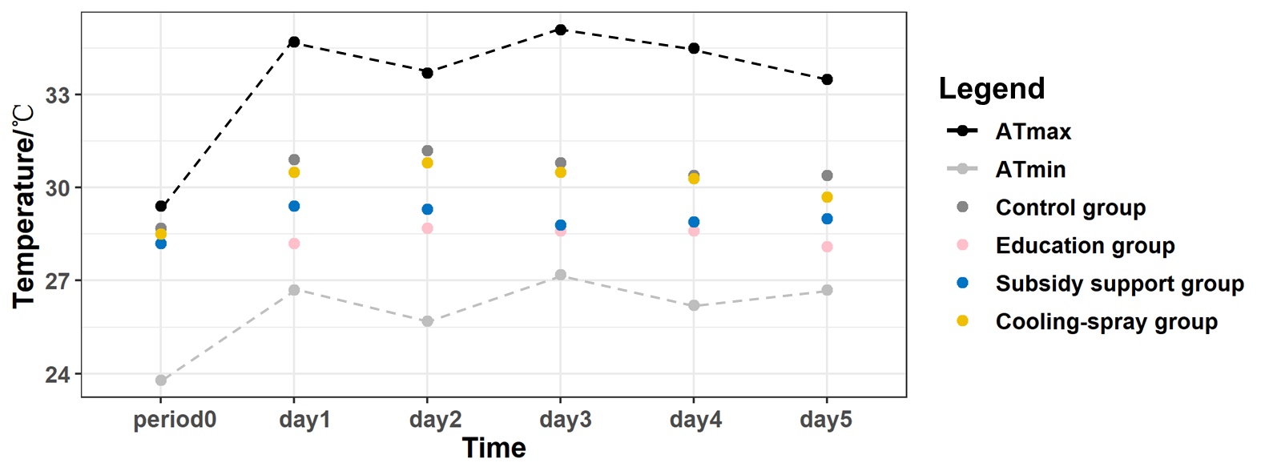
Figure S1 Air temperature range and average personal exposure temperature
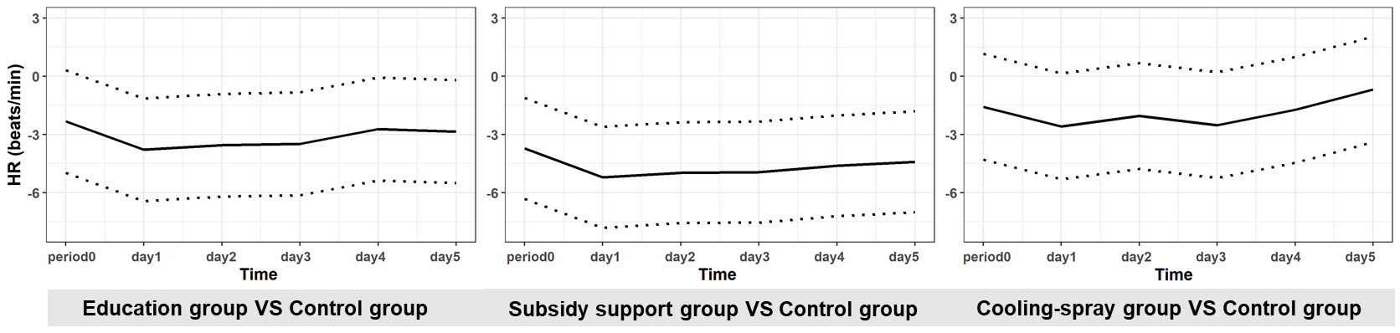
Figure S2 The difference in heart rate between intervention groups and control group (the dotted lines represent estimate value±SE)
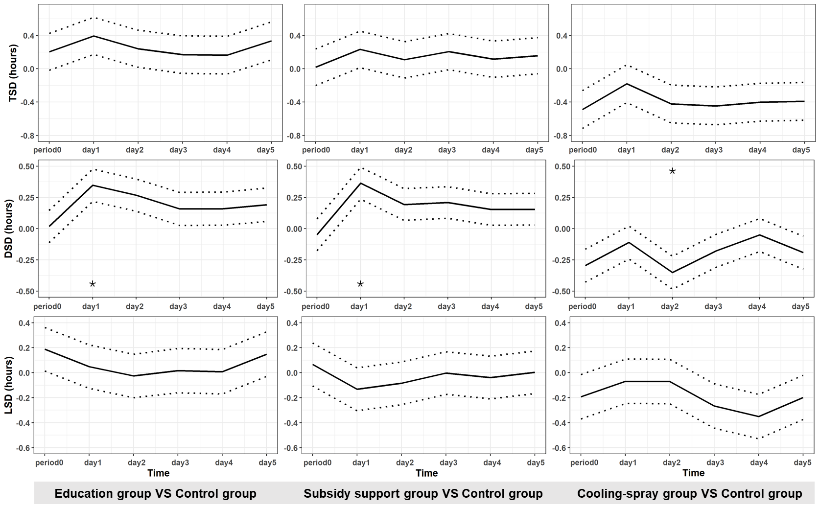
Figure S3 The difference in sleep duration between intervention groups and control group (* p<0.05, compared with control group, the dotted lines represent estimate value±SE)

