Supporting Information
Micro-Raman and X-ray photoemission spectroscopic investigations of heterojunction between delafossite CuGaO₂ and wurtzite ZnO obtained by hydrothermal method
Minuk Choi¹, Christoph Brabec² and, Tomokatsu Hayakawa^{1,3*}
¹ Field of Advanced Ceramics, Department of Life Science and Applied Chemistry
Nagoya Institute of Technology, Gokiso, Showa, Nagoya 466-8555, Japan
² Department of Materials Science and Engineering, University of Erlangen-Nuremberg, Martensstraße 7, DE-91058 Erlangen, Germany
³ Frontier Research Institute of Materials Science (FRIMS), Nagoya Institute of Technology, Gokiso, Showa, Nagoya 466-8555, Japan
*Corresponding author

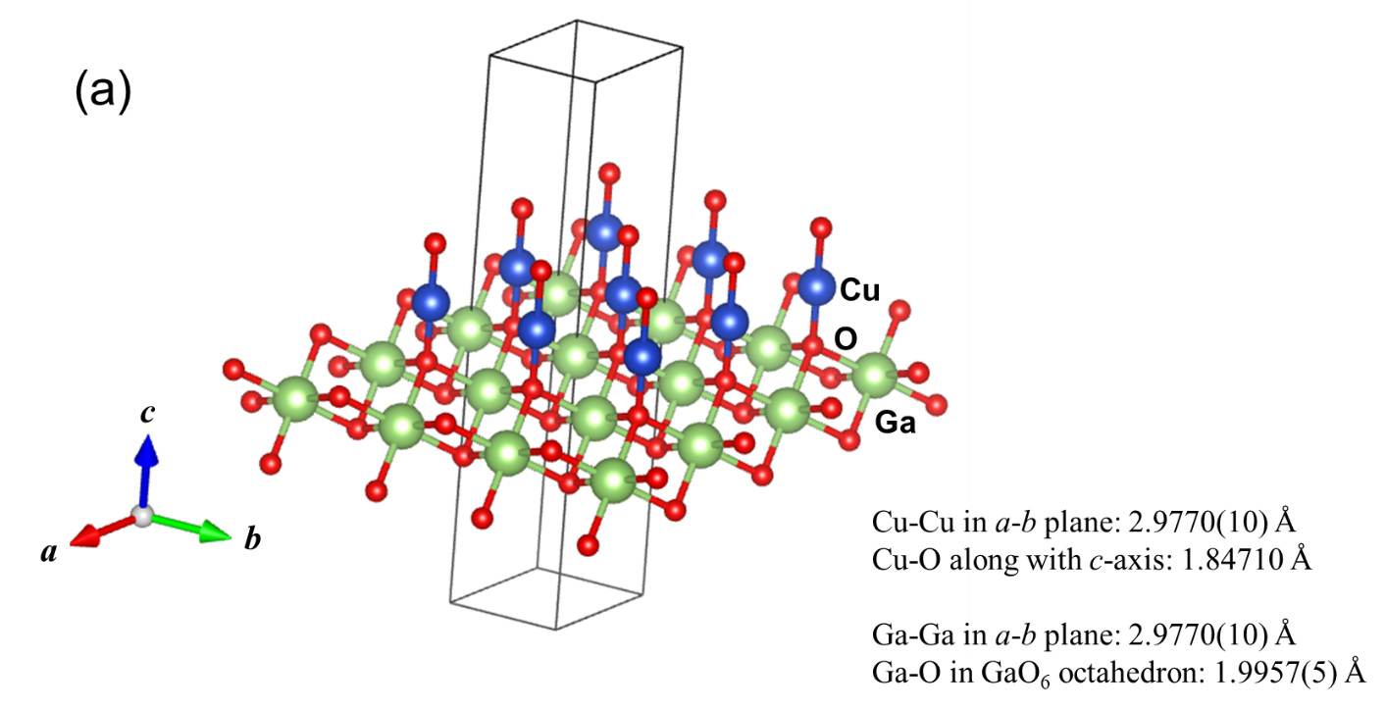
Fig.S1(a) Extracted crystal structure of rhombohedral CuGaO₂ (R-3m). Blue, red, and green balls
show Cu, O, Ga elements, respectively. The lattice parameters are taken from ICDD PDF 01-082-8561.

Fig.S1(a) shows crystal structure in part of rhombohedral CuGaO₂ (R-3m). The closest distance of Cu-Cu found in a-b plane is 2.9770(10)Å and one of Cu-O is 1.84710 Å along with the c-axis. On the other hand, the closest distance of Ga-Ga is 2.9770(10) Å and the Ga-O distance in GaO₆ octahedron is 1.9957(5) Å. It is also seen that oxygen has fourfold coordination with one Cu and three Ga. Cu is combined with two oxygens along with the c-axis and Ga has six-fold coordination with oxygens.

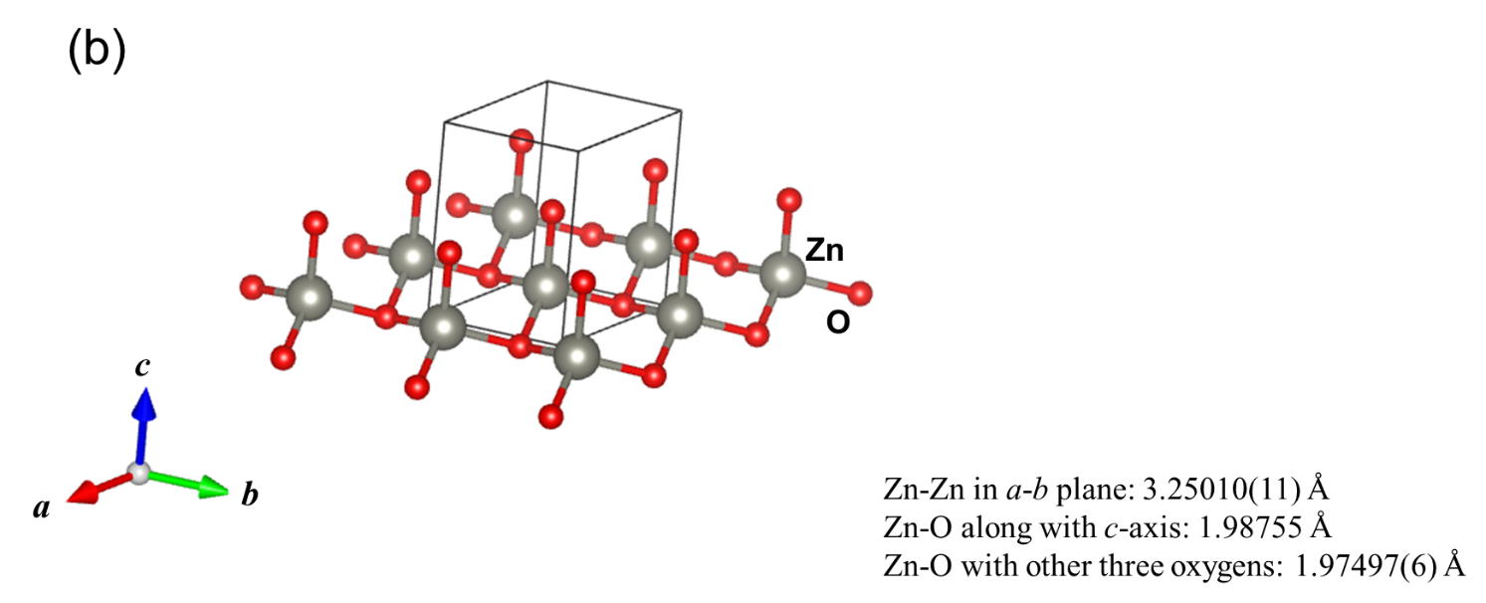

Fig.S1(b) Extracted crystal structure of wurtzite(hexagonal) ZnO (P6₃/mmc). Grey and red balls
show Zn and O elements, respectively. The lattice parameters are taken from ICDD PDF 04-003-2106.

As for ZnO shown in Fig.S1(b), the closest distance of Zn-Zn found in a-b plane is 3.25010(11) Å. The Zn-O distance along with the c-axis is 1.97497(6) Å, which Zn element has bonds with the other three oxygen in a length of 1.98755(4). As it is well known, Zn has fourfold coordination with oxygens and O has four neighboring Zn elements within a distance < 1.99 Å.

Table S1 Sample names and synthesis conditions for CuGaO₂/ZnO hybrids
Sample name | CGO used | Mass of Zn(ac)₂·2H₂O | Nominal [Zn]/[Cu] ratio
CZ1 | CGO1 | 0.18 g | 2.75
CZ2 | CGO1 | 0.36 g | 5.5
CZ3 | CGO1 | 0.72 g | 11
CZ4 | CGO2 | 1.08 g | 16.5

(The sample preparation of CuGaO₂/ZnO hybrids are given in the maintext.)

Table S2 XRD peak assignment for the CZ3 sample
No. | XRD peak position | Assignment (h k l)
No. | XRD peak position | CuGaO₂, rhombohedral | ZnO, hexagonal | CuGa₂O₄, cubic | ZnCu₂O₄, tetragonal | Cu₂O, cubic | Cu(fcc),  fcc or hexa
1 | 13.961 | n.a. | n.a. | n.a. | n.a. | n.a. | n.a.
2 | 15.465 | 0 0 3
3 | 28.132 |  |  |  | 1 1 2
4 | 28.600 |  |  |  | 1 0 3
5 | 30.970 |  |  | 2 2 0
6 | 31.240 | 0 0 6
7 | 31.741 |  | 1 0 0
8 | 32.610
9 | 34.382 |  | 0 0 2
10 | 35.752 | 1 0 1
11 | 36.220 | 0 1 2 | 1 0 1 |  |  | 1 1 1
12 | 40.866 | 1 0 4
13 | 42.671 |  |  |  |  | 2 0 0
14 | 43.306 |  |  |  |  |  | 1 1 1 (fcc)
15 | 47.517 |  | 1 0 2
16 | 50.692 |  |  |  |  |  | 2 0 0 (fcc)
17 | 56.173 | 0 1 8
18 | 56.574 |  | 1 1 0
19 | 60.618 |  |  |  |  |  | 1 0 4 (hexa)
20 | 61.621 |  |  |  |  | 2 2 0
21 | 62.390 | 1 1 0
22 | 62.824 |  | 1 0 3
23 | 65.164 | 1 0 10
24 | 66.334 |  | 2 0 0
25 | 67.905 |  | 1 1 2
26 | 69.074 |  | 2 0 1
n.a.: not assigned

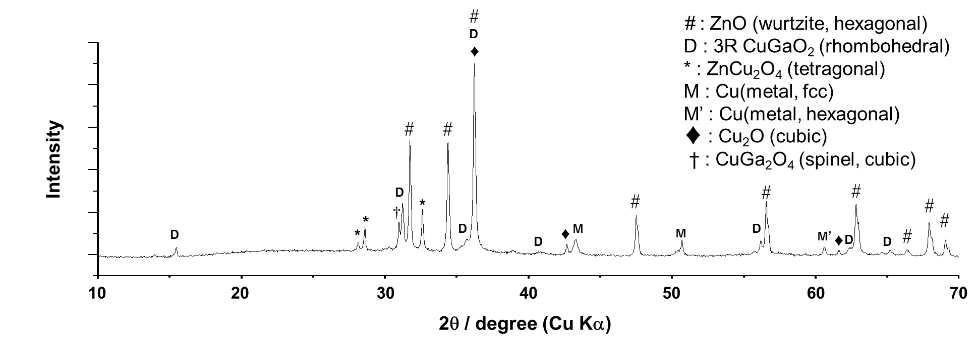
Fig.S2 XRD pattern of CZ3 sample (after the H₂ annealing process) and assignment of the corresponding crystals.

Fig.S3 XRD patterns of CuGaO₂/ZnO hybrids of CZ1-4 before the H₂ annealing process. (#:wurtzite ZnO, D:rhombohedral(3R) CuGaO₂).

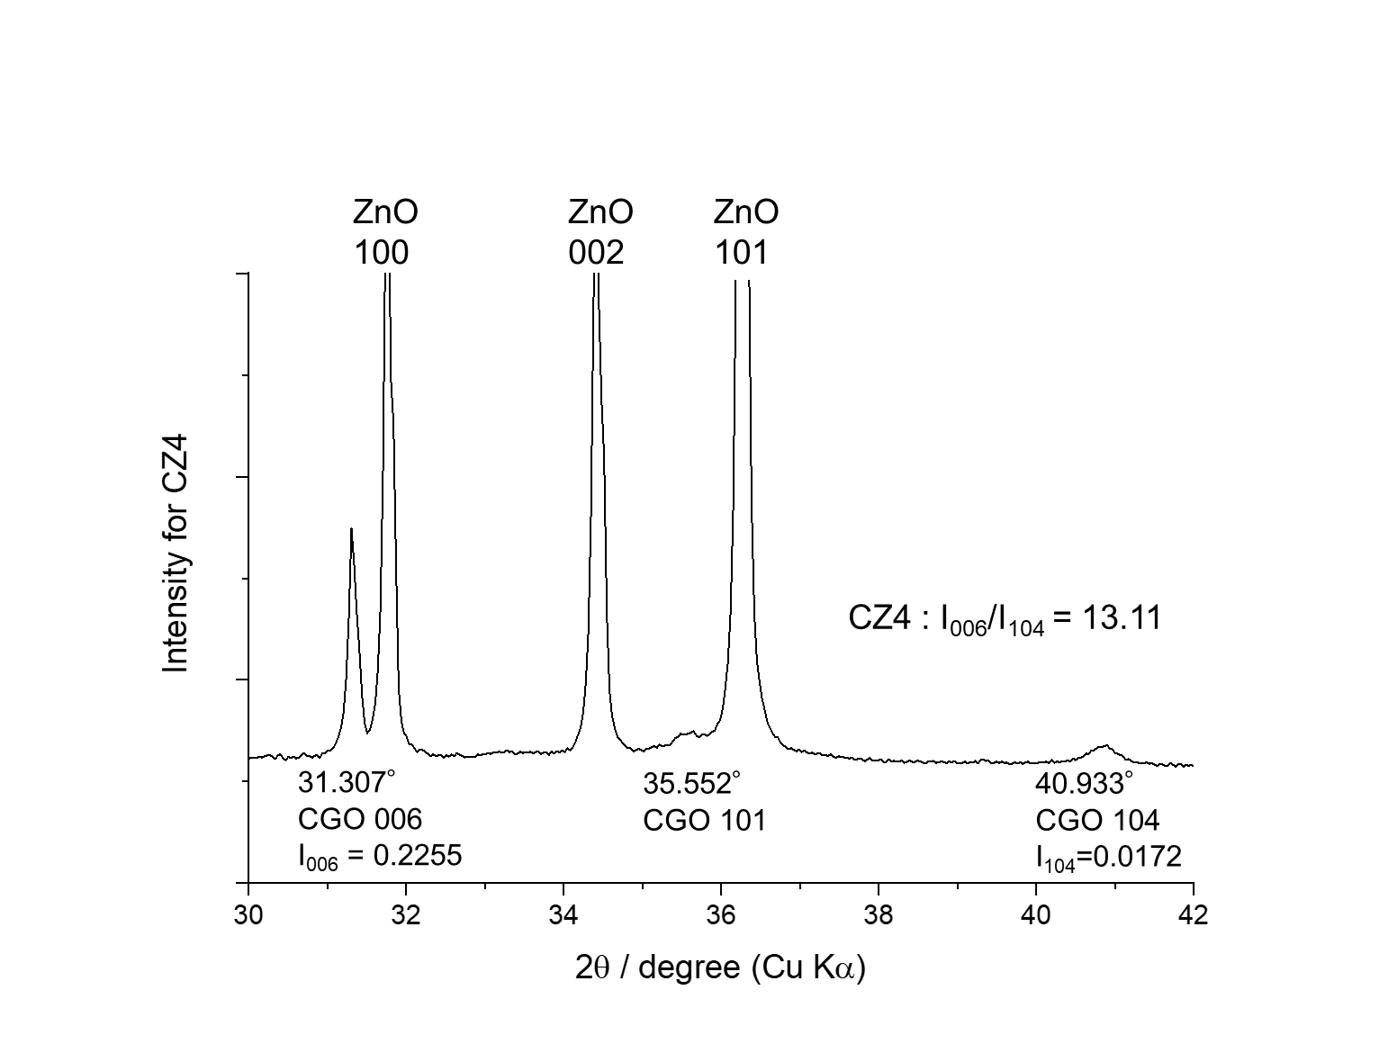
Fig.S4 XRD pattern (magnified) of CZ4 sample after the H₂ annealing process.

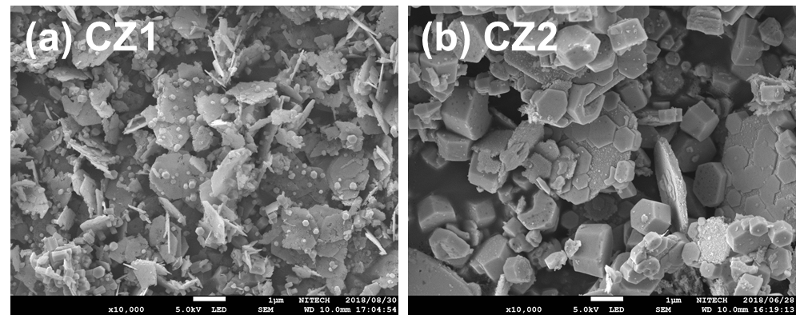
Fig.S5 SEM images of the CZ1 (a) and CZ2 (b) samples.

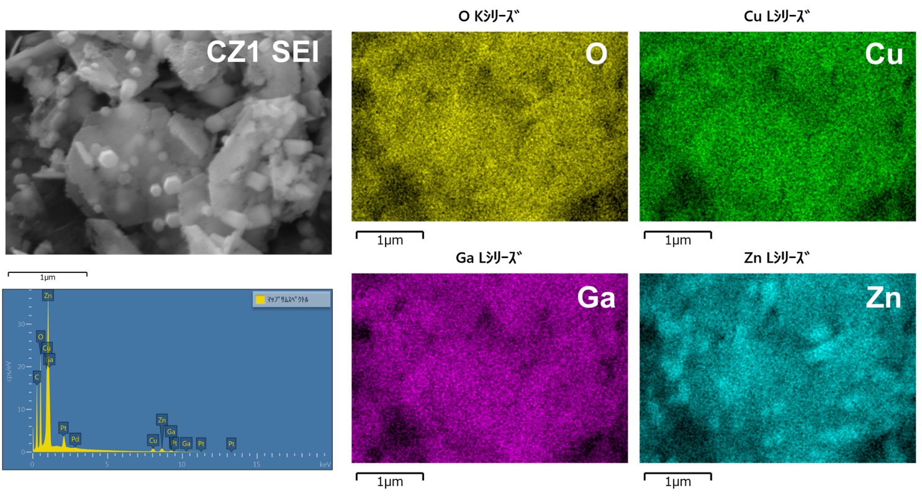
Fig.S6 SEM-EDS results of the CZ1 sample.

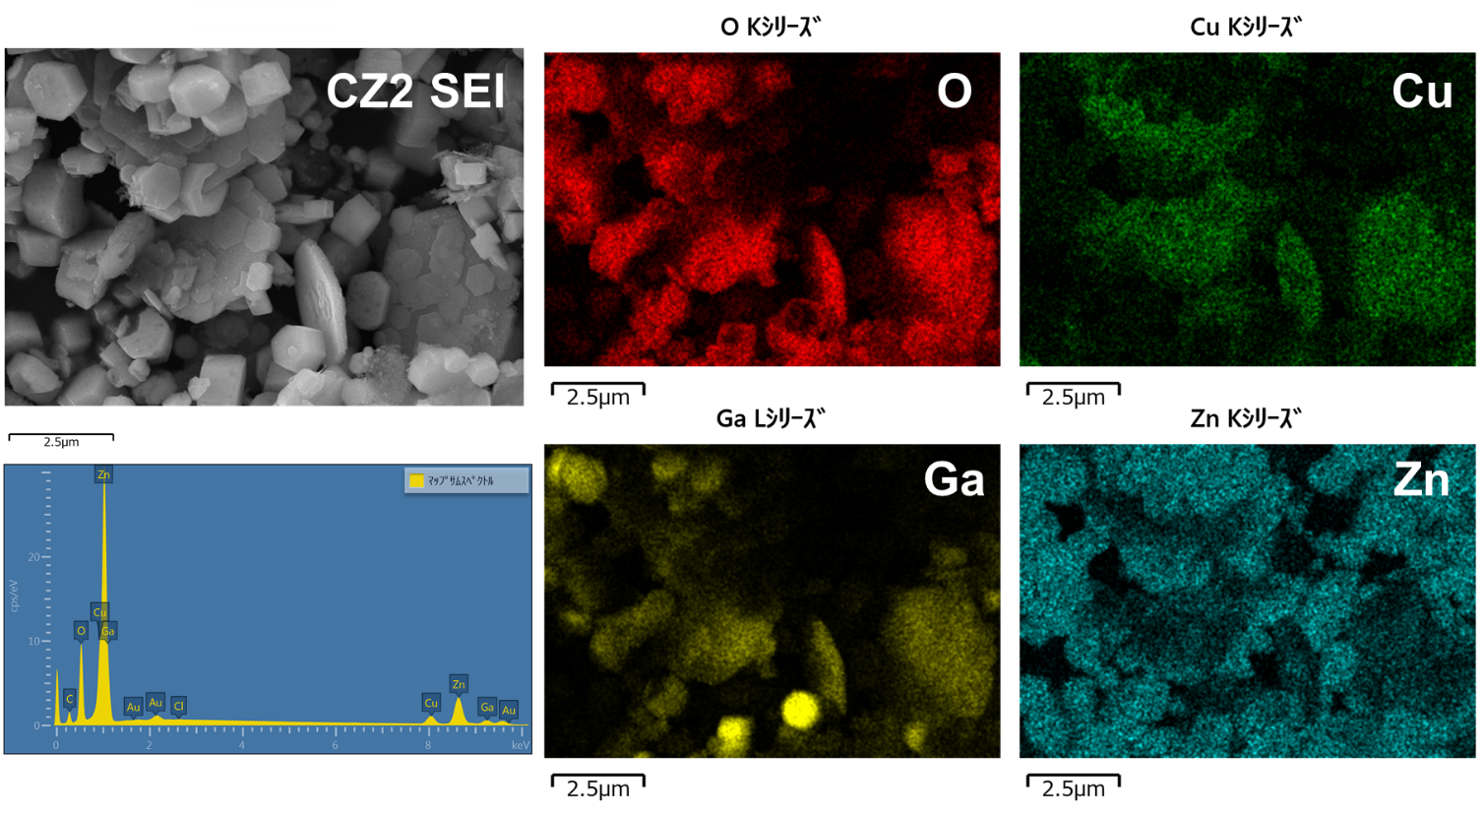
Fig.S7 SEM-EDS results of the CZ2 sample.

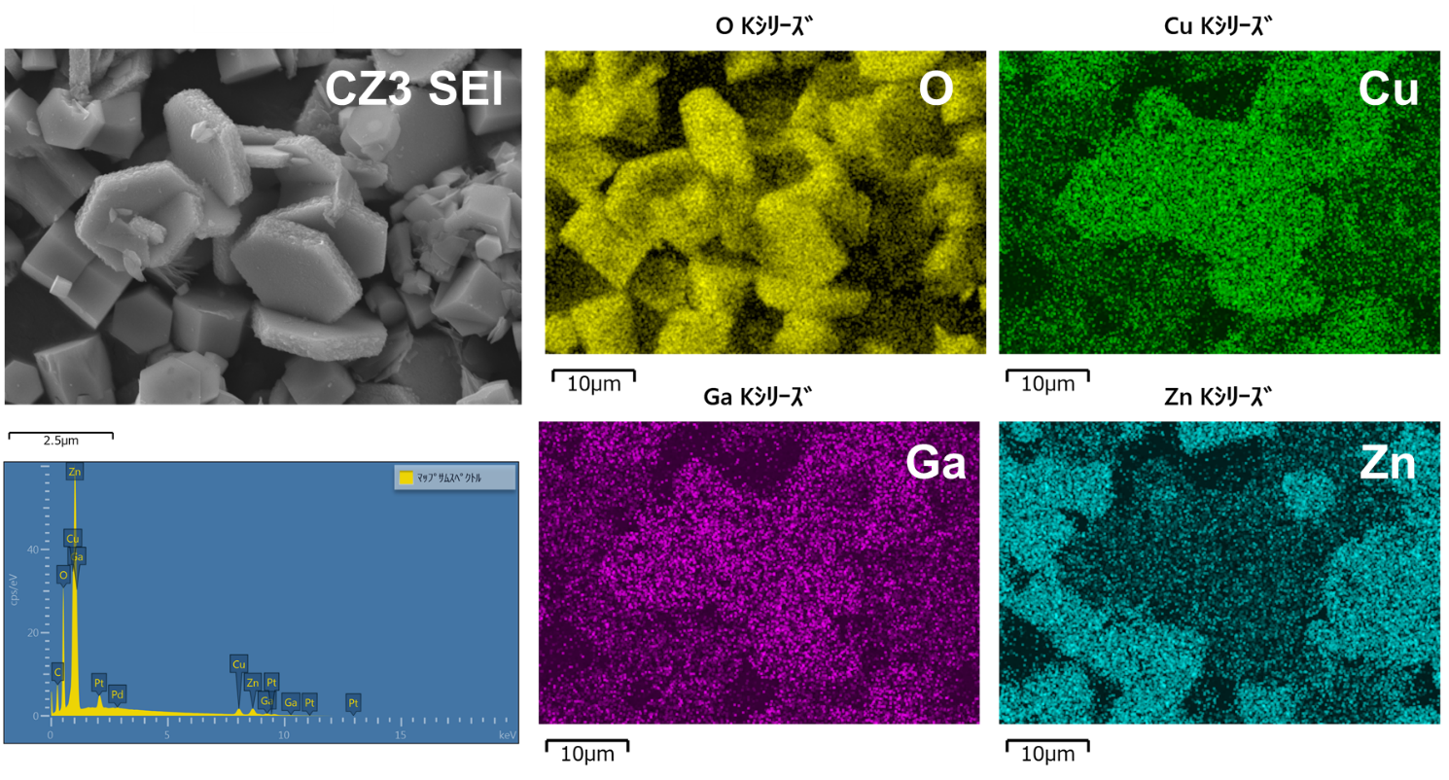
Fig.S8 SEM-EDS results of the CZ3 sample.

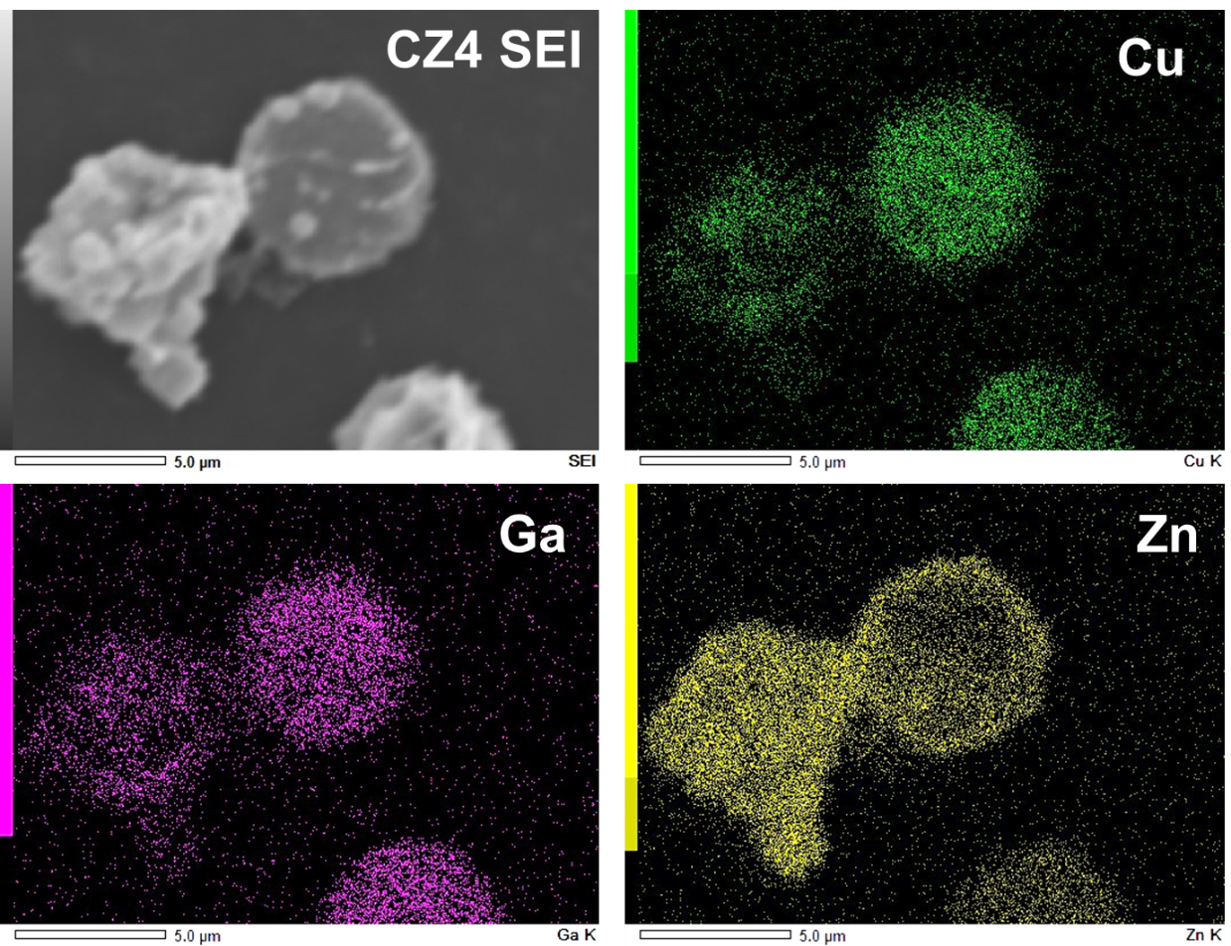
Fig.S9 SEM-EDS results of the CZ4 sample, which are taken, for comparison with Fig.S5-7, from the literature (M. Choi, S. Yagi, Y. Ohta, K. Kido and T. Hayakawa, J. Phys. Chem. Solids, 150 (2021) 109845).

Fig.S10 Comparison of XRD patterns for two CuGaO₂/ZnO hybris synthesized with the same [Zn]/[Cu] ratio (=11) but by use of the different base crystals, CGO1 and CGO2 (#:wurtzite ZnO, D:rhombohedral(3R) CuGaO₂). Both the hybrids were annealed in the H₂ atmosphere. The CGO1 particles used were mainly 1~3 μm in size, while the CGO2 particles with the size bigger than 3 μm, typically 5~8 μm were obtained, meaning that the specific surface area (SSA) of the particles of CGO1 was higher, and thus that more oxygen molecules would possibly be adsorbed on CGO1, which make it more likely that the partial decomposition to CuO and Ga₂O₃ took place on CGO1. This would make it possible to form the ZnCu₂O₄ and CuGa₂O₄ in CZ3 by Reactions 1 and 2 given in the maintext.

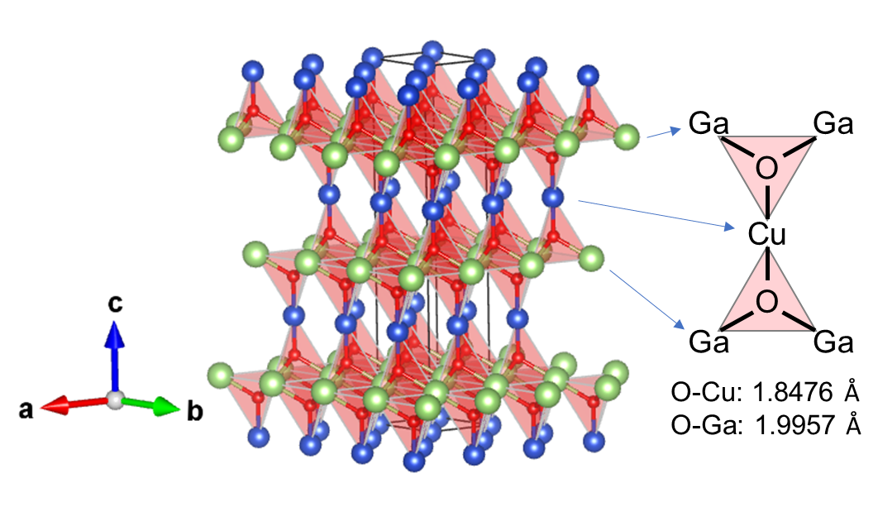
Fig.S11 Overview of OCuGa₃ polyhedra in 3R CuGaO₂ structure.

