Supplementary Data:
RECTAL SWABS AS A VIABLE ALTERNATIVE TO FAECAL SAMPLING FOR THE ANALYSIS OF GUT MICROBIOTA FUNCTIONALITY AND COMPOSITION

- Supplementary Methods:
Sample preparation for ¹H-NMR analysis
Faecal water (FW) was made using two parts Ultra High Performance Liquid Chromatography water (UHPLC H₂O) to one-part faeces in an Eppendorf tube, which was then vortexed for 5 minutes. These samples were then centrifuged at 20,000 g and 4C° for 20 minutes, and the supernatant transferred to a fresh Eppendorf tube with 1.5M KH₂PO₄ buffer (pH 7.4, 100% of deuterium oxide (D₂O), 2 mM sodium azide, and 1% of TSP (3-trimethylsilyl-[2,2,3,3,-²H₄]-propionic acid sodium salt) in a 9:1 ratio, respectively. This mixture was vortexed, briefly centrifuged, and the supernatant pipetted into the NMR tube. Rectal swab sample tips were broken off at a pre-marked breakpoint approximately 2 cm from the swab tip into an Eppendorf tube. An aliquot of 300 μL of 1.5M KH₂PO₄ buffer-UHPLC H₂O mixture (1:9 ratio) was added to the tube, and the samples were vortexed and sonicated for 5 min. These samples were then centrifuged at20 000g and 4C° for 20 minutes. The swab tip was removed, samples were briefly centrifuged, and the supernatant was pipetted into NMR tubes. For all prepared samples, a total volume of 180 μL was pipetted into 3 mm NMR tubes.

¹H-NMR set-up parameters:
Rectal swabs and faecal sample extracts were analysed using a Bruker 600 MHz AVANCE III NMR spectrometer at precisely 300 K. The 1D ¹H NMR spectra were acquired using a standard one-dimensional pulse sequence, with saturation of the water resonance (noesygppr1d pulse program) during both the relaxation delay (RD = 4s) and mixing time (t_{m} = 10 ms). For both sets of samples, a standard one-dimensional NOESY pulse sequence was acquired using a pulse width of approximately 13 µs. During this time, a water pre-saturation pulse was applied to suppress the water signal. The two magnetic field z-gradients implemented were applied for 1 ms, the receiver gain was set to 90.5 and acquisition time (ACQ) to 2.73s for all experiments. Each spectrum was acquired using 4 dummy scans, 128 scans, 64 K data points and a spectral window of 20 ppm. Prior to Fourier Transformation, each free induction decay was multiplied by an exponential function corresponding to a line broadening of 0.3 Hz.

2D ¹H−¹H J-resolved experiments were also acquired for each sample to detect the J-couplings in the second dimension using the pulse program with suppression of the water resonance during the relaxation delay (jresgpprqf). The parameters set for this pulse sequence were as follows: 16 dummy scans and 2 scans, 8K data points with a spectral window of 16.7 ppm for f2 and 40 increments with spectral window of 78 Hz for f1. Incremented delay of 3µs, RD of 2 s, and ACQ of 0.41 s. The receiver gain was set to 90.5. A sine-bell apodization function was applied on both dimensions, followed by Fourier transformation, tilting by 45°, and symmetrisation along f1²⁶.

Selective 1D TOCSY sequence and 2D NMR experiments with water pre-saturation during relaxation delay including gradient ¹H–¹H TOtal COrrelation SpectroscopY (TOCSY) and ¹H–¹³C Heteronuclear Single Quantum Coherence (HSQC) were acquired from a representative swab sample for identification purposes.

- Supplementary Tables:

Participant Characteristics | Healthy Volunteers
Sex | Male |  | 8
Sex | Female |  | 2
Age (mean + range) |  | 31 (24 - 36)
Ethnicity | White British |  | 4
Ethnicity | White Spanish |  | 1
Ethnicity | British Indian |  | 4
Ethnicity | British Sri Lankan |  | 1

Supplementary Table 1: Demographic details of study participants

Name | Assignment |  |  |  |  |  |  |  |  |  | Confirmation Experiments
Butyrate | 0.89 (t)* | 1.56 (sext) | 2.16 (t) |  |  |  |  |  |  |  | 1D, JRES, TOCSY, HSQC
Isoleucine | 0.94 (t) | 1.01 (d) | 1.26 (m) | 1.47 (m) | 1.99 (m) |  |  |  |  |  | 1D, JRES, TOCSY, HSQC
Leucine | 0.96 (d) | 0.97 (d) | 1.70 (m) | 1.74 (m) |  |  |  |  |  |  | 1D, JRES, TOCSY, HSQC
Valine | 0.99 (d) | 1.05 (d) | 2.28 (m) | 3.62 (d) |  |  |  |  |  |  | 1D, JRES, TOCSY, HSQC
Propionate | 1.06 (t) | 2.19 (q) |  |  |  |  |  |  |  |  | 1D, JRES, TOCSY, HSQC
Lactate | 1.33 (d) | 4.12 (q) |  |  |  |  |  |  |  |  | 1D, JRES, TOCSY, HSQC
Threonine | 1.34 (d) | 3.6 (d) | 4.26 (m) |  |  |  |  |  |  |  | 1D, JRES, TOCSY, HSQC
Lysine | 1.46 (m) | 1.72 (m) | 1.91 (m) | 3.03 (t) | 3.77 (t) |  |  |  |  |  | 1D, sel-TOCSY, JRES, TOCSY, HSQC
Alanine | 1.48 (d) | 3.79 (q) |  |  |  |  |  |  |  |  | 1D, JRES, TOCSY, HSQC
5-aminovalerate | 1.63 (m) | 1.65 (m) | 2.24 (t) | 3.02 (t) |  |  |  |  |  |  | 1D, sel-TOCSY, JRES, TOCSY, HSQC
Glutamate | 2.06 (m) | 2.14 (m) | 2.36 (m) | 3.77 (dd) |  |  |  |  |  |  | 1D, JRES, TOCSY, HSQC
Methionine | 2.14 (m) | 2.14 (s) | 2.21 (m) | 2.65 (t) | 3.87 (m) |  |  |  |  |  | 1D, JRES, TOCSY
Succinate | 2.41 (s) |  |  |  |  |  |  |  |  |  | 1D, JRES, HSQC
3-hydroxyphenylpropionate | 2.47 (t) | 2.84 (t) | 6.75 (m) | 6.81 (m) | 6.87 (m) | 7.25 (t) |  |  |  |  | 1D, sel-TOCSY, JRES, TOCSY, HSQC
Aspartate | 2.69 (dd) | 2.82 (dd) | 3.91 (dd) |  |  |  |  |  |  |  | 1D, JRES, TOCSY, HSQC
Trimethylamine | 2.88 (s) |  |  |  |  |  |  |  |  |  | 1D, JRES
Tyrosine | 3.06 (dd) | 3.2 (dd) | 6.9 (d) | 7.19 (d) |  |  |  |  |  |  | 1D, JRES, TOCSY, HSQC
Phenylalanine | 3.13 (d) | 3.29 (dd) | 7.33 (m) | 7.38 (m) | 7.43 (m) |  |  |  |  |  | 1D, JRES, TOCSY, HSQC
a/b-Glucose | 3.25 (dd) | 3.41 (m) | 3.42 (m) | 3.50 (m) | 3.54 (m) | 3.72 (m) | 3.85 (m) | 3.9 (m) | 4.65 (d) | 5.24 (d) | 1D, JRES, TOCSY, HSQC
Serine | 3.85 (dd) | 3.96 (dd) | 4.00 (dd) |  |  |  |  |  |  |  | 1D, JRES, TOCSY, HSQC

Supplementary Table 2: Details of ¹H-NMR assignment strategy

- Supplementary Figures:

Supplementary Figure 1:
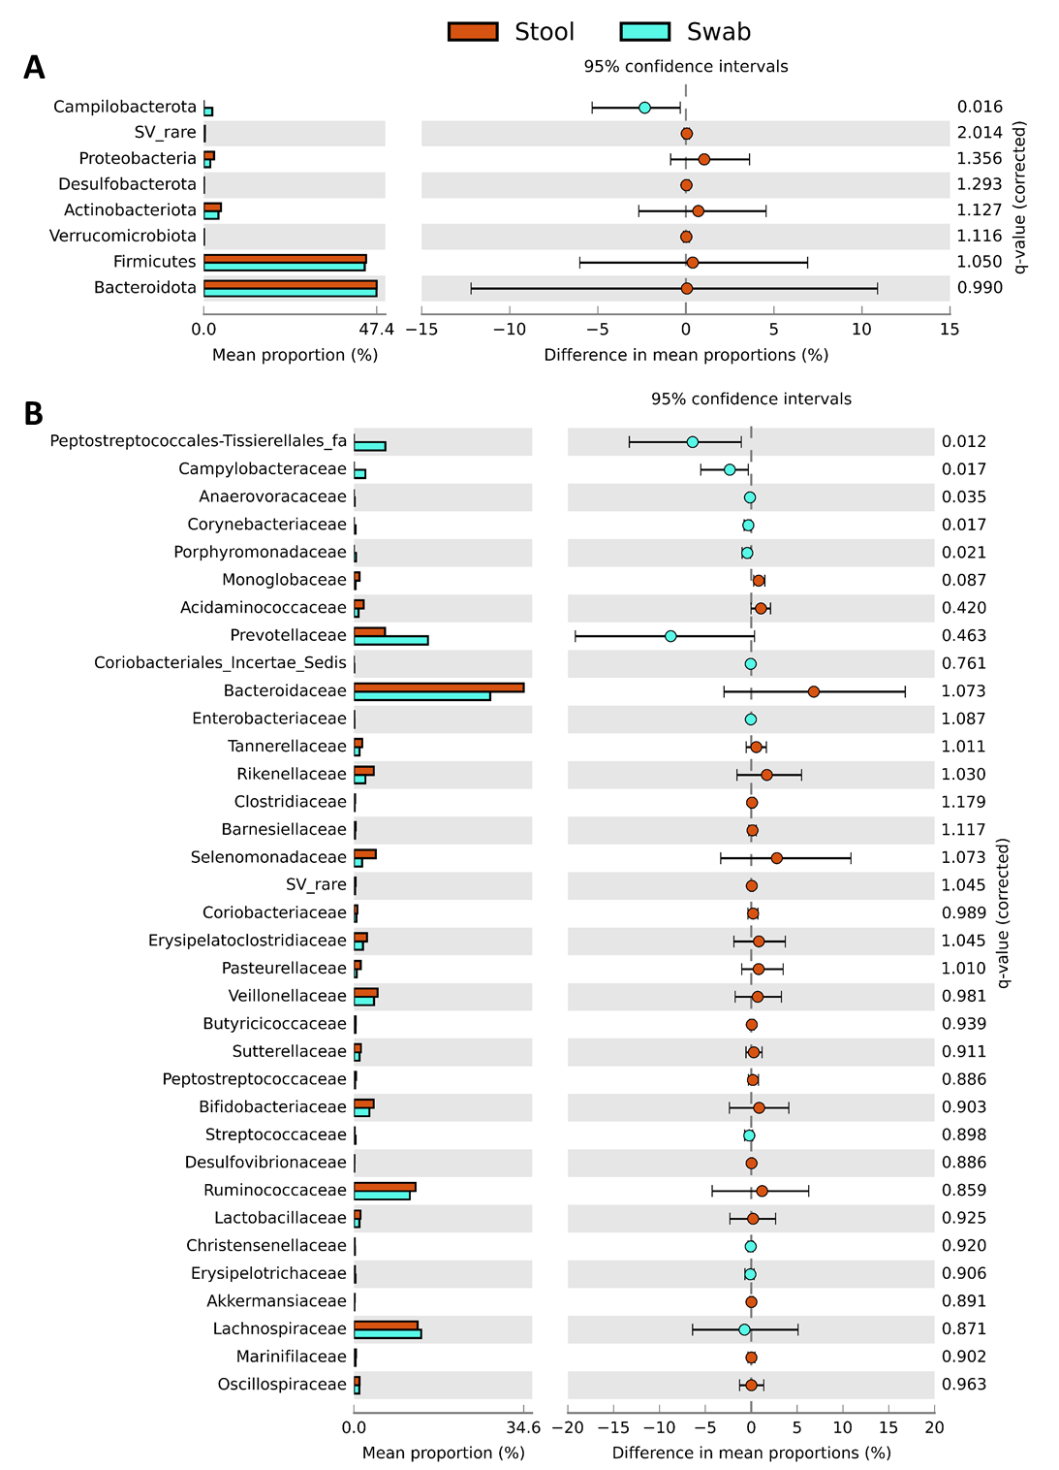
Supplementary Figure 1: Extended error bar plot of differences in relative abundance of bacteria between faecal and matched swab samples at different taxonomic levels. A) Bacterial phyla; B) Bacterial families. Statistically assessed using White’s non-parametric two-sided t-test with Benjamini-Hochberg false discovery rate correction. Faeces: n=10 samples; swabs: n=10 samples. SV = sequence variants.

Supplementary Figure 2: Phylum-level 16S rRNA gene profiling of stool and swabs, corrected for bacterial biomass: Bacterial biomass as established using 16S qPCR. Only phyla present in at least 25% of samples are included. Statistically assessed using Mann-Whitney test. NS=non-significant. Faeces: n=10 samples; swabs: n=10 samples.

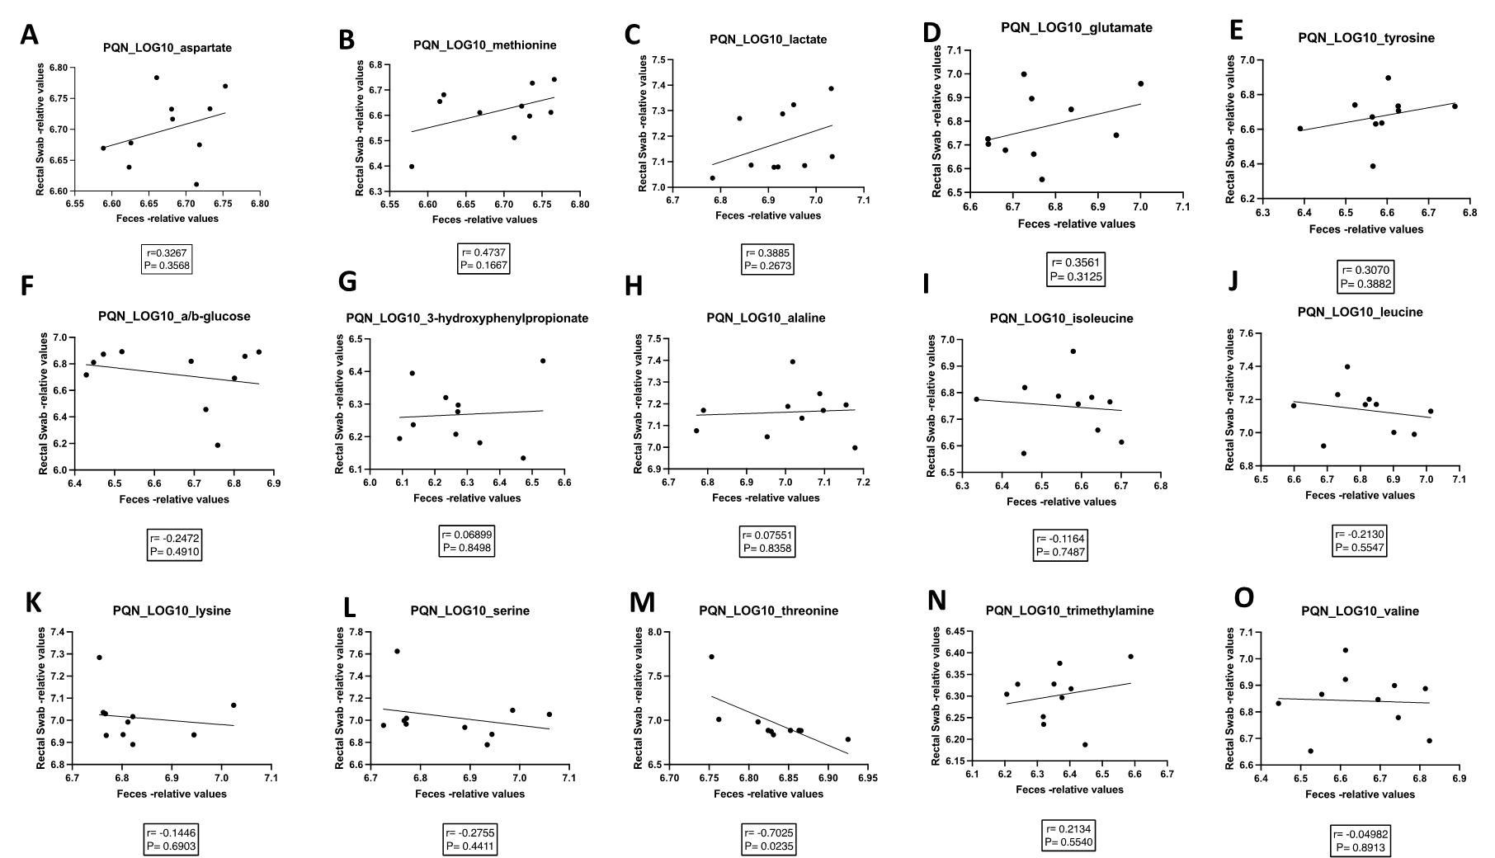
Supplementary Figure 3: Correlation of levels of other annotated gut microbial-related metabolites in rectal swabs and matched stool samples. A) aspartate; B) methionine; C) lactate; D) glutamate; E) tyrosine; F) a/b-glucose; G) 3-hydroxyphenylpropionate; H) alanine; I) isoleucine; J) leucine; K) lysine; L) serine; M) threonine; N) trimethylamine; O) valine. Faeces: n=10 samples; swabs: n=10 samples. PQN = probability quotient normalisation.

